Grade 8

INTEGRATED SCIENCE

- Identify one quality of each matter
- Solid
- Liquid
- Gases
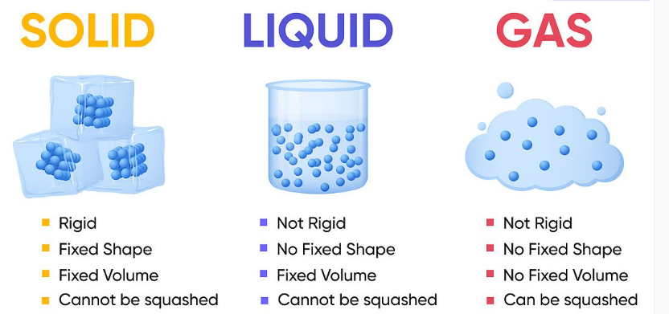

- Identify some of the ways that help to keep the kidney healthy.
- Exercising.
- Controlling blood sugar.
- Monitoring blood pressure.
- Monitoring weight and eating a healthy diet.
- Drinking plenty of fluids.
- Avoid smoking.
- Having regular medical checkups.

- Name the following components of a circuit
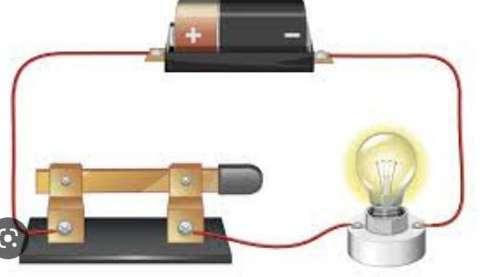
Wire
Bulb
Switch
Dry cell
- Name the following components of a simple circuit
Dry cells | 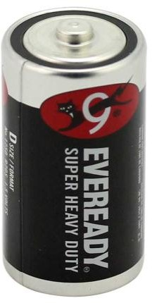
Current conductor or wire | 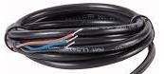
Bulbs with bulb holder | 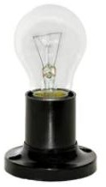
Switch | 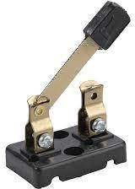

Ammeter | 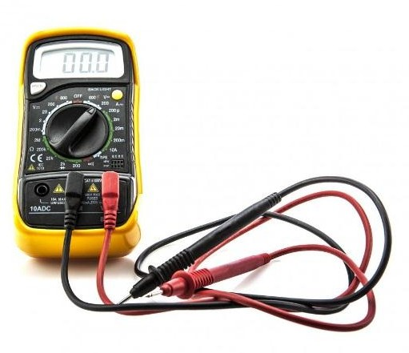
Voltmeter | 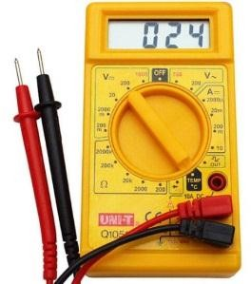

- Name two forms of electric energy.
- Static energy
- Current energy

- Examples of conductors of electricity are:

Copper wire.
  - Aluminium foil.
  - Iron
  - Carbon
- Examples of insulators include:

Plastics.
  - Glass.
  - Cloth.

Threads.
  - Rubber.
  - Paper.
  - Stone.

Dry wood.
  - Mattress.
  - Sisal.

Dry sponge

- State the uses of electricity :
- Running machines.
- Cooking.
- Heating.
- Lighting.
- Refrigerators
- Entertainment.

- Name four electric appliances:

  - Electric cooker.
  - Iron box.
  - Fan.
  - Television.
  - Printer.
  - Electric kettle.
  - Laptop.
  - Desktop computer.
  - Refrigerator.
  - Phone.
  - Radio.
  - Heater.

- Safety measures are put in place when handling electrical appliances to prevent any dangers brought about by electricity. Discuss
Possible danger of electricity. | Safety measure to apply
Overloading a single socket | Do not overload a single socket
Inserting metallic objects or fingers into the sockets. | Do not insert objects or fingers into sockets
In case of a power outage or leakage. | Switch of the main switch.
Naked exposed electric copper wires | Insulate or mask the naked wires or cables.
Wet hands | Dry your hands.
Illegal connection. | Do not connect electricity illegally.
Using spoiled, broken or defective appliances. | Repair broken appliances, devices and sockets.
Splash water near sockets | Do not splash water near sockets.
- State Safety measures to observe when using electrical appliances.
- We should switch off the main switch when not using any electrical appliance.
- We should repair broken appliances, devices and sockets.
- We should not touch naked wires with bare hands.
- We should not handle electrical appliances or switches with wet hands.
- We should not over load a sing socket.
- We should not insert objects or fingers into sockets.
- We should not splash water near sockets and switches.
- We should not attempt to connect electricity illegally.
- State the Uses of Magnets in day to day life
- Magnetic recording media-computers have hard disks that record data on a thin magnetic coating.
- Credit, debit and ATM cards-all of these cards have a magnetic strip on one side.
- Common televisions and computer monitors-some televisions and computer screens contain a device that has an electromagnet.
- Electric guitars-they use magnetic devices to convert the vibration of guitar strings into electric currents that they amplify.
- Speakers -most speakers use magnets to generate sounds.
- Medicine-Hospitals use magnetic devices (magnetic resonance imaging) to spot problems in a patient’s organ.
- Toys- magnets are often used in children’s’ toys.
- Picking up magnetic items-iron nails, staples, tacks and paper clips that are either too small, too hard to reach or too small for fingers to hold can be picked using magnets. Some screw drivers are magnetized for this purpose.

