JUNIOR SCHOOL

2024 ANSWERS

G8 HOMESCIENCE

- State the guidelines to be followed when grilling different types of foods to ensure the food is well cooked.
- Foods to be grilled for example, meat, should not be too thick to allow them to cook properly.
- The grill should be preheated to the correct temperature before.
- The food must be attended to constantly to prevent burning or over-cooking.
- The food should be turned frequently to ensure even cooking.

- Name the following cooking tools
- Two prong fork | 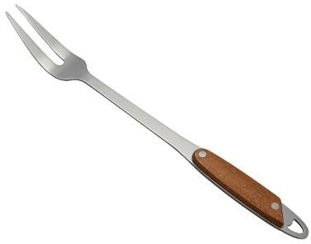
Skewer | 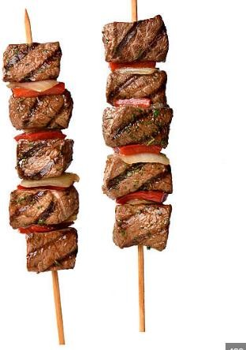
Tongs | 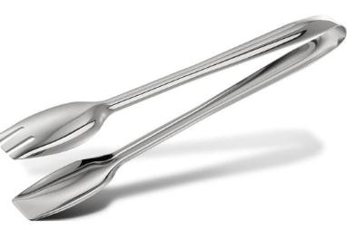

- State the desirable properties of linen
      - Linen is a strong fibre.
      - Linen creases badly since it has no resilience.
      - Linen can withstand high temperatures.
      - Linen is not easily damaged by mild alkalis.
      - Linen is a good conductor of heat hence ideal for hot weather.
      - Linen is more resistant to high temperatures than cotton.
      - Linen is moth proof.
      - Linen is shiny.
      - Linen does not pick dirt particles easily.
      - Linen is more resistant to sunlight than cotton.
- State the undesirable properties of linen

      - Linen frays easily.
      - Linen is attracted by mildew if stored damp.
      - Linen catches fire easily.
- State the challenges experienced or faced when buying household goods and services.
- Increase in prices.
- Scarcity of goods and services.
- Transport challenges.
- Expired goods.
- Cheating on weights of goods and other measurements.
- Poor Quality of goods.
- Network problems for on-line shops and services.
- Incompetent service provides.
- Availability of fake online outlets that are fraudsters.
- Lack of market information to consumers.
- What are the ways of Saving Income when buying household goods and services?
    - Bargaining.
    - Shopping in bulk.
    - Buying household goods and services during promotions.
    - Comparing prices before buying goods and services.
    - Using a shopping list.
    - Buying goods and services from exhibitions and trade fairs.
    - Improvising some items, you intended to buy using locally available materials.
- There are several ways of buying various household goods and services from the sale outlets. Name a few.
  - Use of Cash.
  - Through credit.
  - Use of Mobile money.
  - Through barter trade.
  - Use of cheque.
  - Use of credit card.
  - Use of Debit card.
- State three reasons for having a kitchen garden
- Clean air
- Herbs detox
- Aesthetics matter
- Stay grounded
- Organic vegetables
- Compost your waste
- Cheap and easy
- Recycle and use
- Health friendly
- State three types of kitchen gardens.

Hanging kitchen gardens in Kenya

Container kitchen gardens in Kenya

Raised bed kitchen gardens in Kenya

In-ground kitchen gardens in Kenya

Indoor kitchen gardens:

Potager kitchen garden

Permaculture kitchen garden

Vertical kitchen garden in Kenya

Hydroponic kitchen garden in Kenya

Staircase kitchen garden in Kenya

Simple drip garden

Tyre kitchen garden

Multi storey kitchen garden

Food robe kitchen garden

Sack kitchen garden

Wick irrigation kitchen garden

Moist bed kitchen garden

Aquaponics kitchen garden

Yard small kitchen garden

Cone kitchen garden

Micro-kitchen garden

State three methods of cooking food:
- Baking
- Boiling
- Steaming
- Grilling
- Frying
- Identify the methods of heat transfer when cooking below
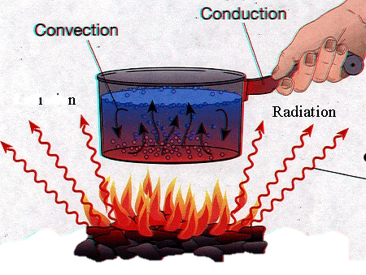

- What is meant by the following terms?
Dextrinisation: The reaction of dry heat on the surface of food which changes starch to dextrin, e.g. toast.
Gelatinisation: The process of thickening which takes place when a mixture of starch and liquid is heated.

Mention five ways used to retain nutrients while cooking
- Choose fresh foods that are not over-ripe, bruised, cut or scraped.
- Peel thinly or cook inn their skins, jacket
- Aim at golden brown when cooking in dry heat.
- Use enough water to cover
- Cook them for the appropriate time
- Blend starchy flavours with cold water before cooking
- Stir thoroughly and continuously over low heat
- Wash vegetables before cutting. Soaking or washing time should be reduced to minimize nutrient loss.
- Cut vegetables into big pieces so that exposure of vitamins to water is less while cooking and washing.
- Use a vegetable peeler to remove skin as it helps remove only a very thin layer of skin.
- Use minimum water for cooking. Bring the water to boil and add the vegetables to cook.
- Cook vegetables by steaming and pressure cooking to conserve nutrients.
- Cover the vessel with a lid while cooking as it hastens cooking.
- Vegetables salads should be prepared just before serving to conserve nutrients.
- Use acids such as lime juice or vinegar to salads as it prevents loss of Vitamin C since Vitamin C is stable in acid.
- Store foods in a cool, dark place.
- When boiling, add the raw food to the boiling water rather than to cold water.
- Steaming is a way of cooking with a minimum amount of water.
- If possible use the cooking water for gravies, sauces or soups as it is a source of water-soluble vitamins and elements (minerals).
- Cook for the minimum time necessary to make the food palatable and safe.
- Do not use baking soda to help keep the green colour of vegetables, as this increases loss of vitamin C.
- Do not use copper utensils. (Copper helps to destroy vitamin C.)
- Soak whole pulses overnight

- State the factors to consider when setting a table.
- The number of people taking the meal as this determine the number of covers to be laid.
- The meal to be served as this ensures that all the tableware is available.
- Number of courses/dishes as this enables one to set the cover for the courses.
- Tableware as this determines their placement.
- Type of meal service as each type has its own way of laying the table.
- The type of dinners determines the way of table setting e.g. ages, special needs.
- A centre piece should be available for beauty/enhance appetite.
- Provide adequate space to avoid overcrowding for comfort.
- Ensure the room is clean for hygiene.
- The table cloth should be well laundered for neatness.
- Table appointments should be clean for hygiene/enhance appetite

