GRADE 8 CREATIVE ARTS AND SPORTS NOTES – TERM 2

STRAND 2 CREATING & PERFORMING IN CREATIVE ARTS & SPORTS.
2.3 Composing Melody.
- When you listen to a song, you will notice that it falls into short sections in form of sentences or lines of words.
- The short sections in which the melodies naturally fall are called phrases.
- In music, we use the word phrase to describe a series of notes that communicates musical idea. A phrase therefore, is a musical sentence.
- Musical phrases come in two forms:
- Question phrase and answer phrase.
- There is a natural place to take a breath and the end of each phrase. A 4-bar melody may consist of two phrases of two bars each. The first two bars form the question phrase and the last two bars form the answer phrase.

- Question phrase leaves the melody incomplete, it tells the listener that there is more to come.
- An answer phrase sounds complete or final. It marks the end of the music.
- A good 4-bar melody has a question phrase that consists of two bar and an answer phrase that is also made up of two bars.
- Phrase in music are shown using a curved line written on top of the music staff covering all the notes forming it. This curved line is called a phrase mark. The following is a question phrase and an answer shown using a phrase mark.

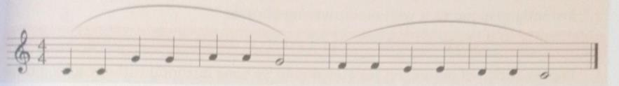

Improvising answer phrases to given opening phrases in simple.
- Improvisation of answering phrases should be done instantly without taking time to write down the rhythmic or pitches.
- When providing the answer to a given question you should listen to the pitch, melodic shape and rhythmic patterns and respond orally and appropriately.
- In order to come up with a good response you should:
✗ Listen to the time patter and stick to the time signature.
✗ Listen to the pitches. This will guide you in choosing the pitches to use when improvising your answering phrase.
✗ Stick to the key. The ability to stay in the original key of the question phrase is important.

✗ Listen to the rhythmic patter used in the question phrase. The rhythm you will come up with in you answer phrase should borrow from the rhythm used in the opening phrase so as to bring unity in your melody.
✗ Balance your phrases, consider having the question phrase and the answer phrase in length. If your opening phrase is two bars long, for example, then the answering phrase should equally be 2 bars long.
The following are some of the techniques applied when improvising answering phrases to given question phrases.
🠖 Retaining the rhythm that is already used, but changing the pitches.
🠖 Repeating the rhythm and pitch, but changing the last note of sound final.
🠖 Moving each note up or down to form a sequence.

- We can create 4 bars melodies of our own consisting of questions and answer phrases by:
✗ Adding so-lfa pitches to rhythms.
✗ Moving notes in the question phrase up or down.
- Sometimes when you move pitches in the question phrase up or down, the ending pitch may no sound finaly. If this occurs you can change the oitch of the last two notes to end with r-d or s-d depending on the direction your ending is taking.
For example
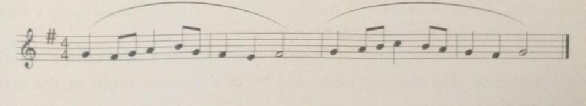

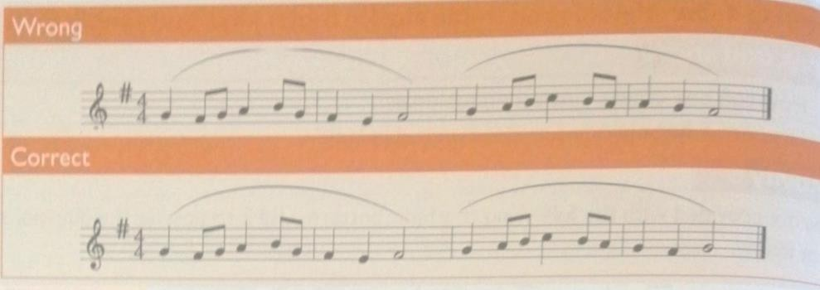

- A 4-bar melody consists of two phrases-question phrase and the answer phrase. The question phrase as well as the answer phrase should each be 2 bars long.
You can be provided with the question phrase to complete up to 4bars or create an original 4—bar melody of your own.
To create an answering phrase to a given opening phrase, consider the following:
  - Balance-the first phrase should be of the same length as the second phrase.
  - Time signature-make sure that you stick to the time signature already given.
  - Rhythm-rhythmic idea given in the question phrase will determine which rhythms you choose to use in answering phrase.
  - Ending of phrase-the question phrase sounds incomplete. The answering phrase sound complete or final.
  - Intervals between notes-always have your notes move in steps (stepwise motion). If you intend to use notes with larger intervals between them, then use them carefully.
When creating your own original 4-bar melodies you should:
⭸ Choose a key.
⭸ Choose your preferred clef, both bass or treble.
⭸ Insert appropriate key signature.
⭸ Insert an appropriate time signature for your melodies.

⭸ Give you melody a strong beginning by starting with sol-fa syllable d or m or s in major keys.
⭸ Think of rhythm and melodic shape of the composition. One rhythmic or melodic pattern should serve as an idea which is referred to as the motif. A motif, if repeated makes your melody memorable.
⭸ Choose a technique that will help your melody develop.
⭸ Finish your first phrase (question phrase) with s,t or r sol-fas that give a feeling of a question. This gives a feeling of incompleteness which has an effect equivalent to comma or question mark in language. Finish your melody at bar four. The ending should sound final. To make your ending final, your last two notes of the piece should progress from r-d or t-d or any other progression that gives a sense of finality.
⭸ Balance-in order to have balance, divide the four-bar melody into two bar
phrases. The first two bars should be question phrase while the last two bar, an answer phrase.
⭸ Keep distance-the difference in pitch between the notes in the melody should not
exceed 5 steps. Notes should move step by step (stepwise movement)
- There are different techniques of creating new melodies or completing melodies with opening phrases. They include:
⭢ Repeating the entire question phrase in the answer phrase and changing only
the ending, for example,
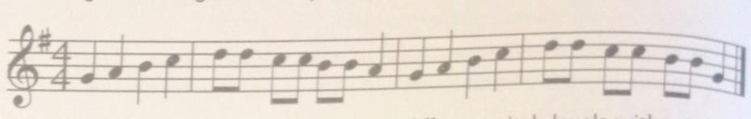
⭢ Moving your motif up and down to different pitch levels without disrupting the pattern. You may only modify the ending to make the melody sound complete or final, for example.

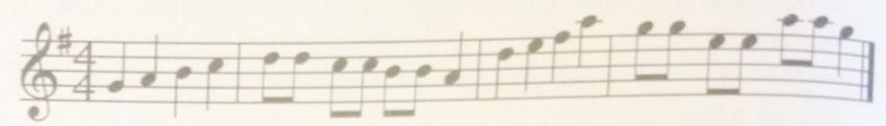

⭢ Changing the entire melody and rhythm.
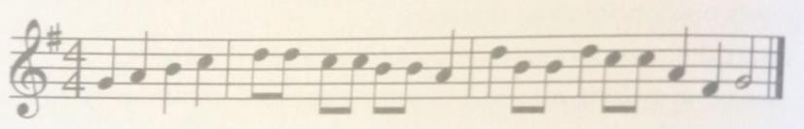

Performing melodies created by created by self and other. Melodies can be performed by using voice or a melodic instrument.
When performing melodies, one should observe proper phrasing. This can be achieved by playing or singing an entire phrase without breaking it unnecessarily.
When performing, a breath should be taken at the end of each phrase.
Phrases in music are always shown using a curved line written connecting the first notes to the last notes of the phrase.

2.4 Netball.
Chest pass in Net ball.
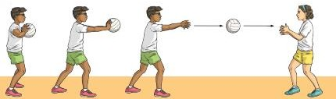

- Chest pass is a way of throwing the ball to a teammate where the ball is released and received at the chest level.
- The pass is usually used when the teammates are not far from each other. Learning points for the chest pass.
- Grip
  - Spread your fingers out behind the ball to form a W formation, holding it at chest height with your elbows out in front of you.
- Stance.
  - Face the direction you want the ball to go in.
  - Step forwards with your dominant foot as you begin to straighten your arms.
- Execution of the pass.
  - Push the ball away from your body at chest height by powerfully extending the arms forwards and flicking the wrists.
  - Follow through with the arms, wrists, hands and fingers in the direction of the throw.

Chest pass drills
Dodging and marking in Netball.
Dodging is a technique used to counter the marking attempts.
🢒 It is applied by members of the team in control of the ball.
🢒 The player being marked attempts to get free from the marker and move into space to receive a pass.
🢒 It may involve changing pace and use of deceptive body actions to put the marking player off balance.
🢒 Deceptive means misleading or trickiness while off-balance means not steady or stable.
🢒 Intercept means block a pass or prevent it from reaching destination or to block something from happening.

Body movements used by a player when dodging an opponent.
- Using bending or leaning movements with the body trunk to the left or right or left once or repeatedly.
- Sprinting off from the marker.
- Sprinting and stopping.
- Extending the left or right arm away from the opponent.

Marking is a technique used by a team that is not in possession of the ball to prevent an opponent from receiving a pass.
The intention is to obstruct passes made by the team in control of the ball.
A player can mark an opponent in possession of the ball or an opponent without the ball.
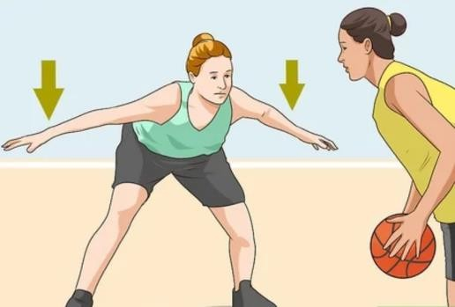 Marking opponent with the ball. 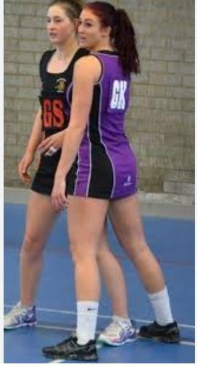Marking opponent without the ball.

Body movements used by a player when marking an opponent.
- Standing in front of the player being marked.
- Standing beside the player being marked.
- Raising hands up or to the side to reach the path of the ball.
- Stepping forward, or sideways while avoiding any obstruction. Things to learn when dodging and marking stance.
Marking a player without the ball.
🢒 Establish the basic stance for marking with body weight on your toes.
🢒 Take a position slightly in front of the player you intend to mark.
🢒 Be on your toes, with knees slightly bent, ready to catch the ball or move in the direction of the opponent.
🢒 The hands should be on the side of the body.
🢒 React quickly when the opponent being marked makes any movement, move in the direction of the opponent using short steps, shuffle sideways without crossing the feet.
🢒 Focus on both the ball and the player and forth from one place to another. Activity.
Guided by the teacher Demonstrate
Basic stance for dodging, marking, body movement for dodging and marking.

Footwork in Netball. Landing techniques.
In netball, the ball is played using hands. During play, the players may:
 Run to doge an opponent or to reach a ball.
 Jump to catch a high ball or rebound from the ring.

 Stop the running action suddenly to dodge an opponent or avoid getting to an offside position.
 Land on the floor or the ground as dedicated by the laws of gravity in integrated science and as guided by the law of the game. However, players need to land safely for safety and healthy living.
There are two landing techniques in Netball:
- The double foot landing.
- Single foot landing.
Pivoting.
Pivoting is the act of turning with one foot on the ground while the other foot makes repeated short steps.
Picoting:
✗ Helps the player develop balance after landing.
✗ It helps the player turn away from the defender who may be marking.
✗ Helps in locating teammates who may be well-positioned to receive the pass.
Things to learn in Pivoting.
  - Land one foot and maintain balance.
  - Maintain a firm grip of the ball.
  - Keep the landing foot grounded with knees slightly bent.
  - Keep the head up and the trunk upright.
  - Step with the non-landing foot and turn around.
  - Keep the ball close to the body.

2.5 Descant recorder or Any other western instrument.
Examples of western solo instruments.

Instruments | Playing technique | Fingering chart for  the G scale.
Violin  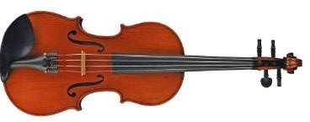 | Bowing on the strings
Guitar.  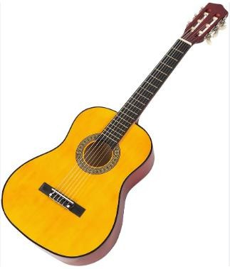 | Plucking the strings
Trumpet in B flat  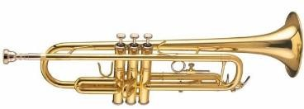 | Blowing air while producing a buzzing sound. Tones can be varied by pressing the  valves.
Xylophone  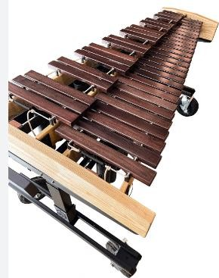 | Hitting the bars with a small mallet.  Each piece of wood is a different length so it produces different sounds when they are  hit.

Piano  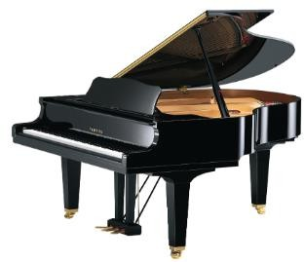 | Pressing on the keys.
Playing the recorder using appropriate techniques.
The following techniques are used to play descant recorder:
- Tonguing.
  - Gently say ‘tu’ when blowing air into the recorder.
- Embouchure.
  - This is how one places their mouth on the recorder’s mouthpiece to ensure that
no air is lost when blowing into the instrument.
- Fingering.
  - Correct placement of the fingers on the recorder. As a rule, the left hand is always at the top part of the recorder. All the holes must be tightly covered to prevent leakage of air.
- Blowing.
  - Blow warm air into the recorder. Blowing gently gives a good sound. Blowing too hard generates unpleasant sounds.
- Slurring.
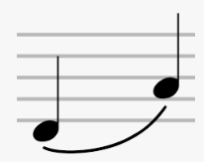
  - This is the technique of playing more than two notes in one breath. This involves only the movement of fingers while the airflow is constant.

- Staccato.
  - Playing notes in a detached manner.
  - Notes to be played staccato have a dot above or below the note.
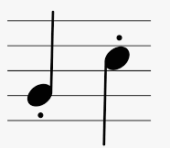

- Tone quality.
  - Listen carefully to the sound you produce when you blow into the recorder.
  - Blowing gently and having consistent air gives a good tone.
- Blend and balance.
  - Being able to listen to what the other in an ensemble are playing helps to blend and create a balanced sound.

Interpret performance directions when playing the descant recorder.
You should be able to play melodies on the descant recorder while observing the following directions:
- Repeat.
Repeat signs are two dots that are placed before or after a double bar line.
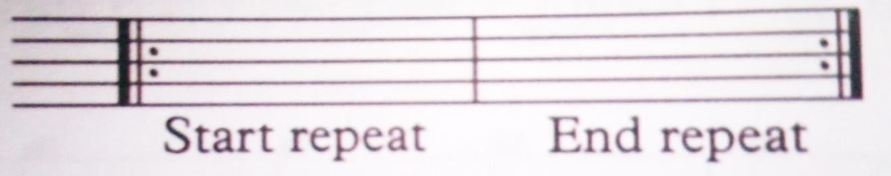
Whey they are placed after a double bar line, it means it is the start of the repeat. However, when they are placed before a double line, it means the end of repeat.

- 1st and 2nd ending
The two lines above the staff mean that one will avoid playing 1 notes when repeating. This applies where there is a repeat and the last part of the melody is different from the first one.
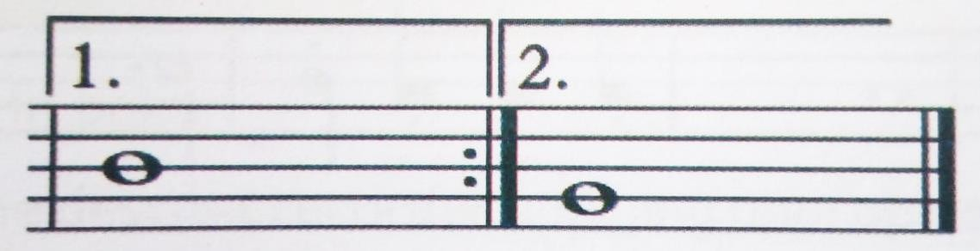

- Da capo al fine
It is often abbreviated as D.C al Fine.
It means one goes back to the beginning of the piece and plays to the point written.

- Dal segno al fine.
It is often abbreviated as D.S al fine.
It means you go back to a point in the piece of music with the sign and  play or sing to the bar marked Fine (end) then stop.

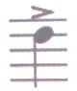
- Accent.
The note with sign is played with emphasis.
- Fermata. 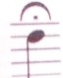
This sign means that you can hold the note a little longer that its given
time value or number of counts.
- Dynamics.
This refers to how quietly or loudly a piece of music should be played. Italian terms are used to indicate dynamics in the piece of music.

Dynamics | English meaning.
Pianissimo (pp) | Very soft
Piano (p) | Soft
Mezzo piano (mp) | Moderately soft
Mezzo forte (mf) | Moderately wide.
Forte (f) | Loud.
Fortissimo (ff) | Very loud.

- Tempo.
This term is used to refer to how fast or slow a piece of music can be played. Italina terms are used to indicate what tempo the music is played
Tempo terms | English meaning.
Andante | At a walking pace (73-77 beats per minute)
Allegro | Fast (109-132 beats per minute)
Adagio | Slow (ss-65 beats per minute)
Lento | Slowly (40-45 beats per minute)
2.6 Volleyball.
Overarm and Jump serve in Volley. Over arm serve.
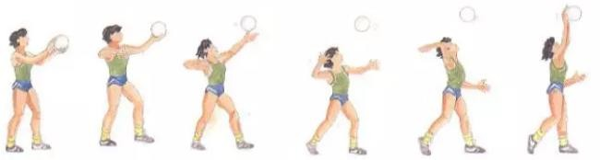

Over arm serve is where a player tosses the ball with one hand and strikes it in the air above their head with the other hand so that it crosses the net and lands into the opponents’ side.
Safety instructions.
  - Ensure you perform thorough warm up activities.
  - Avoid congestion by maintaining a safe distance from your peers.
  - Follow instructions.

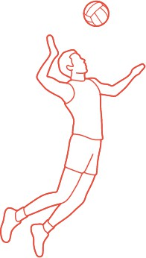
Jump serve in Volleyball.

This is a type of serve where the serving player increases power and serve height by jumping to hit the ball when serving in volleyball.

Minor Games and basic rules.
Minor games are small sided games that help you practice skills learnt in volleyball while applying the rules of the games.

Safety precaution.
⭢ Never fist hit the ball as you could hit someone’s face.
⭢ Do not swing on the post.
⭢ Do not go under the net, always walk around the nets.
⭢ Do not throw the ball over the net, roll it under the net.

Diagram of human figures playing Volley.
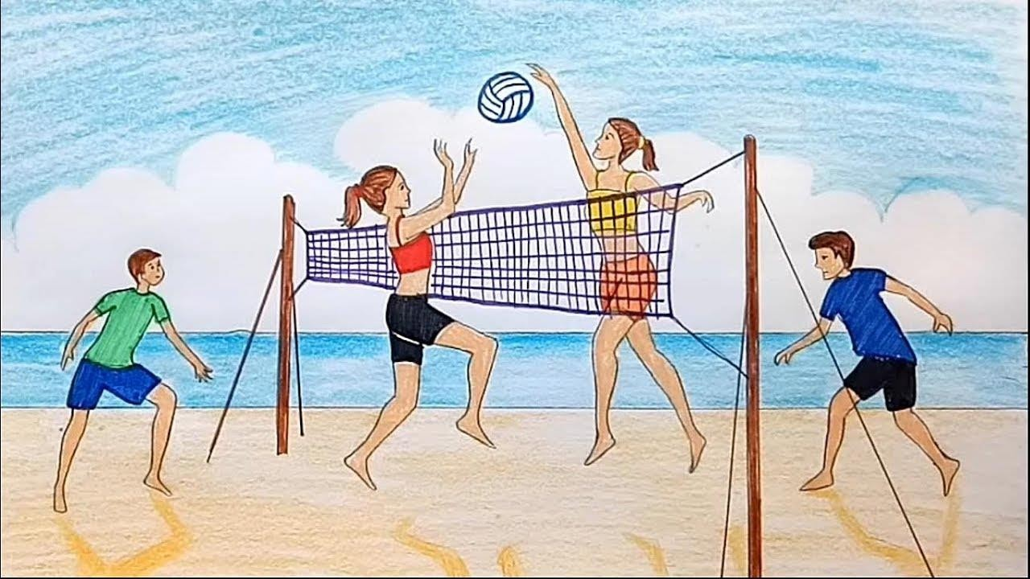

Student activities monitored and instructed by the teacher
    - Draw human figures of players serving or volleying a ball.
- Serve the ball using the jump serve over a net.
- Perform the volley for skill acquisition,

