COMPETENCE BASED CURRICULUM
JUNIOR SCHOOL
GRADE 8
FORMATIVE ASSESSMENT
CREATIVE ARTS

2 HOURS
SCHOOL: ……………………………………………………………………………..……
NAME: ……………………………………………………..……………………..………..
ASSESSMENT NO: ……………….………. SIGN: …....DATE: ………..….
RUBRICS (for official use)
Mark Score Range | Below 40 | 40-59 | 60-79 | 80-100
PERFORMANCE LEVEL | Below expectation | Approaching expectations | Meeting expectations | Exceeding expectations
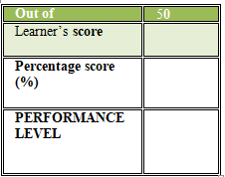
FOR EXAMINERS
INSTRUCTIONS TO CANDIDATES
- Answer all the questions in the spaces provided.
- Ensure your work is neat.

- Name three social media we can use to market our art work.( 3mks)
  - ……………………………………………………..
  - ……………………………………………………..
  - …………………………………………………….
- ……………………. Is a term used to describe skills, feelings and imagination? (1 mk)
- Name two categories of arts.(2 mks)
- ………………………………………….
- ………………………………………….
- State two techniques used in shading a drawing.(2 mks)
- ……………………………………………………..
- ……………………………………………………..

- Name three elements of an art presentation.(3 mks)
- ……………………………………………………..
- ……………………………………………………..
- ……………………………………………………..
- …………………………………………………….
- Name two digital devices that can be used when making an art presentation.(2 mks)
- ……………………………………………………..
- …………………………………………………….
- Write whether the following images are 1D 2D or 3D (3 mks)

……………………… …………………… …………………..
- Identify three components of perspective.(3 mks)
- ……………………………………………………….
- ……………………………………………………….
- ……………………………………………………….
- Identify any two types of puppets.(2 mks)
- …………………………………………………….
- …………………………………………………….
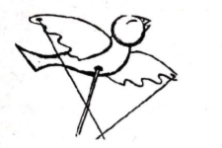
- Name the type of puppet shown below……………………………(1 mk)

- Name two materials that can be used in crayon etching. (2 mks)
- ……………………………………………
- ……………………………………………
- ……………………………………………
- Decorate the drums below then Shade drawing using any of the three shading techniques.(5 mks)

- What is a colour wheel?(1 mk)
……………………………………………………………………………………………………………………………………………………………………………………………………………………………………
- Identify 2 examples of the following colours in a colour wheel.(4 mks)
Analogous colours | Complementary colours

- Trace the image below to make it clearer. Using only smudge technique, colour the image.(10mks)

- Complete the following drawing showing the three components of perspective.(3 mks)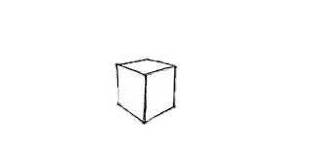
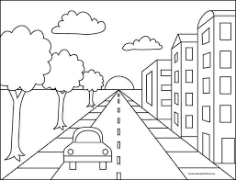
- Below is a sketch drawing. Paint the sketch with appropriate colours making the picture look real.(11mks)

- Name the following types of perspective views. (3 mks)
……………………. ………………………. ……………………

- State the kind of view in the following photographs.(2 mks)
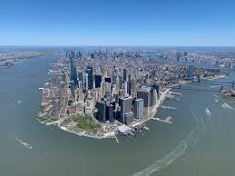
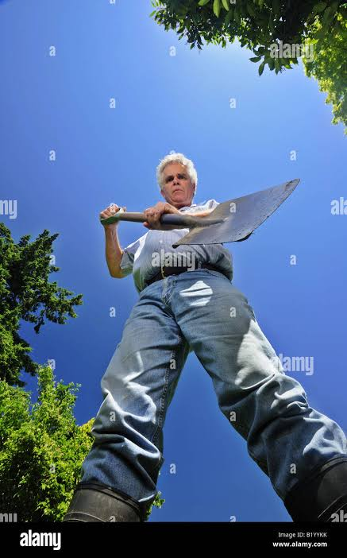

…………………………….. ………………………...

- Mix the following primary colours in the circles below and state the colours you get when you mix. (4 mks)
- Blue and yellow=……………………………………………..
- Blue and red = …………………………………………………
- Red and yellow = ……………………………………………….
- Red and blue and yellow = ………………………………………..

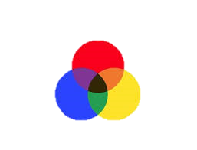
RED
(4 mks)

YELLOW
BLUE

- Name three properties of a colour. (3 mks)
- …………………………….
- ……………………………
- ……………………………
- The picture technique that involves creating a pictorial composition using a collection of pictures is called?......................................................................(1mk)
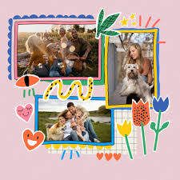
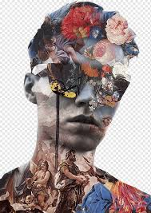
- Name the type of art activity illustrated below(4 mk)

- What is value? (1 mk)
………………………………………………………………………………………………………………….
- Use the boxes below to create value gradation.(3 mks)
- What is intensity of a colour? (1 mk)
…………………………………………………………………………………………………………………………………………………………………………………………………………………………………….
- Create intensity scale in the following strip?(3 mks)

- Which colour represents agony or sadness?............................................ (1 mk)
- The image below represents a person who is sad. Use any of the shading technique to show the theme of sadness or agony. ( 5 mks)

- Name three examples of secondary colours. (3 mks)
- ………………………………………………………
- ………………………………………………………
- …………………………………………………….
- In the space below draw a colour wheel.

(5 mks)

THIS IS THE LAST PRINTED PAGE

