COMPETENCE BASED CURRICULUM
JUNIOR SCHOOL
FORMATIVE ASSESSMENT
TERM ONE 2024
GRADE 8

MARKING SCHEME
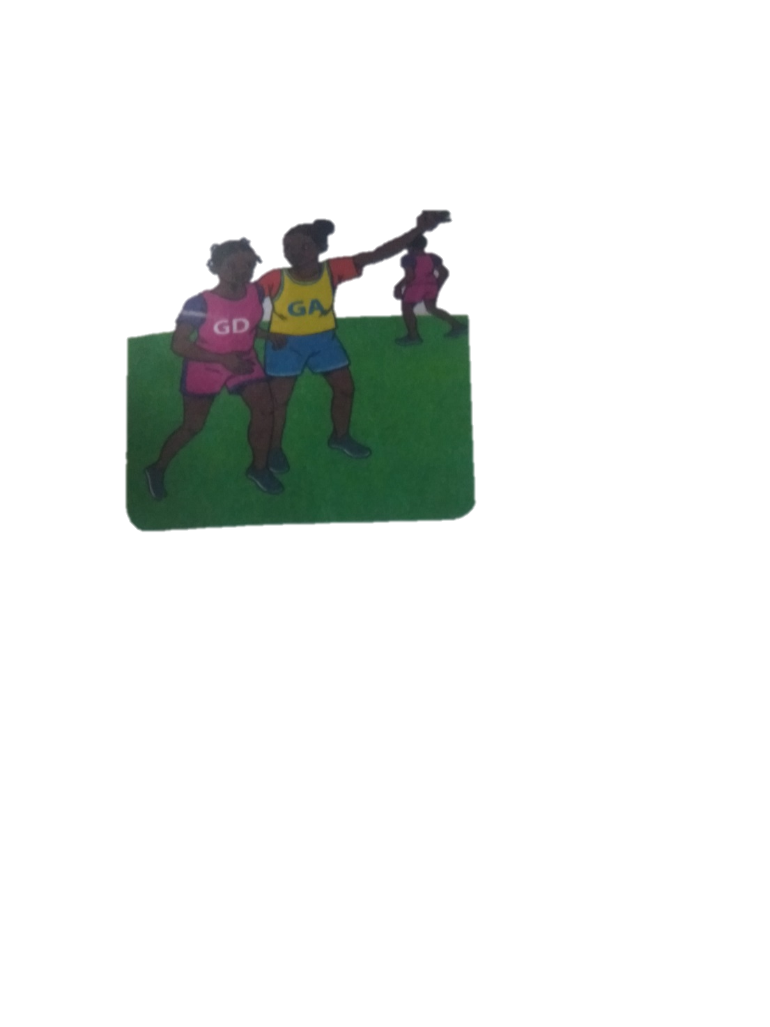
CREATIVE ARTS AND SPORTS
- Identify the type of marking illustrated below.( 2 mks)

Marking player with a ball marking player without a ball

- From the game of netball, what do you think these two players are doing? (1 mk)

Marking
- A centre player if offside whether he of she enters which part of the netball court?goal area (1 mk)
- Which is the most common type of injury in a netball game?_sprains,bruising,fracturs and dislocation(1 mk)
- What does a referee do to start a netball game ?(1 mk)
By blowing the whistle.

- Identify the materials needed in the game of handball.(2 mks)
- Balls Red Cards
- Whistle Yellow Cards
- Give two types of passes in a game of handball. (2 mks)
- Jump pass
- Side pass flick pass
- Define the following terms. (4 mks)
- Reception.
Is the act of receiving the ball with one or both hands.
- Passing
Is delivering the ball to a team mate during play in a handball game.
- Pivoting
Is the act of turning with one foot on the ground while the other foot makes repeated short steps.
- Marking
It is a defensive action that limits the chances of attacking players gaining possession of the ball.
- What size is a handball court?(1 mk)
- 20 by 40m
- Name the type of pass below
Overhead pass

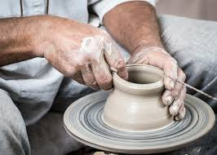
- Name the type of art activity illustrated below(4 mk)

Carving

Pottery
- Name the three types of perspective viewpoints.(3 mks)
- Bird’s eye view
- Normal eye view
- Worm’s eye view

- Differentiate between analogous and complementary colours. (2 mks)
Analogous colours are colours that are next to each other on a colour wheel. They create harmony when used in a composition while complementary colours are colours that are directly opposite each other on a colour wheel.
- Name two examples of analogous colours. (2 mks)
Analogous colours
Red,orange
Red-orange orange etc
- How can a song benefit a singer and listeners?
- Stress reliever
- Earn income
- Entertaining
- Pass time
- Hobby and improving talent etc.
- Educate and enlighten
- Embrace moral values etc.
- When performing a dance or a song adjudicators/judges check on;
- Tonal variation
- Adornments
- Accompaniment
- Volume
- Pitch
- Message/ theme
- Articulation of words and voices
- Harmony etc.
- Costumes
- Name two categories of participants in a dance presentation:
- Presenter
- Listeners
- Define the following terms
  - Pitch: highness or lowness of sound
  - Volume: loudness or softness of a sound
  - Tempo; speed of a sound
  - Dance formation: how performers are arranged in a dance/ presentation
- What is body adornment?
The make ups or jewellery worn while performing
- What is the meaning of: (2mks)

  - An artiste:
It is a professional entertainer, especially a singer or dancer

  - Audience
Audience in the arts refers to an individual's. Or group's viewing, hearing, reading, and/or listening of an artistic product or products.
- Draw a drum and name the following parts; skin membrane, sling, sound box and tuning laces. (4mks)
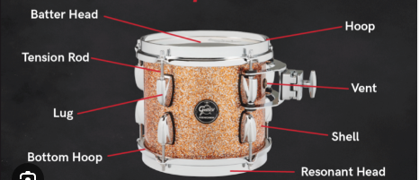

- Drama can be described as?
the art of composing, writing, acting, or producing plays; a literary composition intended to portray life or character or enact a story, usually involving conflicts and emotions exhibited through action and dialogue, designed for theatrical performance. (2mks)

THE END

