JUNIOR SCHOOL

2024 ANSWERS

G8 BUSINESS

Which devices can be used when setting up personal goals easily.
- A desktop computer.
- Laptop.
- Diary booklet.
- Tablets or iPad.
- Smartphone.
- An exercise book.

State three differences between talent and ability.

TALENT | ABILITY
It is a gift from God. | It is acquired and developed.
It is possessed by few people. | Many people can possess it through learning.
It requires recognition. | It requires development.
It requires guidance and coaching. | It requires training.

What are the Differences between Needs and Wants?

NEEDS | WANTS
They are limited (food, shelter and clothing) | They are unlimited. (they are very many)
They are a necessity i.e. one cannot do  without them. | Luxury i.e. one can do without them.
They may remain constant over time. | They may change with time.

- Define the following terms
Scarcity
A situation where the economic resources are insufficient to satisfy needs and wants.
It means the demand for goods and services is more (greater) than the available goods and services. Economic resources are limited.
Resources are scarce because the quantities available are less than the quantities we require to satisfy our wants which are limitless.

Opportunity cost.
This is the value lost when choosing one item instead of the other.

Choice.
it is the act of deciding on which need or want to be satisfied first.

Scale of preference.
This is a list of goods and services (for example, shoes, socks, books, haircut etc.) prepared for purchase in order of priority.

Explain the Categories of Business Activities.
Extraction- Business activities that involves obtaining natural resources from the earth such as lumbering.
Processing- Business activity that involves changing raw material into goods in their finished form such as cars.
Manufacturing- Conversion of raw materials into useful products such as converting iron into steel.
Construction- business activities that involves establishment of structures such as buildings, roads etc.
Trade- Business activities that involves buying and selling of goods to the final consumer such as fruits.
Provision of services- Business activities that involves human acts which can be mental or physical such as entertaining and driving.

- Outline four Types of large-scale retail outlets
- Supermarkets-a large-scale self-service store that mainly deals with household appliances and groceries.
- Chain stores-it is a large-scale selling outlet operated by one business organization and spread nationwide.
- Departmental stores-many single shops that are divided into many special sections or departments. Each department sells specific goods and services under different management.
- Hypermarkets-a large shopping centre consisting of many businesses under one management.
- Mail order stores- this type of retail outlets, goods and services are ordered through telephone, post office or emails. The goods are normally delivered by courier.
- State the Importance of Studying Business studies in schools

- Studying business studies in school helps learners to acquire and develop skills required in business such as recording skills and wise buying as well as attitude necessary.
- It also helps help in developing careers for those interested in exploring the business field in future.
- It also helps one to know how business and the environment interdepend on each other for survival and one exists because of the other.
- It can help one to choose career later in life.
- It assists the learner or member of the society to acquire knowledge and awareness of business terminologies which are necessary when discussing business issues such as profit and loss.
- It assists individuals in appreciating the role of business in society /in provision of goods and services.
- It equips the members of society with knowledge and skills necessary to start and run a business comfortably.
- It makes members of the society to appreciate the need for good business management practices.
- It assists individuals to acquire self-discipline and positive attitude towards work. Equips individuals with abilities to promote co-operation in society through trade.
- It enables the individual to understand the role of government in business activities.
- It equips individuals with abilities to understand the role of communication and information technology in modern business management.
- It helps individuals to develop positive attitudes towards the environment.
- It equips a person with knowledge and skills required to evaluate business performance.
- It helps individuals to develop various intellectual abilities such as inquiry, critical thinking, analysis, interpretation, rational judgment, innovation and creativity.
- It creates a firm foundation for further education and training in business and other related fields.
Entrepreneurship
Components of Business studies
Economics
Accounting
- It enables one to understand and appreciate the basic economic issues that affect the society such as increase in prices of goods and services.

State the meaning of the Components of Business

 | Component of Business | Meaning.
1 | Economics | It is the study of how human beings try to satisfy endless wants using the available scarce resources.
2 | Commerce | It is study of trade and aids to trade. Trade is exchange of goods and services with the aim of making profit while aids of trade are activities that support trade such as warehousing, insurance,  transport, banking, advertising etc.
3 | Accounting | It is the study of recording business activities which are used for decision making.
4 | Entrepreneurship | It is the study of the process of setting up and running a business with the aim of making profit.
5 | Financial literacy | It is the knowledge and skills in the use of money.

What are the uses of Money?
- Money serves as a medium of exchange and people use money to pay for goods and services.
- Money serves as a store of value. You do not need to spend it immediately because it will still hold its value the next day or year.
- Money serves as a unit of account, which means that it is used to measure and record financial transactions or buying and selling of goods and services.
- Money serves as a means of transfer of immobile properties. One can sell or buy immovable properties such as land by use of money.

What are the security features of Kenyan denominations below?

- Feel the word KENYA.  - Feel the value (50).  - Feel 1 bar | - The watermark of a perfect lion’s head, the text CBK and the value of the note (50).  - The security thread appears as a continuous line. | - The security thread changes colour from red to green.  - The 200, 500 and 1000 notes have additional rainbow colours on the thread.  - The golden band on the note shows the value of the bank note 50

Distinguish the following goods

Free goods and economic goods.
Free goods are goods that are naturally provided like sunshine, rain, oceans.
Economic goods are commodities which have money value that can be used to satisfy human needs and wants.

Producer goods and consumer goods.
Producer goods are used in producing other goods. They include machines, equipment and tools.
Consumer goods are final products that are bought and used by consumers. They include microwaves, fridges, t-shirts and candles.

Perishable goods and durable goods.
Perishable goods are goods that go bad easily unless stored using very special facilities. These goods include meat, milk and vegetable
- Durable goods are goods that are used for along period of time for example radio, furniture or building among others.

Public goods and private goods.
Public goods are goods that are enjoyable by all citizens like roads, airports, rivers, public hospitals, public parks, railway or churches.
Private goods are goods that are owned by individuals such as personal cars, private schools, private land among others.

- Distinguish between goods and services.
GOODS | SERVICES
Goods are tangible | Services are intangible.
Goods can be separated from the seller. | Services cannot be separated from the service  provider.
Goods can be stored for future use. | Services cannot be stored for future use.
Goods have a significant time gap between  production and consumption. | Services are purchased and consumed  together.
Goods can be seen. | In order to provide services, you need  physical tools.
Goods can be spoiled over time. | Services are rendered directly by one person  to another and they expire.
Goods can be standardized. | Quality of services can be standardized.
Goods can be transported from one place to  another. | Services cannot be transported from one place  to another.

- What is
Resources are all the materials available in our environment which are accessible, economically feasible and culturally sustainable and help us to satisfy our needs and wants.
Economic resources are the resources used for carrying out economic activities.

- There are four factors of production namely:
  - Land.
  - Capital.
  - Labour.
  - Entrepreneurship

State the Importance of paying taxes in Kenya.
- Taxes are the primary source of revenue for the government.
- Taxes are collected from people so as to have ways of improving the social lives of people in the country.
- Taxes makes it easy for the government to distribute resources that are lacking to the rural and poor areas of the country.
- Tax money is spent to improve and maintain public infrastructure, including the roads and fund public services, such as schools, emergency services, and welfare programs.
- Taxation helps in development of human capital and education. Money from taxes is used in funding, furnishing and maintaining the public education system.
- Taxes help to geo the economy which in turn has great effect on the country’s economy by raising the standards of living and increasing job creation.
- The money received from taxation also pays public servants such as police officers and members of National assembly.
- Government uses taxes collected to fund contribute to the health sector. Tax fund health services such as social healthcare, medical research and social security.
- The government imposes high levies on these products like alcohol and tobacco to discourage people from buying or selling them.
- Government uses money collected from taxes to fund sectors that are crucial for the wellbeing of their citizens such as security, scientific research and environmental protection.
- The government can provide taxes money back into the economy inform of loans and other funding forms.
- Name the Financial documents used in buying and selling in business.
  - Receipts.
  - Invoice.
  - Payment vouchers.
  - Credit notes.
  - Debit notes.
- Name the Methods of payment:
- Cash.
- Cheques.
- Banker’s cheques or bank draft.
- Mobile money.
- Electronic fund transfer (EFT).
- Standing orders.
- Debit card and credit card
- State the Stages followed during a credit transaction
- Inquiry stage.
- Order stage.
- Delivery stage.
- Invoicing stage.
- Payment stage.
- State the Legal requirements for Starting and Operating a simple business in Kenya
- Register for a business name, trade license or permit.
- Have a Kenyan identity card or passport.
- Have a KRA pin (personal identification number)
- Fire safety certificate.
- Have a national hospital insurance fund.
- Have a national social security fund.

- Identify the following business documents

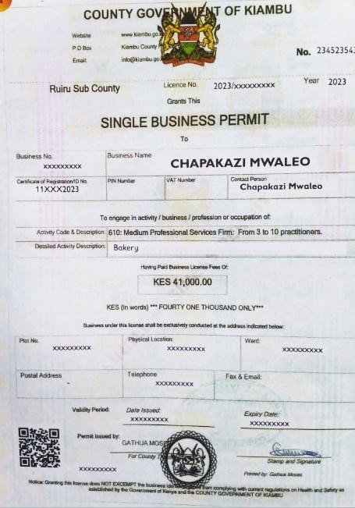
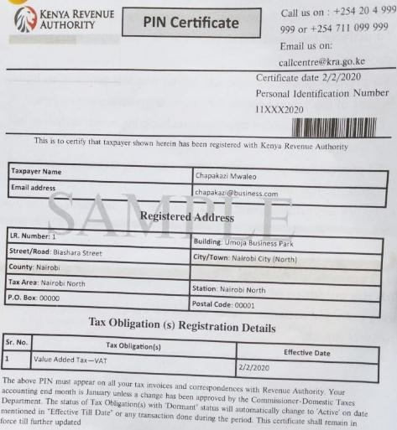
KRA pin certificate
Business permit
licence

