COMPETENCE BASED CURRICULUM
JUNIOR SCHOOL
FORMATIVE ASSESSMENT
TERM ONE 2024
GRADE 8

Name……………………………………………………………….………………………………………………
Centre ………………………………………………………………………………….......................................
Assessment No. ……………………………………………………………… Stream………………………
Learner’s Sign……………………………………………………..… Date: ………………..…………………..
AGRICULTURE AND NUTRITION
FOR EXAMINERS

ASSESSMENT RUBRICS (for official use)
%SCORE RANGE | Below 40 | 40-59 | 60-79 | 80-100
PERFORMANCE LEVEL | Below expectation | Approaching expectations | Meeting expectations | Exceeding expectations
 | 1 | 2 | 3 | 4

- Name the following types of innovative gardens below. (4 mks)

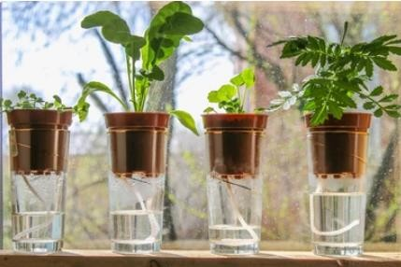

- What is Poultry rearing?(2 mks)
………………………………………………………………………………………………………………………………………………………………………………………………………………

Name six Materials used in the Construction of a poultry fold. (6 mks)
- ……………………………………………..
- ……………………………………………
- ……………………………………………..
- ……………………………………………..
- ……………………………………………..
- ……………………………………………..

Gordon has reared poultry in a fold at his home; identify various practices which he must carry out when rearing poultry in a fold. (5 mks)
- …………………………………………………………………………………………….
- …………………………………………………………………………………………….
- ……………………………………………………………………………………………
- ……………………………………………………………………………………………
- ……………………………………………………………………………………………
- We can identify various vegetables attacked by crop pests through the following ways :( name at least three ways)(3 mks)
- ……………………………………………………………………………………………..
- ……………………………………………………………………………………………..
- ……………………………………………………………………………………………..

.

Observe the following diseased plants carefully. Identify the following effects of vegetables crops attacked by pests and diseases.(6 mks)
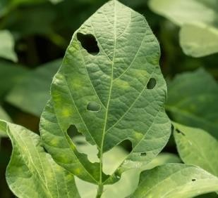
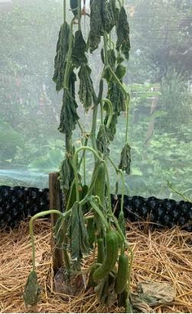

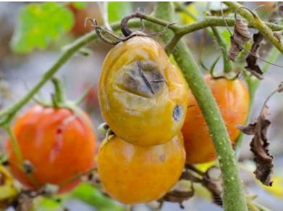
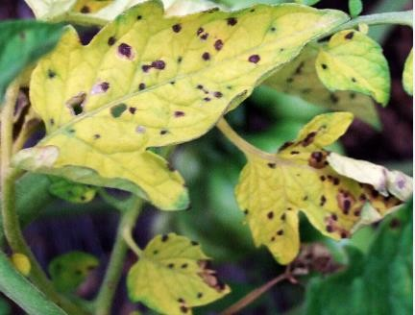

f

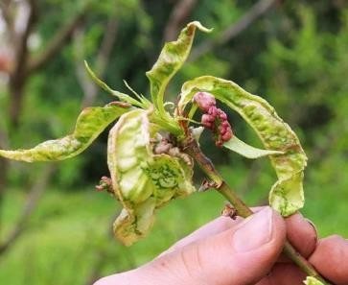

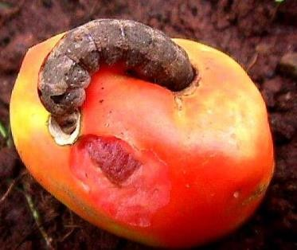

State five ways used to Control of pests and diseases on vegetables crops. (5 mks)

- ………………………………………………………………………………………..
- ……………………………………………………………………………………….
- ……………………………………………………………………………………….
- …………………………………………………………………………………………
- ………………………………………………………………………………………..

- Grace is a fish farmer from Lake Victoria. Identify three processes she carries out to prepare fresh fish for transportation, storage and consumption.(3 mks)
  - ……………………………………………..
  - …………………………………………….
  - ……………………………………………

- Abraham visited a fish processing site and took the following photographs. Identify the process or activity taking place in each picture.(4 mks)
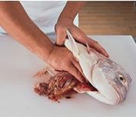
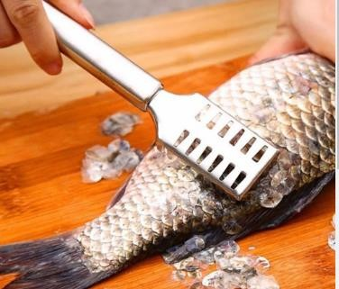

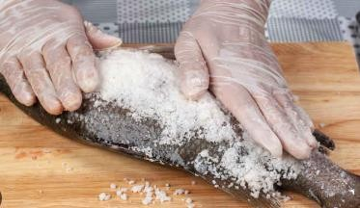
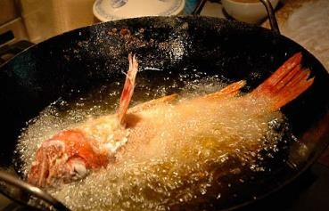

- Which part of poultry has been prepared below?(1 mk)
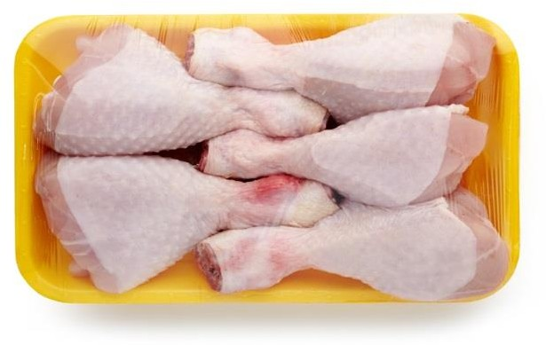
……………………………………………

Name four practices carried out to dress a poultry carcass.(4 mks)

…………………………………………………………………………………..

…………………………………………………………………………………..

…………………………………………………………………………………..

…………………………………………………………………………………..

- State two Methods used in preserving milk. (2 mks)
- ……………………………………………
- …………………………………………….
- Mention three Methods used to preserve meat. (3 mks)
- ……………………………………………
- ……………………………………………
- …………………………………………….

- What is the importance of preserving milk and meat? (2 mks)
- …………………………………………………………………………………………
- …………………………………………………………………………………….……

State five methods of soil conservation in agricultural environment. (5 mks)
- ………………………………………………………………………………….
- ……………………………………………………………………………….
- ………………………………………………………………………………….
- ………………………………………………………………………………..
- ………………………………………………………………………………..
- State two components of agriculture and nutrition. (2 mks)
- ……………………………………………………………………………….
- ……………………………………………………………………………….
- Mention five causes of Soil Pollution in Farming.(5 mks)

- ………………………………………………………………………………
- ………………………………………………………………………………
- ………………………………………………………………………………..
- ………………………………………………………………………………..
- ………………………………………………………………………………..

THE END

