COMPETENCE BASED CURRICULUM
JUNIOR SCHOOL
FORMATIVE ASSESSMENT
TERM ONE 2024
GRADE 8

MARKING SCHEME
AGRICULTURE AND NUTRITION

- Name the following types of innovative gardens below. (4 mks)

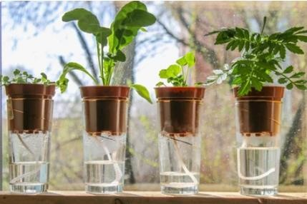
Multi-storey garden
Wick garden

Simple-drip garden
Container garden

- What is Poultry rearing?(2 mks)
It is the keeping of domesticated birds such as chicken, ducks, turkeys, geese,
pigeons, guinea fowls and ostriches.
Poultry are kept for production of meat, eggs and other products
- Name six Materials used in the Construction of a poultry fold. (6 mks)
- Wire mesh.
- Fencing staples
- Reused and recycled wires.
- Plastic materials.
- Wood materials.
- Nails.
- Claw hammer.

Gordon has reared poultry in a fold at his home; identify various practices which he must carry out when rearing poultry in a fold. (5 mks)
- Moving the fold to new sites regularly for the birds to feed on fresh vegetation.
- Ensure birds are provided with clean water.
- Ensure hygiene is maintained in the poultry fold.
- The fold should be strong enough to secure birds and kept in a safe place.
- The fold should be sheltered from the rain to avoid wetness. It should be placed in such a way that the open side is away from direct winds to avoid drought.
- We can identify various vegetables attacked by crop pests through the following ways :( name at least three ways)(3 mks)
- Punctured leaves – vegetables have leaves that are damaged and have holes in them. This indicates the vegetables are attacked by pests.

- Cut-off seedlings – vegetables damaged by pests also have seedling that are cut off and fall.

- Curling leaves – leaves shrink and reduce in size because of pests sucking.

Observe the following diseased plants carefully. Identify the following effects of vegetables crops attacked by pests and diseases.(6 mks)
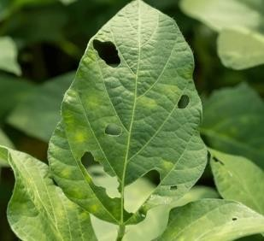
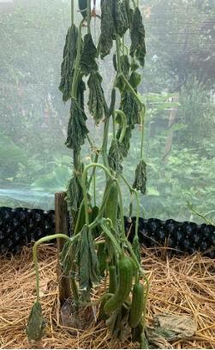

Wilted plant/wilting

Wilted plant
f
Holes on leaves/punctured leaf
f

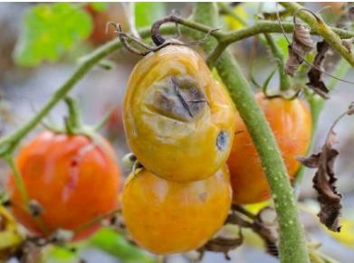
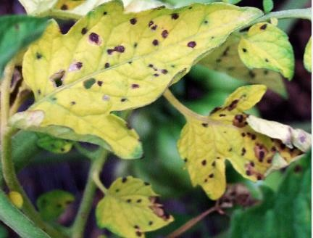

Spots on leaves
f
Rotten fruit
f

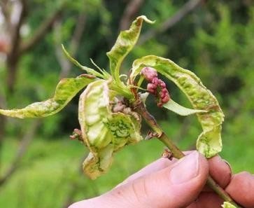

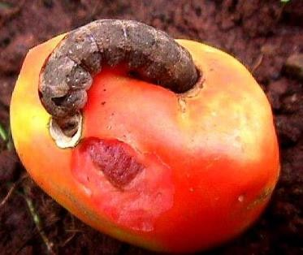
Curled leaves
f
Holes on fruit
f

State five ways used to Control of pests and diseases on vegetables crops. (5 mks)

- Handpicking-pests are removed by hands.
- Removing affected plants parts-affected plant parts should be removed to prevent spread of pests to other plant parts.
- Uprooting heavily affected crops-uprooting heavily affected plants stops spread of pests in the farm.
- Applying natural pesticides such as ashes-some natural pesticide such as ashes help to prevent attack of pests.
- Removing affected plant parts.
- Uproot heavily affected crops.

- Grace is a fish farmer from Lake Victoria. Identify three processes she carries out to prepare fresh fish for transportation, storage and consumption.(3 mks)
  - Scaling-removal of scales.
  - Gutting-removal of gut or the alimentary canal.
  - Cleaning-washing the fish with clean water.

- Abraham visited a fish processing site and took the following photographs. Identify the process or activity taking place in each picture.(4 mks)
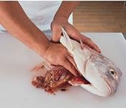
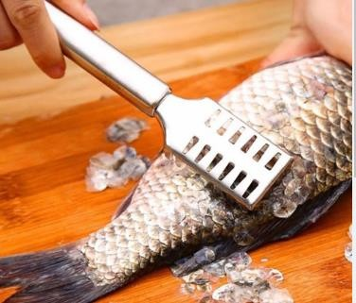
Gutting
Scaling

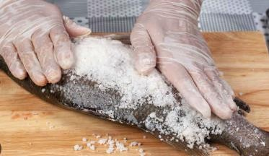
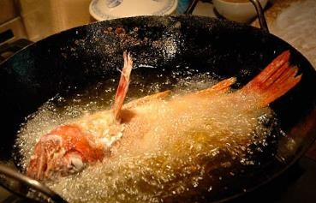

Frying
Salting

- Which part of poultry has been prepared below?(1 mk)
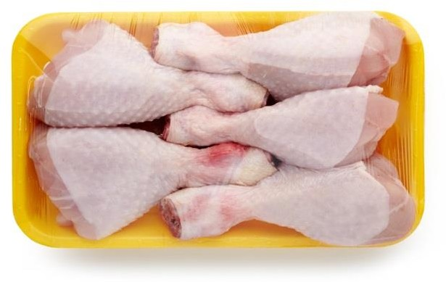
Poultry thighs

Name four practices carried out to dress a poultry carcass.(4 mks)

Beheading-restrain the poultry well and cut the neck muscles with a sharp knife.

De-feathering-scald the bird into hot water of a temperature of 55⁰ C for about 2 minutes to loosen the feather. Remove and pluck off loose feathers completely.

Singeing-hold the de-feathered bird over a flame for a few minutes to burn the hair like structures left on the skin.

Washing-wash the whole bird in clean cold water to remove the surface dirt.

- State two Methods used in preserving milk. (2 mks)
- Boiling.
- Fermentation.
- Mention three Methods used to preserve meat. (3 mks)
- Sun drying.
- Smoking.
- Salting.

- What is the importance of preserving milk and meat? (2 mks)
- It increases the shelf-life of both milk and meat.
- It makes the two products available for a longer period of time hence enhancing food security.

State five methods of soil conservation in agricultural environment. (5 mks)
- Strip cropping.
- Grassed water ways.
- Stone lines.
- Trash lines.
- Soil bunds.53
- State two components of agriculture and nutrition. (2 mks)
- Agriculture
- Home science/ nutrition
- Mention five causes of Soil Pollution in Farming.(5 mks)

- Excessive use of artificial fertilizers.
- Excessive use of agricultural chemicals (agrochemicals) such as herbicides and pesticides.
- Throwing plastic wastes in the garden.
- Throwing Chemical containers.
- Surface run off carrying contaminated water
- Industrial wastes

THE END

