AGRICULTURE & NUTRITION GRADE 8 NOTES – TERM 2

STRAND 2- FOOD PRODUCTION PROCESSES
2.4 Preparation of Animal Products.
Animal products are materials derived from the body of animals which are consumed by
human beings.
Fish and poultry products require to be prepared to make them ready for human consumption.

How fresh fish is processed.
Fresh fish need to be processed immediately after being harvested from water to prevent spoilage.
Various processes are carried out to prepare fresh fish for transportation, storage and consumption.
⭸ Fish is prepared after harvesting by:
  - Scaling-removal of scales.
  - Gutting-removal of gut or the alimentary canal.
  - Cleaning-washing the fish with clean water.
⭸ These processes usually slow down the growth of micro-organisms and keep it fresh before use.

Procedure followed when processing fresh fish.
Specific methods of processing fish for consumption, storage and transportation are as follows:
Inspect and select fresh fish for processing. Start the process as follows.

a.) Scaling.
∼ Rinse fish to remove slime.
∼ Place fish on a chopping board or tray with absorbent paper.
∼ Hold fish firmly by the tail and use a fish scaling tool or back of a knife to scrape off the scales moving from the tail to head on both sides
∼ Rinse the fish in clean water to remove any loose scales.
∼ Run your fingers over the fish skin to make sure that all scales have been removed.
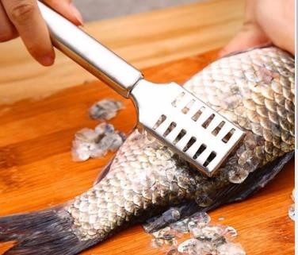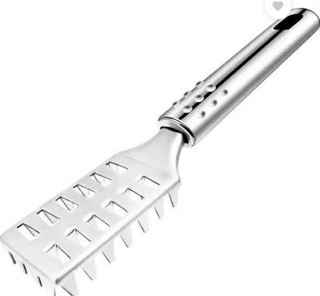

b.) Gutting.
∼ Lie the fish on its side on either a chopping board or a tray.
∼ Make a cut in the belly of the fish at the tail-end and cut through the skin to the head.
∼ Insert your fingers into the belly through the cut opening and remove internal organs by easily pulling them out.
∼ Place them on a separate plate or tray.
∼ Rinse the inside of the fish with cold water until the water becomes clear.
∼ Use a kitchen paper or towel to dry the fish.
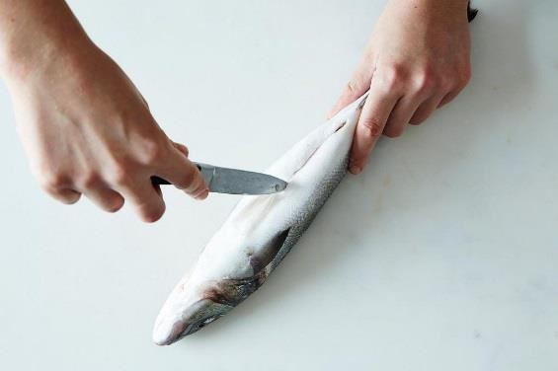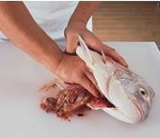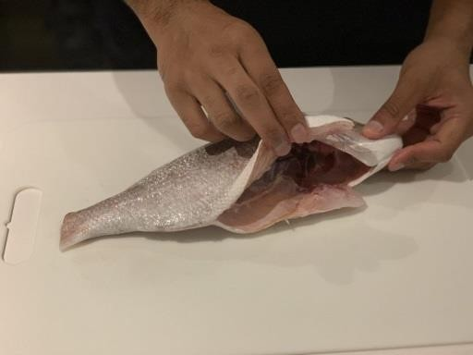

c.) Cleaning.
∼ Clean the fish thoroughly before and after gutting.
∼ Use cold water when cleaning fish.

d.) Salting.
∼ Use the fish that have been well prepared by scaling, gutting and properly cleaned.
∼ Place the fish on a flat clean surface or tray where they will remain after salting.
∼ Sprinkle layers of salt on all the parts of the fish.
∼ Leave the fish in layers of slat for at least 2 days.
∼ Keep the salted fish in a cool dry place.
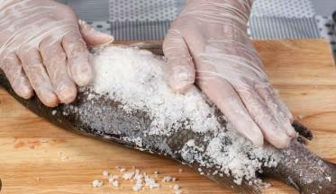

e.) Frying fish
∼ Select a clean well-prepared fish.
∼ Heat oil in a saucepan and dip the fish to cook for 4 to 5 minutes.
∼ Remove the fish from the oil using a draining spoon.
∼ Place the fish on a mesh tray to drain excess oil.
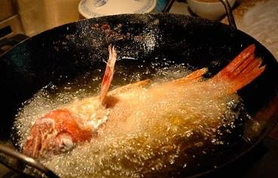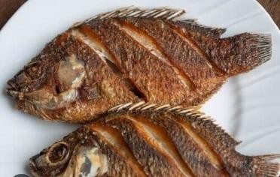
NOTE:
∼ Processing fish should be carried out in a hygienic environment to prevent contamination.
∼ Cold water should always be used when cleaning fish to remove all the blood. This prevents deterioration due to multiplication of bacteria.
∼ Gutting fish may sometimes include the complete removal of the gills and the fins.
∼ Salting draws water from the fish increasing its shelf life.

How to dress poultry carcass.
∼ Quality of poultry products can be linked to a variety of factors such as handling at slaughter.
∼ Poultry dressing procedures should be done in a hygienic manner in order to produce products fit for human consumption.
∼ When dressing poultry carcass, some parts can be detached and packed separately.
However, the whole carcass can be packed with the parts attached.
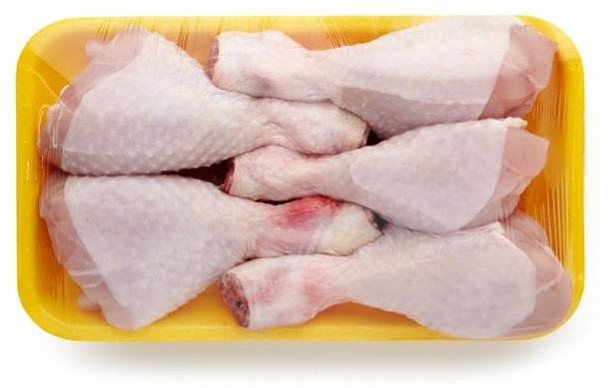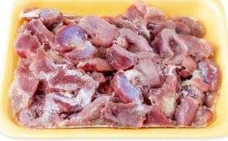
Poultry thighs poultry gizzards

Dressing a poultry carcass.
The following practices are carried out to dress the poultry carcass.
a.) Beheading-restrain the poultry well and cut the neck muscles with a sharp knife. b.) Defeathering-scald the bird into hot water of a temperature of 55⁰ C for about 2 minutes to loosen the feather. Remove and pluck off loose feathers completely.
c.) Singeing-hold the defeathered bird over a flame for a few minutes to burn the hair like structures left on the skin.
d.) Washing-wash the whole bird in clean cold water to remove the surface dirt.

Prepare the poultry carcass for various purposes as follows.
- Place the carcass on its back on a clean surface or chopping board. Remove oil gland with a knife.
- Remove the offals by:
⭸ Make a cut above the vent but avoid cutting too deep.
⭸ Press on the breast and insert fingers through the cut made on the vent.
⭸ Grab the visceral and pull them out avoiding too much pressures to prevent puncturing the gall bladder.
⭸ Slit the neck skin to remove the crop, trachea and Oesophagus.
⭸ Place the internal organs on a separate plate.

Cutting the carcass into various pieces.
⭸ Cut joints between thigh and the body and separate the thigh and the leg at the joint.
⭸ Cut the joint between the wings and the body and then separate the wings.
⭸ Cut the breast into two parts by separating the muscle in front of the keel.
⭸ Cut the backbone and neck strip into 3 pieces each.

Separate the gizzard, liver and the heart from the other internal organs.
⭸ Cut open the wall of the gizzard lengthwise to the lining to remove hard grit and then peel out the lining.
⭸ Wash these organs in cold water and then pack them.

- Pack all the pieces in clean storage bags as required.

NOTES:
∼ High hygiene standards should be maintained when handling raw poultry meat to avoid contamination which can lead to food poisoning.
∼ Complete bleeding of carcass prevents discolouration of the meat due to formation of clots in the muscles. The clots attract micro-organisms.
∼ Care should be taken not to burst gall bladder as this makes the meat bitter.
∼ Pieces from poultry carcass are packed separately and sold at different prices.

What is the importance of processing fresh fish and dressing poultry carcass?
~ It adds value to the meat.
~ Keeping quality of both fish and poultry products is increased hence prolonged shelf life.
~ Packing poultry pieces separately enables selling at a higher price than the whole carcass.
2.5 Preserving Meat and Milk.
Animals gives products such as milk, meat, eggs, honey, hides and skin.
Some of the products easily go bad, hence they should be preserved to increase their shelf- life.

Methods of preserving milk and meat in the locality.
- Milk and meat deteriorate in quality with time.
- They should be well preserved to prolong their shelf-life and availability.
- Food preservation is the process of preventing food from spoilage.
- There are various methods of preserving milk and meat.
- Methods used in preserving milk include:
 Boiling.
 Fermentation.
- Methods used to preserve meat include:
 Sun drying.
 Smoking.
 Salting.

Preservation of Milk and Meat at household level.

Common methods of preserving milk are:
a.) Fermentation-Fermentation of milk produces certain acid that preserves milk.
b.) Boiling or pasteurization of milk-boiling milk kills micro-organisms by exposing them to high temperatures at the milk boiling point. This method preserves fresh milk.

Common methods of preserving meat are:
a.) Sun drying-it removes moisture from meat making the action of micro-organism difficult. Meat is cut into small pieces, sundried and then packaged.
b.) Smoking-meat is covered with a layer of smoke which stops action of micro-organisms. c.) Salting-salt is applied on the surface of pieces of meat or dipped in a highly
concentrated salt solution know as brine. This salt solution dehydrates (removes water) the micro-organisms and stops their action on meat.

What is the importance of preserving milk and meat?
- It increases the shelf-life of both milk and meat.
- It makes the two products available for a longer period of time hence enhancing food security.

Strand 3 -HYGIENE PRACTICES.
3.1-Cleaning the Kitchen.

Methods of removing dirt from the kitchen surfaces.
Food should be prepared and cooked in a clean and orderly environment.
A dirty kitchen can be a breeding place for other harmful living things such as pests and flies which can lead to health hazards.
There are may ways of removing dirt from kitchen surface. The methods depend on types of dirt found on the surfaces.

Methods of removing dirt from kitchen surfaces. Sweeping-Done using a broom, brush and dustpan.

Dusting-it is done after sweeping a room. It ensures any dust that may have been blown in the air and deposited on the surface is removed.
Wiping -it is used to remove fixed dirt on the surfaces that can be damaged by scrubbing. Surfaces that are wiped include furniture, ornaments, walls and windows.
Scrubbing-this is where warm soapy water is used to together with a hard scrubbing brush. Vacuum cleaning-a vacuum cleaner is used to remove loose dirt from the surfaces which is sucked into a dirt bag attached to the vacuum cleaner and it is disposed of after cleaning.
Mopping-this is the removal of fixed dirt from a surface by using a mop, bucket, water and detergents.

State the reasons for cleaning the Kitchen.
A kitchen must be kept clean at all times.
Frequency of cleaning depends on type of fuel used and amount of cooking done. Therefore, cleaning the kitchen is necessary for the following reasons:
To preserve clean kitchen appearance.
to prolong life of a surface, dirt can destroy the surface if allowed to accumulate. Psychological satisfaction of the user.
To cut down cost of cleaning
Types of leaning for a kitchen.

Daily cleaning.
It is the removal of loose dirt from the kitchen surfaces on daily basis. It involves the following methods:
⮑ Sweeping.
⮑ Brushing.
⮑ Dusting.
⮑ Suction cleaning.

Weekly cleaning.
Involves the removal of both loose and fixed dirt. It involves:
⭸ Sweeping.
⭸ Dusting.
⭸ Scrubbing.
⭸ Wiping.

Special cleaning.
This is the thorough cleaning that is done occasionally when it is necessary. For example,
✰ Cleaning the chimney to remove soot,
✰ Painting the walls.

Cleaning different kitchen surfaces.

Area | Daily cleaning | Weekly cleaning | Special cleaning
Earthen floors | Close windows, sprinkle water on the floor  Sweep from farthest corner towards the door.  Collect loose dirt and dispose appropriately. | Close windows, sprinkle water on the floor  Sweep from farthest corner towards the door.  Collect loose dirt and dispose appropriately. | Close windows, sprinkle water on the floor Sweep from farthest  corner towards the door. Collect loose dirt and dispose appropriately.  Floor can be redone to cover holes and cracks.
Cemented floors | Sweep floor and collect to dispose off loose dirt.  Mop the floor.  Rinse with a mop wrung and dry the floor using a dry soft cloth | Seep the floor and dispose the waste.  Scrub the floor using soapy and warm water.
Wooden floors | Sweep.  Dispose loose dirt appropriately.  Mop and rinse. | Sweep. Mop.  Apply polish.
Tiled floors. | Sweeping.  Mopping and dry the floor
Terrazzo floors | Sweeping to dispose loose dirt.  Mopping.  Rinse and dry using a dry soft cloth or mop | Sweeping. Scrubbing.

