Grade 8

AGRICULTURE

NAME………………………………………………………………………………………………..
SCHOOL ………………………………………………………………………………………….
TIME 1hr

- State the Importance of Off-season Cropping in Agriculture.
- …………………………………………………………………………………………………………………
- …………………………………………………………………………………………………………………
- …………………………………………………………………………………………………………………

- Identify the following agricultural technologies

2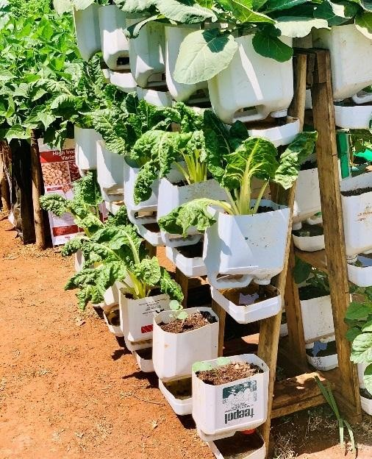

…………………………………..……………………………………
.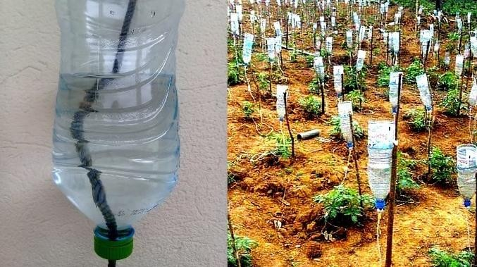
- ………………………………………………………………………………..
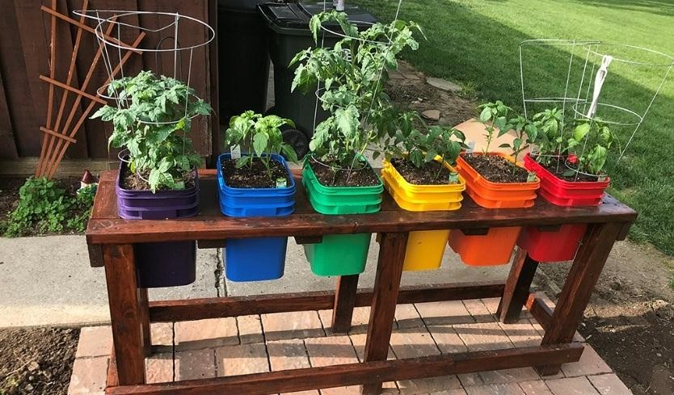
- …………………………………………………………………………….
- Define the following terms
Succession planting …………………………………………………………………………………………………………………………………………………………………………………………………………
Staggered planting …………………………………………………………………………………………………………………………………………………………………………………………………………………………………………………………………………………………..……………………………
Timed planting ……………………………………………………………………………………………………………………………………………………………………………………………………………………………………………………………………………………………………………………

State the factors that help to increase food security in the country.
…………………………………………………………………………………………………………………
…………………………………………………………………………………………………………………
…………………………………………………………………………………………………………………
…………………………………………………………………………………………………………………

State the Importance of off season cropping techniques for food security
……………………………………………………………………………………………………………………………………………………………………………………………………………………………………
…………………………………………………………………………………………………………………
…………………………………………………………………………………………………………………
…………………………………………………………………………………………………………………
- Name two qualities of the Materials used in the Construction of the Framed Suspended Gardens
…………………………………………………………………………………………………………………
…………………………………………………………………………………………………………………
…………………………………………………………………………………………………………………

Name two Materials for the Construction of the Framed Suspended Gardens
- ………………………………………
- ………………………………………..
- ………………………………………….

Identify the Procedure for constructing wooden boxes.
…………………………………………………………………………………………………………………
…………………………………………………………………………………………………………………
…………………………………………………………………………………………………………………
…………………………………………………………………………………………………………………
…………………………………………………………………………………………………………………
…………………………………………………………………………………………………………………

- Give Examples of value addition in crop produce
- ……………………………………………………………..
- ……………………………………………………………..
- …………………………………………………………….
- …………………………………………………………….

- Name the value added product in the following crop produce

Crop produce | Value added product.
- Potatoes
- Mangoes.
- Vegetables
- Cassava
- Groundnuts
- Sim sim
- Sweet potatoes
- pumpkins

- State the Importance of Value Addition in Crop Produce
- ………………………………………………………………………………
- ……………….………………………………………………………………
- ……………………………………………………………………………….
- ………………………………………………………………………………

