Grade 8

AGRICULTURE
- State the Importance of Off-season Cropping in Agriculture.
- It leads to growing of high value short season crops.
- There is proper use of land and labour in both dry and rainy seasons.
- Farmers get high profits from producing crops during the time when the supply is low.
- There is continuous supply of food.

- Identify the following agricultural technologies

2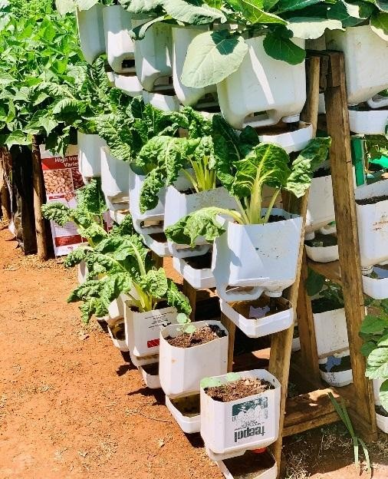

Wick irrigated garden
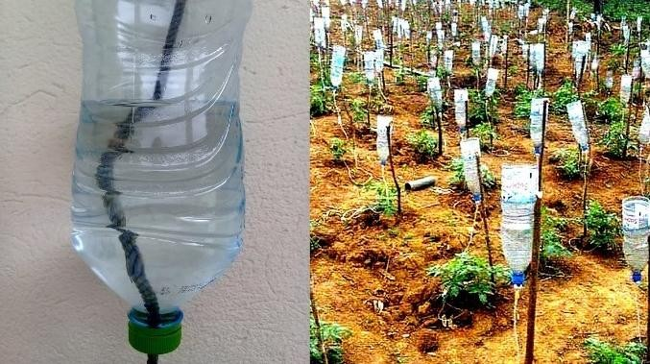
- Innovated drip irrigation.
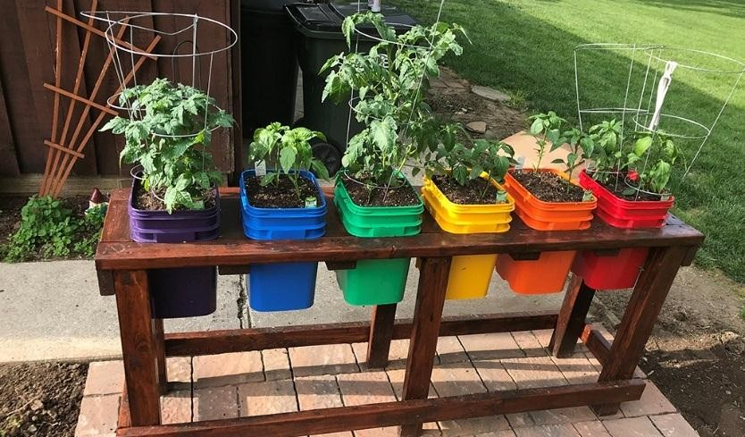
- Container gardening.
- Define the following terms
Succession planting this is where a new crop is placed immediately after harvesting the first crop to maintain consistent supply of produce.
Staggered planting this is making several plantings at certain intervals so as to space the harvesting.
Timed planting this means planting is done in such a way that the crop matures when it is required.

State the factors that help to increase food security in the country.
  - Using crops adapted to different agro-climatic conditions.
  - Using improved crop varieties which mature faster.
  - Adjusting planting time.
  - Use of green houses to modify climate.
  - Use of innovative drip irrigation.

State the Importance of off season cropping techniques for food security
- Increase in food supply by producing crops in both rainy and dry season.
- High value and fat growing crops are produced such as vegetable and fruits which fetch high prices.
- Consumers get fresh produce with high nutrition throughout the year.
- Commercial production is adapted leading to increased exports of fresh produce from one country to another.

- Name two qualities of the Materials used in the Construction of the Framed Suspended Gardens
- Cheap.
- Easily available.
- Long lasting.
- Easy to work with.

Name two Materials for the Construction of the Framed Suspended Gardens
- Available timber.
- Left over wires.
- Nails.
- Metal bars.
- Wooden planks.
- Poles.

Identify the Procedure for constructing wooden boxes.
- Cut the pieces of wood for the for the frames of the boxes.
- Join the wood pieces with nails or screws at the four corners to make the frames.
- Fix a wire mesh at the bottom of the frame and hold with staples.
- Fix a plywood piece to hold back the wire mesh from outside and secure with nails.
- The box is ready for use. Its depth depends on the crop to be planted.

- Give Examples of value addition in crop produce
- Fresh mango fruits to Dried mango pulp.
- Groundnuts in pods to parked roasted groundnuts.
- Raw potatoes tuber to Fried and packed potato crisps,
- Raw cassava root tuber to Dried and milled cassava flour.

- Name the value added product in the following crop produce

Crop produce | Value added product.
- Potatoes | - crisps, flakes, canned potatoes
- Mangoes. | - Juice, sliced dried and packed mangoes.
- Vegetables | - Dries and packed vegetables.
- Cassava | - Flour, chips and crisps.
- Groundnuts | - Packed roasted beans.  - pressed groundnuts cake
- Sim sim | - simsim balls, and oil
- Sweet potatoes | - Crisps, flor
- pumpkins | - Flour and juice.

- State the Importance of Value Addition in Crop Produce
- Increase the storage life of produce.
- Improve the selling price of produce for the farmer.
- Reduces the loss of produce after harvesting.
- It makes the produce attractive to the customers and therefore increases the demand of the produce.
- It makes the crop produce available in the market for a longer time and hence promotes food security.
- It makes it possible to store produce in small space.
- It makes transportation of produce easier and less costly.

