JUNIOR SCHOOL

2024 QUESTIONS

Agriculture

- What is soil conservation?
soil conservation refers to the protection and management of soil resources to prevent their degradation and promote sustainable land use practices.

- Identify the primary threats to soil conservation
- Chemical contamination
- Slash and burn
- Land overuse,
- Overgrazing, etc.

- Why is soil conservation a important?
- Preserving Agricultural Productivity:
- Protecting Ecosystems and Biodiversity:
- Water Quality and Quantity:
- Climate Change Mitigation
- Mitigating Soil Erosion:
- State effective methods and techniques for soil conservation.
- Grass water ways
- Stone lines
- Trash lines
- Bunds
- Crop rotation
- Contour Plowing:
- Terracing:
- Windbreaks:
- Strip Cropping:
- Conservation Tillage:
- Cover Crops:
- Mulching:
- Conservation Buffer Strips
- Identify the following soil conservation npractices

Contour Ploughing
Terracing

- Name the following agricultural practice for conserving water.

Mulching

- Name five Benefits of Soil Conservation
- Sustaining Agricultural Productivity: Preventing Soil Erosion:
- Enhancing Water Quality: Mitigating Climate Change:
- Conserving Biodiversity and Ecosystems:
- Improves soil quality and productivity
- Optimizes water infiltration.
- Provides food and shelter
- State four techniques to apply in water harvesting for farming.
- Shallow Water Pans

Water Ponds

Water Tanks
- Sand Dams
- Grey Water Recycling
- Contour Trenching
- Fog Harvesting
- Gutter Installation
- Identify the following water harvesting techniques
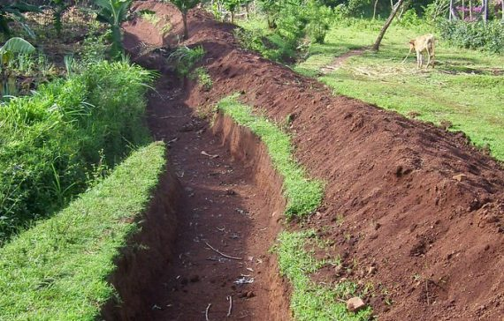
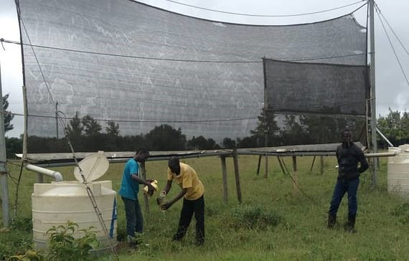

Contour Trenching Water Ponds Fog Harvesting

- Define
Square foot gardening is the practice of dividing the growing area into small square sections, typically 1 foot (30 cm) on a side, hence the name.
- Name the following pest
Rat aphid cut worm

- Name two Vegetables attacked by pests
- Kale
- Spinach...
- Tomatoes
- Onions ...
- Carrots ...
- etc

- Identify the farming tools below

Pair of gloves
Watering can
Wheelbarrow
Rake
Spade

