COMPETENCE BASED CURRICULUM
JUNIOR SCHOOL
GRADE 8
FORMATIVE ASSESSMENT
AGRICULTURE AND NUTRITION

2 HOURS
SCHOOL: ……………………………………………………………………………..……
NAME: ……………………………………………………..……………………..………..
ASSESSMENT NO: ……………….………. SIGN: …....DATE: ………..….
RUBRICS (for official use)
Mark Score Range | Below 40 | 40-59 | 60-79 | 80-100
PERFORMANCE LEVEL | Below expectation | Approaching expectations | Meeting expectations | Exceeding expectations
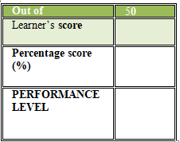
FOR EXAMINERS
INSTRUCTIONS TO CANDIDATES
- Answer all the questions in the spaces provided.
- Ensure your work is neat.

- What is soil conservation? (2 mks)
………………………………………………………………………………………………………………………………………………………………………………

- Identify the primary threats to soil conservation. (4 mks)
- ……………………………………………………………………………………………………
- ……………………………………………………………………………………………………
- ……………………………………………………………………………………………………
- …………………………………………………………………………………………………

- Why is soil conservation a important? (4 mks)
- ………………………………………………………………………………………
- ………………………………………………………………………………………
- ……………………………………………………………………………………….
- ……………………………………………………………………………………….
- Identify the following soil conservation practices. (2 mks)

- Name the following agricultural practice for conserving water.(1 mk)

- Name five Benefits of Soil Conservation. (5 mks)
- ………………………………………………………………………………….
- ………………………………………………………………………………….
- …………………………………………………………………………………
- …………………………………………………………………………………
- ………………………………………………………………………………….
- State four techniques to apply in water harvesting for farming.(4 mks)
- …………………………………………………………………………………….
- …………………………………………………………………………………….
- ……………………………………………………………………………………..
- ……………………………………………………………………………………….
- Identify the following water harvesting techniques. (3 mks)
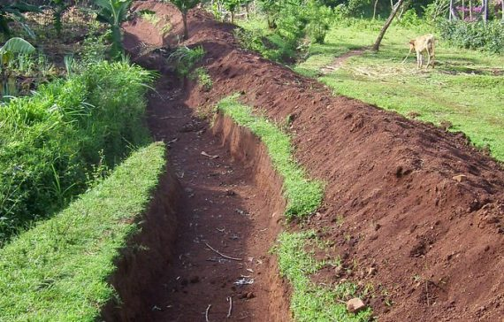
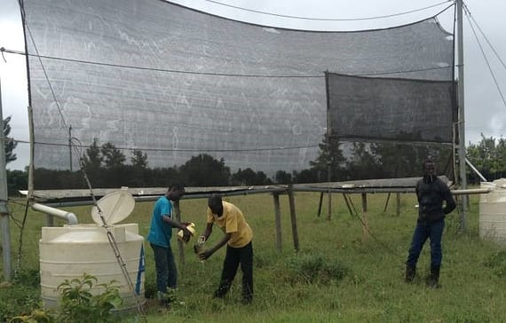

………………………. …………………………. ………………………….

- Define (2 mks)
Square foot gardening
………..…………………………………………………………………………………………………………………………………………………………………………………
- Name the following pest. (3 mks)

..................................... …………………………… …………………………….

- Name two Vegetables attacked by pests. (2 mks)
- ………………………………..
- ………………………………….

- What is soil pollution?1 mk)
…………………………………………………………………………………………………………….…………………………………………………………………….
- Define the following terms.(3 mks)
- Mulching………………………………………………………………………………………………………………………………………………………………
- Weeding………………………………….….…………………………………………………………………………………………………………………………….
- Thinning…………………………………………………………………………….……………………………….………………………………………………….
- Grade eight learners conducted an experiment on soils as shown below.

- What were the learners investigating?............................... (1mk)
- From the above activity of water holding ability, which of the soil does the first drop of water come out first?............................................... (1 mk)
- From which type of soil was most water collected? …………………(1 mk)
- From which type of soil was least amount of water collected? ………………………………………………………..(1 mk)
- Identify the type of agricultural practices shown below. (2 mks)

- Give two importance of weeding.(2 mks)
- ………………………………………………………………………………………
- …………………………………………………………………………………

- Identify the types of fruit shown below. (1 mk)
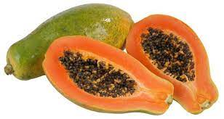

………………………………………

- Identify the farming tools below. (5 mks)

- State the guidelines to be followed when grilling different types of foods to ensure the food is well cooked.(4MKS)
- ………………………………………………………….……………………………..………………………………………..
- …………………………………………………………….…………………………………………… ……………………….
- …………………………………………………………………………………………………………………………………..
- …………………………………………………………………………………………………………………………………..

- Name the following cooking tools(3 MKS)
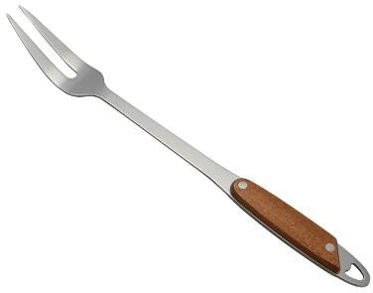
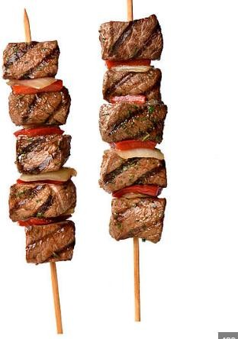
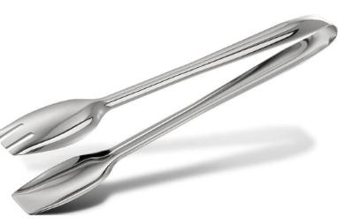

- State the desirable properties of linen(4MKS)
      - ………………………………………………………….………………………………
      - …………………………………………………………………………………………..
      - ………………………………………………………………..………………………..
      - ……………………………………………………..………………………………….
- State the undesirable properties of linen(3MKS)

      - ……………………………………………………………………….
      - ………………………………………………………………………….
      - …………………………………………………………………………..
- State the challenges experienced or faced when buying household goods and services.(4MKS)
- ………………………………………………………………………………………….
- ……………………………………………………………………………………………
- ……………………………………………………………………………………………
- …………………………………………………………………………………………..
- What are the ways of Saving Income when buying household goods and services? (4MKS)
    - …………………………………………………………………………………………….
    - …………………………………………………………………………………………….
    - …………………………………………………………………………………………..
    - …………………………………………………………………………………………………
- There are several ways of buying various household goods and services from the sale outlets. Name a few.(3MKS)
  - ……………………………………………………………………………………….
  - ………………………………………………………………………………………..
  - ……………………………………………………………………………………………
- State three reasons for having a kitchen garden(3MKS)
- …………………………………………………………………………………………..
- ……………………………………………………………………………………………
- ……………………………………………………………………………………………
- State three types of kitchen gardens. (3MKS)

……………………………………………………………………………………….

………………………………………………………………………………………

………………………………………………………………………………………

State three methods of cooking food( 3 MKS)
- ……………………………………………………
- ………………………………………………………
- ………………………………………………………
- Identify the methods of heat transfer when cooking below( 3 MKS)
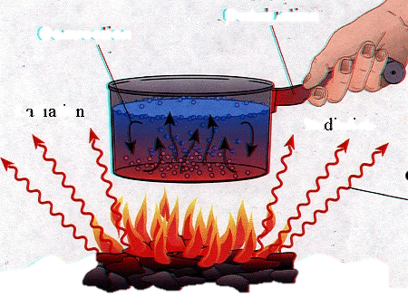

- What is meant by the following terms?( 4MKS)
Dextrinisation: .................................................................................................................................................................................................................................................................................................................
Gelatinisation: …………………………………………………………………………………………………………………………………………………………………………………………………………

Mention five ways used to retain nutrients while cooking(5MKS)
- ………………………………………………………………………………………..
- ……………………………………………………………………………………….
- ……………………………………………………………………………………….
- ……………………………………………………………………………………….
- ………………………………………………………………………………………

- State the factors to consider when setting a table.(4MKS)
- …………………………………………………………………….
- …………………………………………………………………….
- ……………………………………………………………………..
- …………………………………………………………………….

THIS IS THE LAST PRINTED PAGE

