COMPETENCE BASED CURRICULUM
JUNIOR SCHOOL
FORMATIVE ASSESSMENT
TERM ONE 2024
GRADE 7

Name………………………………………………………..……….…………………………………...………………
Centre ………………………………………………………………….......................................................
Assessment No. …………………………………………… Stream………………………….…………………
Learner’s Sign…………………………………..………..… Date: …………………………………..…………..
SOCIAL STUDIES
FOR EXAMINERS
ASSESSMENT RUBRICS (for official use)
%SCORE RANGE | Below 40 | 40-59 | 60-79 | 80-100
PERFORMANCE LEVEL | Below expectation | Approaching expectations | Meeting expectations | Exceeding expectations
 | 1 | 2 | 3 | 4

- State three reasons for the migration of Nilotes.(3 mks)
- ………………………………………………………………………………
- ……………………………………………………………………………..
- ……………………………………………………………………………….
- Name two examples of volcanic mountains.(2 mks)
- ………………………………………………………………
- ………………………………………………………………

- Name any two theories explaining the origin of the earth.(2 mks)
- ………………………………………………………………………………
- …………………………………………………………………………….
- Identify the following planets. (4 mks)

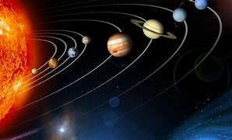

- Conditions of the atmosphere of a place at a given time is called ……………… (1 mk)

- Name two branches of social studies. (2 mks)
- ………………………………
- ………………………………
- Name two types of maps. (2 mks)
- Sketch maps Topographical maps
- Atlas maps Directional maps
- Study the diagram on structure of the earth below and answer the questions that follow.

c

- Name the regions above. (3 mks)

- Write two effects of rotation and revolution of the earth.(4 mks)
Rotation of the Earth | Revolution of the Earth

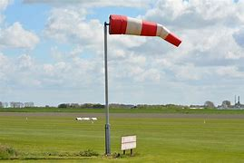
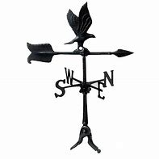
- Identify the following weather measuring instruments.(3 mks)
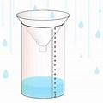

- State two factors to consider when siting a weather station.(2 mks)
- ……………………………………………………………………………………….
- ………………………………………………………………………………………..
- An area with high population is said to be ………………………………….populated whereas an area with low population is said to be …………………populated. (2 mks)
- The way of life and doing thing in a community is known as …………………1 mk)
- List two aspects of culture in most of our communities; (2 mks)
- ……………………………………………
- ………………………………………….
- List four elements of weather; (4 mks)
- ………………………………………………
- ……………………………………………….
- ……………………………………………….
- ……………………………………………….
- Monuments, museums, historic buildings and cultural centres are referred to as
……………………………………………….. (1 mk)
- Large carvings and models that remind us of our past heroes like Jomo Kenyatta are known as ………………………………………….(1 mk)
- Name the capital cities of the following African countries.(2 mks)
- Ghana -…………………………………………..
- Ethiopia- ………………………………………….

- Identify the following continents that were mentioned by the following students.(4 mks)
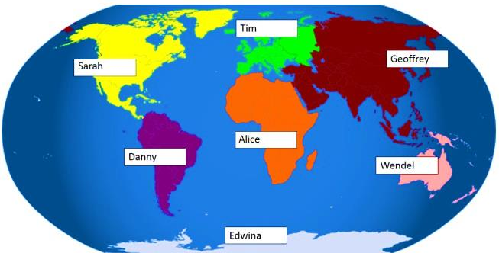

Tim: …………………………………………..
Wendel ………………………………………
Danny ………………………………………..
Alice …………………………………………..

- Name any two facts about planet earth.(2 mks)
- …………………………………………………………………..……………..
- ………………………………………………………………………………….
- The sun is overhead the equator on dates. (2 mks)
- ……………………………………………………..
- ………………………………………………………

- The atmosphere consists of? (3 mks)
- ……………………………………………….
- ………………………………………………..
- ………………………………………………..
- If the time in Monrovia , Liberia ,12⁰W is 8:00am, what is the time at Addis Ababa, Ethiopia, 38 ⁰E?(2 mks)

- Name Life skills that enhance negotiations during social interaction.(3 mks)
- ………………………………………….
- ………………………………………….
- ………………………………………….
- Define the following terms as used in life skills.(4 marks)
    - Personal management skills.
……………………………………………………………………………………………………………………………………………………………………………………………………….
    - Self-awareness
…………………………………………………………………………………………………………………………………………………………………………………………………………

- Define psychological dimension as used in personal management skills. (2 marks )
…………………………………………………………………………………………………………………………………………………………………………………………………………

- Outline five different dimension one uses to define himself/herself. (5 marks)
  - …………………………………………………………..
  - …………………………………………………………..
  - ……………………………………………………………
  - ……………………………………………………………
  - …………………………………………………………….
- Discuss five physical changes that happens to girls and boys during adolescence.(5 marks)
  - ……………………………………………………………………………….
  - ………………………………………………………………………………
  - ………………………………………………………………………………
  - ……………………………………………………………………………….
  - ……………………………………………………………………………….
- State four ways of maintaining personal hygiene and health during adolescence. (4 marks )
  - ………………………………………………………………………………….
  - ………………………………………………………………………………….
  - ………………………………………………………………………………….
  - …………………………………………………………………………………..
- What is self-esteem? (2 marks)
…………………………………………………………………………………………………………………………………………………………………………………………………………
- Name three types of families. (3 marks)
  - ………………………………………………………………
  - ………………………………………………………………
  - ……………………………………………………………….

THE END

