COMPETENCE BASED CURRICULUM
JUNIOR SCHOOL
FORMATIVE ASSESSMENT
TERM ONE 2024
GRADE 7

Name……………………………….…………………………………………
Centre ………………………………………….......................................
Assessment No. …………………………… Stream……………………
Learner’s Sign………………………..… Date: ………………………..
SOCIAL STUDIES
- Name the methods of fishing shown below. (4 mks)

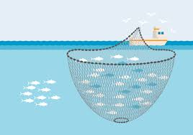
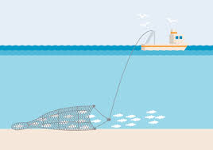

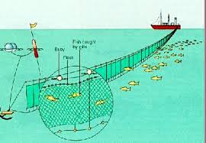
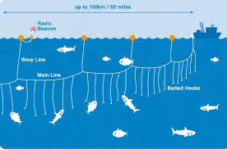

- State three branches of social studies. (3 mks)
- ………………………………………………
- ………………………………………………
- ……………………………………………..
- Identify three entrepreneurial opportunities for social studies.(3 mks)
- ……………………………………………..
- …………………………………………….
- ……………………………………………..
- Name the capital cities for the following African countries. (3 mks)
  - Sudan –………………………………..
  - Eritrea- …………………………………
  - Tunisia –…………………………………
- List four continents in the worlds. (4 mks)
- …………………………………………………
- …………………………………………………
- ………………………………………………..
- ………………………………………………..
- Name
- The major longitude passing through Africa. ………………………….
- The major latitude passing through Africa …………………………….
- Explain the origin of the earth as prescribed by the passing star theory.(4 mks)
………………………………………………………………………………………………………………………………………………………………………………………………………………………………………………………………………………………………………………………………………………………………………………………………………………………………………………………
- If the time in Monrovia , Liberia ,12⁰W is 8:00am,what is the time at Addis Ababa, Ethiopia, 38 ⁰E?(2 mks)

- State the countries in Africa that are crossed by the equator;(6 mks)
- ……………………………………….
- ………………………………………..
- ………………………………………..
- ………………………………………..
- ………………………………………….
- ………………………………………….
- Identify three countries that are crossed by the tropic of cancer. (3mks)

……………………………………….

………………………………………

………………………………………
- Draw the following weather instrument. (3 mks)
- Windvane Windsock Anemometer

17. Match the following weather instruments to their use.
Measures the amount of rainfall
Hygrometer

Measures the amount of water vapour in the atmosphere
Barometer

Measures the amount of atmospheric pressure
Raingauge

- List any five planets in the solar system .(5 mks)
- ………………………………..
- ………………………………..
- ………………………………..
- ………………………………..
- …………………………………
- Name two physical features you have learnt before. (2 mks)
- ……………………………..
- ……………………………..
- State two effects of the rotation and revolution of the earth of the earth. (4 mks)
Rotation of the Earth | Revolution of the Earth

- Identify four seasons. (4 mks)
- ……………………………………….
- ……………………………………….
- ……………………………………….
- ………………………………………..

- Name three elements of weather. (3 mks)
- ……………………………………….
- ………………………………………
- ………………………………………
- Name any three sources of information. (3 mks)
- ………………………………………..
- …………………………………………
- …………………………………………
- Identify two factors to consider when siting a weather station. (2 mks)
- …………………………………………………………………………..
- ………………………………………………………………………….
- Name Life skills that enhance negotiations during social interaction.(3 mks)
- ………………………………………….
- …………………………………………
- …………………………………………
- Define the following terms as used in life skills.(4 marks)
  - Personal management skills.
………………………………………………………………………………………………………………………………………………………………………………
  - Self-awareness
………………………………………………………………………………………………………………………………………………………………………………

- Define psychological dimension as used in personal management skills. (2 marks )
……………………………………………………………………………………………………………………………………………………………………………..

- Outline five different dimension one uses to define himself/herself. (5 marks)
  - ……………………………………………………………….
  - ……………………………………………………………….
  - ……………………………………………………………….
  - ………………………………………………………………..
  - ………………………………………………………………..
- Discuss five physical changes that happens to girls and boys during adolescence.(5 marks)
  - …………………………………………………………………………….
  - ……………………………………………………………………………….
  - ………………………………………………………………………………...
- State four ways of maintaining personal hygiene and health during adolescence. (4 marks )
  - ………………………………………………………….…………….
  - ……………………………………………………………..…………
  - …………………………………………………….……………………
  - ………………………………………………………………………….
- What is self-esteem? (2 marks)
……………………………………………………………………………………………………………………………………………………………………………..
- Name three types of families. (3 marks)
  - ………………………………………………
  - ……………………………………………….
  - ………………………………………………..

FOR EXAMINERS

ASSESSMENT RUBRICS (for official use)
%SCORE RANGE | Below 40 | 40-59 | 60-79 | 80-100
PERFORMANCE LEVEL | Below expectation | Approaching expectations | Meeting expectations | Exceeding expectations
 | 1 | 2 | 3 | 4

