COMPETENCE BASED CURRICULUM
JUNIOR SCHOOL
FORMATIVE ASSESSMENT
TERM ONE 2024
GRADE 7

MARKING SCHEME
SOCIAL STUDIES
- State three reasons for the migration of Nilotes.(3 mks)
- Search for water and pasture
- Attacks by diseases both for their livestock and people
- Internal disputes
- Outbreak of drought and famine
- Attacks from the hostile neighbours
- Name two examples of volcanic mountains.(2 mks)
- Mt kenya
- Mt elgon
- Mt. Longonot in kenya
- Mt karisimbi in rwanda
- Mt meru and mount kilimanjaro in tanzania

- Name any two theories explaining the origin of the earth.(2 mks)
- Passing star theory
- Nebula cloud theory
- Big bang theory
- Supernova theory
- Identify the following planets. (4 mks)
Mercury
Mars

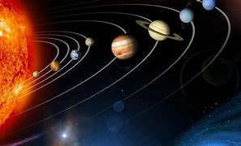
Neptune

Saturn

- Conditions of the atmosphere of a place at a given time is called Weather (1 mk)

- Name two branches of social studies. (2 mks)
- Geography
- History
- Citizenship
- Name two types of maps. (2 mks)
- Sketch maps Topographical maps
- Atlas maps Directional maps
- Study the diagram on structure of the earth below and answer the questions that follow.
A Core

B Mantle

c
C Crust

- Name the regions marked A,B and C. (3 mks)
- Write two effects of rotation and revolution of the earth.(4 mks)
Rotation of the Earth | Revolution of the Earth
Causes day and night | Causes seasons
Causes winds and ocean currents to change direction | Causes varying lengths of days and nights
Causes rising and falling of ocean tides | Causes changes in position of the midday sun

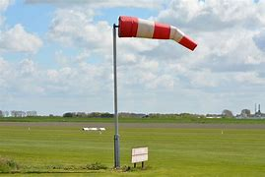
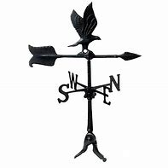
- Identify the following weather measuring instruments.(3 mks)
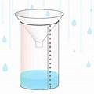

Windvane
Raingauge
Windsock

- State two factors to consider when siting a weather station.(2 mks)
- The area should be flat and away from tall buildings and trees.
- The area should be accessible
- The area should have good security etc
- An area with high population is said to be densely populated whereas an area with low population is said to be sparsely populated. (2 mks)
- The way of life and doing thing in a community is known as Culture.(1 mk)
- List two aspects of culture in most of our communities; (2 mks)
- Greeting Food Dressing
- House Gender Roles Economic Activity Etc
- List four elements of weather; (4 mks)
- Sunshine C. Wind
- Temperature D. Rainfall/Precipitation Any Other Correct
- Monuments, museums, historic buildings and cultural centres are referred to as
Historic Built Environments (1 mk)
- Large carvings and models that remind us of our past heroes like Jomo Kenyatta are known as Monuments/statutes (1 mk)
- Name the capital cities of the following African countries.(2 mks)
- Ghana -Accra
- Ethiopia- Addis Ababa

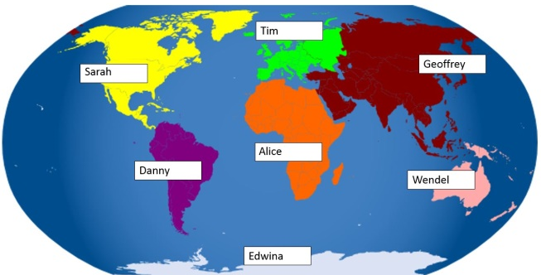
- Identify the following continents that were mentioned by the following students.(4 mks)
Tim: Europe Wendel Australia
Danny South America Alice Africa

- Name any two facts about planet earth.(2 mks)
- It supports life, it the only planet with people and vegetation
- It’s a blue planet has liquid water, has oxygen, takes 24 hr to make a complete rotation
- It is the third planet from the sun, takes approximately 149m km from sun
- It is an inner/ terrestrial planet, takes 3661/4 days to make a complete revolution
- The sun is overhead the equator on dates. (2 mks)
- 21st March
- 23rd September
- The atmosphere consists of? (3 mks)
- Water vapour
- Gases
- Dust particles
- Clouds smoke particles
- If the time in Monrovia , Liberia ,12⁰W is 8:00am, what is the time at Addis Ababa, Ethiopia, 38 ⁰E?(2 mks)
Longitudina Difference= 38⁰+12º=50º
1⁰ =4 Min Or 15⁰ =1hour
If 1⁰=4mins
What About 50o?= 50×4= 200 Mins
Chnge Minutes To Hours= $\left(\frac{200mins}{60mins}\right)×Ihr$
=$3hours 20 Mins$
Since Addis Ababa Is Ahead Of Monrovia, Add Time
$$=8:00am+3hr 30 Min=11:20am$$

- Name Life skills that enhance negotiations during social interaction.
- Courage.
- Problem solving.
- Empathy.
- Communication.
- Patience.
- Listening.
- Creativity.
- Define the following terms as used in life skills.(4 marks)
    - Personal management skills.
These are skills that help us to overcome life challenges.
    - Self-awareness
This is knowing what makes you who you are

- Define psychological dimension as used in personal management skills. (2 marks )
This includes how we feel, reason and think as we respond to different situations. These are skills which will help us overcome challenges.

- Outline five different dimension one uses to define himself/herself. (5 marks)
  - Physical dimension
  - Economic dimension
  - Psychological dimension
  - Spiritual dimension
  - Social dimension
- Discuss five physical changes that happens to girls and boys during adolescence.(5 marks)
  - Becoming taller and masculine for boys
  - Becoming taller and feminine for girls
  - Increase in weight
  - Production of sex hormones
  - Menstruation and wet dreaming
  - Desire for opposite sex.
  - Growth of hair in pubic areas
  - Feeling of shyness
  - Development of breasts
  - Chest broadens etc
- State four ways of maintaining personal hygiene and health during adolescence. (4 marks )
  - Bathing daily
  - Regular exercise
  - Washing fruits,vegetables before eating or cooking.
  - Eating a healthy diet.
  - Washing hands before eating.
  - Bathing daily
  - Eating a balanced diet
  - Washing your personal items like cloths
  - Brushing of teeth and combing of hair
  - Maintaining proper body grooming like cutting nails short, brushing teeth, combing hair and cutting hair short.Etc
- What is self-esteem? (2 marks)
Refers to the feelings and opinions you have about yourself based on your looks, abilities and the skills that you have.
- Name three types of families. (3 marks)
  - Nuclear family
  - Extended family
  - Single parent family

THE END

