COMPETENCE BASED CURRICULUM
JUNIOR SCHOOL
FORMATIVE ASSESSMENT
TERM ONE 2024
GRADE 7

Name……………………………….…………………………………………
Centre ………………………………………….......................................
Assessment No. …………………………… Stream……………………
Learner’s Sign………………………..… Date: ………………………..
SOCIAL STUDIES

- Name the methods of fishing shown below. (4 mks)

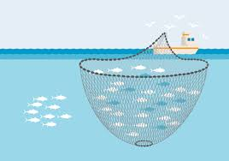
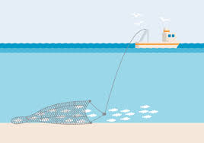

PURSE SEINING
TRAWLING

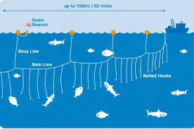
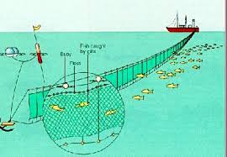

LONG LINING
NET DRIFTING
- State three branches of social studies. (3 mks)
- History
- Geography
- Citizenship
- Identify three entrepreneurial opportunities for social studies.(3 mks)
- Meteorology pilot historian etc
- Name the capital cities for the following African countries. (3 mks)
  - Sudan –Khartoum
  - Eritrea- Asmara
  - Tunisia –Tunis
- List four continents in the worlds. (4 mks)
Antarctica
Africa
Asia
Europe
North America
South America
Australia
- Name
- The major longitude passing through Africa. Prime meridian/Greenwich meridian
- The major latitude passing through Africa Equator

- Explain the origin of the earth as prescribed by the passing star theory.
A star with a greater gravitational force passed near our sun
It attracted large volume of gaseous materials.
The materials condensed and stuck together to form planets with the sun at the centre
- If the time in Monrovia , Liberia ,12⁰W is 8:00am,what is the time at Addis Ababa, Ethiopia, 38 ⁰E?(2 mks)
Longitudina Difference= 38⁰+12º=50º
1⁰ =4 Min Or 15⁰ =1hour
If 1⁰=4mins
What About 50o?= 50×4= 200 Mins
Chnge Minutes To Hours= $\left(\frac{200mins}{60mins}\right)×Ihr$
=$3hours 20 Mins$
Since Addis Ababa Is Ahead Of Monrovia, Add Time
$$=8:00am+3hr 30 Min=11:20am$$
- State the countries in Africa that are crossed by the equator;

Gabon
- Congo

DR Congo
- Uganda

Kenya
- Somalia
- Identify three countries that are crossed by the tropic of cancer

Western Sahara
- Mali

Mauritania
- Algeria

Libya
- Name the following weather instrument
- Windvane Windsock Anemometer

17. Match the following weather instruments to their use.
Measures the amount of rainfall
Hygrometer

Measures the amount of water vapour in the atmosphere
Barometer

Measures the amount of atmospheric pressure
Raingauge

- List any five planets in the solar system .(5 mks)
- Mercury Venus Earth Mars Jupiter Saturn Uranus Neptune
- Name two physical features you have learnt before. (2 mks)
- Mountains
- Hills
- Valleys
- Plateaus
- Plains etc
- State two effects of the rotation and revolution of the earth of the earth. (4 mks)
Rotation of the Earth | Revolution of the Earth
Causes day and night | Causes seasons
Causes winds and ocean currents to change direction | Causes varying lengths of days and nights
Causes rising and falling of ocean tides | Causes changes in position of the midday sun

- Identify four seasons. (4 mks)
- Summer
- Winter
- Spring
- Autumn

- Name three elements of weather. (3 mks)
Sunshine Wind Rainfall Humidity Pressure Temperature Cloud cover Etc
- Name any three sources of information. (3 mks)
- Other people, school, radios, television
- Magazines, pamphlets, journals, internet etc
- Identify two factors to consider when siting a weather station. (2 mks)
- The area should be flat and away from tall buildings and trees.
- The area should be accessible
- The area should have good security etc
- Name Life skills that enhance negotiations during social interaction.
- Courage.
- Problem solving.
- Empathy.
- Communication.
- Patience.
- Listening.
- Creativity.
- Define the following terms as used in life skills.(4 marks)
  - Personal management skills.
These are skills that help us to overcome life challenges.
  - Self-awareness
This is knowing what makes you who you are

- Define psychological dimension as used in personal management skills. (2 marks )
This includes how we feel, reason and think as we respond to different situations. These are skills which will help us overcome challenges.

- Outline five different dimension one uses to define himself/herself. (5 marks)
  - Physical dimension
  - Economic dimension
  - Psychological dimension
  - Spiritual dimension
  - Social dimension
- Discuss five physical changes that happens to girls and boys during adolescence.(5 marks)
  - Becoming taller and masculine for boys
  - Becoming taller and feminine for girls
  - Increase in weight
  - Production of sex hormones
  - Menstruation and wet dreaming
  - Desire for opposite sex.
  - Growth of hair in pubic areas
  - Feeling of shyness
  - Development of breasts
  - Chest broadens etc
- State four ways of maintaining personal hygiene and health during adolescence. (4 marks )
  - Bathing daily
  - Regular exercise
  - Washing fruits,vegetables before eating or cooking.
  - Eating a healthy diet.
  - Washing hands before eating.
  - Bathing daily
  - Eating a balanced diet
  - Washing your personal items like cloths
  - Brushing of teeth and combing of hair
  - Maintaining proper body grooming like cutting nails short, brushing teeth, combing hair and cutting hair short.Etc
- What is self-esteem? (2 marks)
Refers to the feelings and opinions you have about yourself based on your looks, abilities and the skills that you have.
- Name three types of families. (3 marks)
  - Nuclear family
  - Extended family
  - Single parent family

