GRADE 7 RATIONALIZED AGRICULTURE AND NUTRITION LESSON NOTES
STRAND ONE -CONSERVATION OF RESOURCES.
1.1 Controlling soil Pollution
- It is very important to human beings and animals to conserve the agricultural environment.
- This can be done by learning about soil pollution and how to control it when carrying out agricultural farming activities or practices.
- Soil pollution is the contamination of soil with harmful substances.
- The harmful substances in the soil are known as pollutants or contaminants

Causes of soil pollution in farming
- Excessive use of artificial fertilizers.
- These fertilizers introduce pollutants such as Nitrogen compounds and heavy metals into the soil which accumulate in the soil to toxic levels and become harmful to crops and soil living organisms.
• Excessive use of agricultural chemicals (agrochemicals) such as herbicides and pesticides.
- These chemicals become pollutants when they get into the soil. They accumulate into the soil and become toxic to soil living organisms.
• Throwing plastic wastes in the garden.
- Plastic wastes are not broken down by soil living organisms. They contaminate the soil and interfere with the growing crops or reduces agricultural space.
• Throwing Chemical containers.
- Chemical leftovers from these containers get into the soil and become pollutants. The pollutants accumulate to toxic levels and become harmful to the soil living organisms.
• Surface run off carrying contaminated water
- Surface run-off that contains any contaminants deposits them to the soil when passing over.
• Industrial wastes
- Waste from industries have dangerous chemicals and heavy metals if not disposed off well ends up in the soil. The contaminants get into the soil and affect soil micro-organisms.
•
❖ What is the effect of soil pollution?
- It causes production of crops that are not safe for consumption or use by human beings. This poses health risks.
- Soil pollution also affects soil fertility and soil pH affecting agricultural production. This affects food security.
Control of soil pollution
How can soil pollution be controlled in Farming?
- Soil should be protected from pollution to make agricultural produce safe.
- Safe soil pollution control practices are measures that are taken to reduce the pollutants in the soil.
- Safe Soil pollution Control measures include the following methods:
o Reusing of plastic materials such as using bottles for drip irrigation. o Use of correct types and amount of artificial fertilizer and agrochemicals. o Safe disposal of used agricultural chemical containers. o Safe disposal of plastic wastes, containers and straws. o Recycling waste materials into other useful products. o Practicing organic farming which is the growing of crops and rearing livestock without using artificial fertilisers and agricultural chemical. o Planting trees and cover crops to reduce surface run-off than carry contaminants and distribute over the soil surface.
Creating Awareness on Prevention of Soil Pollution in Framing.
  - The farming community may not know that the practices they carry out on the farm pollute the soil.
  - We can make the members of the community aware of soil pollution by creating a message to make them aware of soil pollution and how to prevent it.
  - Therefore, the awareness message on soil pollution is aimed at sensitizing members of the public on the harmful effects of soil pollutants in farming.
  - The awareness message should target the different categories of the people in the community.
  - The awareness message should be designed to educate the public on a wide range of soil pollution control measures such as:
- Safe disposal of used agricultural chemical containers.
- Use of correct types and amount of fertilisers and agricultural chemicals.
- Reusing of plastic materials such as using bottles for drip irrigation.
- Safe disposal of plastic wastes, containers and straws.
- Recycling waste materials into other useful products.
- Practicing organic farming which is the growing of crops and rearing livestock without using artificial fertilisers and agricultural chemical.
- Planting trees and cover crops to reduce surface run-off than carry contaminants and distribute over the soil surface.

The awareness message can be passed using the following methods:
    - Dramatization.
    - Presenting songs.
    - Poems.
    - Displaying posters etc.
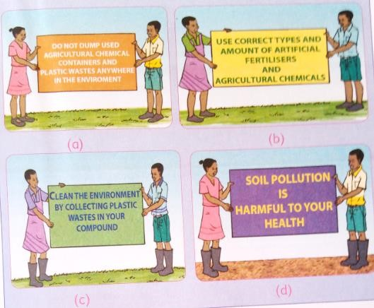

1.2 -Constructing Water Retention structures.
- In rainy seasons a lot of water flows into rivers in form of surface runoff and finally gets into lakes and oceans.
- Surface run off is the water flowing on the ground after a heavy rainfall.
- The water may be conserved to be used for farming during the dry season.  Surface run off causes a lot of damage to property if not properly collected  Some of the damages caused by surface run off include:
  - Soil erosion.
  - Deposits contaminants such as fertilizer, oil, pesticides and dirt into water bodies causing water pollution.
  - Destruction to crops.
  - Destruction to buildings and other infrastructure such as roads.
- Surface run off is conserved or collected in structures such as:
    - Water retention ditches.
    - Earth basins.
    - Water retention pits.

What is the importance of conserving water in Farming?
- Surplus or excess water can be conserved and used during the times of water scarcity in the farm.
- Conserving water reduces the cost of farming. This is because money that would be used to buy water in the farm is saved.
- Conserving water ensures availability of water for human life and livestock.
- A lot of water is wasted during rainy season.
- Rain water which forms surface run-off after heavy downpour is prevented from damaging property.
What are the way or methods used to conserve Surface run-off?
1. Construction of water retention ditches.
  - A trench is constructed along the contour to collect and hold surface off when there is heavy rainfall.
  - The trench should be dug along the contours.
  - The surface run-off collects at the retention ditch as it rains.
  - The water collected in the water retention ditches is used by the crops growing around it. Steps followed when constructing a water retention ditch.
- Determine the contour lines using an A-frame.
- Mark the contour lines with pegs.
- Dig the soil along the marked line to make a trench about 0.6m or 60 cm deep and 60 cm wide.
- Remove the soil with a spade and throw it downward to form an embankment.
- Plant grass or any other crop on the embarkment
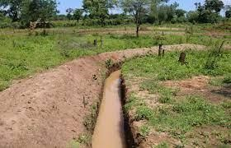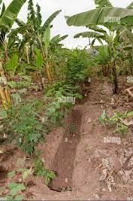

Photographs showing water retention ditches
2. Construction of an earth basin.
- An earth basin is a small pond or a depression that is constructed on the surface of land to collect surface run-off water after rains for use in farming.
- Water is collected in the earth basin when there is heavy rainfall and also runoff collects in the earth basin.
- Water is drawn from the earth basin for irrigation.
- An earth basin holds surface runoff form the surrounding area. It can store this water long after the rains. This water is used in growing crops.

Steps followed when constructing an earth basin.
- Clear the area where the earth basin is to be constructed.
- Excavate the basin by digging the soil and throwing it to the sides to form an embarkment.
- Leave the upper side of the basin open to allow the flow of run odd into the basin. ⬇ Plant a crop or grass around the earth basin to prevent soil erosion.
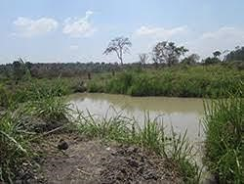

3.

Construction of a water retention pit.

A
Photograph showin
g
an earth basin

- This are small depression in which crops grow and are used to trap water around the base of the crop to be used by the crop. This reduces run-off.
- Surface runoff collects in water retention pits when it is raining.
- The water collected in the retention pits may be used to grow crops such as vegetables, bananas and Napier grass.
- Water retention pits traps surface run off and allow it to seep into the soil.
- A series of pits may be dug into the ground where run off occurs and the pits joined with furrows so that when one pits is full, water can spill over to the next pit.
Steps followed when constructing a water retention pit.
- Measure the spacing of the pits and mark with pegs.
- Dig the pits about 20-30 cm deep and spaced at 90 cm.
- The pits are planted with a crop. They help to hold surface run-off preventing soil erosion.
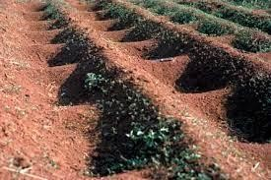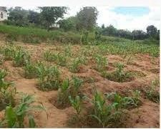

Photographs showing water retention pits with crops in them.

Crops that can be established in water retention structures:
- Bananas.
- Arrow roots.
- Napier grass.  Sugarcane.

1.3 -Conserving Food Nutrients.
Ways of conserving vitamins and mineral salts in vegetables during food handling, preparation and cooking.
    - Washing - Wash vegetables before cutting. Soaking or washing time should be reduced to minimize nutrient loss.it is advisable to wash vegetables with cool water rather than hot water. It is also advisable to wash vegetables before cutting. Avoid cutting then washing as this may cause leaching of nutrients.

    - Peeling – Most vegetables have more nutrients preserved when consumed with out peeling. Therefore, excessive peeling should be avoided to ensure more nutrients are conserved.

    - Cutting – most vegetables loss nutrients once cut because they are exposed to air. Therefore, it is advisable after cutting vegetable they should be stored in air tight containers. Ensure you remove excess air from the containers.

    - Cooking time -cooking time affects nutrients such as vitamin C which is lost when cooking food for long time. This is also determined with cooking method used. Incase boiling is much involved and cooking time is long, then the vegetable tend to lose a lot of nutrients.

    - Covering - cooking vegetables with the lid on can help to retain some of the watersoluble vitamins, such as vitamin C and the B vitamins, by trapping steam inside the pot and reducing the amount of nutrient loss through leaching into the cooking water.

Ways to cook vegetables to preserve nutrients
- Choose the right chopping method. The wrong chopping method can also lead to loss of nutrients. ...
- Be careful about the size of the vegetables. ... o Cook food for the right time. o Use the right amount of water. o Avoid re-heating the food.

1.4 -Growing Trees.
Importance of Trees in conserving the environment.
- Trees are planted to help conserve the environment and provide other benefits to farmers.  Farmers derive various benefits from trees such as:
    - Timber/poles.
    - Firewood.
    - Shade.
    - Food and livestock feed.
    - Organic matter that increases soil fertility. ✓ Conservation of both soil and water.

Difference between afforestation, reafforestation and deforestation.
- Afforestation refers to planting trees where tress had never existed.
- Reafforestation means planting of tress where forests have been cleared.  Deforestation-this is indiscriminate removal of trees from forested areas.

Roles of tress in soil and water conservation
  - They protect the soil from raindrop erosion by reducing the force with which it fall on the ground.
  - Trees provide shade hence reducing loss of moisture through evaporation.
  - Trees act as windbreaks preventing wind erosion.
  - Roots of trees binds the soil particles together.
  - Trees also reduce speed of running water thus reducing its erosive power which reduces soil erosion.
  - Tree leaves decay/decompose to supply humus to the soil which improves soil fertility and water infiltration.
- Agroforestry-refers to the growing of crops, trees and rearing of animals on the same piece of land. The planting of trees and shrubs helps to conserve soil and water as described in the roles of trees above.
State and explain nine nursery management practice done in a tree nursery.
- Mulching-alight mulch should be applied to prevent excessive evaporation and moderate soil temperatures.
- Watering-tree nursery should be watered regularly preferably in the mornings and evenings.
- Weed control-weeds should be removed through uprooting to avoid competition for nutrients and moisture.
- Pricking out-where seedlings are overcrowded, some should be removed (pricked out)and planted in another nursery bed.
- Root pruning-regular root pruning is done to make lifting of seedlings easier during transplanting and reduce chances of damage to seedlings.
- Shading-a shade should be erected over the nursery to reduce the impact of raindrop hence controlling splash erosion.
- Pest and disease control- sterilize the soil through heat treatment or application of appropriate chemicals.
- Hardening off-practice of preparing seedlings to adapt to the prevailing conditions in the seedbed.it is achieved through gradual reduction of shade and reduced watering.
- Transplanting-should be done at the onset of rains to give young trees a good start.
This makes the soil to stick around the roots and makes it easy for removal of polythene sleeves during transplanting. After transplanting seedlings should be watered, mulched then provided with a temporary shade to conserve moisture.

Care and management of trees.
  - Protection-young trees should be protected from damage by animals. This can be done for individual trees or the entire farm.
  - Pruning and training-pruning is the removal of extra or unwanted parts of plants. The unwanted parts may be due to breakages, overcrowding, pest or disease attack and low productivity.
  - Grafting old trees-this is the practice of uniting two separate woody stems, root stock and scion. Old agroforestry trees that have good characteristics can be used to unite with scions from different trees that are compatible with it.

STRAND 2-FOOD PRODUCTION PROCESSES.
2.1-Preparing planting sites and establishing crops.
Determine appropriate tilth for selected planting materials.
- Planting sites are prepared according to the type of planting materials.
- Different planting materials require different planting sites preparations.
- The size of the planting materials determines the soil fineness or the tilth of the planting site.
- Soil tilth refers to the degree of fineness or coarseness of a soil in relation to its suitability for planting a specified planting material.
- Soil tilth is described as fine, medium or coarse depending on the physical condition of the soil.
- Small sized planting materials require fine tilth.
- Examples of crops that require fine tilth include:
- Millet.
- Sorghum. ✓ Wheat.

- Medium sized planting materials requires medium tilth. ✗ Examples of crops that require medium tilth include:
    - Maize.
    - Beans.

- Large sized planting materials require coarse tilth.
- Examples of crops that require coarse tilth include:
      - Tubers.
      - Suckers.
      - Cuttings.
2.2 - Selected Crop Management Practices.
▪ Crop management is a set of practices carried out in an already established crop on the field to provide it with proper conditions for healthy growth.
Weeding in a Crop Field
- Farmers should get rid of weeds that grow in crop fields by removing them physically.
- Weeds should be removed in crops to avoid competition for nutrients and moisture with established crops.
- There are various methods used to control weeds in the farm.
- Some are physical, cultural, chemical and biological methods.
- Chemical methods are where farmers use herbicides to control weeds.
- Biological methods are where farmers use living organisms to control weeds.

- Cultural methods farmers used some farming practice to control weeds in the farm such as mulching.
- Physical methods involve where farmers use mechanical force to remove weeds.  Farmers can use the following physical methods to remove weeds:
  - Uprooting.
  - Tilling.
  - Slashing.
- Uprooting weeds- refer to pulling out the roots of weeds from the soil.
- Slashing weeds-involves the use of a cutting tool such as a slasher, sickle or pangas to cut off weeds at the ground level to remove their shoots.
- Tilling-involves breaking and turning (slight cultivation) the soil to remove weeds using a jembe or a panga.

Thinning and Gapping in a Crop Field.
- Thinning is the removal of excess seedlings in a crop field.
- When farmers carry out thinning, they uproot excess plants from the garden to prevent overcrowding.
- Gapping is the replacement of seeds that did not germinate or dried after planting.
- In gapping farmer replace crops that refuse to grow may be due to pest and diseases.
- Thinning helps to prevent overcrowding of plants which causes competition for nutrients, sunlight and moisture.
- When thinning, care must be taken to avoid damaging the roots of the remaining plants.
- Thinned-out plants can be used for gapping or as livestock feed.
- Carrying out thinning and gapping helps to maintain optimum plant spacing and optimum plant population in the crop field.

Earthing Up in Crop Production.
- Earthing up is the heaping of soil around the base or root zone of the crop.
- Earthing up is carried out to strengthen the roots and hold them firmly in the soil.
- In tubers, earthing up provides room for tubers to increase in size.
- Earthing up helps to conserve moisture around the base of the growing crops.
- Earthing up encourages development of propping roots in cereal crops like maize. This prevents lodging (falling of crops after bearing) in cereals.

Hardening in Crop Management.
- Hardening is a practice carried out after harvesting crops to prepared produce for storage. It is also called curing if produce.
- Hardening harvested produce makes their skins tough to avoid peeling and rotting in the store.
- It is also known as curing in some crops.
- Tubers such as Irish potatoes and bulbed onions are hardened just before harvesting to prepare them for storage by heaping the produce under shade and covering with grass for about four days. They are turned daily to ensure even drying.
- Hardening prevents the delicate skin of Irish potato tubers from peeling off during storage.
- Hardening also helps to remove excess water in mature bulbed onions preventing rotting in the store.
- Hardening can be done both in the field immediately after harvesting the crops.
- Hardening makes the crop not to lose quality during transportation. Importance of Management Practices in Crop Production.
- Crop management involves agricultural practices carried out to improve the growth and development of crops throughout their growth period.
- Crop management practices are specific to specific crops.
- Well managed crops make maximum use of soil as a resource and give good returns to the farmer’s efforts.
- Management practices are important because;  Improves crop yields for food security.
 Improves the quality of produce. This makes the produce attractive and marketable.  Good management practices increase the storage shelf life of the produce.

2.3 – Preparing Animal Products: Eggs & Honey.
- Most domestic animals are keep for their products.
- Animal products include milk, meat, eggs, honey, skin, wool and fur. Sorting and Grading Eggs.
- Sorting is the process of placing items into a certain order so that they can be analysed in a more effective way.
- Grading is classifying items according to quality or size.
- Sorting separates eggs according to the following factors:
  - Size ✓ Cleanliness.
  - Shell Colour. ✓ Texture.
  - Shape. ✓ Quality.
- When sorting and grading, eggs are examined carefully and then separated according to their size, weight, conditions of the shell, shell colour, shape and cleanliness.
- The graded eggs should be placed in plastic or cardboard trays.
- The broad end of the egg should be packed facing upwards.
- Eggs should be handled with care during sorting and grading to prevent breakages and loss.

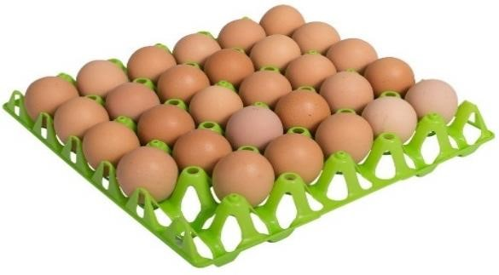
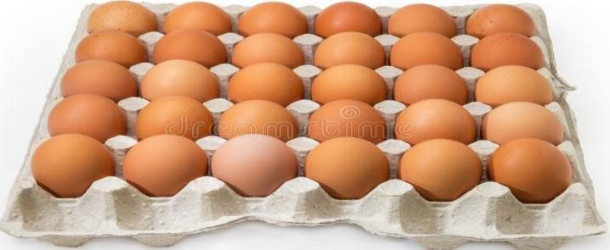
·

Eggs on clean cardboard tray Eggs on clean plastic tray Reasons for sorting and grading eggs.
- For incubation purposes.
- For selling purposes.

Factors to consider when Sorting and Grading Eggs
· | The following factors are considered when sorting  Size of the eggs.  - Weight of the eggs.  - Colour of the eggs.  - Shape of the eggs.  ❖ Note; | and grading eggs.  - Condition of the shell, i.e. broken, smooth or rough.  - Cleanliness of the eggs.
· | Cracked eggs should be sorted out and removed when grading eggs.
· | Eggs for hatching should be removed and separated from those for consumption during sorting and grading.
· | Clean trays should be used for the sorted out and graded eggs.
Importance of Sorting and Grading Eggs.
- When marketing eggs consider what the consumers or buyers want. Consumers will buy most attractive products.
- Consumers prefer eggs with strong smooth shells and those that are clean.
- Therefore, sorting and grading eggs has the following importance.
  - High quality eggs fetch high market prices.
  - Grading encourages farmers to produce high quality eggs, assuring the of high profits.
  - Sorting of eggs helps to grade them.
  - Buyers prefer large eggs for consumption. Those who need eggs for incubation usually but the medium sized eggs.
  - Consumers prefer eggs with strong, smooth shells and those that are clean.

Processing of Honey
- Honey processing is the extracting of honey from the combs to make it easy to package into containers.
- Honey combs are harvested from the bee hive or any site where the honey bees have built their combs.
- Raw honey may also be in form of honey crushed and stored with combs together.  Comb honey may contain some impurities.

Steps followed when processing honey
- Collect all the tools required such as muslin cloth, glass bottle, wooden spoon and wooden rods.
- Break the honey combs into small pieces.
- Place the broken pieces of honey combs on a muslin cloth.
- Wrap honey combs with the muslin cloth.
- Crush and strain honey from honey combs into a container using the wooden rods.
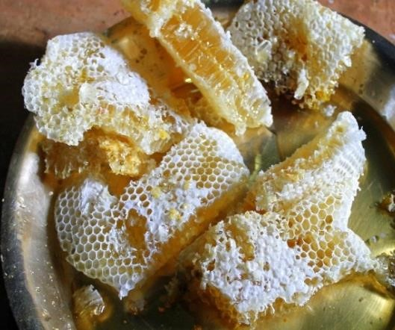

Honey combs to broken into small pieces.

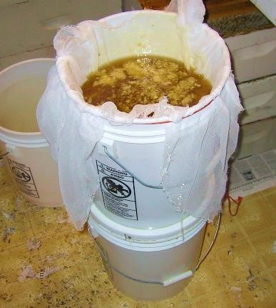

Place the broken pieces of honey combs on a muslin cloth.

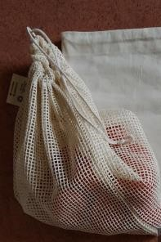
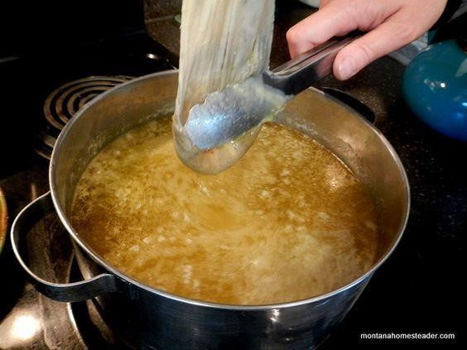
Wrap honey combs with the muslin cloth

Crush and strain honey combs into a container using the wooden rods.

Packing Honey.
- Once honey is harvested from the combs, it is packed into suitable containers for use or storage or for sale.
- Honey stored in suitable containers remain clean and safe for consumption and can be stored for longer period of time.
- Honey should be stored in containers that do not allow moisture into honey.
- When honey is stored in an open place, it absorbs moisture from the atmosphere and spoils quickly.
- Honey should be stored in plastic, glass or Aluminium containers and sealed tightly to prevent air and moisture from getting into the honey.
- Packed honey should be stored at room temperature in a dry place to avoid crystallization.
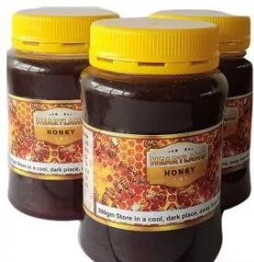
Honey stored in closed containers that do not allow in moisture.
Importance of Processing Raw Honey.
- To ensure clean and quality honey is produced.
- To obtain other products such as bee wax.
- To make honey safe for consumption.
- To remove impurities such as wax, dead bees, bee wings and legs.
- To enable honey, stay for longer period without spoiling before use.
- To add value to the final product.
- Processing makes honey lighter and easier to transport.

The Value of Preparing Animal Products.
- Some animal products cannot be used in their raw form until they are prepared or processed first.
- Animal products need to be transported from where they are produced to where they consumers are located hence the need to prepare them.
- Unprocessed animal products get spoilt quickly if stored fro along time.
- Processing and packing animal’s products prevents interference with product quality.  Preparing animals products through processing adds vale and increases the consumer’s choice for many products.

2.4 – Cooking: Grilling, Roasting & Steaming.
- Good cooking allows us to enjoy a healthy meal and snacks.
- Participating in preparation of food enables you to learn different methods and improves your skills in cooking.
- There are different methods of cooking food. The choice of a cooking method is determined by several factors.

Factors determining the choice of a cooking method.
  - The type of food to be cooked.
  - Time available.
  - Fuel or means of cooking.
  - Equipment available.

Methods of cooking different types of foods.
1. Grilling.
  - This is dry method of cooking food.
  - Grilling food is done by using direct heat, over, under or In front of a fire.
  - It can be done using an electric, gas or charcoal grill.
  - Grilling is a very popular method of cooking during festivities.
  - Some of the foods suitable for grill include green maize, plantains, fish, beef, chicken, sausages, tomatoes and bacon.

Equipment used for grilling food.
  - Charcoal grill.
  - Electric grill.
  - Gas grill.
Improvising grilling equipment.
Requirements.
  - Wire mesh.
  - A stand.
  - Charcoal holder.
  - 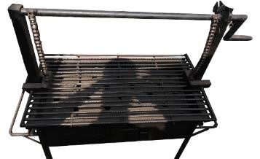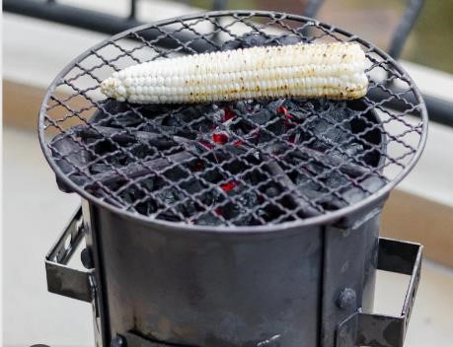

Guidelines for cooking food by Grilling method.
The following guidelines should be followed when grilling different types of foods to ensure the food is well cooked.
  - Foods to be grilled for example, meat, should not be too thick to allow them to cook properly.
  - The grill should be preheated to the correct temperature before.
  - The food must be attended to constantly to prevent burning or over-cooking.  The food should be turned frequently to ensure even cooking.

Safety measures during grilling of food.
  - Wear protective clothing to prevent contaminants from coming into contact with the food surfaces and equipment. The hair should be entirely covered and kitchen shoes worn.
  - Hands should be washed before handling food, after visiting toilet, handling money, refuse, touching other parts of the body or blowing the nose. Finger nails should be kept short and clean. Jewellery such as rings, watches and bracelets should not be worn as they trap dirt.
  - Bad habits such as smoking or tasting food using fingers should be avoided. - Persons with contagious diseases should not handle food.

Planning, preparing, cooking and presenting grilled food.
Grilled Chicken.
Requirements.
  - A grill.
  - Tongs.
  - Fork.  Tray.
  - Chopping board.
  - Knife.
Ingredients.
  - 1 chicken leg.
  - 1 head garlic crushed.
  - 1 small piece of crushed ginger.
  - Lemon juice.
  - Salt.
  - A little oil.

Method.
  - Clean the chicken under running water and dry it using paper towels. Make deep cuts into the chicken to spread the meat and allow the marinade to penetrate.
  - Marinate in a mixture of salt, ginger, garlic, lemons and oil for about 1 hour.
  - Heat up the grill and place the chicken on a rack. Grill on medium heat and brush with oil from time (basting) until cooked on both sides.  Serve the chicken.
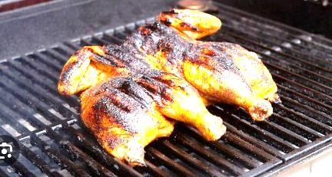

NOTE:
 Should chicken not be available, practice grilling other locally available foods such as green bananas, green maize, fish and tomatoes.

Presenting Grilled chicken.
Requirements.
  - The grilled chicken.
  - Carving knife.
  - Carving board.
  - Platter.
  - 4 plates.
  - 4 forks.
  - 4 knives.
  - A clean table cloth.

Method.
  - Use clean utensils.
  - Cut the grilled chicken into small pieces and place them on a platter.
  - Garnish the grilled chicken. This means using other foods like sliced tomatoes and onion rings to make it attractive.
  - Accompany the grilled chicken with a carbohydrate and vegetable of choice.
NOTE
 Should chicken not be available, practice presenting other grilled locally available foods such as bananas, green maize, fish and tomatoes.

What are the advantages of Grilling food?
  - Grilled food has less calories and fat content.
  - Grilling is a quick and easy method of cooking.
  - Nutrients are preserved as there is little loss.
What are the disadvantages of Grilling method of cooking?
  - Requires constant supervision.
  - Inconvenient.
  - Some skill is needed.
  - Fire and burn hazards.
  - Health concerns.

2. Roasting.
  - Roasting is a dry method of cooking.
  - The food is cooked close to a strong source of heat in an oven.
  - Examples of food that can be roasted include tender cuts of meat, potatoes and green bananas.
an oven.
Equipment suitable for Roasting food.
Roasting can be done using very basic kitchen equipment such as:
Roasting pan. | 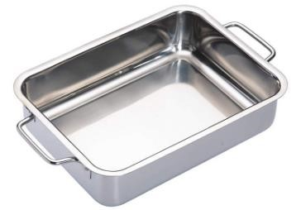
Electric oven | 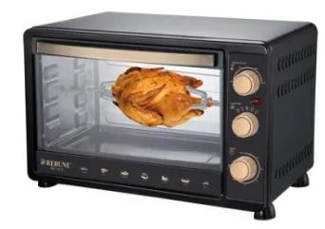
Gas cooker. | 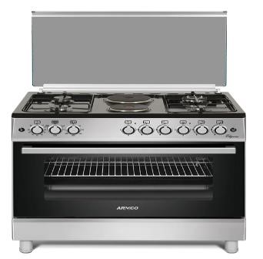
Two prong fork | 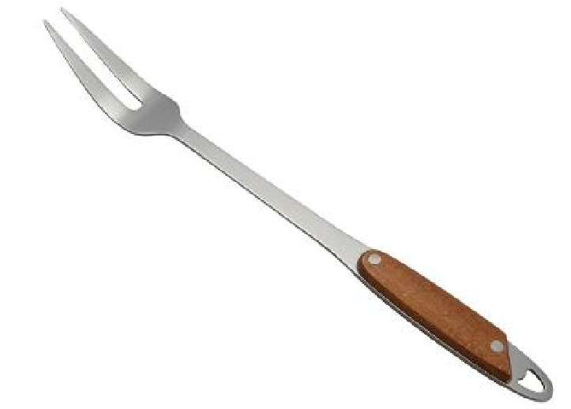
Skewer | 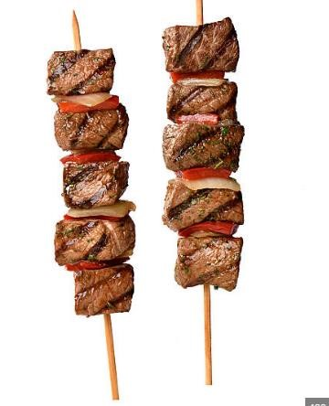
Tongs | 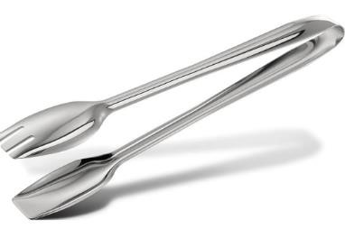
Carving board | 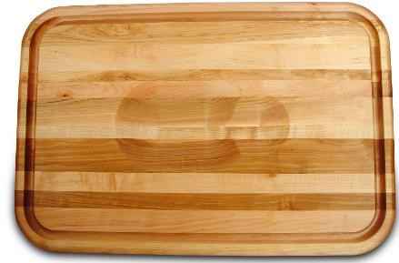
Kitchen thread. | 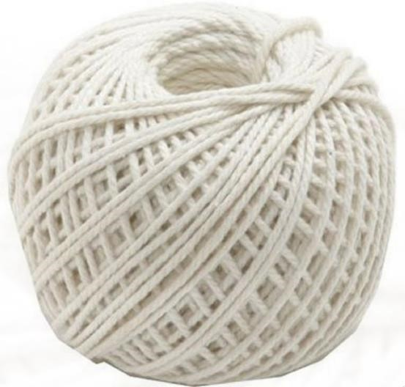
Carving knife. | 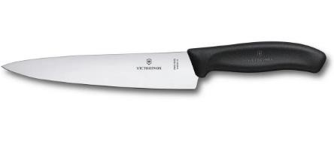

Guidelines for cooking food by Roasting.
- The following guidelines should be followed when roasting different types of food.
  - The meat to be roasted should be seasoned before putting it in the roasting pan.
  - The food to be roasted should be of good quality.
  - Frequent basting is necessary to keep meat moist and ensure even cooking. Basting involves the application of fat, oil or any other juices on meat during roasting to keep it moist.
  - Do not prick the surface of meat as this will allow juices to drain out and leave the roasted meat dry.
  - The kitchen thread is used to tie the meat to maintain its shape during roasting.

Safety measure during Roasting.
  - Wear oven gloves when putting food in and removing it from the oven.
  - Place the hot roasting pan on a heat proof mat after removing it from the oven.
  - When cutting the hot meat, hold it firmly with a fork.
  - Be careful when using hot ash to roast to avoid burns.

Planning, Preparing, Cooking and Presenting roasted food.
Roast Potatoes.
Requirements.
- A cooker.
- A skewer.
Ingredients.
- 10 small potatoes.
- 1 tablespoon oil.
- ¹/₄ tablespoon salt.
- 1 tablespoon crushed garlic.

Method
- Peel the potatoes and parboil them for 10 minutes.
- Drain the water from the potatoes.
- In a larger bowl, combine oil, garlic and salt.
- Stir the potatoes until evenly covered.
- Place potatoes in a single layer on roasting pan.
- Roast for 30 minutes in the preheated oven turning occasionally to brown on all sides.
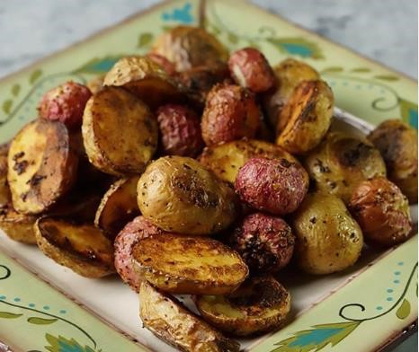
Presenting Roasted potatoes.
Requirements.
  - Roast potatoes.
  - 1 tomato.
  - Parsley or coriander.
  - Serving dish.
  - 4 plates.
  - 4 forks.
  - 4 knives.
  - A clean table cloth.
Method o Use lean utensils. o Serve the roast potatoes in the serving dish.
o Garnish the roast potatoes with sliced tomatoes and parsley.

What are the advantages of Roasting food?
  - Nutrients especially vitamins are preserved.
  - Creates an appealing texture and taste for food as well as improves appearance of food. ✗ Roasting does not require special skills and equipment.

What are the disadvantages of Roasting food?
  - It takes time for thorough and effective coking to be done.
3. Steaming.
  - This is a type of cooking method where food is cooked using steam from boiling water.
  - The food may or may not come into contact with the steam.
  - Steaming is suitable for vegetables, fish fillet and cake puddings.
  - Steamed foods are light and easy to digest.
  - Steamed food is therefore, suitable for sick people and people who are recovering from sickness.
  - Steamed food does not lose nutrients. They also retain their natural flavours.
  - During steaming, different dishes can be cooked at the same time. This helps to save on time and fuel.

Equipment suitable for steaming food.

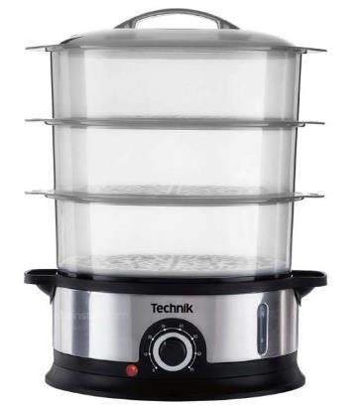
A food steamer.

Improvised steaming equipment.
 Steaming equipment can be improvised using:
- The plate method of steaming food.
- The bowl method of steaming food. ✓ A colander.

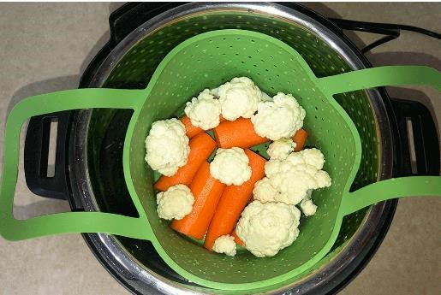
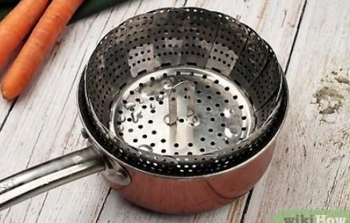
An improvised steamer.

Procedure for streaming foods.
Guidelines on steaming foods.
- Steam must be produced continuously when steaming. The water bath must, therefore, have enough water. This ensures that the pan containing the boiling water is not damaged.
- In order to maintain the temperature of the water bath, always add into it boiling water. iii. The steamer or pan must have a tight-fitting lid to avoid loss of steam.
iv. When using a commercial steamer, follow the manufacturer’s instructions.

Safety precautions when steaming food.
- Be careful when removing the lid to prevent scalding.
- Be careful when removing the water bath from the cooker.
- Remove the lid towards self to prevent scalding.
- Use kitchen gloves to remove the host sufuria from the cooker.

Planning, preparing, cooking and presenting steamed food.
Steamed spinach.
Ingredients.
- 2 bunches of spinach.
- 2 litres of water.
- ^{1/}₄ tale spoon salt.
Method.
- Wash the spinach.
- Remove the stacks.
- Shred the spinach and put it in a bowl. Add salt and stir.
- Cover the bowl with a fitting lid.
- Place it in a bigger sufuria with the water bath.
- Boil the water for five minutes. Stand back when removing the lid to prevent scalding. Be careful when removing the sufuria with boiling water from the cooker.
- Remove and serve.

Presenting steamed vegetables.
You will require:
- Steamed spinach.
- Serving dish.
- 4 plates.
- 4 knifes.
- A clean table cloth.

Methods.
- Use clean utensils.
- Serve in a serving dish.
- Garnish the steamed vegetables.
Importance of steaming.
Steamed food is light and easy to digest.

Advantages of Steaming food.
- Steamed food is healthier.
- Steamed food does not lose nutrients and appearance.
- Steamed food retains its natural flavour.
- During steaming different dished can be cooked at the same time hence saves energy.

Disadvantages of steaming food.
- Requires great care to avoid scalds.

STRAND 3- HYGIENE PRACTICES.
3.1 – Hygiene in Rearing Animals.
Hygiene practices in rearing of domestic animals.
- When rearing animals, farmers are advices to maintain high hygiene standards.
- This helps to prevent spread of diseases and also in production of high-quality produce.
- The following are hygiene practices in rearing animals:
    - Animals should be provided with clean feeder. This enables feeding of clean food that is not contaminated.
    - Provide animals with clean waterer.
    - Animal house should be thoroughly cleaned and have adequate ventilation for free air circulation.
    - Ensure animals are cleaned to prevent any spread of diseases and parasites.
    - Tools used on animals should be sterilized before using on other animals.
    - Equipment used to handle animals’ products should be thoroughly cleaned after usage.

3.2 – Laundry loose coloured items.
Reason for laundering loose coloured clothes.
- Clothes that can easily loose their colour during laundry should be handled with care in order to keep them colourful for longer.
- If proper care is not taken during laundry, the loose dye may discolour other clothes therefore damaging them.
Materials used for laundering loose coloured clothes.
- Different materials are used for laundering loose coloured articles.
- Some of these materials include:
    - Vinegar.
    - Salt.
    - Lemon.
Procedure used for laundering a loose coloured article.
Loose coloured articles will fade if they are not cared for properly during the laundry process. Fading makes clothes less attractive.

Requirements;  Basin.
  - Warm and cold water.
  - Bar soap or mild detergent.
  - Salt.
  - Vinegar or lemon.
  - Iron box.
  - Loose coloured article.  pegs

Procedure;
- use mild detergent or bar soap to help minimise loss of colour.
- Wash the article in warm soapy water using kneading and squeezing method. This method involves gently applying pressure on the article repeatedly while it is still in the soapy water and squeezing it gently.
- Rinse the article in warm water to remove all traces of soap and dirt.
- Make the final rinse in cold water into which salt and vinegar has been added. Salt helps to fix the colour while vinegar and lemon brightens colours.
- Squeeze the article to remove excess water/
- Hang the article to inside out under the shade to avoid the colour from fading, do not hand loose coloured clothes near other clothes to prevent transfer of colour.
- Iron the article from the wrong side when slightly damp using a moderately hot iron.
- Air the article so that it can dry completely.
- Fold and store appropriately in a clean place.
Measures to be observed when laundering-coloured clothes.
- Loose coloured clothes should not be soaked to prevent loss of colour.
- Loose coloured clothes should be washed using a mild a detergent to minimise loss of colour.
- Loose coloured clothes should be washed using kneading and squeezing method to prevent loss of colour.
- Loose coloured clothes should not be wrung to prevent loss of colour.
- Salt is added to the final rinsing water to fix colour. Vinegar and lemon can also be added to the final rinsing water to brighten colour.
- Loose coloured clothes should be hanged inside out under the shade to prevent the colour from fading.
- Loose coloured clothes should not be hanged close to or overlapping each other to prevent transfer of colour.

STRAND 4 – PRODUCTION TECHNIQUES.
4.1 – Sewing Skills: Knitting.
What is knitting?
- Knitting refers to the process of constructing fabric.
- It can either be done by hand or machine.
- It is achieved by applying continuous yarn or set of yarn to form a series of interlocking loops.
- Tools used in knitting include:
    - A pair of scissors-cut yarn after finishing knitting.
    - Knitting needles-used for hand knitting to produce knitted fabric.
    - Yan-used for knitting.
    - Tape measure-used to measure size of items being made.

Basic knitting stitches.
Knitting process is based on two simple stiches, namely the knit stich and the purl stich.
Therefore, the basic knitting stitches are knit and purl.
A knit stich look like a flat V-shaped and is mainly found on the right side of a knitted article. A purl stich looks like a raised bump on both sides of a knitted article.

Knit stitch | 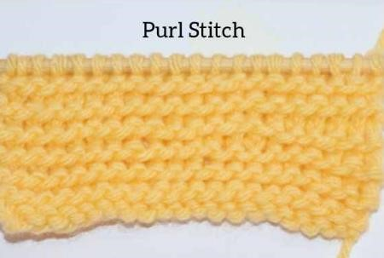  Purl stitch.

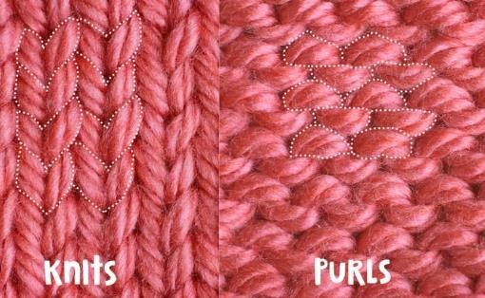

The following items can be knitted at home:
- Tool bags.
- Scarfs.
- Gloves.
- Mats.
- Table wipers.

Safety precautions to observe when knitting/ ✓ Ensure you work in a well-lit area.
- When cutting using a pair of scissors, keep fingers away from the blades.
- Do not use your teeth to cut yarn.
- Do not sit too close to each other as you knit.
- Store scissors, all knitting materials and tools properly after use.

Ways of taking care and storing knitting tools and materials.
- Always put scissors in scissors case after use.
- Wind yarns neatly after use and store them in a box.
- Avoid dropping pair of scissors.
- Oil scissors regularly and store knitting equipment in a clean dry place.

4.2 | Constructing Framed suspended gardens.
- Framed suspended gardens are structures which are creatively build to provide space and support for crops to be grown vertically.
- Suitable Crops for Suspended Gardening.
- Framed suspended gardens are suitable for growing climbing, shallow rooted and crops whose fruits are not too heavy to be supported by the frames and ornamental plants.
- Suspended gardens are suitable for growing off-season crops that require small spaces, use of little water and grow quickly.
- Kitchen gardens made of framed structures serve as a quick way of providing fresh vegetables, fruits and herbs to households at low cost.
- Creeping crops such as squash, sweet melon, cucumber, butternuts, creeping beans and strawberries can grow well when given support.
Suitable sites to prepare Framed Structures for Suspended Gardens.
- Framed gardens can be used as movable free standing structures in places where a temporary garden is needed since they can be moved easily.
- They can also be attached to other structures like fences, walls or balconies to save valuable floor space.
- Suspended gardens are also called “hanging gardens” which are used to grow crops in small spaces.
- Hanging gardens are artistically build structures that provide space and support for crops in the aerial space.
- The gardens can be made on framed vertical structures placed along fences, gates, pathways and on different types of trellises as shown in the pictures below.
- Arbor arch-this are arch-shaped structures whose walls and roof consists of open framework to support creeping and climbing crops.
- Pergola-This is an outdoor garden structure with a roof made of cross-beams where creeping and climbing crops are grown to provide shade along sidewalks, passageways or sitting areas.

In the School Compound Framed structures can be prepared in following areas.
- Near school gates for beauty.
- At school roundabouts.
- At the flag posts.
- Along walls of the hostels

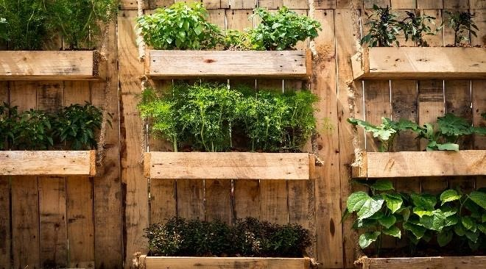 Framed suspended wall gardens

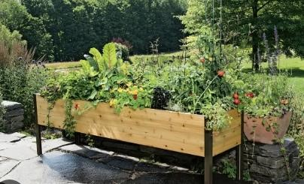

Arbor arch garden.

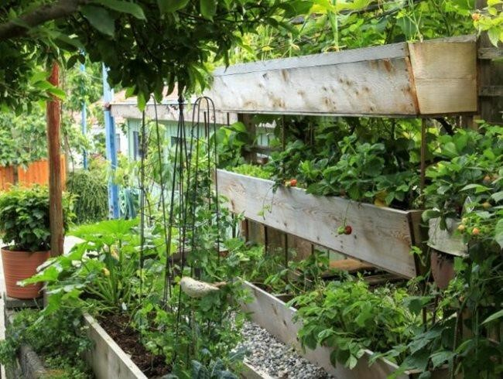

Suspended boxes garden.

Pergola gardens.

Framed Structures designs for Suspended gardens.
- The designs for suspended gardens depend on the materials, space available and the sites for the gardens, though the owners’ choice and preferences are considered.
- When designing framed structures for suspended gardens, it is important to consider the following:
  - The shape the garden will take.
  - The space available for the garden.
  - The site where the garden is to be placed in relation to the surrounds.
  - The type of plants to be grown in the framed structures.
- The sketch plans should show measurement to give an idea of the amount of materials required.
- The plans should also specify the types of materials to be used.
 | Materials for the Construction of the Framed Suspended | Gardens.
- The material selected by farmer for constructions of suspended framed garden should have the following characteristics ✓ Cheap.
  - Easily available.
  - Long lasting.
  - Easy to work with.

Examples of the material for construction of the framed suspended gardens can be:
  - Available timber.
  - Left over wires.
  - Nails.
  - Metal bars.
  - Wooden planks.
  - Poles.

Construction of Framed Structures for suspended gardens.
- The type and size of framed structures for the suspended gardens to be constructed depend on the space and available materials.
- The following types of farmed gardens can be constructed.
  - Arbor arch gardens.
  - Triangular wooden framed gardens.
  - Pergola gardens.
  - Suspended boxes gardens.  Tyre gardens.
  - Trellis gardens
Procedure for constructing wooden boxes.
  - Cut the pieces of wood for the frames of the boxes.
  - Join the wood pieces with nails or screws at the four corners to make the frames.
  - Fix a wire mesh at the bottom of the frame and hold with staples.
  - Fix a plywood piece to hold back the wire mesh from outside and secure with nails.
  - The box is ready for use. Its depth depends on the crop to be planted.
Establishment of Selected Off-season Crops on Suspended gardens.
- Framed suspended gardens are appropriately used for growing off-season crops since it is possible to economise the little water available.
- The gardens should be placed where they will get a lot of sunshine but sheltered from the winds.
- The framed structures can be placed one over the other to form wooden staircase garden as shown in the following photograph.
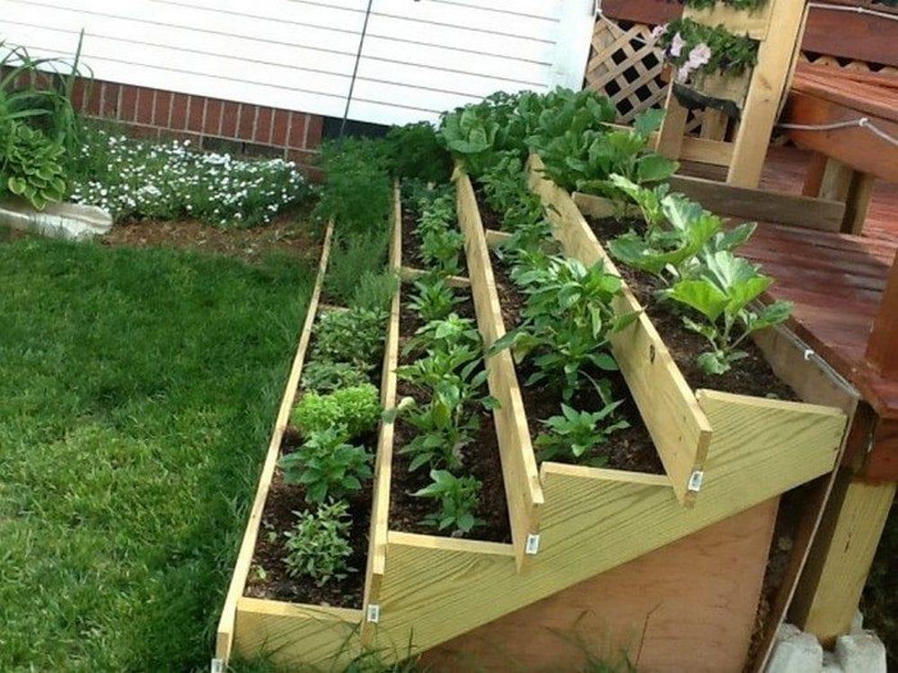
 | Management of Selected Off-season Crops on Framed Suspended Gardens | .
    - Crops established in the framed suspended gardens needs to be given care in order to grow strong and healthy to give expected produce.
    - The management practices carried on the off-season crops in suspended gardens help crops to grow strong and health.
    - The management practices are carried out on daily basis according to assigned tasks.  The practices are carried out as follows:
  - Weeding-done by uprooting weeds.
  - Mulching-done by spreading dry leaves or pebbles around the base of the plant.
  - Watering-dine by use of drip irrigation using pipes or perforated pipes or bottles. Wick irrigation is also recommended.
  - Pests and disease control-done by uprooting or removing the affected plant parts.
  - Care should be taken when carrying the management practices to avoid damaging the crops.
  - Observe safety precautions when working with tools and equipment.
Educative Messages on Framed Suspended Gardens | .
  - We should make the school community aware of the importance of using framed suspended garden to grow off-season crops in our school
  - When educative messages are used, the school community is made aware of how to grow crops in small areas.
  - Various methods of disseminating (passing out) the educative messages can be used.
These methods include:
      - Printing the messages on T-shirts, caps, key holders and wrist bands, then selling or wearing these items during holidays or school open days.
      - Printing posters with the message and placing them in open places such as head teacher’s waiting room at school gates, school canteen and all the notice boards.
      - Role playing and reciting poems during school open days.

4.3 | Value addition techniques.
- Most agricultural products are perishable.
- This means they are easily spoilt when stored for a long period after harvesting.  Hence, they need to be processed to increase the storage.

Meaning of Value Addition in Crop Produce.
- Value addition is the process of changing a product from its original form to a better form.
- It involves transforming of raw materials into forms that can have a long storage (shelf) life and are more profitable in the market.
- Value addition involves changing raw agricultural produce into new products which have more value.
- Value added products have a long storage life.
Examples of value addition in crop produce are as shown below.
- Fresh mango fruits to dried mango pulp.
- Groundnuts in pods to parked roasted groundnuts.
- Raw potatoes tuber to Fried and packed potato crisps,  Raw cassava root tuber to Dried and milled cassava flour.

Ways of Adding Value to Crop Produce | .
- Adding value to a product can be done in a number of different ways which give us new products.
- Some methods used include: drying, frying and roasting.
- They help to remove excess water from the crop produce.
- It prevents fungal attacks on the produce which brings about rotting.

Crop produce | Value added product.
Potatoes | crisps, flakes, canned potatoes
Mangoes. | juice, sliced dried and packed mangoes.
Vegetables | dries and packed vegetables.
Cassava | flour, chips and crisps.
Groundnuts | packed roasted beans. pressed groundnuts cake
Sim sim | simsim balls, and oil
Sweet potatoes | Crisps, flour
pumpkins | Flour and juice.

Processing Crop Produce for Value Addition.
- Processing crop produce changes them from their raw form into a better form which can be easily used.
- The method of value addition depends on the type of crop produce, uses of the produce and the length of storage intended.
- Some value addition processes are lengthy and expensive but they produce a stable product for consumption or sale.

❖ The methods of adding value to selected crop produce are as follows.
Preparation of potato crisps | - Wash the selected tubers.  - Peel the tubers and cut them into small pieces of the desired shape.  - Deep the potato pieces into hot oil.  - Cook until golden brown. (they are now potato crisps).  - Remove the crisps from the boiling oil and allow the crisps to cool.  - Serve the potato crisps or pack them for sale.
Preparation of dried mangos | - Wash the selected mango fruits.  - Cut the peeled mango into thin slices separating the fleshy part from the mango seed (ensure the slices are equal in size, preferably 1 cm thick.  - Deep the cut pieces into lemon juice for preservation.  - Dry the pieces in an oven at low temperature. Allow them to bake for 3 to 4 hours, turning them every 30 minutes for uniform drying.  - Arrange the slices in a tray and then sun-dry them for 2-4 days in low humid (dry) conditions.  - Turn the slices regularly for even drying.  - The dried mangoes can be stored or packed for sale.
Preparation of dried vegetables | - Wash the produce with running water and then chop into small pieces removing all woody or tough parts.  - Deep the cut vegetable produce into hot water to stop enzymes action on the vegetables which may affect flavour and colour of produce during storage. Alternatively, you can steam the cut vegetables but this takes long.  - Dry the cut vegetables in an oven or sun dry it until it is about 10-20% moisture content depending with the vegetable. Leafy vegetables can be dried up to 10% while fruit vegetables can be dried up to 20% moisture content.  - Cool the value added vegetables before storage.  - Store or pack for sale.
Preparation of cassava flour | - Peel the selected cassava tubers and cut them into small cubes.  - Sun dry the cubes.  - Grind the dried cubes into flour with the help of a grinding mill.
 | ✴ The flour is ready for use in various ways. It can be mixed with flour from cereals to prepare uji, ugali or even cakes
Preparation of roasted groundnuts. | - Put the selected groundnuts beans in a clean container and mix them with drops of selected water.  - Put the salted groundnuts beans in a heated oven and roast them until their coats turn brown and feathery.  - Remove the roasted groundnuts from the oven and allow to cool.  - Serve the roasted groundnuts or pack them for sale.
Preparation of simsim balls. | - Select and wash the simsim grains thoroughly removing stones and other foreign objects and allow to dry.  - Place a pan or sufuria on fire and put sugar.  - Put the simsim grains in the melted sugar. And roll into balls.  - Allow the balls to cool.  - Serve or pack in a container for sale.
Preparation of sweet potatoes | - Wash and peel the selected tubers.  - Slice the peeled tubers into the desired shape.  - Deep the chopped pieces into the boiling oil and allow to cool.  - Remove the sweet potato crisps from the boiling oil and allow to cool  - Serve the crisp or pack for sale.
Preparation of pumpkin flour | - Wash and peel the selected fruits.  - Cut the pumpkin into halves and scoop out all the seeds. o Bake the pumpkin for about 1 hour. o Allow the pieces to cool for about 10 minutes. o Scoop the pumpkin flesh into a container.  - Dry the pumpkin flesh into powder. o Grind the dried pumpkin into powder.  - Store in a tightly covered containers.  Pumpkin floor can be stored for a long period of time.

Comparison between Processed and Raw Crop Produce.
- Processed crop produce have many benefits to the farmer and the consumer or example:
      - They sell at higher prices than the raw produce in the market.
      - Processed produce have a longer storage life span than the raw product.

Importance of Value Addition in Crop Produce.
- Value addition in crop produce plays a role in reducing food wastage, improving food security and conserving the agricultural environment.
- Value addition of crop produce helps to:
    - Increase the storage life of produce.
    - Improve the selling price of produce for the farmer.
    - Reduces the loss of produce after harvesting.
    - It makes the produce attractive to the customers and therefore increases the demand of the produce.
    - It makes the crop produce available in the market for a longer time and hence promotes food security.
    - It makes it possible to store produce in small space.
    - It makes transportation of produce easier and less costly.

4.4
-
Making Homemade Soap.

Types of
cleaning agents.

•

Water.

Water is used for washing clothes.
  - Hard water contains calcium and magnesium salts.
  - It is wasteful during laundry work since more soap is required to form lather.
  - It forms scum with soap and can, therefore, discolour clothes.
  - It also causes scales and fur to be deposited in machines and pipes.
  - Soft water is water that does not contain dissolved salts of calcium and magnesium.
  - It readily forms lather with soap.
  - Warm water easily lathers with soap.
  - Cold water is usually used for final rinsing to freshen articles.

• Soap.
- Soap is used together with water to remove dirt.
- There are soaps and soapless detergents.
- Soap detergents are made of animal fats or vegetable oils while soapless detergents are made of chemicals.
Forms of Soap and soapless detergents.
· Soaps and soapless detergents are available in different forms depending on their use.

Examples of soap detergents.
- Liquid soaps are soaps that come in liquid form.
- Cake or bar soap are soaps that are in solid or bar shape and are mostly used for laundry.
- Toilet soaps are used for skin care, they have high content of fat and have more moisturising properties than bathing soaps.
- Medicated soaps contain substances that destroy or remove harmful bacteria from the skin.

Examples of soapless detergents.
- Foam soaps are liquid soaps which are dispended through a special pump mechanism that mixes the liquid soap with air to produce a foam.
- Powder soaps are soaps in powder foam. They are more affordable and effective.
- Liquid soaps come in liquid form and are meant for washing dishes and cleaning hands.  Paste soaps are semi solid soaps that look like bar soaps which have not hardened.

NOTE: Soaps like vanilla soap, peppermint soap, tea soap and lemon grass soap have oils from those herbs or plants. They have a good fragrance.
Basic ingredients and substances added during soap making.
- The major raw materials used in production of soap are:
  - Fats.
  - Alkali.
- Examples of oils or fats used to make soap include palm oil, coconut oil, cotton-seed oil, olive oil, tallow or mutton fats.
- The alkali (lye) used to make soap include caustic soda.
- The best water to use in soap making is rain water or distilled water.
- Other substances can be added to enhance the properties of the soap during manufacturing process. These include:
- Dirt suspending agents holds particles of dirt in suspension.
- Fragrance (perfumes) are added to enhance good scent.
- Dyes (colourants) are used to improve appearance of the soap in terms of colour.  Disinfectants are added to destroy disease causing bacteria and microorganisms.

Qualities of an effective cleaning agents.
An effective cleaning agent is important in household cleaning if good results are to be achieved.
A good effective cleaning household agent has the following qualities/characteristics/features.
- Should be gentle on the hand.
- Lathers easily with water.
- It should have an appealing fragrance.
- It should not contain substances that can harm fabric.
- It should have good cleansing power in both warm and cold water. ✓ It should rinse easily and leave no streaks or scum.

Preparing homemade soap using natural, safe and locally sustainable ingredients.
- Soap is made from fats or vegetable oils with and alkali.
- The purpose or quality of soap determines the ingredients to use in making soap.
- For example. Soap with high oil content is gentle to the skin.
Preparing homemade soap using natural ingredients.
Requirements.
- 2 tablespoons salt.
- 2 teacups water.
- ½ kg fat.
- A cooker.
- 1 teacup ashes. ⬄ Rubber gloves.
Method.
- Sieve the ashes into a clear container. Bean pods and maize stalk ashes are the best because they are fine.
- Add the two cups of water into the container and stir well.
- Strain the liquid into another container using fine cotton cloth. This liquid is called lye. Leave it to stand for 24 hours.
- Place the fat in a small pan or sufuria and melt it over heat.
- Add the lye to the melted fat stirring all the time, using a stick.
- Let the mixture boil slowly while stirring. Add salt and continue stirring until most of the water evaporates and the soap is almost ready to solidify.
- Pour the liquid into a mould and leave it to cool and harden.
- Remove the soap from the mould and cut it into the desired pieces and store in a dry place.

CAUTION.
  - Wear protective gear.
  - Handle fire with care. Ensure fire is put off when not in use.
  - Always add the lye carefully to the melted fat while stirring.  Salt is added to hasten the hardening process.

NOTE:
 Ensure there is enough air circulation for proper drying.
• To improve the soap you may add one or more of the following.
- Dye.
- Perfume.
- Disinfectant.
- Glycerin.

The Use of safe and locally sustainable resources in preparing home-made soap.
Homemade soap manufactured from locally sustainable resources are safe to use. These soaps can be improved so as to have better appeal in various ways.

