GRADE 7 CREATIVE ARTS AND SPORTS TERM 1 LESSON NOTES

Introduction to Creative Arts and Sports.
What is creative arts?
Creative Arts is a description of various artistic activities that allow performers to use their imaginations, creativity, and express ideas through a variety of mediums to passage a message to the audience.
What is sports?
A sport is any activity involving physical or mental effort combined with skills in which an individual or a team or teams compete against another or others for entertainment.
ROLES OF CREATIVE ARTS AND SPORTS IN THE SOCIETY.
- Social roles of Creative arts & Sports.
- Creates a sense of identity-bring people together, creating shared experiences that help to foster a sense of community and collective identity.
- Creative arts and sports promote cohesion through teamwork.
- Through creative arts and sports culture is preserved-it ensures that our history and traditions are not forgotten, and that future generations can appreciate and learn from them.
- Creative arts and sports provide provides us with entertainment through components such as music, dance, drama, narratives, films and movies, various sports i.e., soccer, basketball, netball, volley ball.

- Economic roles of Creative arts and Sports.
- Creative arts and sports provide employment opportunities such as artists, musicians, referees, sports coaches, sports doctors, choreographers. Trainers, teachers etc.
- One can earn income through activities related to creative arts and sports hence eradicating poetry.
-  Through creative arts and sports, a country can earn or generate tax revenue. (boosts revenue collection)
- Creative arts and sports attract investments which in turn increases job opportunities.
- Creative arts and sports stimulate growth of economy through sectors such as tourism. (Encourages tourism)

Components of Creative Arts and Sports.
Creative arts is made of the following components:
- Visual arts -creative art forms appreciated through sense of sight such as;  
- Play - a written work that tells a story through action and speech and is meant to be acted on a stage.

- Music - Music is a collection of coordinated sound or sounds. Making music is the process of putting sounds and tones in an order, often combining them to create a unified composition
- Dance – dance is the movement of the body in a rhythmic way, usually to music and within a given space, for the purpose of expressing an idea or emotion.

Principles of Visual arts.
There are two principles of visual arts namely:
Principle of dominance in Visual Arts.
Dominance is when a single element is so large and/or different compared to the rest of the design that it dominates.
It grabs your attention.
Famous examples include the London Eye that dominates the skyline of London or the Ashoka Lions that dominate the Indian Passport and other official documents.
Principle of Proportion in Visual arts.
Proportion refers to the dimensions of a composition and relationships between height, width and depth. How proportion is used will affect how realistic or stylized. Proportion also describes how the sizes of different parts of a piece of art or design relate to each other. Proportion in any art is the relative size of objects in relation to each other or corresponding to the other elements as a whole.

Basic Elements of a play.
The theme refers to the message (meaning) that is intended to be expressed in the story. In other words, it is the main idea or the lesson to be learned from the story.
Examples of themes in plays include: justice, loyalty. drugs, bullying, human rights etc.
 Character- this is a person or individual taking part in the play or drama that may have defined personal qualities and/or histories.

Plot- A plot is a sequence of events within a play that tells a story. A plot is what makes a story. Five components make up a plot: exposition, rising action, climax, falling action, and resolution. Conflict and theme help drive the plot forward.

Language- Language in drama is represented as spoken language or, in other words, as speech. In drama, language refers to the particular manner of verbal expression, the diction or style of writing, or the speech or phrasing that suggests a class or profession or type of character.

Setting- The setting is the time and place in which the story takes place
Elements of Music in Creative Arts.
Sound-any tone with characteristics such as controlled pitch and timbre
Rhythm- Rhythm is the pattern of sound, silence, and emphasis in a song
Melody- a melody is a combination of pitch and rhythm.
Harmony-harmony, in music, the sound of two or more notes heard simultaneously.

Elements of Dance in Creative Arts.
Body - In dance, the body is the mobile figure or shape, felt by the dancer, seen by others. The body is sometimes relatively still and sometimes changing as the dancer moves in place or travels through the dance area. The body is the mobile instrument of the dancer and helps inform us of what is moving.
Action – This is what a dancer does, for example travelling, turning, elevation, gesture, stillness, use of body parts, floor-work and the transference of weight

Space – Space refers to the area through which the dancer's body moves.

 Time - It is an essential part of choreographing and performing dance. It helps us to stay together when we dance in unison, identify the beat and the rhythm of how we move and provide stimulus for choreography.

CATEGORIES OF ARTS
ARTS - This is a general term used to describe expression of creative human skill, feeling and imaginations. This is mainly appreciated for beauty and emotional value.
The arts can be experienced through the following:
- Sense of light
- Hearing
- Touch
- Smell
- Taste

Entrepreneurship
This is the process of setting up, developing and running a business with the aim of getting profit.
It requires marketing goods, services and new ideas in order to make profit.

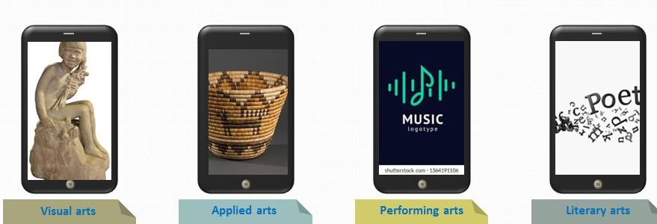

1. Visual arts
- These are arts forms appreciated through the sense of sight.
- They are appreciated for their emotional power and beauty e.g.
    - Drawing ➢ painting
    - montage
    - collage

  - Applied Arts
Applied Arts are related to visual arts but involved making anddecorating of everyday items.
These items are for practical use or utilitarian purposes

  - Performing Arts
Performing arts involves performance or presentation to the audience.
Artist use the following in performing arts
      - Body movement
      - Facial expression
      - Voices artistic expression
It can be done live to an audience or recorded for future use

  - Written or Literacy art
    - This writing of stories that have artistic and cultural value.
    - They display the beauty of speech and language to convey meaning.
    - It may be inform of stories novels, script writing and spoken films and poetry.
- The main reason for doing research is to get new information about a specific area.
- It also help you get different views and what people think about an issue.
- Researching on the categories of art will enable you find out about a wide area in the Art.

1. PERFORMING ARTS
Introduction to Performing Arts Basic Elements
Activity 1: Defining Performing Arts
• Performing Arts can be defined as cultural and creative activities prepared and staged for an audience.

Activity 2: Identifying the Various Disciplines of Performing Arts
- There are different genres of Performing Arts namely music, drama, dance, film and elocution. They can also be referred to as the disciplines of Performing Arts.
- Each discipline is divided into smaller areas, for example music (vocal and instrumental music), drama (skit and play), dance (Creative and folk dances), film (documentaries, fiction films) and elocution (verse, narrative). These are known as the genres of Performing Arts.
- ln some cases, several disciplines can be used together in a particular performance. For example, songs can be used in narratives and skits to make them more interesting poetry is used with background music, while a movie trailer uses drama, film and music.

Activity 3: Discussing the Importance of Performing Arts in Society
- Performing Arts are used as a medium of self-expression.
- Through Performing Arts, talents are identified and developed.
- Performing Arts are a source of entertainment.
- They promote cultural appreciation, unity and cohesion when people come together to watch a performance
- Performing Arts enables the learner to develop skills that can help him or her to solve the issues and challenges of everyday life.

Importance of doing research of art

Preparation for a presentation
Factors to consider when making preparation and presentation of art research .
1. Relevance of the content
- It is important that the information in the presentation is relevant to the main topic.
- This help in preventing the speaker and the audience from talking about things not related to them.
- The information should be well organized starting from what the audience knows to providing new information
  - Oral presentation
- When making oral presentation, use appropriate language and expressions. Remember also to maintain eye contact with the audience.

  - Team work
  - Every member of the group should actively participate in the activities. All members should take part in carrying out tasks during presentations.
  - These includes: preparations, organization sample artwork, operating the equipment and answering questions from the audience.
  - All members should demonstrate respect for one another and unity when carrying out the group activity.
Guidelines to follow when making a presentation on categories of arts

1. Introductions
❖ Introduce yourself and member of the group to the audience.  Give the tittle of the presentation.
2. Body of the presentation
- Discuss the meaning of the arts
- Give as many examples of the arts as possible
- Show actual samples, pictures or drawing to emphasize your points  Demonstrate where necessary

- Conclusion
- Ask the audience whether there are questions of contributions
- Answer the questions confidently, ask other group members, the audience of the teacher if you are not able to give a response to the question.
- When there are not more questions, thank the audience for the co- operation.

Presentation and appreciation categories of arts
❖ A presentation involves talking to an audience about the topic, an idea or a product. The main purpose of a presentation is to pass information and persuade an audience about a certain idea or topic.
Elements of presentation

❖ Speaker of the presenter
The role of the presenter is to communicate with the audience. The speaker also controls the presentation. The presenter should involve the audience and other members of the group during presentation.

❖ The audience
These are people the presenter will communicate with. It is important to maintain attention of the audience by involving them through questions and asking them to participate in some activities.

❖ The content
This is the information you will pass to the audience.
❖ The resources used in the presentation
These may include o samples of artwork o presentation software o charts
o posters

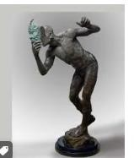

Career pathways in the arts
Career pathways - is an area of study taken so as to lead and prepare someone for a specific career. The arts is a wide a field that has very many opportunities. Careers in the art range from traditional fine art emerging digital and media design. The artist therefore, has an opportunity to choose a career pathway that is interesting and suits their individual abilities in the world of work.

Careers Path in Secondary school
The arts are offered as two subjects in lower secondary: performing and Visual arts.
Performing arts include: - music
- dance
- theatre and film

Visual and applied art: - fine art
- applied art
- time based media

Pupil’s activities Pg. 10

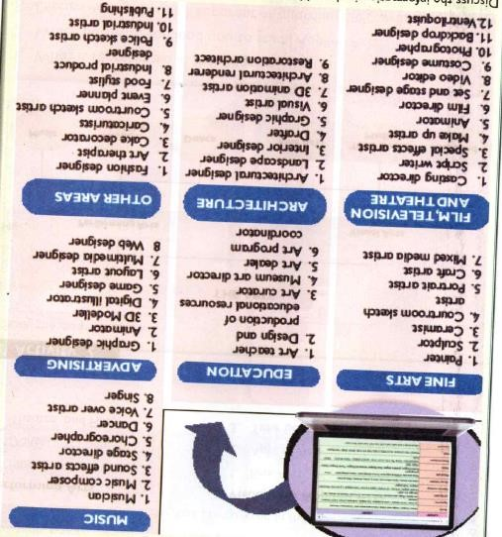

Presentation on career pathways in the Art
When making a presentation on the career in the arts, follow the same procedure as in the categories of the arts. Make sure you have done a good research and that you have enough point for the presentation. Present your points in a simple and clear language that everyone will understand. Present your points in the simple and clear language that everyone will understand. Be careful when talking in a simple and eye contact with your audience. Respect others and appreciate their contributions.

Categories of Visual Arts
The visual arts can be classified as either two dimensional or three dimensional. The two dimensional art forms can be also written as 2D, while three dimensional written as 3D.
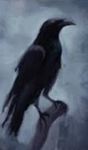

The 2D Forms
These are art forms that only have length and width. These artworks are done on flat surfaces and have no depth. Examples of 2D artwork are:
- Drawing
- Painting
- Montage

The 3D arts Forms
These are artwork with length, width and height
These types of artwork have volume
They can be turned around and viewed from more than one direction. Some examples of 3D artwork are:
- Pottery
- Basketry
- Ornaments

Presentation on the categories of 2D and 3d Arts Pupils activities page 19.

Creating and Performing in Creative Arts and Sports Composing rhythm
Rhythm
Activity 1: Clapping Rhythmic Patterns Incorporating the Semiquaver
- A quaver is half the value of the crotchet.
- A semiquaver is half the value of a quaver
- Two quavers make a crotchet while, four semiquavers make a crotchet.
- The rhythmic patterns that include the semiquaver in simple tune are ta-fa-te-fe, ta-tefe and ta-fa-te
Activity 2: Aurally Recognizing Rhythmic Patterns with Semiquavers and Their Corresponding Rests
Class Activity
- With the help of your teacher, listen to various pieces of music and identity where the semiquavers are round.
- In small groups, sing songs that have the semiquaver patterns.
- Recite the following rhythmic patterns using French Rhythm names and clap them.
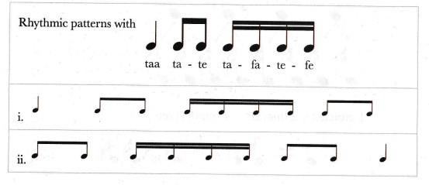
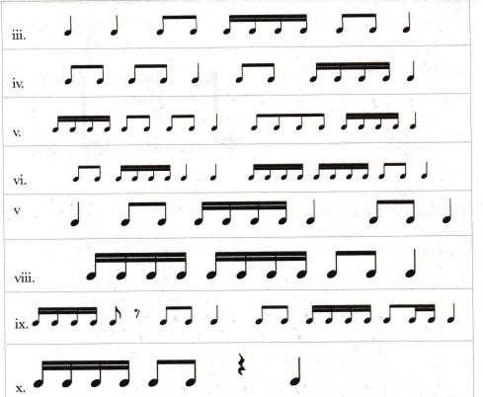

• Use common words or names of the members in the class to practise the rhythmic patterns with semiquavers, for example: apple juice, ripe mango, mama mboga etc.
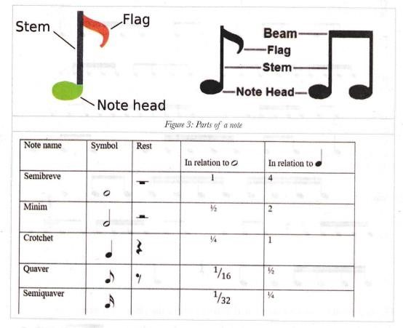

Activity 3: Grouping Notes into Beats in Simple Time
- Notes of small value such as quavers and semiquavers are joined together to form a crotchet beat. This is known as grouping notes.
- A horizontal line, known as a beam, is used to connect two or more notes of small value to form a crotchet beat.
- The number of beams in a group is equal to the number of flags or tails in the separate notes.
- The following shows how the notes are grouped into beats.
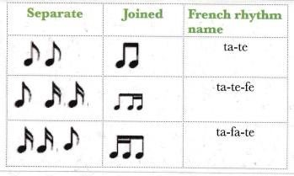
Note
- Music is made up of strong and weak beats.
- The strong beat is shown by the use of a symbol known as an accent (insert)
- The strong beat can recur every two, three or four beats.
- With the help of your teacher, clap the rhythmic patterns below, stressing the strong beats in each.
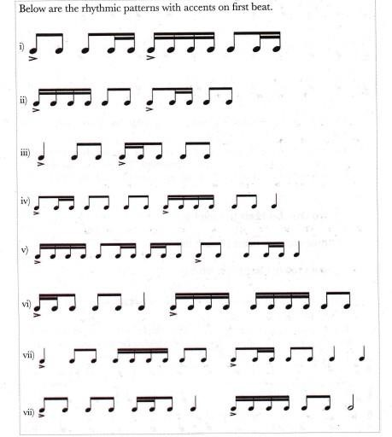

- The repetition of the strong beat after either two, three or four beats is known as meter.
- In written music short vertical lines, known as bar lines, are used to separate the groups of beats into twos, threes or fours. These groups of beats are known as bars.
The first beat of every bar is accented and double bar lines are used at the end.
- The meter of music is shown using a symbol of two numbers, one on top of the other. This is a called a time signature. The top number shows the number of beats in a bar and the bottom number shows the value of the beats.
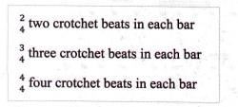
The number 4 is used at the bottom because there are four crotchet beats in a semibreve.
- The commonly used meters are simple duple, simple triple and simple quadruple time. The strong beat can occur after 2 beats, 3 beats and 4 beats.

Activity 4: Writing Rhythms in Simple Time on Monotone.
Can You Recall?
- A time signature is a symbol made up of two numbers that shows the meter of a piece of music.
- Music is divided into strong and weak beats.
- The strong beats occur after every bar line.
- Grouping of notes makes it easier to read music.

Group Activity
- With the help of your teacher, write down 2-bar rhythms in simple time on monotone. Use all the rhythmic patterns you have learnt so far
- Take turns clapping your written rhythms.
- You can also take turns to tap and write down each other's rhythms.
- Your teacher will assist you to write down the rhythms of familiar songs in simple time

Activity 5: Appreciating Music in Simple Time
Class Activity
- Listen to the song "pease porridge hot" played by your teacher:
- With the help of your teacher, study the song to find out what its time signature is.
- Practise beating time for the different time signatures.
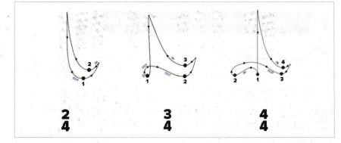
- The conducting patterns in simple duple, triple and quadruple.
- Listen to a variety of excerpts that will be played by your teacher. You will be assisted to beat time for each of them.

Individual Activity
- Listen carefully to the rhythmic patterns which will be played by your teacher.
- Write down the rhythmic patterns in your exercise book.

Group Activity
• Your teacher will play some rhythmic patterns tor you. In groups, write down the dictated rhythmic patterns.

Creating and Performing in Creative Arts and Sports
Athletics Javelin
The javelin throw is a track and field event where the javelin, a spear about 2.5 m (8 ft 2 in) in length, is thrown.
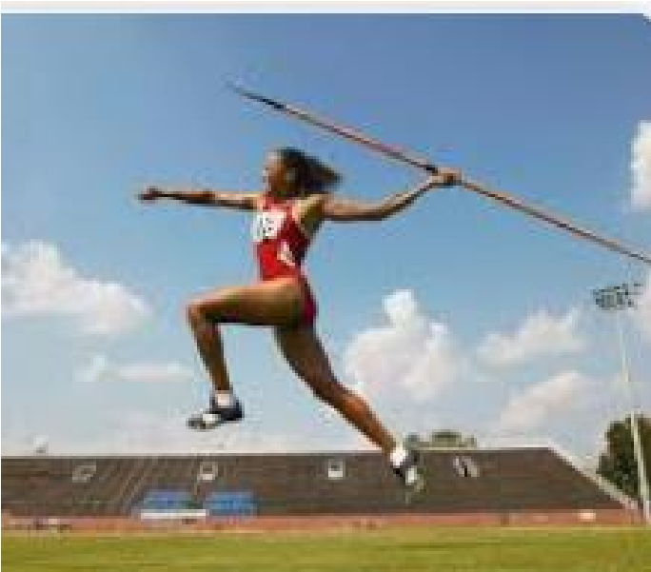

Safety when observing the javelin.
- Always carry the javelin vertical with the pointed part down
- Never run to collect the javelin
- Take care when removing the javelin from the ground
- Ensure that the area is clear before throwing the javelin ➢ Take a few steps backwards continuously ➢ Continue for the desired time and distance.

Demonstrations for javelin
a. Grip in javelin
- Place the javelin along the length of your plan
- Hold the javelin at the back of the cord
- Keep the point of the javelin pointed in the direction you want to throw
- Keep the javelin lined up with your eyes
- Keep your grip relaxed

Types of grips in javelin
There are three types of grip in javelin
  - The American grip
  - The ‘V’ grip
  - The finish grip

a. The American grip
- Here you Place your thumb and the first two joints of you index finger behind the cord
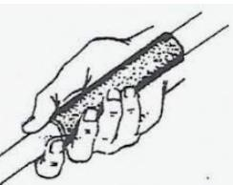
The ‘V’ grip – hold the javelin between your index and middle fingers, behind the cord.
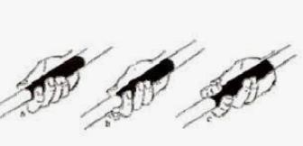
The finish grip: place your thumb and the first tow joints of your index finger behind the cord, while the index finger supports the shaft of the javelin. Extend the index finger further away.
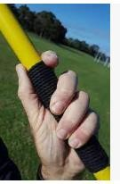

Leaning points in javelin Carriage
- Hold the javelin near your head above your shoulder
- The javelin should point down towards the ground slightly.
- Ensure the javelin is parallel to the ground.
- Look at the direction of your through.

Approach run
- After you have the javelin in position, begin running towards your target with the javelin
- Keep your hips high and down on the balls of your feet
- Let your free arms swing across your body
- Extend the arm carrying the javelin fully behind you.
- Keep your head facing in the direction of your target
- Turn so that the left side of your body faces your target.
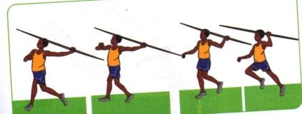
Cross over.
Place yourright foot on the ground and your left foot forward and elevated.
- Put your right ahead in a “lean – back “ positions
- Pull the javelin back a little further so that the tip is lined up with your eyebrows
- Keep the right foot close to the ground
- Let the right heel touch the ground
- As the right foot moves forward, move the left foot up and lean your trunk back at 115 degree angle.
- Place your right foot on the ground and you left leg forward and elevated
- Direct your shoulder and hips towards your left target.
- Wait for your left foot to touch the ground
- Straighten your torso
- Turn your face toward the direction of the throw with the javelin parallel to your shoulder
- Position your throwing and hand above shoulder level.

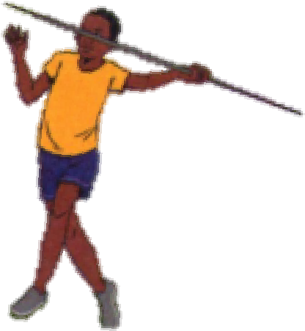

Release
- Through the javelin with your arms as high as possible
- Plant you left heels and thrust forward with your right foot
- Pull back with your left arm keeping it parallel to your right shoulder
- Move your throwing shoulder over your left leg
- Lift your left leg and move your throwing arm, with the elbow placed high and close to the midline.
- Release the javelin with your arm over your head in front of you.

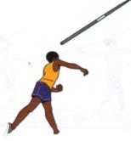

Follow through
- Let your throwing arm travel diagonally across your body.
- For examples if you are throwing with your right arms, it should end up infront of your left side.
- Keep your left foot on the ground.
- Let the right leg pass the left foot and then stop you.
- Finish by standing on your right foot, with your left leg up behind you. ➢ Your right shoulder will turn left, with your chest facing to the left.
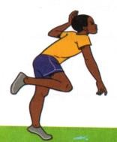
PUPILS ACTIVITIES
Learner to discuss various drills in javelin with the guidance of the teacher
KLB TOP SCHOLAR PAG 47

Creating and Performing in Creative Arts and Sports Composing Melody
Melody
Activity 1: Identifying Qualities of a Good Melody
- The melodies move in stepwise motion with a few leaps.
- The melodies begin on notes d, m or s and end on d.
- They have a good melodic contour.
- They have several rhythmic patterns.

Activity 2: Interpreting 4-bar Melodies in Simple Time
- Sing the melodies below and take note of the melodic contour
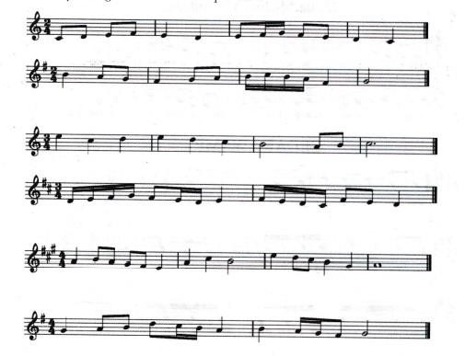
- To interpret a melody, the following should be done:
- Identify the clef, key signature and time signature.
- Tap the rhythms of the melody.
- Write tonic sol-fas of the melody below the staff. Remember "doh'’ is the note that gives the key its name, for example, in C major, doh is C,
- Practise singing the tonic sol-fas of the melody, first in crotchets and then using the correct rhythm.
- Notice the movement of successive notes in each of the melodies. Stepwise motion is where the interval between any two neighbouring notes is not more than a step on the scale.
- In some cases there can be more than a step between two successive notes of a melody. This type of motion is called skipwise motion or movement by leaps.
- Each melody has a shape, which depends on the successive movement of notes. A melody can move upwards, downwards, in waves forming a curve and so on. This is referred to as the melodic shape or contour.
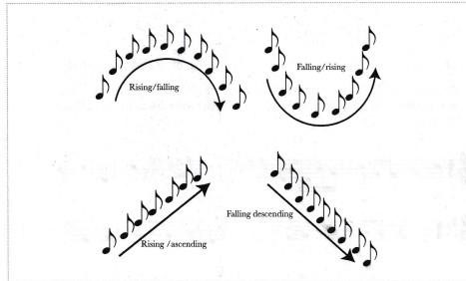

Activity 3: Creating 1-bar Melodies in Simple Time on Treble Clef
Things To Remember
- Before you begin creating a melody, you should: draw the staff, add the treble clef, write the key signature of the scale you want to use, and write the time signature you will use.

Work in Pairs
- What are the qualities of a good melody as was discussed in the previous activity?
- Practise Writing a 4-bar melody in simple time in major scales of C, G, D and A.
- Sing or play the melody you have created.
- Describe the melodic motion and shape or contour.
- What is the first and the last note in each of the melodies?

Activity 4: Playing or Singing Melodies Created by Self and Others
Can You Recall?
• What are the qualities of a good melody?

Work in pairs
- Take turns to play each other's melodies.
- Discuss the qualities in each of the melodies played.

Group Activity
• With the guidance of your teacher, use mobile apps or computer software to create, notate and play back 4-bar melodies.

Activity 5: Appreciating Melodies Composed by Self and Others
Listen and Learn
- You have created 4-bar melodies in simple time in the major scales of C, G, D and A
- In pairs, take turns to sing or play (or use: digital devices to listen to) and appraise each other's melodies.
- Take turns to sing your melodies to the class.

Creating and Performing in Creative Arts and Sports Handball

Handball Passes and reception in handball
Passing – is delivering the ball to a team mate during play in a handball game.
Passing the ball helps in;
- Speeding up the game
- Creating scoring chances
- Breaking tight defense
- Releasing pressure during play
- Expressing creative abilities during play

Qualities of a good pass
- Accurate so that a player has no problem catching the ball.
- Fast and timely to exploit the play chance promptly.
- Useful – a pass should be directed to that player whose position may disadvantage the opponent.

Types of passes
There are three types of passes, namely;
Jump pass
Side pass
Flick pass

1. Jump pass
A jump pass is where a player leaps in to the air and throws the ball to a teammate before landing.
It is completed at the peak of the jump with a player in control releasing the ball to the teammate

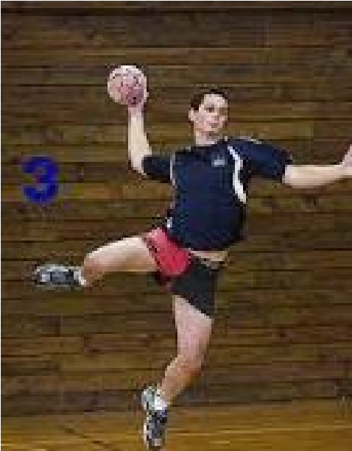

Stages of execution in jump pass a. Preparation
- Take off from the ground either on a single or double foot.
- Bring the passing arm high and back above the level of the head
- Bring the non- passing arm slightly in front of your body ➢ Keep shoulders high and head up b. Execution
- As you bring the passing arm forward to release the ball, pull the non-passing arm backwards at hip level.
- Release the ball to your teammate with a follow through and wrist action.
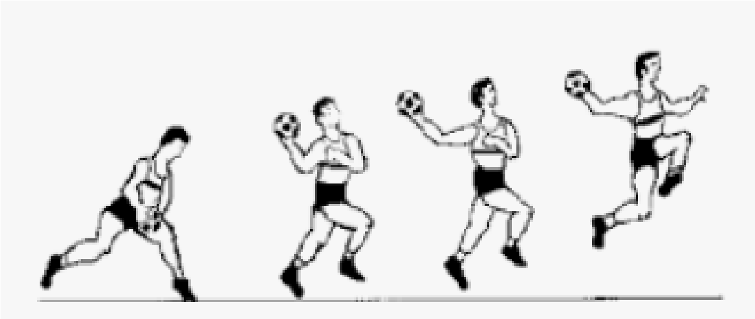

2. Side pass
A side pass is also known as wrist passes and is the most common way of passing the ball across the width of the court. This movement is called ball circulation. Stages of execution in side pass

a. Preparation
- Stand with feet slightly closer together than shoulder-width apart from the target
,the receiver should be on your right or left side
- Hold the ball on the passing hand with palm facing down
- If the pass is to be made at the right side, hold the ball with the right hand , if the pass is to be made on the left side, hold the ball with the left hand

b. Execution
- swing the passing arm across the body from left to right when passing towards the right direction
- release the ball with full extension of the arm with a wrist action
- step sideways towards the direction of the pass for a follow- through
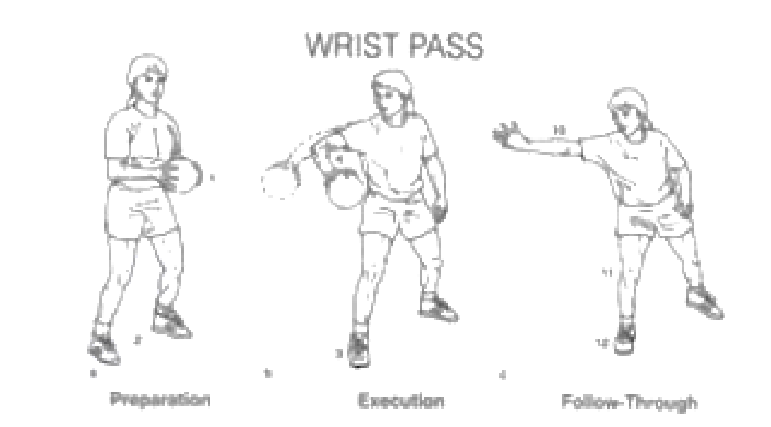

3. Flick pass
A flick pass is an action made using the passing arm which quickly propels the ball forward. The release action of the ball is terminated with a forward wrist action.
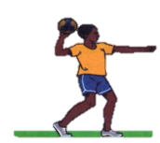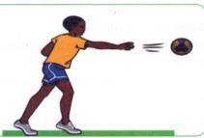

Stages of execution

a. Preparation
- Take a staggered stance with the leg of the non- passing arm leading.
- Hold the ball with one hand in an open palm, fingers well spread behind it at shoulder level
- The non-passing arm should be extended outwards for balance
- Eyes should be focused on the target
➢

b. Execution
- Step with trailing foot forward
- Push the ball forward towards the receiver
- Release the ball by flexing the wrist and the fingers forward for a follow- through. This generates power to propel the ball and give it directions.

Reception
Reception– is the act of receiving the ball with one or both hands. The catch may vary from high level to medium or low level.
Points for reception of the ball

a. Preparation
- Stand on the balls of your feet shoulder-width apart facing the direction of the ball.
- Extend your hands towards the ball
- Move forward to meet the oncoming ball
- Keep your arms pointed towards the ball
- Your hands should form a tunnel shape of a W formation ready to receive the ball.
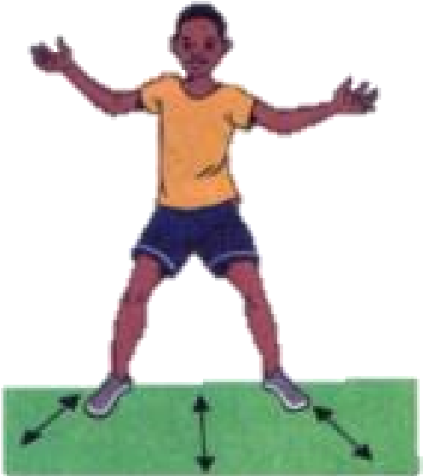

Preparation to catch

b. Termination
- On contact with the ball, wrap the fingers around it and bend the elbows bring the ball towards the chest.
- Ensure the thumbs are behind the ball and get in to a ready position for your next action.
➢
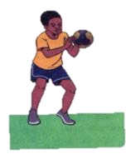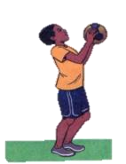

Low catch

high catch

Drills in hand balls
Drill 1: jump passing
In pairs, stand apart. Take three steps toward your partner and then take off
Pass the ball using a jump pass and walk back to your siting position
Your partner also takes three steps and then passes te ball back to you using a jump pass.
Drill 2. Flick pass
In groups of four, stand in a square formation, ass the ball around the square using flick.
Drill 3: two line drill
- Player to form two lines
- The leaders pass the ball using a flick pass
- After making the pass, the leader joins the line from behind
- Ensure everyone get a chance to pass the ball
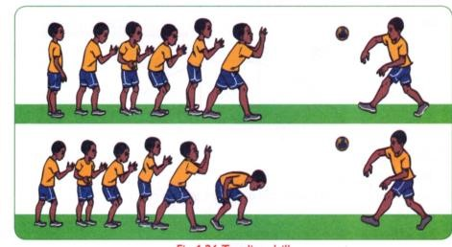

Side pass drills
Drill 1: side passing
In pairs, stand 3m apart side by side. Pass the ball to one another using a wrist pass
Drill 2: pass curve
  - In groups of four, stand three meters apart in a semi-circle
  - The player with the ball to be at the extreme end
  - Pass the ball from right to left without skipping any player
  - When the ball reaches the end, pass the ball back to the left

Drill 3: down court drill
  - In pairs, stand 3 m apart facing the goal, walk down the court passing the ball using the side pass.
  - Change the pace to a jog and continue passing the ball each other up and down the court
Pupils’ activity Pg. 22

Footwork in handball Principles of good landing
- Landing on the balls of the feet
- Knees should be slightly bent to cushion the shock on the impact of landing
- This is also referred to as knee- deep landing.
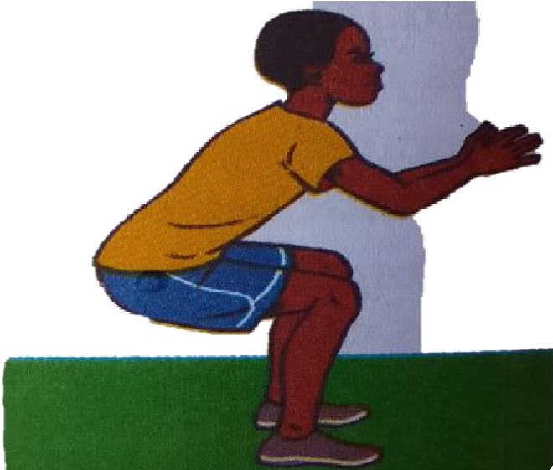

Landing

Stepping progression skills in handball
Drill 1: individually jump, catch a ball and land on one foot.
Drill 2: in pairs, stand 3m apart facing each other, jump, and catch a ball and land on both feet
Drill 3: a) the players are in circular formation passing and catching the ball
b) Catch the ball from a side pass land on both feet and take three steps and then pass it to the next player using a side pass.
Drill 4: a) the players are in a triangular formation passing and catching the ball
b) Catch the ball from a flick pass and land on both feet, take three steps and
then pass the ball using a flick pass.
Drill 5:a) in a group six form a line formation
b) Practice catching the ball and landing on both feet. Use a jump pass while passing.

Dodging and marking in handball Dodging
When dodging, a player may use body actions that mislead the defending player. It enables the attacking player to go past the defender and score goals with ease.

Marking
Marking is a defensive action that limits the chances of attacking players gaining possession of the ball.

Qualities of a good player
- Observant – the marking player needs to pay attention to the attackers who are likely to gain possession of the ball and drive forward
- Good positioning–ability to position himself or herself appropriately between the attacking player and their defending goal
- Quick time reaction – this helps the marking player respond to unexpected tactical actions by the attacking players.
- Resilience and persistence – the marking player should never give up on playing a defensive role.
- Communication – good marking is a product of communicating with teammates to develop a suitable plan or approach to counter the playing actions of the attacking teams
- Courageous – a good marker should be courageous to withstand non-avoidable contacts that may occur during one on one tackling situations
- Peripheral vision – a player who is marking needs to see what is happening around him or her and not just focuses on the player being marked alone.
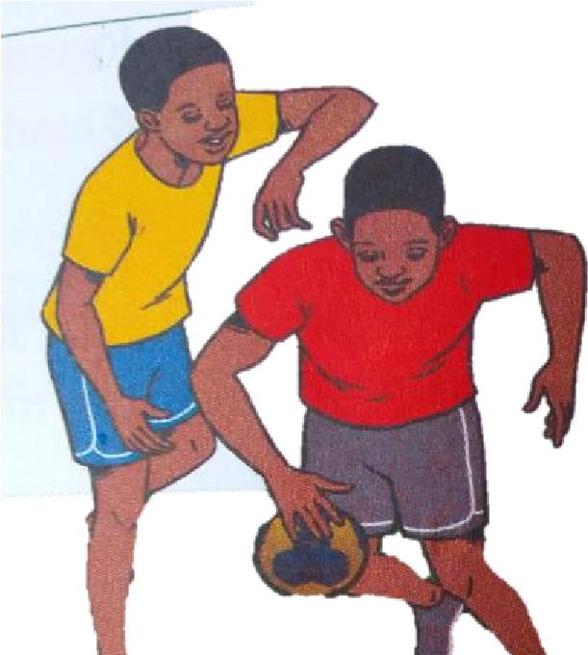

Body feign in handball
Body feigns are performed by using the trunk legs. They involve a shift of balance and weight. This can be done with or without the ball.
Body feigns are used to free the player from an opponent and get a better position for receiving or passing the ball.
Types of dodging technics include:
- Single feign dodge
- Double feign dodge

Single feign dodge
- In group of five players, form two lines facing one another 5m apart
- Players approach each other
- In closing to one another, each of them performs a single feign to the opposite side.

Leaning point for double feign dodge
- Take a position at least 5m in front of an opponent
- Make a short run and break it with a double foot landing referred to as a zero step ➢ Lean towards either the right or left and repeat the feigning. ➢ Complete the original intended love.

Drill 1: Pair feign dodge
- In pairs without the ball, stand facing each other
- One of you to practice the double feign dodge
- Repeat three times and switch roles

Drill 2: Quinque drill
- In groups of five, place a cone in the court and make a line facing the cone
- Sprint to the cone and stop on zero steps, feign to the right, then left and then move to the right to receive the ball.

Dribbling in handball
Dribbling – it is a technique in handball where the player bounces the ball on the ground once or repeatedly.
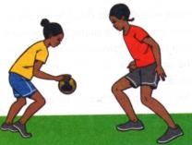

Types of handball dribbling
- High dribble
- Low dribble

Demonstrating low dribble
- Stand with the feet shoulder-width apart
- The knees should be slightly bent and body weight on the balls of the feet
- Push the ball downwards using the wrist and the fingers for better control
- The arm of the non- dribbling hand should be extended outwards from the body for balance
- Use a pump like action to bounce the ball repeatedly with the enough force so that it bounces slightly above knee level. This constitutes a low level.
- Control the ball by flexing the wrist and the fingers
- Bounce the ball below knee level for a low dribble
- Keep the head up and avoid looking at the ball

Learning points for high dribble
- Stand with the feet shoulder- width apart
- Keep erect with a slight lean forward and body weight on the balls of the feet
- Push the ball downwards using the wrist and the fingers for better control
- The arm of the non-dribbling hand should be extended outwards from the body for balance
- Use a pump like action to bounce the ball repeatedly with enough force so that it bounces slightly above knee level for a high. This constitutes a high dribble. ➢ Keep the head up and avoid looking at the ball.

Drills of dribbling in handball

Drill 1: Step and dribble
- Take three steps, make one dribble and take three more steps.
- Increase the number of dribbles between three- step sections
- At the end of the sequence, make a shot or a pass

Drill 2: Walking drill
- Walk across the court with a ball five times making a high dribble
- Repeat the drill using a low dribble

Drill 3: The cone drill
- Place seven cones in a line 1.5m apart
- In groups of five, practice zigzag movement pattern in and out of the cones one at a time
- Start with a low dribble and later a high dribble
- As you perfect the dribble, make more challenging by shortening the distance between the cones

Drill 4:The court drill
➢ Individually dribble a ball along a court marking using high and low dribbles. Use a movement pattern of three high dribble and three low dribbles.

SHOOTING IN HANDBALL
Shooting – it involves throwing the ball in to the opponent’s goal to make a score.

Safety measures to be observed when performing shooting in handball
- Never aim to hit or injure the goalkeeper with the ball.
- Take turn and shoot one player at a time
- Warm up adequately before starting the shooting activity
- Adhere to the instructions given by the instructor
- Be conscious of the nature of the floor or the ground while making a falling or a dive shot
- .
- .
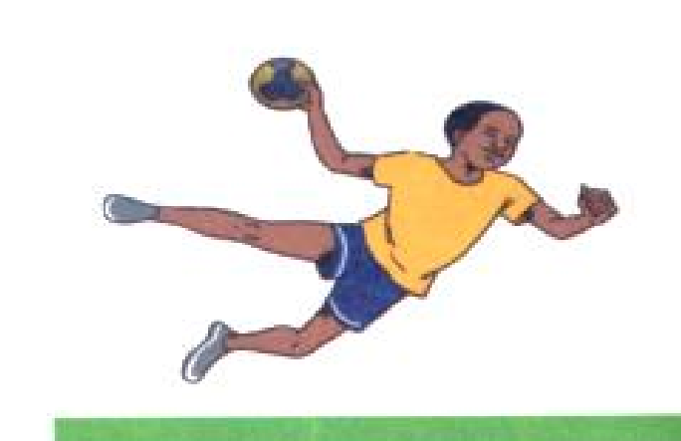
➢

.

Types of shots in handball include:
  - Jump shot
  - Dive shot
  - Running shot
  - Falling shot
  - Lob shot

Demonstrating jump shot
A jump shot is where a player can shoot from a stationary position and gain horizontal distance and the releasing powerfully towards the goal at the highest point of the jump.
- Make a shot run with a maximum of three steps while gripping the ball
- Make a single foot take off in the last step for an upward thrust. Bend the other leg at the knee for more force upward.
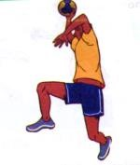

Demonstration for a running short
Running shot is executed while the player is in motion making the three steps progression.
- Make two or three steps towards the attacking goal end then make a shot at the goal
- Follow through with a swing of the throwing hand
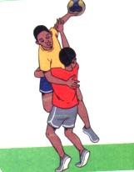

Demonstrating a dive shot
- Take a position outside the 6m line facing the attacking goal.
- Take off with both feet high and the head fast towards the goal area.
- Release the ball while airborne and land in the goal area with the body low.
- Convert your landing into a roll for safety.
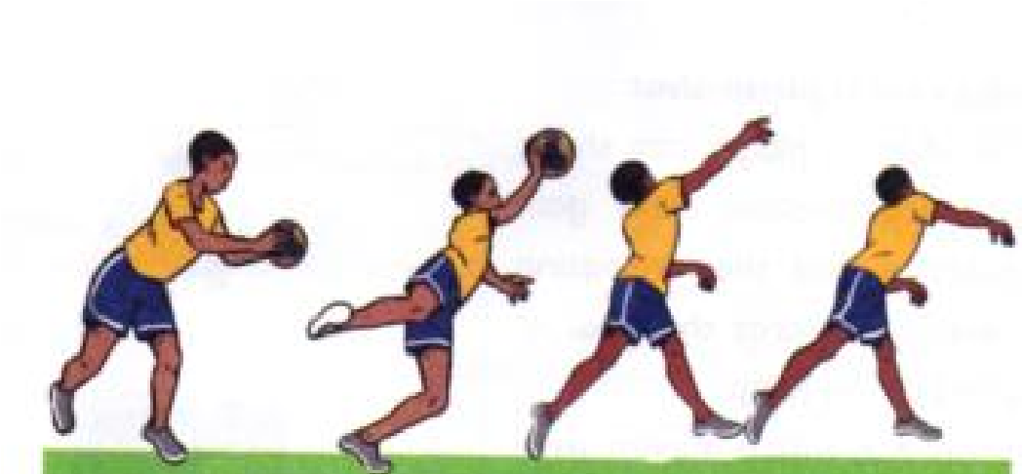

Learning points for falling shot
- Take a position outside the 6m line facing the goal.
- With the feet firm on the floor outside the goal area, fall towards the goal area .
- Release the ball before contacting the goal area with the hands or any other part of the .body

Learning points for lob shot
- Take a position outside the 6m line
- Face the goalkeeper who may have moved closer to you in defense ➢ Throw the ball in a curved path over the goalkeeper ➢ Flick the wrist to give the ball direction and accuracy.
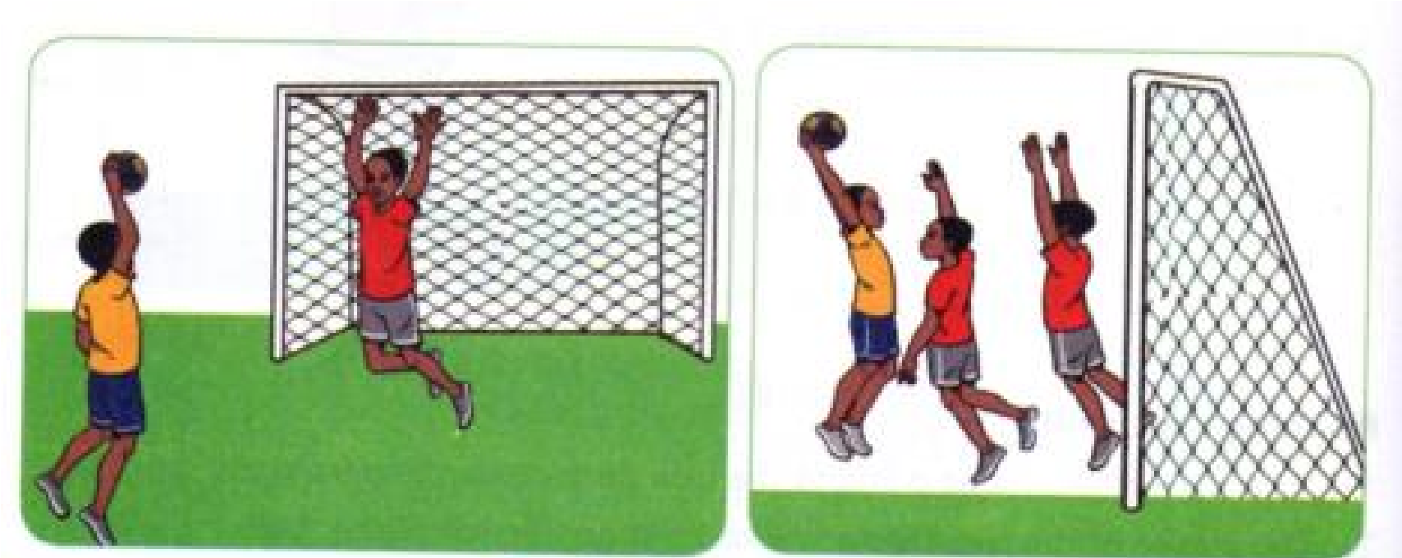

Drills for shooting in handball

Drill 1: Step and shoot
- In groups of five make a line facing the goal with the leader at the free throw line
- The leader makes a pass to the first player in the line
- The player makes 3 steps and then a jump shot
- After making a jump shot the player joins the line from the back
- Repeat the activity3 times then change to practice a running shot

Drill 2: Drill and shoot
- In a group of four players, make a line at the substitution zone facing the goal where you intend to shoot
- Use a high dribble to move towards the goal area
- On reaching the free throw line, catch the ball and make a jump shot
- Retrieve the ball and run along the goal line to the corner and then along the sideline to join your teammates
- After three attempts change and practice a running shot

Drill 3: Corner drill
- In a group of five, make a line at the corner of the court
- The leader to stand at a point within the court
- The first player in the line to run along the goal area line
- When at a comfortable position, catch the ball from the group leader and make a dive short.
Pupils activities Pg. 35.

CREATING AND PERFORMING IN CREATIVE ARTS AND SPORTS WESTERN SOLO INSTRUMENT
Western Solo Instruments
Activity 1: Tuning the Descant Recorder or Any Other Solo Western Instrument • Study the following instruments and answer the questions that follow.
- What can you see?
- With the guidance of your teacher and resource persons, watch a live or recorded solo instrumental performance.
- In groups, discuss the importance of tuning a solo Western instrument in preparation for a performance.
- Watch videos demonstrating techniques of tuning various Western instruments and apply them to your chosen instrument.

Activity 2: Playing the Scale Of C Major On Staff
What I need to know
- Western instruments have different fingering charts to guide in playing of different pitches.
- Use digital devices to download the fingering charts for the instrument of choice.
- Below is the fingering chart for the Descant Recorder showing the notes of the scale of C major.

Descant Recorder Fingering Chart

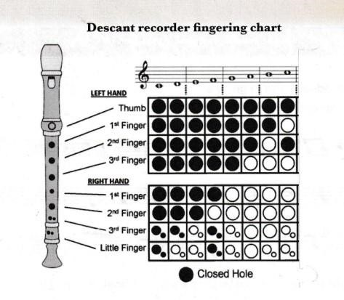

Individual Activity
- Practise playing the notes of the scale of C major ascending and descending on your instrument using the fingering chart.
- On a digital device, watch videos to learn how to play the scale of C major.
- Use the fingering provided to the play the notes C D EF G A B C' on the descant recorder.
- Practise playing the scale in ascending and descending order.

Group Activity
• Play familiar tunes in the scale of C major on your instrument.

Activity 3: Sight Reading Simple Melodies in C Major To do individually and in groups.
- Look at the clef below.
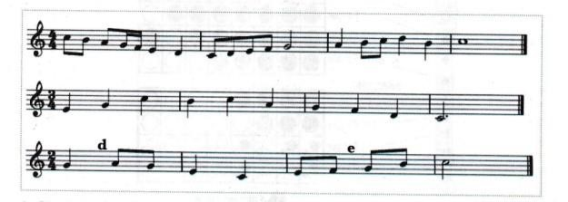
- Check the key signature and keep the key in your head while playing
- Look at the time signature.
- Clap or tap the rhythms of each of the melodies before you play them.
- Locate the notes on the instrument.
- Look at the melodies and play.

- Sight-reading is playing of music without prior preparation.
- Your teacher will provide 2-bar melodies for you to sight-read.
- Do so without referring to the fingering chart or tapping the rhythms before playing.

Activity 4: Playing with Appropriate Techniques
- Every instrument has specific techniques to be applied while playing. For example, for strings there is bowing, plucking, strumming, fingering; and for wind, there is tonguing, blowing and fingering.
- All the techniques when well applied ensure good tone quality.

How To Produce a Good Tone on The Descant Recorder
- Blow gently into the descant recorder as you make the sound ‘du’ with the tongue. This is referred to as tonguing and it helps to produce a clear sound.
- Do not blow too hard into the recorder because it will make a high pitch sound.
- If you are having trouble producing a sound after lots of practice, clean your recorder.
Cover the air hole below the mouthpiece and blow in hard.
Activity 5: Observing Performance Directions
What I Need to Know
- Performance directions are words, phrases or signs showing the appropriate tempo, dynamics, articulation and repeats in a piece of music.
- The directions help to enhance the overall effect in a performance.
- With your teacher’s guidance, play various melodies observing the performance directions shown.
- Your teacher will also help you search for short duets in C major to be played in pairs and groups.

Creating and Performing in Creative Arts and Sports
Football

