COMPETENCE BASED CURRICULUM

JUNIOR SCHOOL

FORMATIVE ASSESSMENT

TERM ONE 2024

GRADE 7

Name……………………………….…………………………………………

Centre ………………………………………….......................................

Assessment No. …………………………… Stream……………………

Learner’s Sign………………………..… Date: ………………………..

**PRETECHNICAL STUDIES**

FOR EXAMINERS

ASSESSMENT RUBRICS (for official use)

|  |  |  |  |  |
| --- | --- | --- | --- | --- |
| %SCORE RANGE | Below 40 | 40-59 | 60-79 | 80-100 |
| PERFORMANCE LEVEL | Below expectation | Approaching expectations | Meeting expectations | Exceeding expectations |
|  | 1 | 2 | 3 | 4 |

#### State three components of pretechnical studies.

1. ………………………………………………………
2. ………………………………………………………
3. ………………………………………………………

#### State three roles of pretechnical studies in day today life.

1. ………………………………………………………………………………………………………………
2. ………………………………………………………………………………………………………………
3. ………………………………………………………………………………………………………………

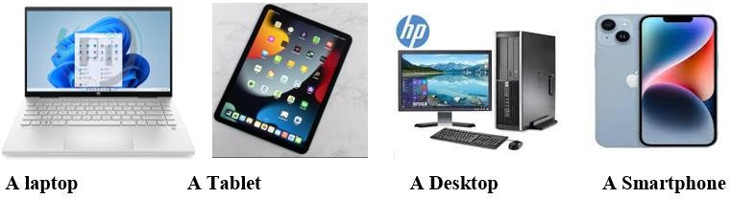

##### Name the parts of the computer shown below. (5 mks)

##### State three examples of safety measures. (3 mks)

1. ……………………………………………………………………………
2. ……………………………………………………………………………
3. ……………………………………………………………………………

#### Identify four Physical threats at workplaces.(4 mks)

1. ………………………………………………………………….
2. …………………………………………………………………..
3. ………………………………………………………………….
4. …………………………………………………………………

##### Name at least four examples of online threats at work place. (4 mks)

1. …………………………………………………..
2. ……………………………………………………
3. ……………………………………………………..
4. ……………………………………………………..
5. State four Ways of mitigating/reducing physical threats to digital devices.(4 mks)
6. ……………………………………………………………………………
7. ……………………………………………………………………………
8. …………………………………………………………………………….
9. …………………………………………………………………………….

#### State three ideas and practices on how to personal and sensitive data from the public when online. (3 mks)

* 1. …………………………………………………………………….
  2. …………………………………………………………………….
  3. ……………………………………………………………………..

#### Identify five Safety Rules and Regulations at Work.(5 mks)

* 1. ………………………………………………………………………
  2. ………………………………………………………………………
  3. ………………………………………………………………………
  4. ……………………………………………………………………….
  5. ………………………………………………………………………..

1. 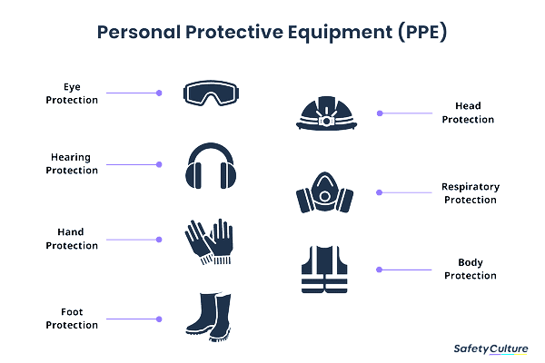Name the following safety wears. (7 mks)

#### Give three examples of Data. (3 mks)

* 1. ………………………………………………………………
  2. ……………………………………………………………..
  3. ……………………………………………………………...

#### List five examples of computers used today.(5 mks)

1. …………………………………………………………………………..
2. ………………………………………………………………………….
3. …………………………………………………………………………
4. ……………………………………………………………………………
5. …………………………………………………………………………..
6. State and explain three characteristics of computers. (6 mks)
7. ………………………………………………………………………….....
8. …………………………………………………………………………….
9. ……………………………………………………………………………
10. We can classify computer by looking at the following: name three. (3 mks)
11. ……………………………………………………
12. ……………………………………………………..
13. ………………………………………………………
14. Name the following digital computers. (4 mks)
15. State two characteristics of 1st generation computers. (2mks)
16. ……………………………………………………………………………..
17. ……………………………………………………………………………..
18. List any two computer hardware components. (2mks)
19. ………………………………………………..
20. ………………………………………………..
21.  Identify the right posture from the above illustration when using a computer. (2mks)

1. Write one factor to consider when selecting appropriate hardware components. (1mk)
2. ……………………………………………………………………………