

COMPETENCE BASED CURRICULUM

JUNIOR SCHOOL

FORMATIVE ASSESSMENT

TERM ONE 2024

GRADE 7

Name……………………………….…………………………………………

Centre ………………………………………….......................................

Assessment No. …………………………… Stream……………………

Learner’s Sign………………………..… Date: ………………………..

**PRETECHNICAL STUDIES**

FOR EXAMINERS

ASSESSMENT RUBRICS (for official use)

|  |  |  |  |  |
| --- | --- | --- | --- | --- |
| %SCORE RANGE | Below 40 | 40-59 | 60-79 | 80-100 |
| PERFORMANCE LEVEL | Below expectation | Approaching expectations | Meeting expectations | Exceeding expectations |
|  | 1 | 2 | 3 | 4 |

1. CPU has 3 components, list them. (3mks)
2. ……………………………………………..……………………
3. …………………………………………………………………..
4. …………………………………………………………………..
5. Write in full. (3mks)

a.) ALU …………………………….…………………….…………………………

b.) USB…………………………….………………………………………………..

c.) HDMI ……………………………………………………………………………

1. State two problems experienced when setting up computers. (2mks)
2. ……………………………………………………………………………..
3. ……………………………………………………………………………..
4. Give the names of the following cables used with computes. (3mks)



1. List down three causes of Repetitive Strain Injury (RSI) (3mks)
2. …………………………………………………………………………….
3. …………………………………………………………………………….
4. ……………………………………………………………………………
5. State three physical threats to computers. (3mks)
6. ………………………………………………………………………………
7. ………………………………………………………………………………
8. ……………………………………………………………………………..
9. State three Function of a computer. (3 mks)
10. …………………………………………………………………………….
11. …………………………………………………………………………….
12. ……………………………………………………………………………
13. Complete the following Stages of computer processing cycle

**STORAGE**

**PROCESSING**

1. Name the following parts of a Model of a computer. (3 mks)

Description: C:\Program Files (x86)\Microsoft Office\MEDIA\CAGCAT10\j0285750.wmf

1. State four Advantages of using a computer. (4 mks)
2. ………………………………………………………………………………
3. ………………………………………………………………………………
4. ……………………………………………………………………………….
5. ……………………………………………………………………………….

#### Outline three Importance of communication in the work environment.(3 mks)

* 1. ……………………………………………………………………….
  2. ……………………………………………………………………….
  3. ……………………………………………………………………….

1. Name four ICT Tools used in Communication.(4 mks)
2. …………….…………………………………….
3. ………………………………………………….
4. ………………………………………………….
5. …………………………………………………
6. Name the types of artistic drawing illustrated below. (4 mks)



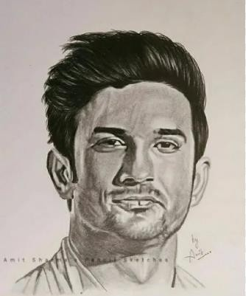

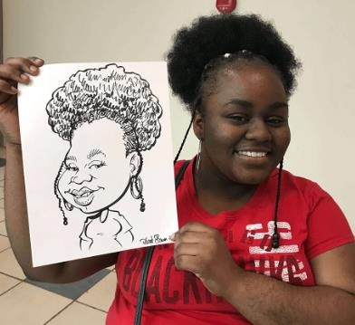

1. Name three examples of technical drawings:
   1. ……………………………………………………
   2. ……………………………………………………
   3. …………………………………………………….
2. Name the types of Lines used in drawing. (4 mks)

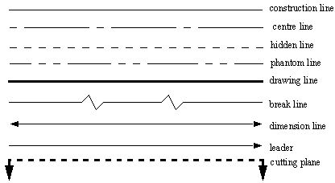

1. State the following basic abbreviations used in drawing in full.(5 mks)
   1. DRG -……………………………………………………………………..
   2. A/F – …………………………………….………………………………..
   3. A/C – ………………………………..…………………………………….
   4. I/D – ……………………………………………………………………….
   5. O/D – ………………………………………………………………………
2. State four factors of production.(4 mks)
3. ………………………………………………
4. ………………………………………………
5. ……………………………………………….
6. ………………………………………………
7. State three characteristics of economic resources used for production of goods and services.(3 mks)
   1. ………………………………………………………………………
   2. ……………………………………………………………………..
   3. ……………………………………………………………………

##### Name three examples of metals. (3 mks)

* + 1. ……………………………..
    2. …………………………….
    3. ………………………………

1. Identify the metal used to make the following material.(5 mks)

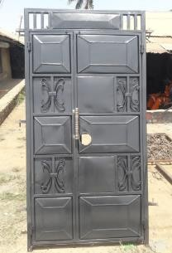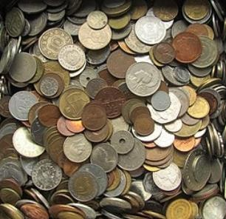

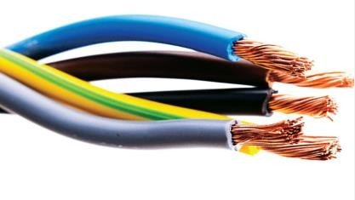

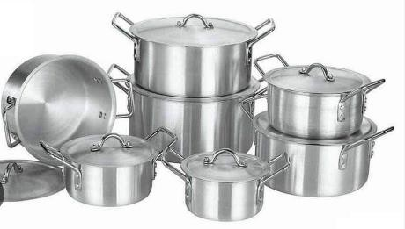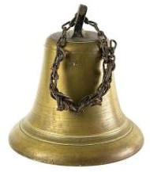

copper

1. Give three examples of non-metallic materials.(3 mks)
   * + 1. ………………………………………
       2. ……………………………………..
       3. ……………………………………..