

COMPETENCE BASED CURRICULUM

JUNIOR SCHOOL

FORMATIVE ASSESSMENT

TERM ONE 2024

GRADE 7

Name……………………………….…………………………………………

Centre ………………………………………….......................................

Assessment No. …………………………… Stream……………………

Learner’s Sign………………………..… Date: ………………………..

**PRETECHNICAL STUDIES**

1. CPU has 3 components, list them. (3mks)
2. Arithmetic and logic unit (ALU),
3. A control unit, and
4. Various registers.
5. Write in full. (3mks)

a.) ALU

The full form of ALU is arithmetic logic unit. It is a combinational digital circuit that performs arithmetic operations on binary numbers.

b.) USB

USB, in full universal serial bus, technology used to connect computers with peripheral devices

c.) HDMI

The full form of HDMI is the High Definition Multimedia Interface. It is an all-digital audio-video interface that transmits information to a computer monitor, video projector, digital television and so on, in uncompressed mode.

1. State two problems experienced when setting up computers. (2mks)
2. The Computer Won't Start.
3. A computer that suddenly shuts off or has difficulty starting up
4. Have a failing power supply.
5. The Screen is Blank.
6. Abnormally Functioning Operating System or Software.
7. Windows Won't Boot.
8. The Screen is frozen.
9. Computer is Slow.
10. Strange Noises.
11. Slow Internet.
12. Forgotten passwords

1. Give the names of the following cables used with computes. (3mks)



ETHERNET VGA AUX

1. List down three causes of Repetitive Strain Injury (RSI) (3mks)
2. Repetitive strain injury (RSI) is caused by repeated use of a body part, such as your shoulder, elbow, forearm, wrist or hand.
3. Some examples of activities that can cause RSI are computer use, carpentry, material handling, or even recreational activities
4. State three physical threats to computers. (3mks)
5. Virus.
6. Trojans.
7. Worms.
8. Spyware.
9. Key loggers.
10. Adware.
11. Denial of Service Attacks.
12. Distributed Denial of Service Attacks
13. State three Function of a computer. (3 mks)
14. Stores data and information
15. Process data into information using given instructions
16. Accepts data from the user
17. A computer gives out information to the user
18. Complete the following Stages of computer processing cycle

**STORAGE**

**PROCESSING**

**OUTPUT/INFORMATION**

**INPUT/DATA**

1. Name the following parts of a Model of a computer. (3 mks)

Description: C:\Program Files (x86)\Microsoft Office\MEDIA\CAGCAT10\j0285750.wmf

**C.P.U**

**Monitor**

**Speaker**

1. State four Advantages of using a computer. (4 mks)
2. Computer process data faster than human beings
3. Computers keep data and information secure
4. Computers can store a lot of data in a small physical space
5. Computer can do the same repeatedly without getting tires or bored
6. Computer are able to perform different types of jobs at the same time
7. A computer is reliable because it consistently does what it is supposed to do.
8. Computers have a very big storage capacity and can store data and information for a very long time

#### Outline three Importance of communication in the work environment.(3 mks)

* 1. Good communication ensures making decision is easier.
  2. Communication helps to build positive relationships, teamwork and trust at workplaces.
  3. Good communication helps to achieve greater goals.
  4. Communication enables managers’ shares goals with shareholders both inside and outside the organisation. It gives managers permission to stimulate behaviour changes in employees and suppliers and to inspire loyalty from the employees and customers.
  5. It allows managers to convince employees and unions to abandon counterproductive practices, managers persuade leaders to provide financing and it permits managers to calm angry customers and impress new ones.
  6. Preventing misunderstanding and conflicts.
  7. Improving customer services.
  8. Meeting goals and earning success.
  9. Promoting creativity and innovation.
  10. Advancing individual career prospects.

1. Name four ICT Tools used in Communication.(4 mks)
2. Emails-used to exchange information over the internet to other individuals.
3. Mobile phones- allows calling and messaging in communication.
4. Computers -computer provide various communication channels such as emailing, video calling etc.
5. Videos and web conferencing- Video conferencing has a focus on face-to-face communication. Web conferencing has a focus on interaction and collaboration such as document sharing.
6. Social networking - use of dedicated websites and applications to interact with other users.
7. Online collaboration - using the internet and online tools to collaborate.
8. Softwares like word processor are used to design letters and memos that are used to pass information in business.
9. Social media is used to give immediate response to customer needs.
10. Name the types of artistic drawing illustrated below. (4 mks)



Illustrations

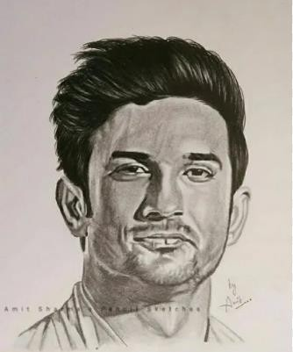

Portrait

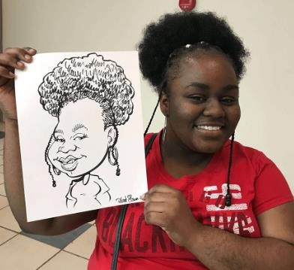

Caricature

Graffiti

1. Name three Examples of technical drawings:
   1. Architectural
   2. Mechanical systems drawings.
   3. Electrical drawings,
2. Name the Types of Lines used in drawing. (4 mks)

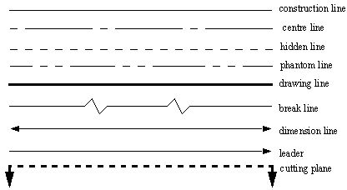

1. State the following basic abbreviations used in drawing in full.(5 mks)
   1. DRG -means drawing.
   2. A/F – means across flat.
   3. A/C – means across corners.
   4. I/D – means inner diameter.
   5. O/D – means outer diameter.
2. State four factors of production.(4 mks)
3. Land.
4. Labour.
5. Capital.
6. Entrepreneurship.
7. State three characteristics of economic resources used for production of goods and services.(3 mks)
   1. Uneven distribution-economic resources are not found in all places.
   2. Scarcity- these resources are not enough to satisfy all human wants.
   3. Economic resources have alternative uses.
   4. Usefulness-Economic resources have utility and they are useful.
   5. Mobility-They can be transported from one place to another.
   6. Combinability-Economic resources can be combined to produce different goods and services.
   7. Monetary Value-Economic resources are measured in terms of money. Therefore, they have monetary value.
   8. They can change ownership.

##### Name three examples of metals. (3 mks)

* + 1. Copper.
    2. Iron.
    3. Aluminium.
    4. Steel.
    5. Silver among others.

1. Identify the metal used to make the following material.(5 mks)

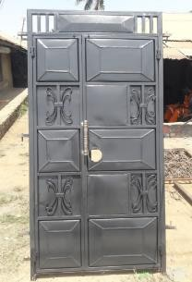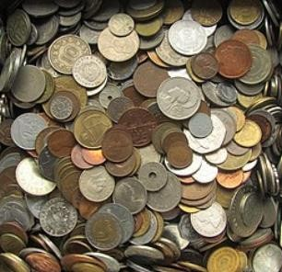

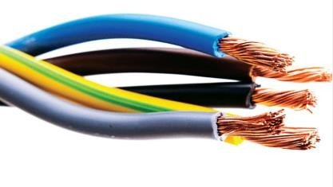

Iron or steel

Silver or copper

Copper

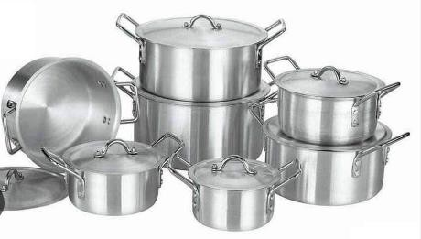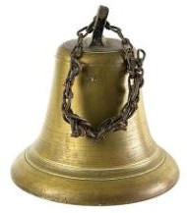

copper

Bronze

Aluminum

1. Give three examples of non-metallic materials.(3 mks)
   * + 1. Wood.
       2. Stones.
       3. Textile.
       4. Soil.
       5. Glass.
       6. Leather.
       7. Plastic.
       8. Rubber.
       9. Water.
       10. Air among others