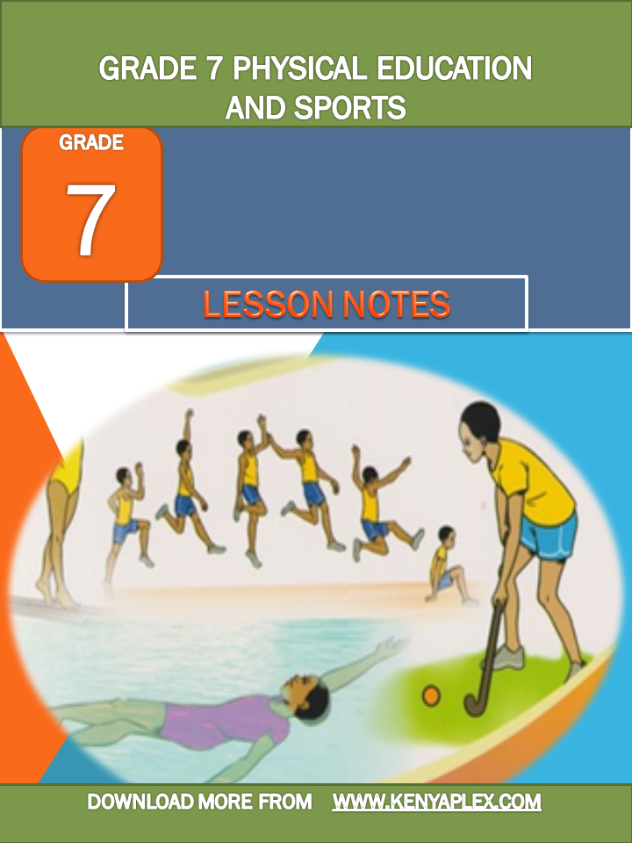

GRADE 7 PHYSICAL EDUCATION AND SPORTS LESSON NOTES
STRAND 1.0 GAMES
Netball is a team sport where the ball is played using hands. During the play the player runs to dodge an opponent or reach the ball, he / she may also jump to catch high ball or a rebound from the ring.
Chest pass in netball
This is a way of throwing the ball to team mate where the ball is released and received at the chest level. The pass is usually used when the teammates are not far from each other.
Making a chest pass
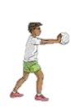

- Grip
- Put your fingers on each side of the ball with your thumb behind the ball and your fingers spread in “W” formation.
- The ball should be at the chest level.
- Your elbow should be pointing out wards.
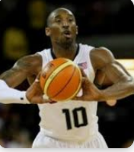

- Stance
- Stand with your feet comfortably should- width apart facing the target.

- Execution of the pass
- Extend the arms fully towards the direction of the pass
- Flick the wrist and the finger as you release the ball
- Step in the direction of the pass for a follow through
- Complete the action with the palm facing outwards and fingers spread.
Pupil’s activities Pg. 3.
DRILL: Line and pass
- Resources needed
- An open area
- Age- appropriate netball or improvised ball
- Field markers or chalk.

Making line and pass drill
- Make a line behind one another facing the team leader at a point 5m away from the learners passing the ball.
- The leading learner passes the ball to the leader and joins the line from the back.
- The team leader passes the ball to the next waiting the learner using the chest pass.
- Repeat until every leaner gets a chance to perform a chest pass.
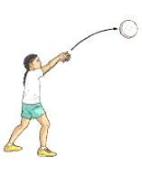

Execution of Pass.

Note: communicate with your peers when performing the task to enhance learning of English, Kiswahili or indigenous languages.

Line and pass drill

Chest pass in motion
- In pairs stand 3m apart facing the goal
- Pass the ball to your teammate using a chest pass
- After passing the ball to your teammate, jog to the point ahead to receive the ball
- Repeat the activity until you reach the goal end of the court .

DODGING AND MARKING IN NETBALL
Dodging – is a technique use to counter the marking attempt.
- It is applied by members of the team in control of the ball.
- The player being marked makes attempt to get free from the marker and move into space to receive pass. It may involve changing pace and use of deceptive body action to put the marking player of balance.

Marking
This is a technique used by the team that is not in possession of the ball to prevent an opponent from receiving a pass.
This intention is to obstruct passes made by the team in control of the ball. A player can mark an opponent in possession of the all or an opponent without ball.

Body movement when marking an opponent
- Standing in front of the player being marked.
- Standing beside the player being marked.
- Raising hands up or to the side to reach the path of the ball.
- The hands should be on the side of the body.
- React quickly when the opponent being marked.
- Make any movement, move in the same direction using short steps, and shuffle sideways without crossing the feet.
- Focus on both the ball and player being marked.
Marking a player with the ball.
- Take a position in front of the opponent 0.9m apart
- Establish a basic stance with feet not more than should –width apart
- Keep the body upright and eyes on the ball
- Hands should be straight up and moving with the position of the ball.
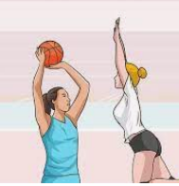

b. marking a player without a ball
- Stand close to you opponent.
- Establish a basic stance with feet not more than shoulder- width apart
- Knees should be slightly bend and body weight on the balls of the feet for better response and ease in change of direction.
- Keep eyes focused on the player with the ball.
- Anticipate the movement of your opponent and move appropriately.
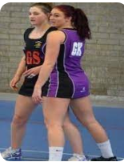

- Making in space
Sometimes the ball is passed in space and not directly to the player.
Body movement to use when dodging an opponent
- Using bending or leaning movement with the body trunk to left or right or left
- Sprinting off from the marker
- Sprinting and stopping
- Extending the left or right arms away from the opponent

Ways of dodging used in netball game

- Changing the speed
- Remain still and move at the same speed with our marker
- Suddenly sprint or slow down at once to displace your marker
- Receive the ball and land in readiness to attach
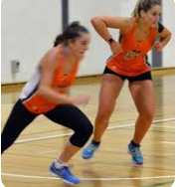

- Single feign
Feign is a situation when one pretends to be affected by feeling in a netball game. It mainly happens when attacking an opponent with a ball in a netball court.
- Establish a basic dodging stance in front of you marker with the feet not more than shoulder- width apart and knees slightly bent and weight on the balls of the feet.
- Pretend to move to the left and then move to the right to receive the ball.

- Double feign
- Stand in front of the marker
- Establish basic dodging stance with feet not more that should –width apart, knees slightly bent and weight on the balls of the feet.
- Pretend to move to the left then right and finally move to the left to receive the ball.

Sprint into a space
- Remain close to your marker
- Stand with feet shoulder – width apart, knees slightly bent and weight on the balls of the feet.
- Make an unexpected sprint into space and receive the ball.

Drills in marking
Mirror drill
- in mirror drill dodging and marking technique the defender stands a slight distance in front of the attacker, there defender therefore respond to the movement made by attacker.
- If the attacker moves to the right, the defender mirrors the same movement and moves to the right.
Four sphere drill
- Here five players draw four spheres in a rectangular formation and another circle at the Centre.
- The four circles are then numbered 1,2,3,4
- The player practicing the marking starts at the Centre of the circle.
- When the teachers call out the sphere number, the player at the Centre moves quickly to that sphere to mark and then move back to the Centre sphere.

Four sphere variation drill
- player take position 1,2,3,4
- the pass is from player 1 to player 1
- After a pass is made the player at the Centre sprint to mark the player receiving the ball then moves back to the Centre.
- Repeat the drill as the ball is passed around the circle.
- Keep substituting the Centre player to give others an opportunity to practices
- After marking, the learner goes back to the Centre circle. This is repeated until all learners get a chance to practice marking.

W

Drills for dodging
- The dodging triad
- Place three cones to form an isosceles triangle with a height of 5m and a base of 4m.
- Two of you stand at the centre of the baseline and behind one behind the other. The learner with the ball stands at the furthest tip of the triangle.
- The leading learner at the base acts as the defender while the trailing learner acts as the attacker.
- The trailing learner performs a single feint to the left and dashes to receive the ball at the right edge of the triangular formation.
- The trailing learner performs a double feint to receive the ball at the right edge of the triangular formation.
- The trailing learner sprints to the center of the formation and receives the ball
- Learners keep changing roles until they all practice the single feint, double feign and sprint dodge.
Activity 5 page. 10

Footwork in netball
There are two landing techniques in netball
- Double foot landing
- Single foot landing

- Making Double foot landing
- Start with a short run and take – off. Make a short run and spring off the floor with both feet into a jump.
- When making a double foot landing a player should :
  - Maintain an upright posture and keep the arms out for balance
  - Land with the feet shoulder- width apart and body weight equally distributed on both feet for balance
  - Land with knees slightly bent and knees, hips and ankles to cushion the landing impact.
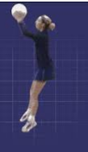
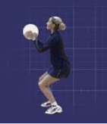

- Making single foot landing
- Take-off to make the body airborne. Make a short run and spring off the floor with one foot in to a jump
- If you take off on the right; land on your left foot.
- If you take off on the left; land on your right foot.
- Contact the floor with the balls of the foot first, with the knees, ankles and hips slightly bent.
- Place the other foot on the ground quickly to absorb the impact and help with balance
- Maintain a low body position for stability and safety.
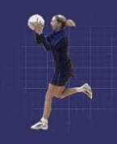

- Pivoting
Pivoting – is the act of turning with one foot on the ground while the other foot makes repeated short steps.
Pivoting;
- Helps the player develop balance after landing
- Helps the player turn away from the defender who may be marking
- Helps in locating teammates who may be well – positioned to receive the pass.
Drill 1; the beeline
Use an open safe playing area to perform the drill. Carry out the activity without using a ball.
- Form groups of five and stand in a line behind one another.
- Ensure you are well spaced in the line
- The leading learner in the line to take off from both feet and land on both
- Other learners to follow the leaders performing a double foot take- off and a double foot landing
Drill 2; the beeline with the ball
- Form groups of five stand in a line behind one another
- Ensure you are well spaced in the line
- Let the leader of the group and the leading learner in the line to make a short run, the ball up, jump, catch the ball and make a double foot landing.
- Other learners to follow and imitate the leaders` actions.
Drill 3; the sickle
- Form group of five members to adapt sickle formation and their leader to take a position in front and at the Centre of the sickle.
- The leader passes the ball to teammates in the arc.
- The teammates to catch the ball and make a single foot landing
Drill 4; the Y drill
- Learners to adapt a Y formation
- The leader of the group to be at the Centre of the Y formation and in possession of the ball
- The leading learner in the line sprints to right or to the left to receive the ball from the leader, make a single foot landing and then pivot.

Handball
Passes and reception in handball
Passing – is delivering the ball to a team mate during play in a handball game.
Passing the ball helps in;
- Speeding up the game
- Creating scoring chances
- Breaking tight defense
- Releasing pressure during play
- Expressing creative abilities during play
Qualities of a good pass
- Accurate so that a player has no problem catching the ball.
- Fast and timely to exploit the play chance promptly.
- Useful – a pass should be directed to that player whose position may disadvantage the opponent.

Types of passes
There are three types of passes, namely;
- Jump pass
- Side pass
- Flick pass

- Jump pass
A jump pass is where a player leaps in to the air and throws the ball to a teammate before landing.
It is completed at the peak of the jump with a player in control releasing the ball to the teammate
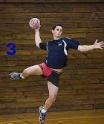

Stages of execution in jump pass
- Preparation
- Take off from the ground either on a single or double foot.
- Bring the passing arm high and back above the level of the head
- Bring the non- passing arm slightly in front of your body
- Keep shoulders high and head up
- Execution
- As you bring the passing arm forward to release the ball, pull the non-passing arm backwards at hip level.
- Release the ball to your teammate with a follow through and wrist action.
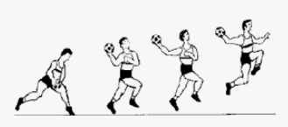

- Side pass
A side pass is also known as wrist passes and is the most common way of passing the ball across the width of the court. This movement is called ball circulation.
Stages of execution in side pass
- Preparation
- Stand with feet slightly closer together than shoulder-width apart from the target ,the receiver should be on your right or left side
- Hold the ball on the passing hand with palm facing down
- If the pass is to be made at the right side, hold the ball with the right hand , if the pass is to be made on the left side, hold the ball with the left hand
- Execution
- swing the passing arm across the body from left to right when passing towards the right direction
- release the ball with full extension of the arm with a wrist action
- step sideways towards the direction of the pass for a follow- through
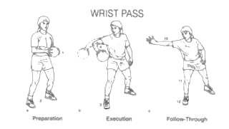

- Flick pass
A flick pass is an action made using the passing arm which quickly propels the ball forward. The release action of the ball is terminated with a forward wrist action.
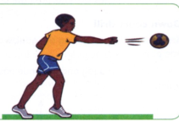

Stages of execution
- Preparation
- Take a staggered stance with the leg of the non- passing arm leading.
- Hold the ball with one hand in an open palm, fingers well spread behind it at shoulder level
- The non-passing arm should be extended outwards for balance
- Eyes should be focused on the target
- Execution
- Step with trailing foot forward
- Push the ball forward towards the receiver
- Release the ball by flexing the wrist and the fingers forward for a follow- through. This generates power to propel the ball and give it directions.
Reception
Reception – is the act of receiving the ball with one or both hands. The catch may vary from high level to medium or low level.
Points for reception of the ball
- Preparation
- Stand on the balls of your feet shoulder-width apart facing the direction of the ball.
- Extend your hands towards the ball
- Move forward to meet the oncoming ball
- Keep your arms pointed towards the ball
- Your hands should form a tunnel shape of a W formation ready to receive the ball.
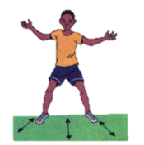

Preparation to catch

- Termination
- On contact with the ball, wrap the fingers around it and bend the elbows bring the ball towards the chest.
- Ensure the thumbs are behind the ball and get in to a ready position for your next action.
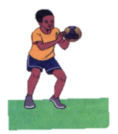
Low catch high catch

Drills in hand balls
Drill 1: jump passing
In pairs, stand apart. Take three steps toward your partner and then take off
Pass the ball using a jump pass and walk back to your siting position
Your partner also takes three steps and then passes te ball back to you using a jump pass.
Drill 2. Flick pass
In groups of four, stand in a square formation, ass the ball around the square using flick.
Drill 3: two line drill
- Player to form two lines
- The leaders pass the ball using a flick pass
- After making the pass, the leader joins the line from behind
- Ensure everyone get a chance to pass the ball
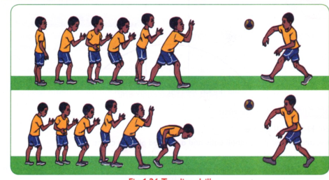

Side pass drills
Drill 1: side passing
In pairs, stand 3m apart side by side. Pass the ball to one another using a wrist pass
Drill 2: pass curve
- In groups of four, stand three meters apart in a semi-circle
- The player with the ball to be at the extreme end
- Pass the ball from right to left without skipping any player
- When the ball reaches the end, pass the ball back to the left

Drill 3: down court drill
- In pairs, stand 3 m apart facing the goal, walk down the court passing the ball using the side pass.
- Change the pace to a jog and continue passing the ball each other up and down the court
Pupils’ activity Pg. 22

Footwork in handball
Principles of good landing
- Landing on the balls of the feet
- Knees should be slightly bent to cushion the shock on the impact of landing
- This is also referred to as knee- deep landing.
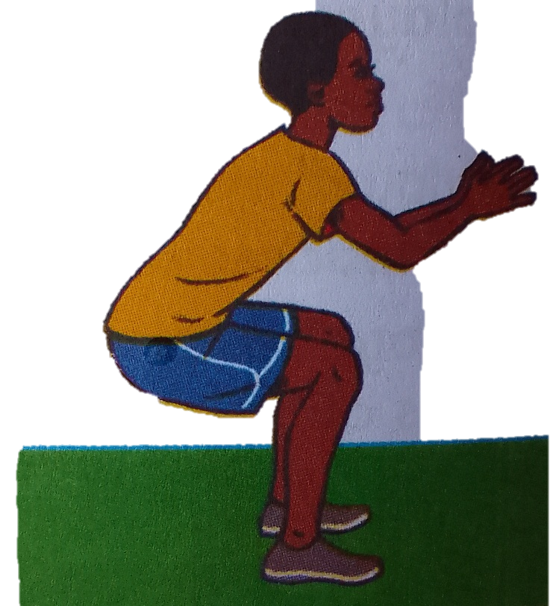

Landing
Stepping progression skills in handball
Drill 1: individually jump, catch a ball and land on one foot.
Drill 2: in pairs, stand 3m apart facing each other, jump, and catch a ball and land on both feet
Drill 3: a) the players are in circular formation passing and catching the ball
b) Catch the ball from a side pass land on both feet and take three steps and then pass it to the next player using a side pass.
Drill 4: a) the players are in a triangular formation passing and catching the ball
b) Catch the ball from a flick pass and land on both feet, take three steps and then pass the ball using a flick pass.
Drill 5:a) in a group six form a line formation
b) Practice catching the ball and landing on both feet. Use a jump pass while passing.
Dodging and marking in handball
Dodging
When dodging, a player may use body actions that mislead the defending player. It enables the attacking player to go past the defender and score goals with ease.
Marking
Marking is a defensive action that limits the chances of attacking players gaining possession of the ball.
Qualities of a good player
- Observant – the marking player needs to pay attention to the attackers who are likely to gain possession of the ball and drive forward
- Good positioning – ability to position himself or herself appropriately between the attacking player and their defending goal
- Quick time reaction – this helps the marking player respond to unexpected tactical actions by the attacking players.
- Resilience and persistence – the marking player should never give up on playing a defensive role.
- Communication – good marking is a product of communicating with teammates to develop a suitable plan or approach to counter the playing actions of the attacking teams
- Courageous – a good marker should be courageous to withstand non-avoidable contacts that may occur during one on one tackling situations
- Peripheral vision – a player who is marking needs to see what is happening around him or her and not just focuses on the player being marked alone.
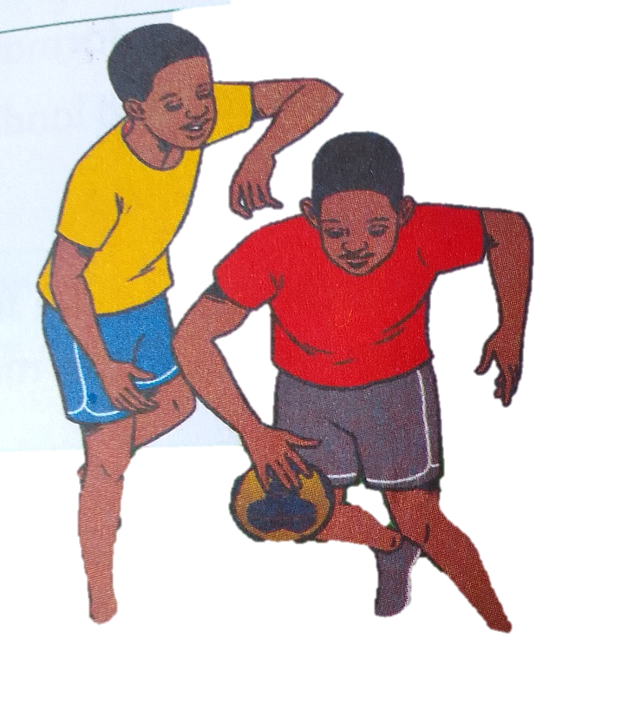

Body feign in handball
Body feigns are performed by using the trunk legs. They involve a shift of balance and weight. This can be done with or without the ball.
Body feigns are used to free the player from an opponent and get a better position for receiving or passing the ball.
Types of dodging technics include:
- Single feign dodge
- Double feign dodge
Single feign dodge
- In group of five players, form two lines facing one another 5m apart
- Players approach each other
- In closing to one another, each of them performs a single feign to the opposite side.
Leaning point for double feign dodge
- Take a position at least 5m in front of an opponent
- Make a short run and break it with a double foot landing referred to as a zero step
- Lean towards either the right or left and repeat the feigning.
- Complete the original intended love.
Drill 1: Pair feign dodge
- In pairs without the ball, stand facing each other
- One of you to practice the double feign dodge
- Repeat three times and switch roles
Drill 2: Quinque drill
- In groups of five, place a cone in the court and make a line facing the cone
- Sprint to the cone and stop on zero steps, feign to the right, then left and then move to the right to receive the ball.
Dribbling in handball
Dribbling – it is a technique in handball where the player bounces the ball on the ground once or repeatedly.
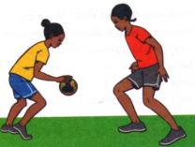

Types of handball dribbling
- High dribble
- Low dribble
Demonstrating low dribble
- Stand with the feet shoulder-width apart
- The knees should be slightly bent and body weight on the balls of the feet
- Push the ball downwards using the wrist and the fingers for better control
- The arm of the non- dribbling hand should be extended outwards from the body for balance
- Use a pump like action to bounce the ball repeatedly with the enough force so that it bounces slightly above knee level. This constitutes a low level.
- Control the ball by flexing the wrist and the fingers
- Bounce the ball below knee level for a low dribble
- Keep the head up and avoid looking at the ball
Learning points for high dribble
- Stand with the feet shoulder- width apart
- Keep erect with a slight lean forward and body weight on the balls of the feet
- Push the ball downwards using the wrist and the fingers for better control
- The arm of the non-dribbling hand should be extended outwards from the body for balance
- Use a pump like action to bounce the ball repeatedly with enough force so that it bounces slightly above knee level for a high. This constitutes a high dribble.
- Keep the head up and avoid looking at the ball.
Drills of dribbling in handball
Drill 1: Step and dribble
- Take three steps, make one dribble and take three more steps.
- Increase the number of dribbles between three- step sections
- At the end of the sequence, make a shot or a pass
Drill 2: Walking drill
- Walk across the court with a ball five times making a high dribble
- Repeat the drill using a low dribble
Drill 3: The cone drill
- Place seven cones in a line 1.5m apart
- In groups of five, practice zigzag movement pattern in and out of the cones one at a time
- Start with a low dribble and later a high dribble
- As you perfect the dribble, make more challenging by shortening the distance between the cones
Drill 4:The court drill
- Individually dribble a ball along a court marking using high and low dribbles. Use a movement pattern of three high dribble and three low dribbles.

SHOOTING IN HANDBALL
Shooting – it involves throwing the ball in to the opponent’s goal to make a score.
Safety measures to be observed when performing shooting in handball
- Never aim to hit or injure the goalkeeper with the ball.
- Take turn and shoot one player at a time
- Warm up adequately before starting the shooting activity
- Adhere to the instructions given by the instructor
- Be conscious of the nature of the floor or the ground while making a falling or a dive shot
- .
- .
- .

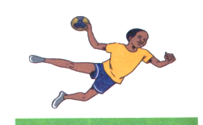

Types of shots in handball include:
- Jump shot
- Dive shot
- Running shot
- Falling shot
- Lob shot
Demonstrating jump shot
A jump shot is where a player can shoot from a stationary position and gain horizontal distance and the releasing powerfully towards the goal at the highest point of the jump.
- Make a shot run with a maximum of three steps while gripping the ball
- Make a single foot take off in the last step for an upward thrust. Bend the other leg at the knee for more force upward.
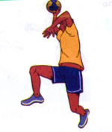

Demonstration for a running short
Running shot is executed while the player is in motion making the three steps progression.
- Make two or three steps towards the attacking goal end then make a shot at the goal
- Follow through with a swing of the throwing hand
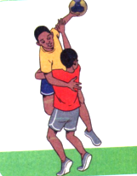

Demonstrating a dive shot
- Take a position outside the 6m line facing the attacking goal.
- Take off with both feet high and the head fast towards the goal area.
- Release the ball while airborne and land in the goal area with the body low.
- Convert your landing into a roll for safety.
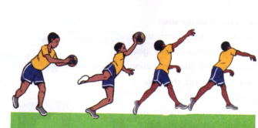

Learning points for falling shot
- Take a position outside the 6m line facing the goal.
- With the feet firm on the floor outside the goal area, fall towards the goal area .
- Release the ball before contacting the goal area with the hands or any other part of the .body
Learning points for lob shot
- Take a position outside the 6m line
- Face the goalkeeper who may have moved closer to you in defense
- Throw the ball in a curved path over the goalkeeper
- Flick the wrist to give the ball direction and accuracy.

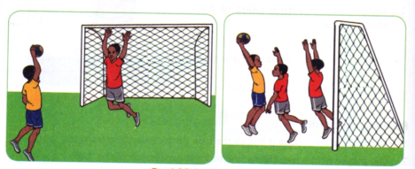

Drills for shooting in handball
Drill 1: Step and shoot
- In groups of five make a line facing the goal with the leader at the free throw line
- The leader makes a pass to the first player in the line
- The player makes 3 steps and then a jump shot
- After making a jump shot the player joins the line from the back
- Repeat the activity3 times then change to practice a running shot
Drill 2: Drill and shoot
- In a group of four players, make a line at the substitution zone facing the goal where you intend to shoot
- Use a high dribble to move towards the goal area
- On reaching the free throw line, catch the ball and make a jump shot
- Retrieve the ball and run along the goal line to the corner and then along the sideline to join your teammates
- After three attempts change and practice a running shot

Drill 3: Corner drill
- In a group of five, make a line at the corner of the court
- The leader to stand at a point within the court
- The first player in the line to run along the goal area line
- When at a comfortable position, catch the ball from the group leader and make a dive short.
Pupils activities Pg. 35.

STRAND 2.0 ATHLETICS
It entails all track events taking place in the field.
They include:
- Long jump
- Javelin
- Sprint
- Middle distance
- hurdle

Long jump
This is a field even that involved jumping for distance. The jump is done in progressive stages namely:
- approach
- take off
- flight
- landing
Approach - this is running on the runway with constant number of strides. An athlete strives to top speed before takeoff.
Take off - this is where the contact with the ground is broken after attaining maximum speed. It is done on a single leg. Gaining maximum height away from the take – off board is good in order to cover long distance.
Flight - is when the body is in the air after take- off. During flight, an athlete can use these techniques:
- sail
- hand
- hitch lack

Safety rules to observe.
- Attempt jump, one learner at a time
- Do not attempt jump unless the landing pit is clear
- Use the long jump pit filled with sand or any suitable material from your environment.
- Do not land outside the landing pit
- Ensure all raking of the sand pit or proper arrangement of the material being used on the landing pit.

The approach
- Mark a starting point
- Start your run from a standing position
- Begin the run with a marked forward lean to develop speed but before reaching the takeoff board , be upright
- Be on the ball of the feet when sprinting with a natural head position, eyes focused beyond the pit and not at the take –off board.
- Repeat several times.
- .

The take off
- Prepare for takeoff in the latter phases of your approach run
- Lower the hips then raise them into the take – off phase
- Your hips should be slightly forward
- Place your take off foot slightly ahead of the hips and strike the take – off boards on the mid line
- Place your final two- foot contacts flat on the take – off board.

Flight technique | Learning points
Sail | - Approach with run , up to a maximum controlled speed at take –off  - Focus ahead  - After takeoff, tuck your knees close to the chest and extend your arms straight forward.
Hand | - Make a fast run – up and drive up powerfully at the takeoff point  - Bend both legs backward after takeoff and then pull them forward forcefully  - Pull and extend your hands on the side of the body and arch you back.  - Pull the legs forward into a landing position.
Hitch kick | - Start with a fast run- up  - Drive up powerfully at takeoff and flex the leading foot at the thigh  - Extend the leading foot to assume a momentary stride position during flight  - Whip the leading foot backward  - Flex both legs and bring them forward for landing

Landing
- During landing, the athlete should aim at getting the heels as far away and ahead from the takeoff board as possible
- Turn on one side and allow the forward momentum to carry the body past the landing position.

Rules of long jump for sportsmanship
- Do not step beyond the take-off board
- Take off should be on single foot
- Landing should be inside the landing pit
- Do not touch the ground outside the pit when landing
- Exit the pit from the front after jump
- Avoid use of illegal substances and practices the can enhance performance.

Drills in long jump.
Drill 1: approach frill
- Line behind the runways
- Take turns on the runways
- Repeat several times ensuring maximum acceleration.
Drill 2: take off drill
- In two groups line behind the takeoff board one meter apart.
- The learners in front make a standing jump, taking off on a single foot.
- Move behind the queue to enable other practice
- Repeat several times to identify your preferred take off foot
- Take turns and take off with your preferred foot.
- Repeat several times for skill masterly.
Javelin
The javelin throw is a track and field event where the javelin, a spear about 2.5 m (8 ft 2 in) in length, is thrown.
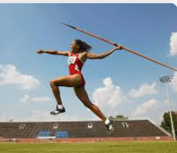

Safety when observing the javelin.
- Always carry the javelin vertical with the pointed part down
- Never run to collect the javelin
- Take care when removing the javelin from the ground
- Ensure that the area is clear before throwing the javelin
- Take a few steps backwards continuously
- Continue for the desired time and distance.

Demonstrations for javelin
- Grip in javelin
- Place the javelin along the length of your plan
- Hold the javelin at the back of the cord
- Keep the point of the javelin pointed in the direction you want to throw
- Keep the javelin lined up with your eyes
- Keep your grip relaxed

Types of grips in javelin
There are three types of grip in javelin
- The American grip
- The ‘V’ grip
- The finish grip

- The American grip
- Here you Place your thumb and the first two joints of you index finger behind the cord
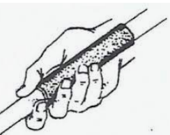
The ‘V’ grip – hold the javelin between your index and middle fingers, behind the cord.
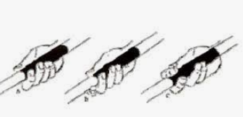
The finish grip: place your thumb and the first tow joints of your index finger behind the cord, while the index finger supports the shaft of the javelin. Extend the index finger further away.
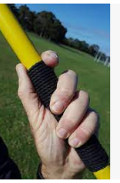

Leaning points in javelin
Carriage
- Hold the javelin near your head above your shoulder
- The javelin should point down towards the ground slightly.
- Ensure the javelin is parallel to the ground.
- Look at the direction of your through.
Approach run
- After you have the javelin in position, begin running towards your target with the javelin
- Keep your hips high and down on the balls of your feet
- Let your free arms swing across your body
- Extend the arm carrying the javelin fully behind you.
- Keep your head facing in the direction of your target
- Turn so that the left side of your body faces your target.
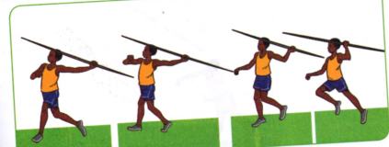
Cross over.
Place your right foot on the ground and your left foot forward and elevated.
- Put your right ahead in a “lean – back “ positions
- Pull the javelin back a little further so that the tip is lined up with your eyebrows
- Keep the right foot close to the ground
- Let the right heel touch the ground
- As the right foot moves forward, move the left foot up and lean your trunk back at 115 degree angle.
- Place your right foot on the ground and you left leg forward and elevated
- Direct your shoulder and hips towards your left target.
- Wait for your left foot to touch the ground
- Straighten your torso
- Turn your face toward the direction of the throw with the javelin parallel to your shoulder
- Position your throwing and hand above shoulder level.

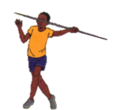
Release
- Through the javelin with your arms as high as possible
- Plant you left heels and thrust forward with your right foot
- Pull back with your left arm keeping it parallel to your right shoulder
- Move your throwing shoulder over your left leg
- Lift your left leg and move your throwing arm, with the elbow placed high and close to the midline.
- Release the javelin with your arm over your head in front of you.

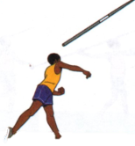

Follow through
- Let your throwing arm travel diagonally across your body.
- For examples if you are throwing with your right arms, it should end up infront of your left side.
- Keep your left foot on the ground.
- Let the right leg pass the left foot and then stop you.
- Finish by standing on your right foot, with your left leg up behind you.
- Your right shoulder will turn left, with your chest facing to the left.
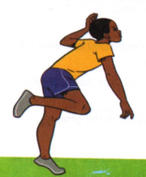
PUPILS ACTIVITIES
Learner to discuss various drills in javelin with the guidance of the teacher
KLB TOP SCHOLAR PAG 47

SPRINT START IN ATHLETICS
The sprint start is intended to propel you into the race as fast as possible. When an athlete breaks technique, his or her speed decreases and he or she has a greater chance of fatiguing sooner. The best way to work on correct form is to begin by watching experts perform these movements.
A starting block - is a fixed object with an angled surface which the athletes use to push off from at the start of the race. It helps to increase the starting speed of an athlete.
Ways of making a starting block
- Place the start of the block rail one step from the start line
- Position the front block two steps from the start line
- Position the back block three steps from the start line
- Place your feet so that the tip of your running shoes touch the track
- Your bodyweight should push into blocks
- Kneel on the back legs
- Place your hands wider hand shoulder – width apart behind the starting line.
- Keep your finger together and thumb in.
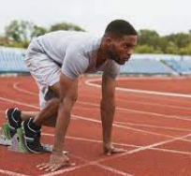
Types of sprint start in athletics
- Bunch or bullet start
- Medium start
- Elongated start

Bunch or bullet start – the toes of the rear foot are approximately leveled with the heel of the front foot. Both feet are placed well back from the starting line
Medium start – The knee of the rear leg is placed opposite at a point in the front half of the front foot.
Elongated start - the knee of the rear leg is level with or slightly behind the heel of the front foot.
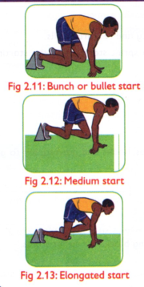
Athletics rules
- Perform the given warm up activities before participation
- Check the ground to ensure that it is not slippery and does not obstacles
- Use the lane assigned to your throughout
- Follow the sprint start commands when starting a race
- Ensure that the starting blocks being used is firmly fixed on the ground.

Pupils activity 6 pg 51
51-52

RUNNING IN SPRINT RACES
- Reaction time - is the time interval between an external signal and your response to it. An examples is hearing a starting gun or a whistle and taking off towards the finish line
- Acceleration - is the rate at which the body changes its speed. For examples, in the first 30m of a 100m sprint’s speed will be increasing.
Phases in sprint | Characteristics
Reaction time | - The athlete is calm and silent on the block waiting for the ‘go’ signal  - The athlete focuses ahead and responds to the commands.  - The hands are triggered split free and forward/ backwards by the gun signal  - It sets the pace and intention to perform  - It mentally affects the confidence level of the athletes at the start of the race
Acceleration | - Hips are pushed forward  - Force is applied to the ground with feet in contact and pushing back against the track.  - Head is kept in line with the body with eyes on the finish line  - An athlete keeps the knees and shoulder up  - Hands cut upwards to help maintain a positive acceleration
Maintaining | - After attaining top speed , an athlete strives to maintain the speed.  - Knees are kept high  - Legs move quickly and lightly  - Arms are driven harder to push through the final meters of the race.

Drill 1: Reaction time
- On a flat ground, stand on a free space in groups of four
- Mark a line on the ground
- Three of you to assume a sprint position of your choice
- The fourth learner will give the sprint commands
- On the command go, takeoff ensuring a quick take off
- Change roles ensuring that everyone performs and give commands
- Give honest feedback on the reaction of the go signal and be truthful.

Drill 2: acceleration
- On the flat ground , stand on a free space in groups of four
- Mark a starting line and a finishing line on the ground
- The learner will give the sprint commands
- On the command go , take off quickly after the go signal
- Apply force on the ground with feet pushing back against the track
- Keep your head in line with the body with eyes on the finish line.
- Cut the upward with your hands to help maintain positive acceleration
- Change roles ensuring that everyone performs and give commands
- Give honest feedback on the reaction on the reaction and acceleration and be truthful

Drill 3: maintaining
- On the flat ground, stand on a free space in group of four
- Make a starting line and a finishing line on the ground
- Three of your assume a sprint technique of our voice
- The fourth leaner should give sprint command
- Move your eyes slightly and fast
- Accelerate towards the finishing line
- Maintain the speed by keeping your knees high
- Drive your arms harder to push through the final meters of the race
- Change roles ensuring that everyone performs and give commands
- Give honest feedback on the reaction, accelerations and ensure you are truthful.
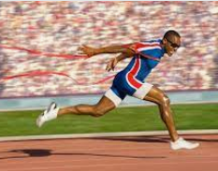
Finishing technique in sprint races
There are several ways of finishing sprint races.
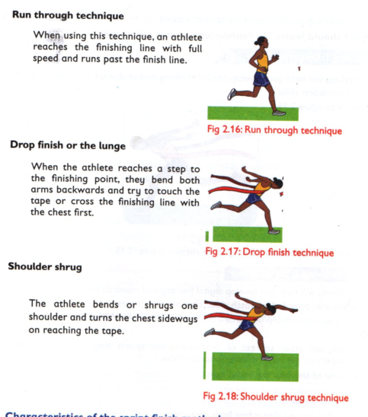
Characteristics of the sprint finish methods
Run through techniques
- The athlete crosses the finish line with full speed
- They stop several metres ahead of the finish line
- It is mainly used by beginners
Drop finish
- Performed when an athlete is just one step to the finishing line
- An athlete bends both arms backwards and tries to touch the tape with the chest.
- It is performed at the last movement when an athlete reaches the finishing line
- An athlete shrugs the shoulder that is opposite the tape by turning the chest sideways into the tape.
Similarities
- They are sprint finish techniques
- They are used at the end of a sprint race
- The movement of the arms distinguishes one from another.
- They are applied a step to the finishing line or upon reaching the finishing line
Rules during sprint race
- Preform the warm up activities given before participation
- Use the lane located to your throughout when racing
- Ensure that the finishing area is clear before your start a race.
PUPILS ACTIVITIES PG 59
BATON CHANGE RELAY
Relay running is a race in which athletes compete as a team. It consists of four stages: with four members from different teams.
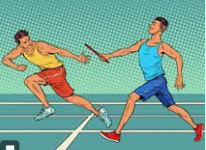
When a team member complete a specified distances, he or she passes on a baton to the next team member standing at the end of the distance he or she has covered. The baton is passed on until the fourth athlete in the team completes his or her distance with the baton in hand.
Relay races in athletics
- 4x100m - four athletes (either male or female) run 100m each
- 4 x 100 relay races - four athletes run 400m each
- The sprint medley relay -
- Mixed relay

Upsweep method of baton change in relay
- This involves the coming athlete passing the baton upwards into the receiving hands
- In this method, the hand is extended back at hip level. The hand is fully open forming a V between the thumb and forefinger.
- The baton is moved upward onto the extended hand of the outgoing runner.
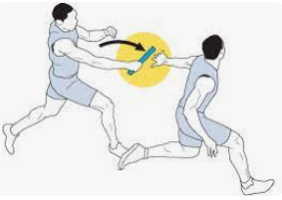

Safety rules:
- Hand over the baton at the designated zone
- Do not through the baton
- Carry the baton throughout the race
- Do not exist your line until its clear and safe to do so without impeding athletes in the other lanes
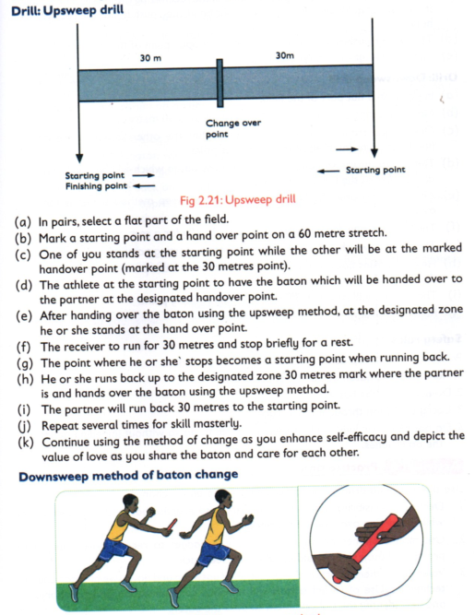

PHYSICAL FITNESS AND HEALTH
Pre exercise assessment of flexibility, balance and coordination

