Grade
7

GRADE 7 PERFORMING ARTS

LESSON NOTES COMPLETE
(TERM 1, 2,3)

COMPETENCE BASED CURRICULUM

1. PERFORMING ARTS

Introduction to Performing Arts Basic Elements

Activity 1: Defining Performing Arts
- Performing Arts can be defined as cultural and creative activities prepared and staged for an audience.

Activity 2: Identifying the Various Disciplines of Performing Arts
- There are different genres of Performing Arts namely music, drama, dance, film and elocution. They can also be referred to as the disciplines of Performing Arts.
- Each discipline is divided into smaller areas, for example music (vocal and instrumental music), drama (skit and play), dance (Creative and folk dances), film (documentaries, fiction films) and elocution (verse, narrative). These are known as the genres of Performing Arts.
- ln some cases, several disciplines can be used together in a particular performance. For example, songs can be used in narratives and skits to make them more interesting poetry is used with background music, while a movie trailer uses drama, film and music.

Activity 3: Discussing the Importance of Performing Arts in Society
- Performing Arts are used as a medium of self-expression.
- Through Performing Arts, talents are identified and developed.
- Performing Arts are a source of entertainment.
- They promote cultural appreciation, unity and cohesion when people come together to watch a performance
- Performing Arts enables the learner to develop skills that can help him or her to solve the issues and challenges of everyday life.

Rhythm

Activity 1: Clapping Rhythmic Patterns Incorporating the Semiquaver
- A quaver is half the value of the crotchet.
- A semiquaver is half the value of a quaver
- Two quavers make a crotchet while, four semiquavers make a crotchet.
- The rhythmic patterns that include the semiquaver in simple tune are ta-fa-te-fe, ta-te-fe and ta-fa-te

Activity 2: Aurally Recognizing Rhythmic Patterns with Semiquavers and Their Corresponding Rests

Class Activity
- With the help of your teacher, listen to various pieces of music and identity where the semiquavers are round.
- In small groups, sing songs that have the semiquaver patterns.
- Recite the following rhythmic patterns using French Rhythm names and clap them.
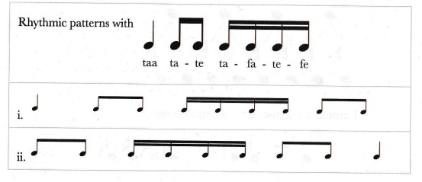
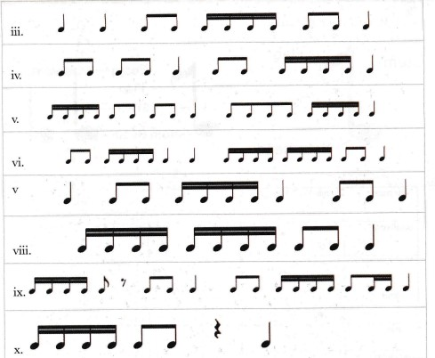

- Use common words or names of the members in the class to practise the rhythmic patterns with semiquavers, for example: apple juice, ripe mango, mama mboga etc.
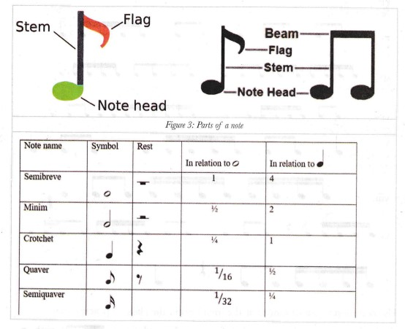

Activity 3: Grouping Notes into Beats in Simple Time
- Notes of small value such as quavers and semiquavers are joined together to form a crotchet beat. This is known as grouping notes.
- A horizontal line, known as a beam, is used to connect two or more notes of small value to form a crotchet beat.
- The number of beams in a group is equal to the number of flags or tails in the separate notes.
- The following shows how the notes are grouped into beats.
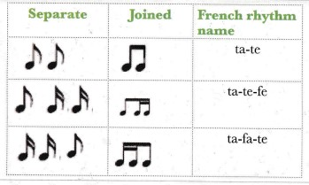

Note
1. Music is made up of strong and weak beats.
2. The strong beat is shown by the use of a symbol known as an accent (insert)
3. The strong beat can recur every two, three or four beats.
4. With the help of your teacher, clap the rhythmic patterns below, stressing the strong beats in each.
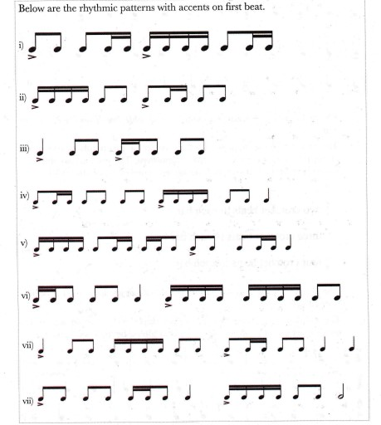

- The repetition of the strong beat after either two, three or four beats is known as meter.
- In written music short vertical lines, known as bar lines, are used to separate the groups of beats into twos, threes or fours. These groups of beats are known as bars.
The first beat of every bar is accented and double bar lines are used at the end.
- The meter of music is shown using a symbol of two numbers, one on top of the other. This is a called a time signature. The top number shows the number of beats in a bar and the bottom number shows the value of the beats.
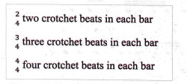
The number 4 is used at the bottom because there are four crotchet beats in a semibreve.
- The commonly used meters are simple duple, simple triple and simple quadruple time. The strong beat can occur after 2 beats, 3 beats and 4 beats.

Activity 4: Writing Rhythms in Simple Time on Monotone.

Can You Recall?
- A time signature is a symbol made up of two numbers that shows the meter of a piece of music.
- Music is divided into strong and weak beats.
- The strong beats occur after every bar line.
- Grouping of notes makes it easier to read music.

Group Activity
- With the help of your teacher, write down 2-bar rhythms in simple time on monotone. Use all the rhythmic patterns you have learnt so far
- Take turns clapping your written rhythms.
- You can also take turns to tap and write down each other's rhythms.
- Your teacher will assist you to write down the rhythms of familiar songs in simple time

Activity 5: Appreciating Music in Simple Time

Class Activity
- Listen to the song "pease porridge hot" played by your teacher:
- With the help of your teacher, study the song to find out what its time signature is.
- Practise beating time for the different time signatures.
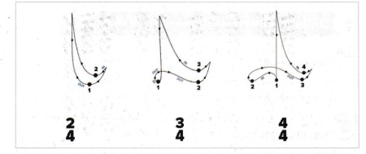
- The conducting patterns in simple duple, triple and quadruple.
- Listen to a variety of excerpts that will be played by your teacher. You will be assisted to beat time for each of them.

Individual Activity
- Listen carefully to the rhythmic patterns which will be played by your teacher.
- Write down the rhythmic patterns in your exercise book.

Group Activity
- Your teacher will play some rhythmic patterns tor you. In groups, write down the dictated rhythmic patterns.

Pitch

Activity 1: Writing Musical Notes on Treble Staff

Can You Recall?
1. Pitch is the highness or lowness of sound.
2. A scale is made up of eight notes d -d¹.

- Pitches can be represented using the letters A, B, C, D, E, Fand G.
- Music is written on a set of five horizontal lines and four spaces between them, known as the staff.
- The lines and spaces are numbered upwards.
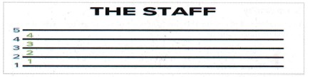
- 4 The lines are numbered 1 to 5, while the spaces are numbered 1-4 starting from the bottom.
- A symbol is written at the beginning of the staff to determine the position of the pitch names (A, B, C, D, E, F, G) on the lines and spaces. The symbol is called a clef.
- The treble clef fixes the second line as the note G. It touches the second line severally and therefore it is also known as the G clef.
- Practise drawing the treble clef by joining the dotted lines starting from the Second line. Join the dots 1-64 to make the treble clef.
- Practise drawing several treble clefs on the staff below
- This is how the lines and spaces are named.
- The word for spaces is F-A-C-E. The lines are E-G-B-D-E. Here are some fun ways to remember the order of the lines.
Every Good Boy Does Fine.
Eleven Girls Bring Donuts Friday.
Can you come up with other interesting sentences to help you remember this? Share with your classmates.
- Below are the notes in the treble clef compared to the notes on the keyboard.
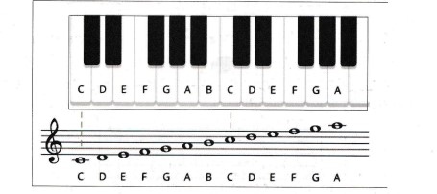
- You will notice a short line below and above the treble staff on which other notes are written. This short line is used to extend the staff to include notes whose pitches are lower or higher than the five lines and spaces. This line is referred to as a ledger line.

Activity 2: Describing Melodic Intervals

What I Need to Know
- An interval is the distance in pitch between two notes.
- The smallest interval on the major scale is a semitone. It can be found between m-f and t-d¹ in the major scale. All the other notes are a tone apart.

Kodaly Hand Signs
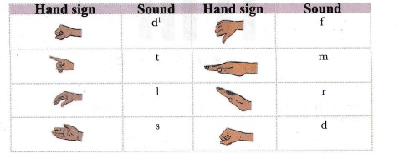
Sing the major scale using hand signs to hear the sounds of semitones and tones.
- The semitone intervals are found between E- F and B-C on the keyboard. Note that they do not have a black key in between them.
- The interval between a black key and the adjacent white key is a semitone. Since the black keys do not have letter names, we use special symbols known as accidentals to name them. An accidental is a symbol that alters the pitch of a note by a semitone.
- There are three commonly used accidentals: sharp (#), flat (b) and natural (). The sharp (#) raises the pitch of a note by a semitone as shown on the keyboard as shown on the following page.
- The flat (b) lowers the pitch of a note by a semitone as shown on the keyboard below.
- The natural () cancels the effect of either a sharp (#) or a flat (b) previously encountered. It, therefore, restores the note to its original state.
- Practise writing the three accidentals
Sharp (#) = Raises by a semitone

Flat (b)= Lowers by a semitone

Natural () = Cancels out previous (#) or (b)
9. Each black key has two letter names relating to the white note on either side.
10. On the staff, the accidentals are written before the note. On the pitch they appear after the letter.
11. Looking at the notes C and D there are two letter names apart and so this interval is a 2nd.
12. Looking at the notes C and E there are three letter notes apart and so this interval is a 3rd.
- There are two ways of describing an interval: numerically (by counting the number of note names in between the two notes) and by quality (using an adjective or descriptor determined by the number of semitones in between the two notes).
- Unison is the simplest interval as it involves a note and its repetition, for example, when you play the note C followed by the same note C. It is called a perfect unison.
- The smallest interval between two notes is a semitone.
- It is round between a white key and the adjacent black key or between the two white keys without a black key in between, that is, E - Fand B-C.
- An interval of a semitone is a 2nd. A second with only one semitone is known as a minor 2nd. A 2nd with two semitones in between the notes is a major 2nd.
- Thirds can also exist as either minor or major. A minor 3rd has three semitones in between the notes, whereas a major 3rd has four semitones.
- Look at the notes on the keyboard and count the number of semitones between note C and E.

What I Have Learnt
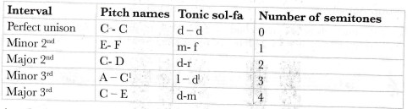
- A major interval can become minor if reduced by a semitone, and a minor interval can become major if increased by a semitone.
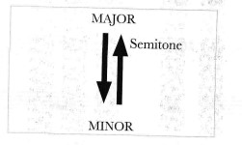

Activity 3: Constructing Major Scales on The Treble Staff

Can You Recall?
- The major scale is made up of eight notes: d, r, m, f, s, l, t, d¹.
- The intervals between the notes of the scale are tones apart except between m-f and t-d^{l} which are semitones.

Class Activity
- Practise singing the major scale from different starting pitches using the tonic sol-fa and hand signs.
- With the guidance of your teacher, take turns to play the scale on the keyboard as others sing along in tonic sol-fa and with the hand signs starting on C to the next C (only the white keys) ascending and descending.
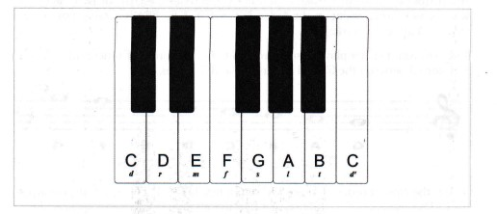
- C D E F G A B C gives us the correct sound of a major scale. If we check the intervals, they follow a specific pattern T T S T T T S.
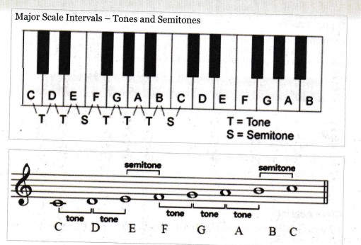

- In order to get the correct sound of a major scale starting from any note, the order of tones and semitones T T S T T T S must be maintained.
- Apart from the scale of C major, all other scales require the use of both black and white keys so as to maintain the order T T S T T T S. This is achieved by using a sharp to correct the order.
- Listen to your teacher play the scale from G to G¹. The order of tones and semitones is distorted between the 6th and 7th, and 7th and 8th notes.
- To get the correct order of tones and semitones T T S T T T S, we use a sharp (#) on F. This increases the distance between the 6th and 7th notes but reduces the 7th and 8th to semitone as shown below:
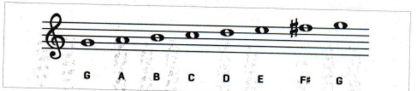
a) Practise playing the scale of G major on the keyboard.

Class Activity
- D major scale
- D-E-F#-G-A -B-C#-D are the notes of the D major scale.
a. Write and practise playing the scale of D major on the keyboard.
A major scale
- A-B-C#-D E-F#-G#- A are the notes of the A major scale.
b. Write and practise playing the scale of A major on the keyboard.
- In written music, the sharps that relate to a particular scale are placed at the beginning of the piece after the clef and before the time signature.
- When they appear at the beginning of a piece of music, they are known as the key signature.
- Music written in C major will not have any sharps at the beginning of
- Music written in the key of G major will have one sharp on F.
- D major will have two sharps on F and C
- A major has three sharps on F, C and G.

- Below is the order of sharps and how they appear on the treble staff.
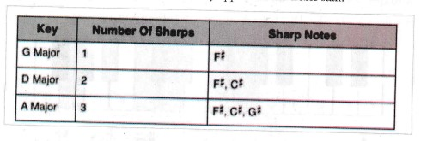
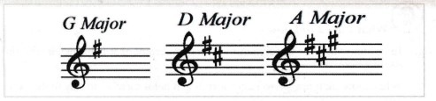
- With the guidance of your teacher, make flash cards or charts of the major scales of C, G, D and A to display in the classroom.

Activity 4: Reading Melodies in Major Keys

What I Need to Know
- In written music the key signature is very important as it helps us identify the starting note, doh.
- When more than one person is performing, it helps them all to stay in the same key.
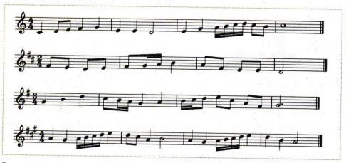
In each of the pieces above:
- Identify the key.
- Identity the meter or time signature.
- The rhythmic patterns used.
- The intervals of a perfect unison, minor 2nd, major 2nd, minor 3rd and major 3rd.
- Sing the melodies in tonic sol-fa.
- Use hand signs to indicate the tonic sol-fas as you sing the melodies.

Narrative
- A narrative is a story or an account of events or experiences whether true or fictitious/imaginative.
- The person who tells a story is known as a story teller or a narrator.
- A narrative is told to a person or people. The person or people watching a narrative is called an audience.
- A narrative is an account of events or experiences narrated by a narrator to an audience. It could also be defined as a story told by a storyteller to an audience

Activity 2: The Elements of a Narrative
- In a narrative, there is a logical sequence or flow of events. This is known as the storyline or the plot. The plot of a narrative usually has a conflict. A conflict refers to the obstacles, setbacks or challenges that the main character has to overcome before the story ends.
- The action or events in a narrative must take place at a specific place or a physical location. The place where the events in a narrative take place is known as the setting.
- A narrative has characters. Characters can be human beings or non-human beings. A narrator uses characters to advance the story.
- Narratives are used to pass important messages to the society. These messages are called themes. A theme is the lesson that is learnt from the narrative at the end of the narration. It is also referred to as the message. Some people call it the moral of the story. Most of the themes addressed in the narratives are contemporary

Activity 3: Demonstrating the Qualities of a Good Story-Teller
- The qualities of a good storyteller are:
- Good storytellers have good memory. They should be able to memorize the story and narrate it afresh every time they meet a new audience
- Good storytellers are creative, original and imaginative. They recreate the story afresh or anew each time it is narrated. They make the story relevant to the audience by using it to address or refer to contemporary issues.
- Good storytellers are confident, courageous and determined. They do not panic or tremble while narrating They face the audience directly without being shy. They do not avoid looking at the audience by facing down, looking sideways or looking up.
- Good storytellers speak loudly in order to be heard by everybody in the audience. Speaking loudly does not mean shouting.
- Good storytellers know how to use their voices to make the story interesting. They can imitate the voices of the characters to make it sound real. They also vary their voices to make sure the story is not boring. Sometimes they even sing songs contained in their narratives.
- Good storytellers use parts of their bodies to tell the story. They use gestures and body movements to drive home the messages in their stories.
- Good storytellers use their facial expressions to capture the mood in the narrative.
- Good storytellers utilize space by making relevant stage movements,
- Good storytellers involve the audience in their story.

Verse

Activity 1: Describing the Basic Elements of a Verse
- Poems are written to be performed or to be read aloud to an audience.
- Poems a have a definite structure that is easily recognized.
- They have lines. A line of a poem is the equivalent of a sentence in prose. In poetry, poets intentionally use broken lines to create rhythm and musicality in a poem.
- A poem has stanzas. A stanza is a collection of several lines in a poem. A stanza is the equivalent of paragraph in prose writing However, not all poems are divided into stanzas. Some poems like Sunset only have one stanza.
- Poems often use language musically. Certain sounds, letters, words, phrases or lines are repeated to create rhythm.
- When some words on the same line of a poem begin with similar consonant sounds, we call that alliteration.
- When some words on the same line of a poem have similar vowel sounds, we call that assonance.
- When some words, phrases or lines are repeated in a poem, we call it repetition.
- Poems are short in nature. The poet uses fewer words to communicate a lot of information. Unlike prose and drama, a poet selects words carefully and uses fewer words to communicate a lot of information.
- Poems communicate strong feelings. Poems convey heavy emotions. Poets carefully select words that are packed with emotions so as to affect the readers emotionally. With the help of your teacher, write down the words which have high emotions in the poems in the previous page.
With the help of your teacher:
- Identify words that appeal to the various senses of your body in each of the poems on page 39.
- Identify similes, metaphors, personification and exaggeration that are used in the poems on page 38.

Activity 2: Discussing Theme in Verse
- When listening to the performance of a poem, we pay attention to what the poem is about.
- We get to know what the poem is about by paying attention to:
- The character speaking in the poem- the persona.
- The experiences of the character speaking in the poem-what he or she goes through and what he or she says.
- From what the persona says or goes through in the verse, we are able to get the message of the verse. The message in the verse is also known as the theme of the verse. Most themes address issues that affect the society.
- Verses convey certain values in the society that we must learn.

Activity 3: Reading a Verse to Convey Meaning
- When reading a verse in order to convey meaning:
- Firstly, we have to read the poem once just to have a feel of the verse.
- Secondly, we have to read the poem while observing the punctuation marks. This helps to bring out the intonation in the poem. Intonation is the rising or falling of the voice while reading.
- Thirdly, we have to read the poem in order to emphasize the content words. Content words are the words that carry the meaning or message of each line. Such words are usually nouns, verbs and adjectives.
- The next step is to read while observing the stressed and unstressed syllables in each word. This ensures that the rhythm of the verse comes out well during the reading.
- The last step is the reading of the verse so as to bring out the various emotions in different words, phrases or lines. For example, if we read very fast, we want to convey emotions of excitement, anxiety or tension, we read slowly when expressing sadness or lamentation; we read loudly when emphasizing something (reading loudly does not mean shouting or screaming); we read softly to express emotions of love, persuasion (reading softly does not mean we should be inaudible).

Skit

Activity 1: Describing, Structure and Themes of a Skit
- Skit -This is a short performance intended to educate or inform. It is usually performed in an informal set up. It requires little preparation. It is meant to be acted.
- Structure - It is the general organization of a skit. It refers to how the story in the skit is laid out from the beginning, middle to the end. It entails the following:
- Plot - How the story in a skit is brought out from the beginning, middle to the end. It shows the following:
  - The beginning - The introduction or beginning of the story. It is the first important event from which the rest of the plot develops. Here, the audience asks, what next? A series of events that follow and where characters are introduced and the problem or conflict is made known, characters are seen to struggle to solve the problem they are experiencing, leading to the climax.
  - Middle - When the plot reaches Climax, it is at its most important part. It is the turning point that determines the outcome of the conflict and when the problem is resolved.
  - The ending - From the climax, a series of events leading to the end of the story follow
- Milestones - This is the series of events that show how the plot unfolds from beginning to the end. They show the problems or the challenges that the character or characters are facing and their struggles to solve them.
- Theme - This refers to the issues being addressed in the skit. Most are contemporary issues that affect us in the society. It gives us the message in the skit.
- Characters-These are the people taking part in the various roles in a skit. They are the actors and actresses. The main character is called the protagonist, while the villain or the character who is in conflict with the main character is referred to as the antagonist. Support characters serve various roles in the skit.
- Setting - When and where the action is taking place
- Conflict - Problems, challenges or issues being experienced by the characters that need to be resolved.
- Language - Manner of communicating or the choice of words used to bring out the desired message effectively. It varies from one character to another depending on the role.

Activity 2: Discussing the Importance of Improvisation and Use of Dialogue in a Skit
- In a dialogue, the exact words of the speakers are used.
- It refers to the speeches or lines that the character says.
- It is the most critical part of a skit.
- It carries the information that the writer wishes to convey to the audience.
- Person's thoughts and feelings are revealed through his or her tone of voice and way the word is spoken.
- Language should be appropriate for the character.
- How a person interacts with others is based on his or her responses and how much or how often he or she speaks.
- It is through a dialogue that a character is developed.
- Stage directions such as Mary: (disgusted) should be minimized and character dialogue to be self-explanatory.
- Shortened form is often used as well as hesitation markers like, mm...I...um... and interjections like ouch! Hurray! Wow!
- Improvisation is the acting of a scene without prior preparation.
- It is not scripted.
- One should avoid negative ideas that may not build the improvisation.
- Always keep the focus of the scene clear.
- Keep questions direct.
- Build stories on the spot, use your mind but, do not over-think.
- To make improvisation successful;
- Do not try to be better than those in the group, work with them.
- One must connect with the other players.
- Do not deliberately make a joke out of everything.
- Use your body to perform different actions.
- It builds confidence and imaginative and creative abilities.

Activity 3: Discussing Functions of Costumes and Props in a Skit
- Costumes are clothes and accessories worn by the actors to portray character.
- They can indicate style, genre and period, as well as give clue about the character.
- Props, which is short for properties, are the other items used in the skit apart from costume such as hand props like walking stick, fly whisk or spear. They can also be movable items on stage that ad in telling the story.
  - They help to tell the story.
  - They help in identification of the character[s].
  - They help the actors get into character.
  - They communicate details of a character's personality to the audience and bring out different aspects of the character.
  - Help actors to transform into new and believable persons.
  - They immediately tell the audience what is going on.
  - They indicate time and place of the skit, that is, the setting
- It is of utmost importance to learn of items from other cultures and understand them. This is called appreciation.

2. CREATING

Rhythm

Activity 1: Outlining Factors to Consider When Creating a Rhythmic Pattern
What I need to know
  - A good rhythm has a variety of rhythmic patterns.
  - In order to achieve unity, some rhythmic patterns can be used more than once (repeated).
  - The number of notes in each bar should correspond to the time signature.

Activity 2: Interpreting Rhythmic Patterns in Simple Time
- Play or sing the short melodies provided.
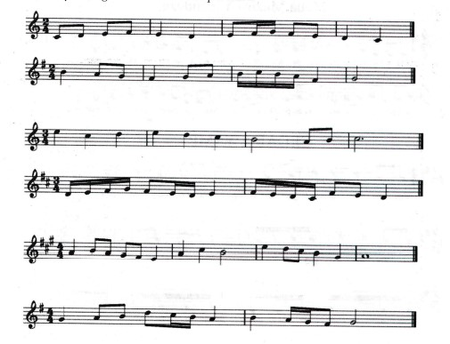

2. The time signature will guide you to emphasize the main beat, and the number of beats in every bar.
3. Write down the French rhythm names below each melody, then tap or clap them while reciting.
4. In groups, clap the following 2-bar rhythms as you recite the French rhythm names.

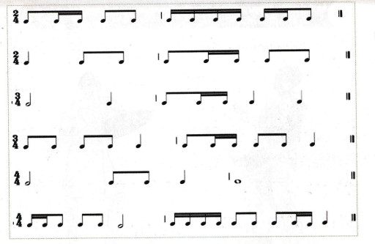

Activity 3: Improvising Rhythmic Accompaniments to Tunes in Simple Time

What I Need to Know
- Percussive instruments are used to provide rhythmic accompaniment.
- The rhythmic accompaniments can be written or improvised based on the main beat.
- Sing familiar tunes in Simple time and improvise accompaniment on drum or any other percussive instrument. For example: Maua mazuri can be accompanied using any of the following rhythmic patterns.
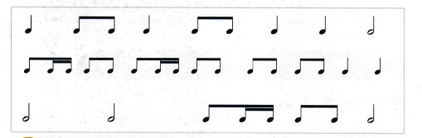

Activity 4: Creating Rhythms in Simple Time

Can You Recall?
1. Rhythms are created by combining various rhythmic patterns.
2. In simple time, and time signatures are used.
3. The first beat in every bar in simple time is an accented beat

Individual Activity
- Combine the rhythmic patterns you have learnt to create 2-bar rhythms in simple time and write them down in your exercises book.

Work In Pairs
- Take turns to clap or tap the rhythms you have created as the other recites the French rhythm names.

Activity 5: Appreciating Rhythms in Simple Time

Rhythm Puzzle
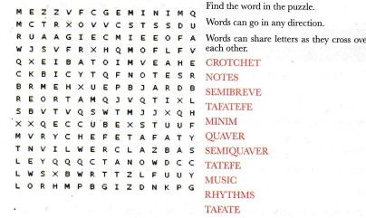

Melody

Activity 1: Identifying Qualities of a Good Melody
    - The melodies move in stepwise motion with a few leaps.
    - The melodies begin on notes d, m or s and end on d.
    - They have a good melodic contour.
    - They have several rhythmic patterns.

Activity 2: Interpreting 4-bar Melodies in Simple Time
- Sing the melodies below and take note of the melodic contour
- To interpret a melody, the following should be done:
- Identify the clef, key signature and time signature.
- Tap the rhythms of the melody.
- Write tonic sol-fas of the melody below the staff. Remember "doh'’ is the note that gives the key its name, for example, in C major, doh is C,
- Practise singing the tonic sol-fas of the melody, first in crotchets and then using the correct rhythm.
- Notice the movement of successive notes in each of the melodies. Stepwise motion is where the interval between any two neighbouring notes is not more than a step on the scale.
- In some cases there can be more than a step between two successive notes of a melody. This type of motion is called skipwise motion or movement by leaps.
- Each melody has a shape, which depends on the successive movement of notes. A melody can move upwards, downwards, in waves forming a curve and so on. This is referred to as the melodic shape or contour.
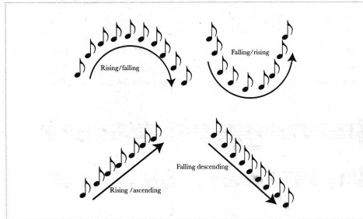

Activity 3: Creating 1-bar Melodies in Simple Time on Treble Clef

Things To Remember
- Before you begin creating a melody, you should: draw the staff, add the treble clef, write the key signature of the scale you want to use, and write the time signature you will use.

Work in Pairs
    - What are the qualities of a good melody as was discussed in the previous activity?
    - Practise Writing a 4-bar melody in simple time in major scales of C, G, D and A.
    - Sing or play the melody you have created.
    - Describe the melodic motion and shape or contour.
    - What is the first and the last note in each of the melodies?

Activity 4: Playing or Singing Melodies Created by Self and Others

Can You Recall?
- What are the qualities of a good melody?

Work in pairs
- Take turns to play each other's melodies.
- Discuss the qualities in each of the melodies played.

Group Activity
- With the guidance of your teacher, use mobile apps or computer software to create, notate and play back 4-bar melodies.

Activity 5: Appreciating Melodies Composed by Self and Others

Listen and Learn
    - You have created 4-bar melodies in simple time in the major scales of C, G, D and A
    - In pairs, take turns to sing or play (or use: digital devices to listen to) and appraise each other's melodies.
    - Take turns to sing your melodies to the class.

PERFORMING ARTS GRADE 7 NOTES – TERM 2

Narrative

Activity 1: Creating A Narrative
- Can you recall?
- Name the qualities of a good narrator.

- The process of developing a theme of a narrative begins with an idea.
- An idea is an issue that is affecting the society and which you have a strong feeling about. When you decide to compose a narrative on this issue, it becomes a theme of the narrative.
- We can develop themes of narratives from various sources such as:
- Our daily experiences — the daily conversations that we have with our classmates, schoolmates, friends, family, relatives and even neighbours.
The things we observe within our environment.
- What we watch on television or listen on the radio.
- What we read in books, magazines or newspapers.
- Issues that are trending on the media.

Activity 2: Creating a Narrative Story
- Can you recall?
- Name four sources of ideas for scripting a narrative.

- Narratives are created in order to educate the audience about a chosen theme.
- A good story begins with the introduction. This is the beginning point of the narrative. At this point:
- The audience is told about where the action of the narrative is taking place (setting).
- The audience is told who the main characters is (name) and what he or she wants to achieve in the story (the goal).
- The main problem that the main character faces is introduced to the audience (conflict).
- As the main character struggles to overcome the initial problem, he or she encounters other problems that prevent him from overcoming the first problem. These are called milestones.
- At some point in the narrative the problems may become too much for the main character until he or she seems defeated and cannot fight anymore because he or she has finished all the efforts and tricks. This is the point of no return. This point is called the climax of the story.
- The last point in the narrative is when the main character finally manages to overcome all his or her problems. This is called the conflict resolution. It marks the end of the story.

Activity 3: Creating Characters in A Narrative
- Can you recall?
- Define the following terms:

- Setting.
- Beginning.
- Goal.
- Middle.
- Milestone.
- Ending

- There are two types of characters in narratives:
- The main character.
- The minor characters.
- The main character is the one that the story is about. He or she is the one who carries the story. Most events in the story revolve around the main character.
- The minor characters play very important roles in the narrative:
- Some support the main character to achieve his or her goals.
- Some oppose the main character or create problems and trouble for the main character.
- When minor characters support or create problems for the main character they help in creating milestones in the story.

Activity 4: Writing A Narrative Script
- Can you recall?
- Who is a main character?
- What are the functions of the minor characters?

- Writing is the process of putting the narrative that has been created into a written text.
- A narrative text is a written story of the narrative that is going to be performed.
- Before writing a narrative ensure that all milestones are plotted. These are the series of events in the narrative.
- As we write the story, we use descriptive words that make the story interesting,
- In the written text, the following should be well described in order to help the audience to understand them:
- The introduction
- The setting.
- The goal.
- The conflict.
- The beginning.
- The middle.
- The ending.

Verse

Activity 1: identifying a theme for a verse script
- Can you recall?
- How can you read a poem in order to bring out its meaning?

- The theme of a verse is an issue that affects the society.
- People who write poems get their themes from:
- Their own personal experiences in homes, school, mosques, churches
- or even at the places of work.
- What they observe other people do or go through in life.
- What they watch or listen to using digital devices such as televisions,
- radios and computers.
- What is trending on the media.
- What they read in the newspapers or magazines.

Activity 2: Writing A Poem
- Can you recall?
- What is a theme of a verse?
- From which sources do poets get the ideas for writing their poems?

- Before you write a verse, you must decide on the theme you want to write about.
- After identifying a theme, you have to come up with one topic under that theme that you will write the poem about.
- It is good to write a poem about your own experiences that are related to the topic you have chosen.
- As you write a poem, you must choose a character who will tell the experiences you want him or her to share the poem with people. This is the person speaking in your poem. We call this person the persona.
- After writing a few stanzas of the poem, keep it in the portfolio for future use. This enables you to go and think about the poem you are writing. As you think about it you will discover many things that will help you to improve on the poem to make it better.
- The poem that you have kept for future use is known as the draft.
- A draft is a script of a poem that is still being worked on. It is an incomplete verse script.

Activity 3: Using Poetic Devices to Write a Verse
- Can you recall?
- Who is a persona in a poem?
- What is a draft?

- Writing a poem is a process.
- The first stage (which you have already done) is called the drafting stage.
- The second stage is called the reworking stage. Reworking on a poem can be done several times.
- In the reworking stage the following things take place:
- Poetic devices are included in the poem. Some of the poetic devices are:
- rhyme - words at the end of different lines end with similar sounds.
- repetition — some words, phrases or lines are repeated in the poems.
- You can compare things in the poem using similes and metaphors. You can also use personification by making non-human beings like animals and plants to behave like human beings.
- Words that describe emotions are also introduced in the poem to add emotions to it.

Can You Recall?
Define the following terms:
- Rhyme.
- Simile.
- Alliteration.
- Metaphor.
- Assonance.
- Personification.
- Repetition.

Activity 4: Improvising Props
- A prop is an item that a performer of the verse uses to demonstrate an action.
- Examples of props include: balls, caps, hats, stethoscopes, school bags, pens, pencils, books, Bibles and jembes.
- Props are made from locally-available materials such as carton boxes, manila papers, sugar bags, plywoods and sticks.
- We do not use real objects as props. Props must be improvised.

Skit

Creating A Scenario for A Script
- Can you recall?
- What is a dialogue?
- Who is a character?
- What are costumes and props?
- Tell your partner about some issues that you have already come across in the skits learnt in the previous lessons.

- Creation of a skit means coming up with a skit. It begins with an idea which makes up the story.
- Ideas for a skit can be got from:
- Our own experiences or other peoples’ experiences.

- What we watch on television, listen to on radio, read in newspapers or from happenings in the social media.
- Idea determines the theme or message to be communicated.
- One needs to decide who will be in the story and what will happen.
- One needs to think of the problem that arises and needs to be solved.
- Think of where actions will take place.
- Always remember to answer the who, the what and the where.
- Scenario is thus, the storyline or framework or outline of the plot. It is the summing up of what is going on or what the situation is. It is essentially a story with characters and situations. It must be believable.

Activity 2: Improvising Costumes, Props and Make-Up
- Can you recall?
- What are costumes?
- What are props?
- What is the importance of costumes, props and make-up in a skit?

  - Costume design is the creation of clothing for the overall appearance of character or performer.
  - Improvisation is to make or do something by using locally-available materials. It provides an alternative to the original. Improvised items should convey the desired message just as the original material. It involves serious thinking, creativity, communication and coming together of different opinions.
  - Make-up enhances the illusion that the actor has become the character, It is used to cover all the exposed parts that are not covered by the costume won by the actor. It helps in easy interpretation of the skit and its location.

Activity 3: Scripting for Stage -Language and Style.
- Can you recall?
- What is a scenario?
- What are milestones?
- What is a dialogue?

- While scripting a skit, it is of utmost importance to note the following:
  - Milestones: They bring show problems or issues that the characters are faced with in skits and how they try to resolve them. They show the expectation in a skit or how it will flow from the beginning to the end. They develop the story line. They guide you in writing the script of a skit.
  - Characters: the audience interacts with the skit through the characters and their speech. The main characters as well as the support characters must be believable. Clear description of the characters is important in the writing of a dialogue in a skit.
  - Language and Style: concerns itself with the use of words with maximum effect. One needs to avoid unnecessary words that may hinder the development of the story and character. The language used should be appropriate to the character (s) in question. It should define them, for instance, a skit with a police officer, street child and a lawyer, will not use the same language for all. While the street child is likely to use ‘sheng’, the doctor should use formal language and the officer, a semi-formal language.
  - Copying: is the use of other people’s work without their approval. Thus, when writing a script use your own ideas.

Activity 4: Using Locally Available Resources in A Skit
- Can you recall?
- What is improvisation of costume, prop and make-up?
- What is the importance of make-up in a skit?
- Name some materials that can be used for improvisation.

  - Watching skits from other communities helps us to respect one another.
  - Understanding skits from other communities makes us to understand and enjoy watching skits from those communities This is referred to as appreciation,
  - Using locally-available materials as costumes, props and make-up boosts our creativity and imagination.

3. PERFORMING

Folk Songs

Activity 1: Classifying Kenyan Folk Songs According to Origin, Type and Function
  - With the guidance of the teacher, watch live or recorded performance of Kenyan folk songs. Discuss any observations you make about the common aspects, such as:
- The community of origin.
- The participants — are they male, female, young, old, mixed?
- Body movements.
- Costumes used by the participants.
- Instruments used to accompany the performance.
  - A folk song is a traditional song originating from a particular community. It is performed in the native language. It is passed down from generation to generation orally. Folk songs can be:
- Solo - involving one performer singing.
- Solo and response - involves singing or leading the performance and a group responding.
- Group - involves a group singing without a soloist.
  - Folk songs are associated with other activities in the community, such as weddings, child birth, naming, burial among others.

Talk Activity
- Talk about various social activities in the community where folk songs are performed.

Activity 2: Social Economic Uses of Folk Songs
- With the help of your teacher or resource person, watch live or recorded performances of folk songs. For each folk song, fill in the following table.
Folk song | Community | Occasion | Purpose or function | Participants | Movements | Costumes | Instruments | Message

Group Activity
- Discuss the social and economic uses of folk songs in Kenyan and Western communities, during various occasions as follows:
- Childbirth.
- Naming ceremony.
- Singing games.
- Initiation.
- Marriage.
- Funeral.
- Work songs.
- Other social gatherings.

Individual Activity
- Study the following pictures and answer the questions that follow.
  - State the occasion shown in each of the pictures.
  - Which type of folk song is being performed?
3. Identify the costumes used by the participants.
4. What kind of message is being passed by the participants?

Activity 3: Performing Solo and Group Folk Songs
1. With the help of your teacher, parent or guardian, watch or listen to various folk songs.
  - Select a folk song to be performed in class.
  - In groups, select one solo and one group folk song.
  - Learn the selected folk songs, for presentation.
  - Use appropriate costumes, body movements and instruments to accompany your performance
2. Discuss the techniques used in performing Kenyan folk songs.

Activity 4: Report Writing
  - You have discussed, learnt and performed different types of Kenyan folk songs. Write a report on the folk songs in your community.
  - In groups, collect a variety of folk songs and classify them according to origin, type, function and occasion.

Kenyan Idiophones

Activity 1: Classification of Idiophones
- Can you recall?
- Percussion instruments produce sound when hit, shaken or scraped.
- Study the pictures and name the instruments.
- How are the instruments played?

  - Idiophones are percussion instruments. They produce sound by vibration of the instrument itself.

Home Activity
  - Use digital devices to watch clips of various percussion instruments and identify the idiophones.
  - Collect photographs of various Kenyan percussion instruments and name the idiophones.
  - Idiophones are either melodic or non-melodic.
  - Idiophones are further categorized by the way they are played. They can be shaken, clapped, stamped, plucked, scraped and struck.
  - Here are examples of idiophones from Kenyan communities. Add more instruments on the list.

Name of idiophones | Community | Type
Adongo | Iteso | Plucked
Marimba | Mijikenda | Struck
Kayamba | Mijikenda | Shaken
Ibirandi | Kuria | Shaken
Itende | Kuria | Stamped
Kigamba | Kikuyu | Shaken
Chinchigiri | Gusii | Shaken
Sanduk | Luo | Struck

Activity 2: Role of Idiophones in A Performance
1. Idiophones are mostly rhythmic and, therefore, enhance the rhythmic aspects of a performance such as:
  - Keep time or maintain pace,
  - Providing rhythmic accompaniment,
  - Providing rhythmic variety.

Activity 3: Care and Maintenance Procedures For Idiophones.
  - Idiophones are made from different materials such as wood, animal skins and metals.
  - For proper care and maintenance of the instruments, note the following:
- i Keep them away from water.
- Keep them away from fire.
- Avoid dropping them.
- Replace or repair damaged parts.
- Store them properly by hanging or placing them on a shelf or cupboard.
3. In groups, apply proper care and maintenance techniques on the idiophones available in school.

Activity 4: Techniques of Tuning Idiophones
- Melodic idiophones require tuning from time to time. This ensures that they stay in pitch for the case of melodic idiophones.
- With the help of your teacher or resource person, discuss the various ways of tuning idiophones.
- In groups, practise tuning idiophones available in school.

Activity 5: Performance Project

Group Activity
- L. Select any available idiophones and tune them applying proper techniques.
- In groups, select various idiophones to form a percussion band.
- Take turns to play different instruments in the percussion band.
- Practise and perform in a percussion band in class, school or community functions.

Western Solo Instruments

Activity 1: Tuning the Descant Recorder or Any Other Solo Western Instrument
- Study the following instruments and answer the questions that follow.
- What can you see?
- With the guidance of your teacher and resource persons, watch a live or recorded solo instrumental performance.
- In groups, discuss the importance of tuning a solo Western instrument in preparation for a performance.
- Watch videos demonstrating techniques of tuning various Western instruments and apply them to your chosen instrument.

Activity 2: Playing the Scale Of C Major On Staff

What I need to know
- Western instruments have different fingering charts to guide in playing of different pitches.
- Use digital devices to download the fingering charts for the instrument of choice.
- Below is the fingering chart for the Descant Recorder showing the notes of the scale of C major.

Descant Recorder Fingering Chart

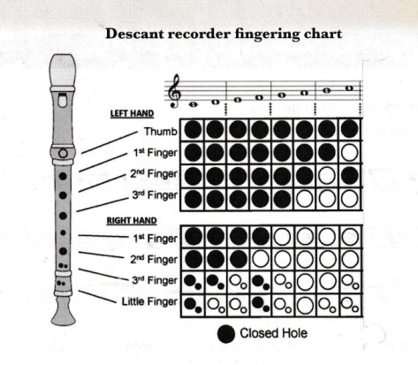

Individual Activity
  - Practise playing the notes of the scale of C major ascending and descending on your instrument using the fingering chart.
  - On a digital device, watch videos to learn how to play the scale of C major.
  - Use the fingering provided to the play the notes C D EF G A B C' on the descant recorder.
  - Practise playing the scale in ascending and descending order.

Group Activity
- Play familiar tunes in the scale of C major on your instrument.

Activity 3: Sight Reading Simple Melodies in C Major
To do individually and in groups.
    - Look at the clef below.
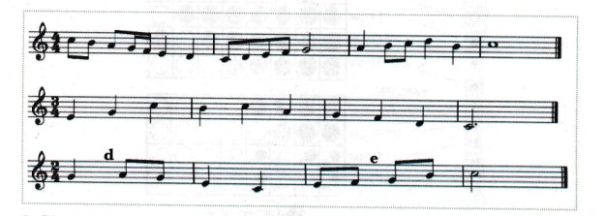
    - Check the key signature and keep the key in your head while playing
    - Look at the time signature.
    - Clap or tap the rhythms of each of the melodies before you play them.
    - Locate the notes on the instrument.
    - Look at the melodies and play.

1. Sight-reading is playing of music without prior preparation.
2. Your teacher will provide 2-bar melodies for you to sight-read.
3. Do so without referring to the fingering chart or tapping the rhythms before playing.

Activity 4: Playing with Appropriate Techniques
  - Every instrument has specific techniques to be applied while playing. For example, for strings there is bowing, plucking, strumming, fingering; and for wind, there is tonguing, blowing and fingering.
  - All the techniques when well applied ensure good tone quality.

How To Produce a Good Tone on The Descant Recorder
  - Blow gently into the descant recorder as you make the sound ‘du’ with the tongue. This is referred to as tonguing and it helps to produce a clear sound.
  - Do not blow too hard into the recorder because it will make a high pitch sound.
  - If you are having trouble producing a sound after lots of practice, clean your recorder. Cover the air hole below the mouthpiece and blow in hard.

Activity 5: Observing Performance Directions

What I Need to Know
- Performance directions are words, phrases or signs showing the appropriate tempo, dynamics, articulation and repeats in a piece of music.
- The directions help to enhance the overall effect in a performance.
- With your teacher’s guidance, play various melodies observing the performance directions shown.
- Your teacher will also help you search for short duets in C major to be played in pairs and groups.

Kenyan Folk Dance

Activity 1: Classification of Kenyan Folk Dances
With the teacher’s guidance, watch performances of folk dances from diverse Kenyan communities.

Group Activity
  - Discuss the performances you have watched and categorize them in terms of the following:
- Gender of the performers.
- Occasion.
- Age of the performers.
- Community of origin.
- With the guidance of the teacher or resource persons, discuss the function, themes or messages in the folk dances.
- Here are examples of dances from Kenyan communities. Add more to the list.

Name of dance | Community | Gender | Occasion
Isukuti | Luhya | Men and women | Entertainment
Ndumo | Kikuyu | Women | Marriage ceremony
Sengenya | Mijikenda | Men and women | Entertainment
Ramogi | Luo | Men | Entertainment
Eunoto | Maasai | Men | Initiation

Activity 2: Providing Background Information of Kenyan Folk Dance

Group Activity
  - With the help of the teacher, select a folk dance and get the following information about it.
- Title.
- Community.
- Gender.
- Theme.
- Occasion.
2. Write the information in your exercise book.
3. Take turns to present the information you collected on a folk dance from your community.

Activity 3: Performing A Kenyan Folk Dance with Appropriate Dance Movements

Class Activity
- Watch performances of folk dances from different communities and observe the movements in them.

Group Activity
- Select a Kenyan folk dance from the ones you have watched.
- Learn the dance movements, keeping to the traditional idiom.
- Perform the dance before the class.

Activity 4: Singing Songs Appropriate for The Dance
- With the help of your teacher, resource person, parent or guardian, write down the words of the songs used in the folk dance.
- Learn singing the songs to be used in the folk dance performance articulating the words clearly.

Activity 5: Using Appropriate Music Instruments, Costumes, Décor and Props in A Kenyan Folk Dance

Group Activity
  - Identify and source for the music instruments to be used in the dance.
  - Learn playing the musical instruments.
  - Collect costumes and props to be used.
  - Get the material for the body adornment.
  - Practise and present a performance of a Kenyan folk dance incorporating the appropriate music instruments, costumes, décor and props.
  - Use digital devices to record each group’s performance for sharing and review.

Narrative

Activity 1: Selecting A Narrator and The Support Cast for Our Narrative
- Can you recall?
- Describe the process of writing a narrative script.

- After coming up with a narrative script, a process called casting follows. Casting is the process of selecting a group of performers who will perform certain roles in a given performance.
- A narrative has the main narrator or narrators and the support cast.
- The main narrator is selected based on the qualities of a good narrator.
- The support cast is selected based on the roles they are supposed to play in the narrative. Most narratives have dancers, singers and instrumentalists. The support cast helps the narrators to enhance the narrative.

Activity 2: Designing A Rehearsal Programme
- Can you recall?
- What is casting?
- What should be considered when casting narrators?

  - Rehearsals are important when preparing a narrative for performance.
  - It is important to have a rehearsal programme that guides you when to rehearse, especially when you are free.
  - A good rehearsal programme should allow room for individual rehearsal, group rehearsal and team rehearsal.

Activity 3: Rehearsing the Narrative
- Can you recall?
- What should be considered when making a rehearsal timetable?
- Rehearsal is a continuous process. We have to keep on rehearsing until the narrative communicates the message well and is entertaining.
- Rehearsals help the narrator and the support cast to memorise and internalise their lines.
- Rehearsals help the narrator and the support cast to improve on their gestures, voice variation, facial expressions and stage movements.
- Rehearsals help the narrator and the support cast to introduce aspects in the narrative that make it interesting such as asking the audience rhetorical questions, song and dance, riddles, proverbs and even jokes or funny lines that are relevant to the narrative.
- The other members of the class who are not participating in the narrative are important during rehearsals. They help the narrators to internalise their lines, use appropriate gestures, facial expressions and voice variations. Their work is to correct mistakes and encourage the cast to improve. Their input can add value to the performance of the narrative.
- 1 can also rehearse during my free time at home as follows:
  - Before a friend.
  - Before a digital video recording device.

Activity 4: Designing Props and Costumes for The Narrative
- Can you recall?
  - What is the importance of rehearsal?
  - How are rehearsals conducted?

- Costumes are very important in a narrative.
- Costumes help us to know the setting of the story.
- The costume won by the narrator(s) helps us to identify who the main character is in the story.
- The costumes worn by the support cast help in enhancing the message in the story. They may also help us to understand who the other characters in the narrative are.
- In a narrative we use very few props. This is because the narrative relies more on telling the story or narrating. The props only enhance the telling of the story.

Verse

Activity 1: The Persona’s Point of View and Meaning In A Verse
  - The persona is the voice speaking in a poem.
  - Poets use the persona to express their viewpoints about certain issues in the society. In this poem, the poet has created a dog as a persona so as to criticise the inhuman treatment of domestic pets. The persona could also be seen symbolically as a domestic worker who is lamenting about the inhumane treatment he receives from his boss.
  - We need to use empathy when reading a poem. When we put ourselves in the shoes of the persona, empathy helps us to understand the meaning of the verse.
  - We get to know the meaning and point of view of the persona by paying attention to the words in the poem. The choice of words in a poem is called diction.
  - The choice of words in a poem helps us to decide the facial expressions to be used to enhance the meanings of those words.
  - The choice of words used helps us to decide on which gestures and dramatisation to be used on the selected words.

Activity 2: Expressing the Performance Features of A verse

Can You Recall?
  - What is the importance of empathy when reading a verse?
  - What is diction in a verse?
  - What is tone?

  - The performance of a verse begins with the script. The script must be poetic. It must have a poetic language with poetic devices.
  - The voice is an important aspect of a verse performance. The voice is used to communicate the various emotions brought out in the verse. Voice variation is important as it creates variety and breaks the boredom created by using only one tone.
  - Facial expressions are used to bring out the mood and emotions in the verse. They are determined by the words in the verse.
  - Gestures are used to demonstrate actions in the verse. In a verse, we are encouraged to use minimal gestures and rely on the voice and face more for communication.
  - Stage movements are important in a verse performance. In verse, performers move on stage for a reason. They do not just move unnecessarily.

Activity 3: Rehearsing the Verse
- Can you recall?
- Define the following terms:
- Facial expressions.
- Voice variation.
- Tempo variation.
- Gestures.
- Body movement.
- Stage movement.
- Can you draw a rehearsal timetable like the one you drew for the narrative?
- Remember to allocate time for individual, group and team rehearsal.

- When rehearsing a verse, one needs to memorise and internalise a poem.
- For us to internalise the poem, we must put ourselves in the shoes of the characters in the verse and begin to feel like them. This is called empathy.
- We should also draw a lot from our own past experiences of a similar experience as the one the character in the verse is going through.
- These experiences help us to bring out the best feelings through the voice and the face.
- Meaningful gestures, body movements and stage movements are helpful in verse performance.
- We can rehearse in many ways as follows:
- Before our friends so that they can correct our errors.
- Before our classmates so that they can give us a feedback.
- We can record ourselves rehearsing then view and correct our mistakes.

Activity 4: Performing the Verse
- Can you recall?
- How does one internalise a poem?
- How many ways of rehearsing can you recall?

  - Before performance of a verse, casting has to be done. This is the selecting of the people who will perform the verse.
  - The criteria for selecting those who perform a poem is based on the following:
  - Voice quality.
  - Ability to vary voice.
  - Ability to use facial expressions.
  - Ability to use gestures well.
  - Flexibility in stage movement.
  - When performing a verse, the following should be considered:
  - Mastery of the poem.
  - The use of voice to display the different emotions in the verse.
  - The use of facial expressions to bring out the different moods in the poem.
  - The use of relevant gestures.
  - The use of relevant body movements.
  - The use of relevant stage movements.
  - Verses can be performed as solo verses or choral verses. Solo verses are performed by one person, while choral verses are performed by more than one person.

Skit

Activity 1: Describing Scenario, Milestones, Role Play
- Can you recall?
- What is improvisation?
- What are milestones?
- What is a scenario?

  - Role play takes place between two or more people who act out roles from a particular scenario. It builds self-confidence while handling the situations in life and making correct reactions to situations.
  - Appreciating other peoples’ efforts enhances love and respect towards each other.

Activity 2: Auditioning and Casting for A Skit
- Can you recall?
  - What is role-play?
  - What is the importance of role-play?

Group Activity
  - Get the skit devised in Activity 1 to use for auditions.
  - In your groups, select members that will represent you in the auditioning panel to select the best actors for the various roles and the support cast.
  - Run the lines on the skit and select the best members to represent the group.

Class Activity
- Auditioning panel to sit at the front of the class.
- Actors are selected to present the part of the skit allocated to them.
- Using the scenarios given in the skits the panel finds the best possible talents for various roles.
- All the actors to demonstrate their suitability and skills.
- Members can also be given various other tasks to perform as they say a few lines.

Activity 3: Manipulating Voice, Body and Space in Delivery of a Skit
  - Plot is the series of related events that take place before the audience. It brings out the storyline. Milestones show the issues, problems or conflicts being addressed in the skit from the onset to when they are resolved.
  - Body language entails the use of non-verbal expressions. These are all the expressions that do not make use of words. For example, facial expressions, body movements and gestures. A lot of communication between humans is through the body and this must be well manipulated to bring out the right message.
  - Voice should be well used so that the audience can hear and understand the actor. It should be loud enough and not too loud. Pitch should be as natural as possible. The pace in speaking is dictated by the response at hand. Tone is brought out through the use of words by the actor.
  - Space: This includes the place where the action takes place. Actors need to be aware of not only their place on stage but also of the other actors so that they can interact well. Position on stage affects everything in a skit thus, it is of utmost importance to be aware of space and utilise it well.
  - Rostrum and parts of the set can be used to create levels in a skit. All these help to develop the character and the story.

Activity 4: Using of Props, Costumes and Make-Up to Enhance Performance of a Skit
- Can you recall?
- The importance of costumes.
- 'The importance of props in a skit.
- The importance of make-up.
- The importance of voice, body and space while acting.

- Rehearsing is practising a skit in preparation for a presentation.
- It involves going over or running through the lines.
- It involves learning lines, character work, warming-up, taking direction, staging and basically bringing everything together.
- Project: Rehearse the scripted skit in readiness for presentation.

KLB TOP SCHOLAR PERFORMING ARTS GRADE 7 NOTES – TERM 3

CRITICAL APPRECIATION

KENYAN FOLK MUSIC

Activity 1: Identifying Media of Performance, Components and Messages in Kenyan Folk Music
- Watch performances of various Kenyan folk music and identify the medium of performance as:
- Vocal only.
- Vocal with instrumental accompaniment.
- Instrumental only.

- Watch performances of various Kenyan folk music and identify the components in them as:
  - The performers (soloist, respondents or dancers, instrumentalists).
  - Songs.
  - Instruments.
  - Costumes, décor and props.
  - Dance movements.
- In groups, discuss the messages and values passed in Kenyan folk music.

Activity 2: Describing the Style of Performance and Expressing Personal Feelings
    - Watch performances of Kenyan folk music and describe the styles as:
  - Solo - involving only one person either singing or playing instrument(s) or both.
  - Solo-response — involves a soloist as a leader and a response group.
  - Choral - involves group performing without a soloist.
    - In groups, discuss personal feelings, mood and attitudes towards Kenyan folk music you have watched and listened to.

Kenyan Folk Dance

Activity 1: Analysing the Components of Kenyan Folk Dance Performance
- Watch various folk dances from different Kenyan communities and in groups, discuss the components in each of them:
- Songs
- Vocal ornamentation
- Instrumental accompaniment
- Performers (soloist, singers or dancers)
- Costumes and décor
- Props and artefacts
- Dance steps, formations, patterns and transitions
- With the guidance of the teacher, discuss the messages and values passed through Kenyan folk dance performances.

Group Activity
- Describe the sequence of events in a folk dance performance as:
  - Entry
  - Main part
  - Climax
  - Exit.

Individual Activity
- Select one of the folk dance performances you have watched and write down a detailed report about it.
- The report should include the following:
- Title of the dance.
- Community of origin.
- Gender and age-group of performers.
- Occasion.
- Performers (soloist, singers, dancers, instrumentalists).
- Style of performance (solo, group).
- Vocal ornamentation.
- Costumes and décor.
- Props and artefacts.
- Dance steps, movements, formations and transitions.

Narrative

Activity 1: Appreciating the story of the narrative
- Can you recall?
- What is a costume?
- What is a prop?
- What is the importance of costumes and props in a narrative?

- When appreciating a narrative, we begin by looking at the theme, a good theme addresses important issues that affect the people in the community.
- We also look at the storyline or plot of the narrative.
- We also look at how entertaining the narrative is.
- We also appreciate a narrative by looking at the language used. If the language is too difficult, then it becomes hard for us to understand and appreciate the narrative.

Activity 2: Appreciating the Narrator(S) And the Narration Techniques
- Can you recall?
- Do you remember all the narratives you have watched using a digital device?
- Do you remember the narrative that was performed by your classmates?

  - There are three common narration techniques in Kenyan context used in narratives:
- Solo narration, where one narrator tells the story single-handedly from the beginning to the end.
- Tandem narration, where two narrators narrate the story together at the same time.
- Relay narration, where more than two narrators take turns to narrate the story. Unlike the tandem narration where two narrators speak at the same time, in relay narration each narrator waits for their turn to narrate. When a narrator’s turn reaches, he or she is given a baton that allows them to narrate. A baton is anything that is handed over to the next narrator such as a walking stick, a school bags, a sweater.
  - Good narrators use their voices to recreate the story afresh as well as hold the attention of the audience. They also use mimicry or imitation of the characters in the narratives. The narrators also communicate well using gestures, facial expressions, body movements and stage movements.

Activity 3: Appreciating the Role of Costumes and Props as Well As The Audience in Narrative Performances
- Can you recall?
- List the three narration techniques or styles that were covered in the previous activity.

- Costumes define the main narrator of a narrative.
- The costume of the main narrator may help in identifying who the main character is in the story.
- The costumes of the support cast help in identifying the other characters in the story.
- Generally, costumes help us to understand the narrative.
- The props used in narratives enhance the story.
- In narratives it is recommended that fewer props be used since the empbhasis is on narrating the story rather than dramatising.
- The audience plays a very important role in the performance of a narrative. The audience responds to the narrators in different ways:
- They may cheer, applaud, clap if the story reaches an exciting moment or if they are happy with what the main character is doing.
- They may jeer or boo if the main character does something irritating or unpleasant.
- They may sigh with relief if the main character manages to successfully go through a terrifying experience.
- They may nod their heads in agreement or shake their heads in disagreement.
- They may use facial expressions such as smiling at events they like, frowning at events they dislike or sneer at events they hate.
- They may join in song and dance depending on how interesting the narrator has been.
- They may also respond to questions posed or riddles thrown at them.

Verse

Activity 1: Evaluating A Verse – Themes, Poetic Language
- Can you recall?
- What is the difference between a choral and a solo verse?
- What do we consider when performing a verse?
- What criteria do we use when selecting people to perform a verse?

  - The process of appreciating verse begins with identifying the type of verse being performed.
    - A solo verse is performed by one person.
    - A choral verse is performed by more than one person.
  - We also need to appreciate the verse by identifying the theme being addressed in the poem. We appreciate the poem more if the theme being addressed is about the issues affecting our community. This makes us to identify with the verse more.
  - We appreciate a verse as a poem if the language used in it is poetic. We appreciate the language is poetic if we are able to identify poetic devices in it. Common poetic devices are repetition, rhyme, rhythm, alliteration, assonance, similes, metaphors and personification.

Activity 2: Evaluating Verse – Voice and Characters
- Can you recall?
- Apart from the type of verse being presented, what else do we consider when appreciating a verse?

- We appreciate a verse to see whether the performers are projecting the voices or not. Voices that are well projected are said to be audible. Voice projection is not shouting. Shouting is irritating to the ear. Speaking very softly is also not pleasant to the ear since we strain to hear what is being recited.
- We appreciate a verse when there is voice variation. Voices are usually varied to communicate certain messages. The pitch can be either high or low depending on the message to be communicated.
- We appreciate verses by assessing whether there is speed variation in recitation. Speed variation means the performers recite very fast or very slowly at certain moments in the verse. They may recite very fast when they are celebrating or when there is a quarrel between two characters in the verse. They may recite slowly to show a sad mood or during a lamentation by one character.
- We appreciate a verse if we are able to identify the different characters speaking in the verse. In a solo verse, we may have only one character who takes many roles alone. In a choral verse, we have several characters doing different roles.

Activity 3: Evaluating A Verse – Using of Body and Movements
- Can you recall?
- Give your teacher the answers to the home activity you did previously.

  - We appreciate a verse by looking at how the performers use different facial expressions to show different moods in the verse.
  - We appreciate a verse by looking at how the performers use gestures to communicate different messages.
  - We appreciate a verse by looking at how the recitors use body movements to communicate important messages.
  - We appreciate a verse by looking at how the performers use stage movements, and how important those movements are in communicating the message to the audience.

Skit

Activity 1: Evaluating Plot and Thematic Concerns in A Skit
- Can you recall?
- What is a plot in a skit?
- What is a theme in a skit?

- In evaluation of plot, check if the plot has communicated the message effectively.
- conflict in a skit should be resolved.
- Thematic concerns should be contemporary and should bring out desired moral values.

Activity 2: Evaluating Character Development, Use of Body, Voice and Space to Communicate Message in Skit
- Can you recall?
- What do you look for in evaluating a plot in a skit?
- What do you look for in evaluating them in a skit?

  - Character’s physical voice and energy levels must be appropriate for character roles.
  - Stage space must show different locations and actions.

Activity 3: Evaluating Role of Costume and Make-Up in Depicting Character
  - Can you recall?
  - How do you evaluate character?
  - How do we appreciate use of body, voice and space in a skit?

  - We appreciate the use of costumes, props and make-up when they help to define or depict the intended character effectively.

PERFORMING ARTS IN SOCIETY

Performing Arts in Society

Activity 1: Social and Economic Roles of Performing Arts in The Society
    - Performing Arts is a medium of expression, knowledge and understanding for an individual and the society.
    - Performing Arts is a tool that is reflective of the society. It teaches society about itself and can be used to educate people about their current situation.
    - Performing Arts provides us with an opportunity to engage the mind, body and emotions, and to explore and express our talents.
    - It boosts creativity and innovativeness.
    - It promotes physical and personal development.
    - It promotes self-confidence and self-belief.
    - It fosters trust between participants.
    - It unifies people across regions.
    - It creates cultural awareness.
    - Performing Arts is a career opportunity for singers, actors, comedians, dancers and other performers.
    - It promotes tourism as visitors watch presentations from different cultures.

Activity 2: Using Performing Arts to Address Pertinent and Contemporary Issues
- Performing Arts helps the learner to relate with real issues and challenges in the society and equips them with skills and knowledge on how to solve them.
- Performing Arts provides a platform to address difficult issues in the society. Some of these issues could be gender violence, racism, marginalization, disability, and politics.
- Performing Arts can be used to instill values like integrity, responsibility, respect, peace, and unity.
- Performing artists can reach a wider audience by collaborating with the broadcast media to air their works. They can also record them in studios and distribute to the general public.

Activity 3: Making Connections Between Performing Arts and Real Life Situations
    - Performing Arts has physical and emotional benefits to the participants.
    - It encourages us to make meaningful and open communication even when faced with difficult situations in life.
    - Participating in Performing Arts boosts one’s confidence, enabling one to contribute ideas, views and personal feelings in every day interactions.

