COMPETENCE BASED CURRICULUM

JUNIOR SCHOOL

FORMATIVE ASSESSMENT

TERM ONE 2024

GRADE 7

**Name……………………………………………………………….………………………………………………**

**Centre ………………………………………………………………………………….......................................**

**Assessment No. ……………………………………………………………… Stream………………………**

**Learner’s Sign……………………………………………………..… Date: ………………..…………………..**

**MATHEMATICS**

FOR EXAMINERS

ASSESSMENT RUBRICS (for official use)

|  |  |  |  |  |
| --- | --- | --- | --- | --- |
| %SCORE RANGE | Below 40 | 40-59 | 60-79 | 80-100 |
| PERFORMANCE LEVEL | Below expectation | Approaching expectations | Meeting expectations | Exceeding expectations |
|  | 1 | 2 | 3 | 4 |

1. A milling factory produced 85147000 kg of maize flour in the year 2023.
   1. Fill in the number of kilograms produced in the two years in the place value chart below.( 2mks)

|  |  |  |  |  |  |  |  |  |  |
| --- | --- | --- | --- | --- | --- | --- | --- | --- | --- |
| Number |  |  |  |  |  |  |  |  |  |
| 854147000 |  |  |  |  |  |  |  |  |  |

1. What is the **place value** of **digit 6** after working out the **sum** of **235,652** and **2,465,021**? (1 marks)
2. What is the total value of digit **7** after working out the **product** of **879 and 54**? (1 marks)
3. What is **eighty eight million, six hundred and three thousand and eight less a thousand**? (1 marks)
4. **Round off 587,890** to the nearest **hundreds of thousands**. (1 mark)
5. What is the distance round the circular swimming pool below of radius 7m? ( 2mks)
6. Find the value of x in the following (2 Mks)
$$15x-60=130+5x$$

7. If r=5, s=2, and t=3, find the value of; (3mks)

$\frac{r^{2}+s^{2}-t}{t^{3}}$

1. Calculate the perimeter of the triangle below.(2 mks)

(x+3) cm (x+3) cm

(2x+1) cm

1. 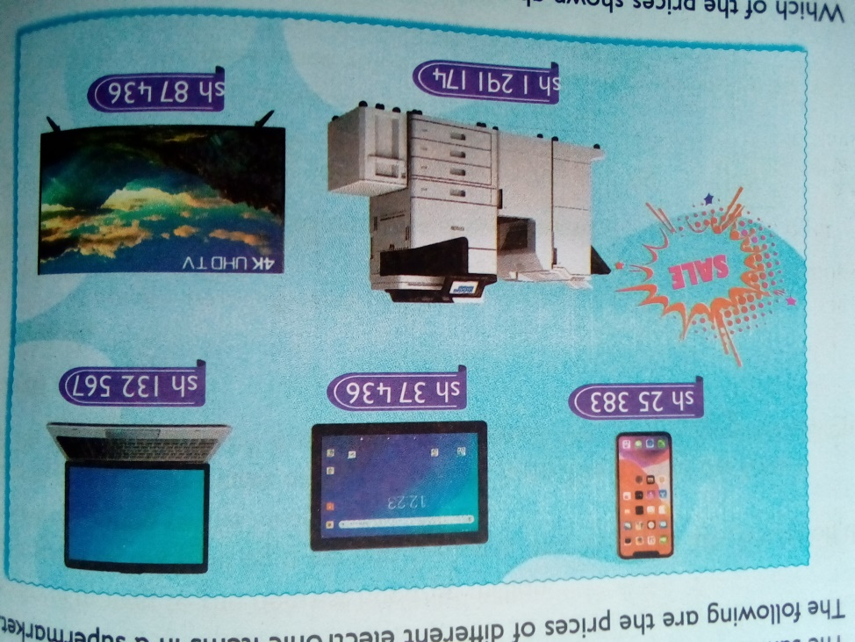Olive went to a supermarket to buy digital devices. She saw them displayed as follows:
   1. What was the price of a mobile phone? ( 1mk)
   2. Of the 5 items, which one was the biggest in size? ( 1mk)
   3. How much more was the printer than the laptop?( 1 mk)
2. Arrange the following numbers in ascending order. ( 1mks)

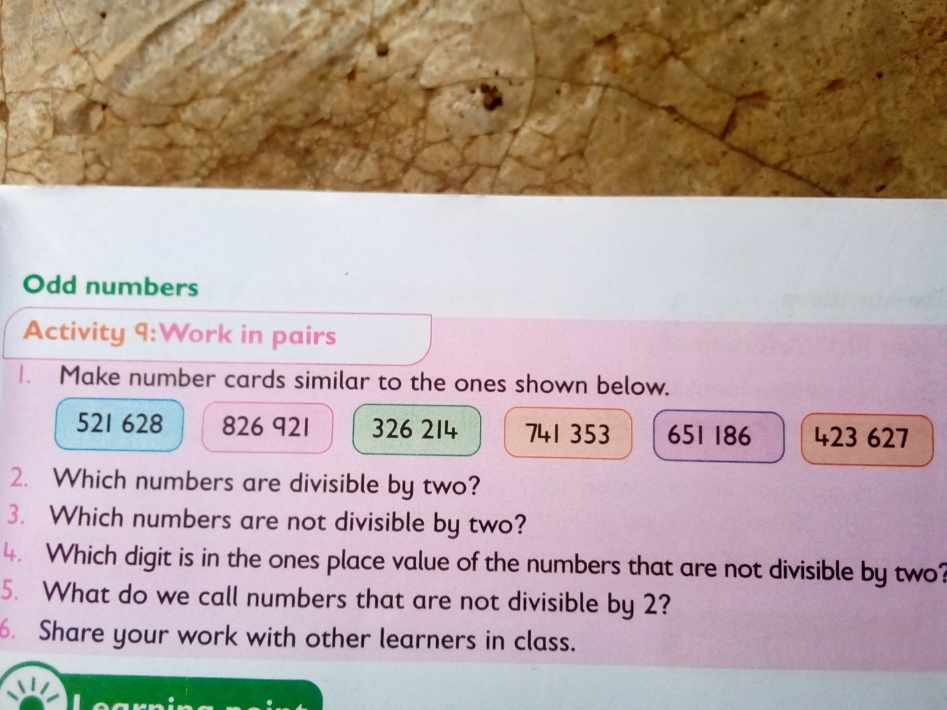

1. What is the **sum** of **all prime numbers** between **10 and 30**? (2 marks)
2. Work out the following. (2 marks)
$$63-9×12÷4+28$$

3. A certain man won a prize of Kenya shillings sixty million, forty-five thousand, two hundred and ninety. What is this prize written in symbols? **(1mk)**
4. What is the sum of total values of the digits in the hundreds and ten thousands position in the number 740,536? **(2mk)**
5. Work out: (2mk)

45-7x6÷ 12

1. Nagoya worked out the difference of LCM of 12 and 24 and the G.C.D of 36 and 54. What answer did he get? **(2mk)**
2. The price of a car is sh.4, 990,675. How much is the amount rounded off to the nearest thousands? **(1mk)**
3. What is the smallest number that can be subtracted from 40658 to make it divisible by 11? **(1mk).**
4. What is $\frac{2}{3},\frac{5}{6},\frac{3}{4}and\frac{7}{12}$ arranged in increasing order? **(1mk)**

. The figure below represents the net of a solid. The net is folded to form the solid. How many edges, faces and vertices will the solid have? **(3mks)**



No of faces=………………

No of vertices =……………….

No of edges=…………………..

1. Find the area of the figure below. (2mk)



1. A school bus left the school at 4.45 p.m. to transport learners’ home. What was the time in 24hrs clock system? **(1mk)**

1. Work out: **(2mk)**

Tones kilograms

15 450

-6 775

1. A dairy farmer sells 240 000 cm3 of milk every day. How many litres of milk does the farmer sell every day? **(2mk)**
2. What is the value of **x** in the equation? **(2mks)**

5x+3 (x-4) =36

1. Work out. (2mk)

0.072 ÷ 0.6

1. The area of a rectangular plot is 576m2. What is the length of a square with the same area? **(2mk)**
2. Work out the following .( 1mk)

$33\frac{7}{12}+40\frac{2}{3}$

**THE END**