

COMPETENCE BASED CURRICULUM

JUNIOR SCHOOL

FORMATIVE ASSESSMENT

TERM ONE 2024

GRADE 7

**Name……………………………………………………………….………………………………………………**

**Centre ………………………………………………………………………………….......................................**

**Assessment No. ……………………………………………………………… Stream………………………**

**Learner’s Sign……………………………………………………..… Date: ………………..…………………..**

**MATHEMATICS**

FOR EXAMINERS

ASSESSMENT RUBRICS (for official use)

|  |  |  |  |  |
| --- | --- | --- | --- | --- |
| %SCORE RANGE | Below 40 | 40-59 | 60-79 | 80-100 |
| PERFORMANCE LEVEL | Below expectation | Approaching expectations | Meeting expectations | Exceeding expectations |
|  | 1 | 2 | 3 | 4 |

**Answer all the Questions in the spaces provided.**

1. A certain country has a population of fifty million, fifty-five thousand, five hundred and five people. What is this population written in symbols? **(1mk)**

2. What is the sum of tot0LValues of the digits in the hundreds and ten thousands position in the number 740536.? **(2mk)**

3. Work out: (2mk)

45-7x6÷ 12

4. Ngoya worked out the difference of LCM of 12 and 24 and the G.C.D of 36 and 54. What answer did he get? **(2mk)**

5. The price of a car is sh.4990675. How much is the amount rounded off to the nearest thousands? **(1mk)**

6. What is the smallest number that can be subtracted from 40658 to make it divisible by 11? **(1mk).**

7. What is 2/3, 5/6, 3/4 and 7/12 arranged in increasing order? **(2mk)**

8. The perimeter of the square flower garden shown below is 60 metres. Calculate the area of the flower garden. **(2mk)**



9. Calculate the size of angle marked K in the figure drawn below. **(2mk)** 

10. What is the square root of 5? **(2mk)**

11. Solomon bought a tray of eggs for sh.450. on his way home ten eggs broke and he sold the remaining at sh.18 each. How much loss did he incur? **(2mk)**

12. Simplify; (2mk)

4(3n+m) + 2(3n-m) 2M///////////////////3. Calculate the distance round the figure drawn in metres. (2mk)



14. A mason constructed a ramp to take materials to the top of a building 6m high as shown below. The distance between the foot of the ramp and the vertical wall is 8m, what is the length of the ramp. **(2mk)**

15. What is the number 29.34046 rounded off to the nearest thousandths? **(2mk)**

16. The figure below represents the net of a solid. The net is folded to form the solid. How many edges will the solid have? **(1mk)**



17. Find the area of the figure below. (2mk)



18. The table below shows the arrival and departure time for buses from a certain company serving Mombasa to Nakuru.

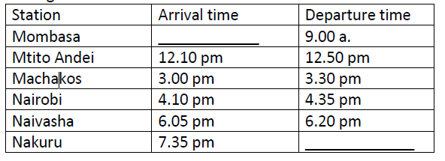

How long does the bus take to travel from Machakos to Naivasha? **(2mk)**

19. Find the area of the circle drawn (take = 𝜋 =22/7 **(2mk)**



20. A school bus left the school at 4.45 p.m to transport learners’ home. What was the time in 24hrs clock system? **(1mk)**

21. Work out: **(2mk)**

Tonnes kilograms

15 450

+6 775

22. A dairy farmer sells 240 000 cm3 of milk every day. How many litres of milk does the farmer sell every day? **(2mk)**

23. What is the value of **x** in the equation. **(2mk)**

5x+3 (x-4)=36

24. Work out. (2mk)

0.072 ÷ 0.6

25. The area of a rectangular plot is 576m2. What is the length of a square with the same area? **(2mk)**

26. The interior angles of a triangle are as shown below.



Find the value of x. (2mk)

27. A cube has a volume of 3.6m3. What is the volume of the cube in cubic centimetres? **(1mk)**

28. Convert 72000m2 into hectares. **(2mk)**