

COMPETENCE BASED CURRICULUM

JUNIOR SCHOOL

FORMATIVE ASSESSMENT

TERM ONE 2024

GRADE 7

**Name……………………………………………………………….………………………………………………**

**Centre ………………………………………………………………………………….......................................**

**Assessment No. ……………………………………………………………… Stream………………………**

**Learner’s Sign……………………………………………………..… Date: ………………..…………………..**

**MATHEMATICS**

**Answer all the Questions in the spaces provided.**

1. A certain country has a population of fifty million, fifty-five thousand, five hundred and five people. What is this population written in symbols? **(1mk)**

50,055,505

2. What is the sum of total values of the digits in the hundreds and ten thousands position in the number 740536.? **(2mk)**

40500

3. Work out: (2mk)

45-7x6÷ 12

41.5

4. Ngoya worked out the difference of LCM of 12 and 24 and the G.C.D of 36 and 54. What answer did he get? **(2mk)**

**6**

5. The price of a car is sh.4990675. How much is the amount rounded off to the nearest thousands? **(1mk)**

**499000**

6. What is the smallest number that can be subtracted from 40658 to make it divisible by 11? **(1mk).**

7. What is 2/3, 5/6, 3/4 and 7/12 arranged in increasing order? **(2mk)**

****8. The perimeter of the square flower garden shown below is 60 metres. Calculate the area of the flower garden. **(2mk)**

**225M2**

9. Calculate the size of angle marked K in the figure drawn below. **(2mk)**

K=600

10. What is the square root of 5? **(2mk)**

**2**

11. Solomon bought a tray of eggs for sh.450. on his way home ten eggs broke and he sold the remaining at sh.18 each. How much loss did he incur? **(2mk)**

**SH 90**

12. Simplify; (2mk)

4(3n+m) + 2(3n-m)

18N+2M

13. Calculate the distance round the figure drawn in metres. (2mk)



14. A mason constructed a ramp to take materials to the top of a building 6m high as shown below. The distance between the foot of the ramp and the vertical wall is 8m, what is the length of the ramp. **(2mk)**

10M

15. What is the number 29.34046 rounded off to the nearest thousandths? **(2mk)**

**29.340**

16. The figure below represents the net of a solid. The net is folded to form the solid. How many edges will the solid have? **(1mk)**

8

17. Find the area of the figure below. (2mk)

180CM2

18. The table below shows the arrival and departure time for buses from a certain company serving Mombasa to Nakuru.

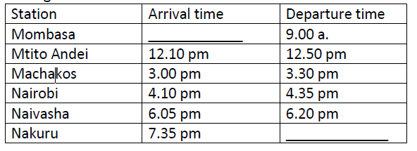

9HRS 20 MINS

How long does the bus take to travel from Machakos to Naivasha? **(2mk)**

19. Find the area of the circle drawn (take = 𝜋 =22/7 **(2mk)**

616CM2

20. A school bus left the school at 4.45 p.m to transport learners’ home. What was the time in 24hrs clock system? **(1mk)**

**1645HRS**

21. Work out: **(2mk)**

Tonnes kilograms

15 450

-6 775

22 225

22. A dairy farmer sells 240 000 cm3 of milk every day. How many litres of milk does the farmer sell every day? **(2mk)**

240L

23. What is the value of **x** in the equation. **(2mk)**

5x+3 (x-4)=36

X=6

24. Work out. (2mk)

0.072 ÷ 0.6

0.12

25. The area of a rectangular plot is 576m2. What is the length of a square with the same area? **(2mk)**

**24**

26. The interior angles of a triangle are as shown below.



Find the value of x. (2mk)

40

27. A cube has a volume of 3.6m3. What is the volume of the cube in cubic centimetres? **(1mk)**

**3600000cm3**

28. Convert 72000m2 into hectares. **(2mk)**

72ha