##### COMPETENCE BASED CURICULLUM

JUNIOR SCHOOL ASSESSMENT

GRADE 7 2024 TERM ONE

**INTEGRATED SCIENCE 1hr 30 minutes**

***SCHOOL:*** *……………………………………………………………………………..……*

***NAME:*** *……………………………………………………..……………………..………..*

***ASSESSMENT NO:*** *……………….……….* ***SIGN:*** *…………....****DATE:*** *………..….*

*ASSESSMENT RUBRICS (for official use)*

|  |  |  |  |  |
| --- | --- | --- | --- | --- |
| %SCORE RANGE | *Below 40* | *40-59* | *60-79* | *80-100* |
| *Mark Score Range* | *1-19* | *20-29* | *30-39* | *40-50* |
| PERFORMANCE LEVEL | *Below expectation* | *Approaching expectations* | *Meeting expectations* | *Exceeding expectations* |
|  | *1* | *2* | *3* | *4* |

**FOR EXAMINERS**

|  |  |
| --- | --- |
| Out of | 50 Marks |
| Learner’s score |  |
| Percentage score (%) |  |
| PERFORMANCE LEVEL |  |

INSTRUCTIONS: *Answer all questions in the spaces provided.*

*QUESTIONS*

1. What are the three components of integrated science? ( 3 mks)
2. …………………………………………………
3. **…………………………………………………
4. 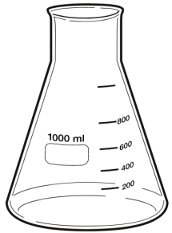…………………………………………………
5. Name the lab apparatus below. (3 mks)

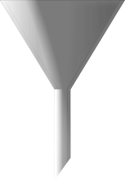

1. Name three careers that are related to the knowledge and skills gained in integrated science.( 3 mks)
2. ………………………………………………..
3. ……………………………………………….
4. ……………………………………………….
5. Name two common accidents in the laboratory.(2 mks)
6. …………………………………………
7. …………………………………………
8. Name the apparatus below. **(1mk)**
9. Name the parts R, T and P. **(3mks)**

R……………………………………

T……………………………………

P……………………………………

1. Give the parts of a light microscope used for. **(3mks)**

a.) Reflect light on the stage

b. Holds the slide that has specimen. ………………………………………………

c. Concentrates light on to the stage. ……………………………………………………

##### Outline two safe ways of handling of the Bunsen burner. (2 mks)

1. ………………………………………………………………………..
2. ………………………………………………………………………..

###### Outline two uses of bases. (2 mks)

1. …………………………………………………………………………
2. …………………………………………………………………………
3. 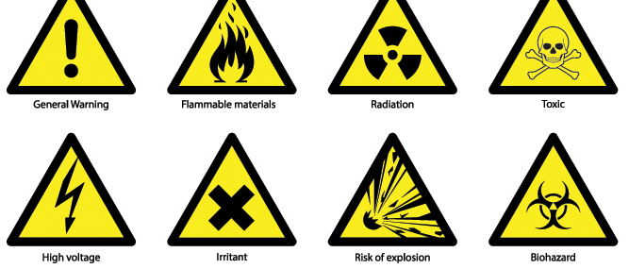Identify the following lab hazards.(3 mks)



1. Indicate their colour in the given solutions. (3 mks)

|  |  |  |  |
| --- | --- | --- | --- |
| Indicator | Acidic solution | Neutral solution | Basic solution |
| Methyl Orange |  |  |  |
| Phenolphthalein |  |  |  |

###### State two uses of acids. (2 mks)

1. ……………………………………………………………………..
2. ……………………………………………………………………….
3. Identify three basic science skills one gains in science practical.(3 mks)
4. ………………………………………….
5. ………………………………………….
6. ………………………………………….
7. Name two apparatus used for measuring length.(2 mks)
8. ………………………………
9. ………………………………
10. Give two differences between luminous and non-luminous flame.( 2 mks)

|  |  |
| --- | --- |
| Luminous flame | Non-luminous flame |
|  |  |
|  |  |

1. Grade 7 students had their practical lesson in the laboratory.name two common accidents their Integrated Science teacher taught them. (2 mks)
2. ………………………………………………….
3. ………………………………………………….
4. Name three protective wear for safety in the laboratory.( 3 mks)
5. ……………………………………..
6. …………………………………….
7. ……………………………………...
8. The following table represents basic quantities. Write their SI units and their symbols.(5 mks)

|  |  |  |
| --- | --- | --- |
| quantity | SI Unit | Symbol |
| Length | **Metres** |  |
| Mass | **grammes** | **g** |
| Time |  | **s** |
| Electric current | **Ampheres** | **A** |
| Temperature | **Kelvin** |  |
| Amount of substance |  | **mol** |
| Luminous intensity | **Candela** |  |

1. 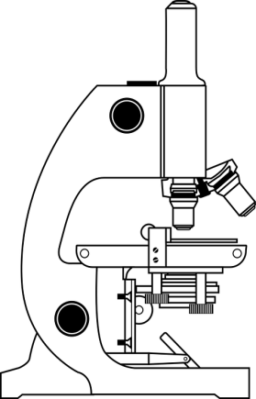Name the following parts of the light microscope.( 3 mks)

**THIS IS THE LAST PRINTED PAGE**

***……………….Every learner counts …………***