COMPETENCE BASED CURRICULUM

JUNIOR SCHOOL

FORMATIVE ASSESSMENT

TERM ONE 2024

GRADE 7

Name……………………………………………………………….………………………………………………

Centre ………………………………………………………………………………….......................................

Assessment No. ……………………………………………………………… Stream………………………

Learner’s Sign……………………………………………………..… Date: ………………..…………………..

**INTEGRATED SCIENCE**

FOR EXAMINERS

ASSESSMENT RUBRICS (for official use)

|  |  |  |  |  |
| --- | --- | --- | --- | --- |
| %SCORE RANGE | Below 40 | 40-59 | 60-79 | 80-100 |
| PERFORMANCE LEVEL | Below expectation | Approaching expectations | Meeting expectations | Exceeding expectations |
|  | 1 | 2 | 3 | 4 |

* + 1. Name the following instruments. (6 mks)

|  |  |  |
| --- | --- | --- |
|  |  |  |
|  |  |  |

##### State three safe ways of Handling common laboratory apparatus and instruments (3 mks).

1. ………………………………………………………………………
2. ………………………………………………………………………
3. ……………………………………………………………………..

1. Name four common accidents in the laboratory.(4 mks)
2. …………………………………………………….
3. …………………………………………………….
4. …………………………………………………….
5. …………………………………………………….
6. Name four protective wear for safety in the laboratory.(4 mks)
7. ………………………………………………………………
8. ……………………………………………………………...
9. ………………………………………………………………
10. ……………………………………………………………...
11. Name three laboratory apparatus used for measuring mass of substances.(3 mks)
12. ………………………………
13. ……………………………….
14. ………………………………..
15. Name three apparatus used for measuring length.(3mks)
16. ………………………………….
17. …………………………………
18. ………………………………….
19. Name the apparatus below. (1mk)



1. Name the parts R, T and P above. (3mks)

R-………………………………………………..

T-………………………………………………..

P-………………………………………………..

1. Give four differences between luminous and non-luminous flame.(8 mks)

|  |  |
| --- | --- |
| Luminous flame | Non-luminous flame |
|  |  |
|  |  |
|  |  |
|  |  |

1. Name the following parts of the light microscope.( 5 mks)

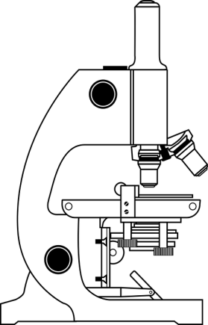

1. Grade 8 students had their practical lesson in the laboratory.name two common accidents their Integrated Science teacher taught them. (2 mks)
2. …………………………………….
3. …………………………………….
4. …………………………………….
5. …………………………………….
6. Name three protective wear for safety in the laboratory.( 3 mks)
7. ………………………………………………
8. ………………………………………………
9. ……………………………………………….
10. Calculate the area of the Circle whose diameter is 14cm. (2 mks)

14cm

##### Outline three safe ways of handling of the Bunsen burner. (3 mks)

1. …………………………………………………………………………
2. …………………………………………………………………………
3. …………………………………………………………………………

THE END