COMPETENCE BASED CURRICULUM
JUNIOR SCHOOL
FORMATIVE ASSESSMENT
TERM ONE 2024
GRADE 7

Name……………………………………………….………………………………………………
Centre ………………………………………………………………….......................................
Assessment No. ……………………………………………… Stream………………………
Learner’s Sign……………………………………..… Date: ………………..…………………..
INTEGRATED SCIENCE
FOR EXAMINERS

ASSESSMENT RUBRICS (for official use)
%SCORE RANGE | Below 40 | 40-59 | 60-79 | 80-100
PERFORMANCE LEVEL | Below expectation | Approaching expectations | Meeting expectations | Exceeding expectations
 | 1 | 2 | 3 | 4

- State three components of integrated science. (3 mks)
- ……………………………………….
- ………………………………………..
- ………………………………………..
- Mention three importance of learning integrated science. (3 mks)
- …………………………………………………………………………
- …………………………………………………………………………
- ………………………………………………………………………….
- How Is Integrated Science useful in the following areas? (4 mks)

  - Transportation.
………………………………………………………………………………………………………………………………………………………………………………

  - Medicine.
………………………………………………………………………………………………………………………………………………………………………………

  - Agriculture.
………………………………………………………………………………………………………………………………………………………………………………

  - Communication.
………………………………………………………………………………………………………………………………………………………………………………

  - Construction.
……………………………………………………………………………………………………………………………………………………………………….……..
- Identify one accident caused by the following hazard. (4 mks)

Hazard | Accident caused.
Acids and bases (chemicals)
Corrosives.
Electrical hazards (heating apparatus)
Glass apparatus

- What is the meaning of the following hazard symbol? (6 mks)
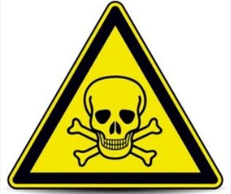
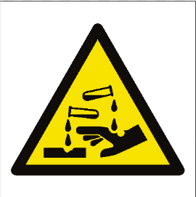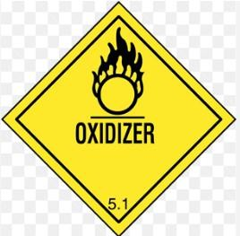
……………………………… ………………………… …………………….…

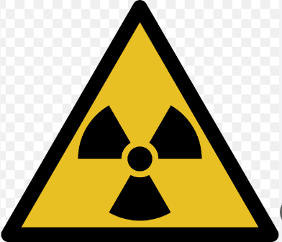
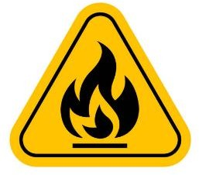

…………………………… …………………………… ………………….……..

Mention four components of a first aid kit. (4 mks)
- …………………………………………………
- …………………………………………………
- …………………………………………………
- …………………………………………………

When working in the laboratory, you must observe the following safety rules: Namely? (4 mks)
  - ………………………………………………………………………
  - ……………………………………………………………………….
  - ……………………………………………………………………….
  - ………………………………………………………………………..
7. Name four scientific skill one attains through learning integrated science.(4 mks)
- ………………………………………………………….
- ………………………………………………………….
- …………………………………………………………..
- …………………………………………………………...

- State four Information that are found on a packaging label. (4 mks)
- ……………………………………………………..
- ……………………………………………………..
- ……………………………………………………..
- ……………………………………………………..

Differentiate between Basic quantities and derived quantities. (4 mks)
…………………………………………………………………………………………………………………………………………………………………………………………………………………………………………………………………………………………………………………………………………………………………………
- State the SI unit and symbol for the following quantities.(10 mks)
Basic quantity | SI unit | Symbol
Mass
Length
Time
Temperature
Electric current

- What is the temperature reading in the following thermometer? (1 mk)
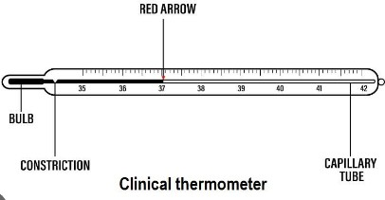

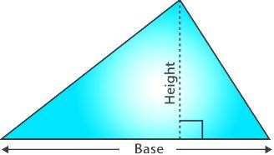
- Work out the area of the following triangle. (3 mks)

20cm

30cm

- State the Functions of the different parts of the Microscope.(4 mks)

 | PART | USE/FUNCTION
1 | Eyepiece lens
2 | Body tube
3 | Stage
4 | Arm

- Name the following heating instruments. (5 mks)
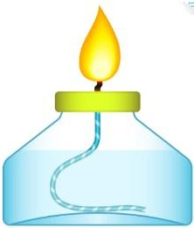 |  | 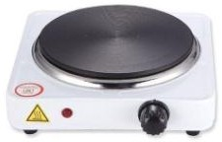 | 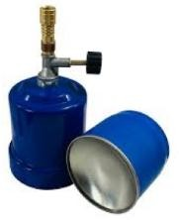 | 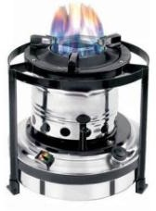

- State the Functions of the parts of a Bunsen burner.( 7 mks)

Part | Function
Collar
Air hole
Chimney
(barrel)
Base
Gas hose
Flame
Gas inlet

