COMPETENCE BASED CURRICULUM

JUNIOR SCHOOL

FORMATIVE ASSESSMENT

TERM ONE 2024

GRADE 7

MARKING SCHEME

**INTEGRATED SCIENCE**

* + 1. Name the following instruments. (6 mks)

|  |  |  |
| --- | --- | --- |
| *Conical flask* | *Syringe* | *Beaker* |
| *Burette* | *Volumetric flask* | *Pipette* |

##### State three safe ways of Handling common laboratory apparatus and instruments (3 mks).

* 1. Handle all glass material carefully. Breakages are dangerous and may result in losing important materials.
  2. Place flasks and beakers on a gauze mat or wire gauze when heating over a Bunsen burner flame.
  3. When diluting concentrated acids, use thin-walled glassware since the heat evolved by the procedure often cracks thick glassware.
  4. Number containers and their corresponding ground glass stoppers to ensure direct matching when you replace the stopper.
  5. All chemicals should be well labelled and stored in the right place using proper containers.

1. Name four common accidents in the laboratory.(4 mks)
2. Cuts
3. burns
4. Fractures
5. scalds
6. Name four protective wear for safety in the laboratory.(4 mks)
7. Gloves
8. Overall
9. Safety goggles
10. Facemask
11. Headgear
12. Name three laboratory apparatus used for measuring mass of substances.(3 mks)
13. Electric balance
14. Double beam balance
15. Triple beam balance
16. Name three apparatus used for measuring length.(3mks)
17. Metre rule, rulers, tape measure, Vernier callipers
18. Name the apparatus below. (1mk)



Bunsen burner

1. Name the parts R, T and P above . (3mks)

R-gas horse/gas pipe

T-air hole/air inlet

P-chimney

1. Give four differences between luminous and non-luminous flame.(8 mks)

|  |  |
| --- | --- |
| Luminous flame | Non-luminous flame |
| Yellow/orange in colour | Blue in colours |
| Used for lighting | Used for heating |
| Has 4 regions and burns quietly | Has 3 regions and noisy |
| Produced when air hole is closed | Produced when air hole is open |
| Produces soot | Does not produce soot |
| Its wavy and large | Its straight |

1. Name the following parts of the light microscope.( 5 mks)

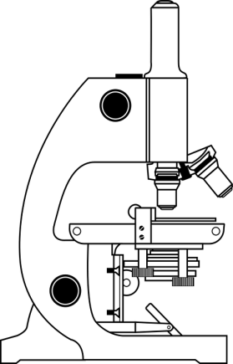

Eye-piece lens

Body tube

Stage

Mirror

Base

1. Grade 8 students had their practical lesson in the laboratory.name two common accidents their Integrated Science teacher taught them. (2 mks)
2. Burns, corrosion
3. Falls and fractures
4. Fires and explosions
5. Cuts and scalds
6. Name three protective wear for safety in the laboratory.( 3 mks)
7. Gloves
8. Overall
9. Safety goggles
10. Facemask
11. Headgear
12. Calculate the area of the Circle whose diameter is 14cm. (2 mks)

14cm

Area = 𝜋𝑟2

Area= $\frac{22}{7}$*7cm*7cm

Area=154cm2

##### Outline three safe ways of handling of the Bunsen burner. (3 mks)

1. Always turn off the Bunsen burner after use.
2. Always make sure that flammable liquids and combustible materials are not near the Bunsen burner to avoid the risk of unwanted fires and explosions.
3. When lighting the gas, have your strikers ready to avoid excess gas leakage that might lead to an explosion.

THE END