COMPETENCE BASED CURRICULUM
JUNIOR SCHOOL
FORMATIVE ASSESSMENT
TERM ONE 2024
GRADE 7

Name……………………………………………….………………………………………………
Centre ………………………………………………………………….......................................
Assessment No. ……………………………………………… Stream………………………
Learner’s Sign……………………………………..… Date: ………………..…………………..
INTEGRATED SCIENCE

- State three components of integrated science. (3 mks)
- physics,
- chemistry,
- biology,
- earth science and
- astronomy
- health education
- nutrition
- Mention three importance of learning integrated science. (3 mks)
- Integrated Science provides learners with an opportunity to measure their ability in science.
- It prepares a learner to study science at higher levels and even choose it as a career.
- It provides learners with the required skills, knowledge and attitudes necessary for specialization in Applied Sciences as well as Pure sciences (Physics, chemistry and Biology), and Careers and technology studies (CTS) offered in the Science Technology Engineering and Mathematics (STEM) pathway at the senior school level.
- How Is Integrated Science useful in the following areas? (4 mks)

  - Transportation.
Science has made the world a global village for example, bicycles, cars and aircrafts are invented of science. Therefore, people and goods can be transported easily and faster.

  - Medicine.
Most equipment used in medical field are scientific inventions. Examples include stretchers, electrocardiogram (ECG) machines and magnetic resonance imaging (MRI) machines etc.

  - Agriculture.
In agriculture field science has major contributions such as the machines like tractors, drip irrigation system, sprinklers irrigation system among others.

  - Communication.
Mobile phones and computers are scientific inventions used majorly in communication.

  - Construction.
Construction of building is based on science and technology. Machines used in construction works such as motor graders, bulldozers are scientific inventions.
- Identify one accident caused by the following hazard. (4 mks)

Hazard | Accident caused.
Acids and bases (chemicals) | - These can irritate or burn the eyes and the skin.  - They can also cause respiratory complications.
Corrosives. | - These can cause severe burns on contact.
Electrical hazards (heating  apparatus) | - Electricity can cause electric shock, burns, fires  and even explosions.
Glass apparatus | - These can cause cuts and bruises.

- What is the meaning of the following hazard symbol? (6 mks)

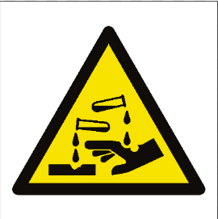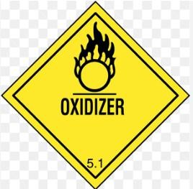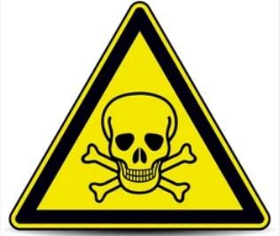
Corrosive
oxidiser poisonous

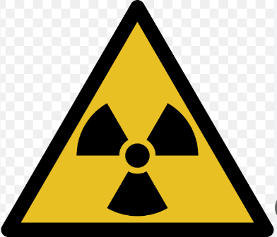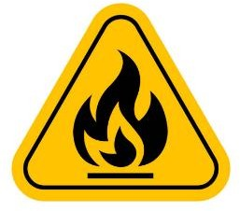

Radioactive flammable
Carcinogenic

Mention four components of a first aid kit. (4 mks)
- An instruction manual giving general guidance.
- Individually wrapped sterile adhesive dressings in a variety of sizes.
- Sterile eye pads with bandages for attachment.
- Triangular bandages.
- Safety pins.
- A bottle that contains eye drops.
- A First Aid manual.
- Scissors.
- Gloves.
- Antiseptic.

When working in the laboratory, you must observe the following safety rules: Namely? (4 mks)
- Work carefully as carelessness can cause accidents as well as inaccurate results.
- Wear gloves, laboratory aprons and safety glasses.
- Never eat or drink in the laboratory.
- Tie back loose hair, roll back and secure open sleeves and neckties and make sure you wear shoes that fully cover your feet.
- Do not carry out laboratory experiments at home or in the dormitories unless directed to do so by your class teacher.
- Carefully read chemical labels and understand the hazard symbol on them.
- Listen carefully to your teacher’s instructions on when and how to use safety equipment such as glasses, protective aprons, fire extinguishers and fire blankets.
- Make sure you know where the nearest fire alarm is in your school laboratory.
- Do not begin an experiment until the teacher instructs you to do so.
- Do not touch substances unless the teacher instructs you to do so. What looks harmless may be dangerous.
- Wash your hands with soap and running water after handling chemical substances. Some chemical substances are poisonous.
- Heat materials in suitable containers only, such as Pyrex glass container that can resist breakage.
- Always keep the open end of the test tube pointed away from the learners and yourself when heating chemicals because the fumes produced may be harmful.
- Pick up hot objects carefully using tongs or insulated materials.
- Make sure that you turn off the heat source when not in use to conserve energy.
- Always unplug electric cords by pulling out the plug and not the cord.
- Check that there are no flammable substances near the burner. Flammable substances will cause fire if exposed to a flame.
- After each experiment, tidy up your working area, clean all equipment and put them in their respective storage areas.
- Report any accidents, broken equipment and damaged facilities to your teacher. In this way, you will be taking responsibility for your safety and for those who use the laboratory after you.
- If a chemical gets into your eyes, wash it out with running water for about 12 minutes and then visit a health centre or hospital for further medical attention.
- If you inhale poisonous gases or vapour, move outside the laboratory for fresh air.Immediately seek medical assistance.
7. Name four scientific skill one attains through learning integrated science.(4 mks)
- Manipulative skills and abilities.
- Observation skills.
- Classification skills.
- Measuring skills.
- Communication skills.
- Predicting skills.
- Conclusion skills.

- State four Information that are found on a packaging label. (4 mks)
- Name under which the product sells.
- The manufacture and expiry date.
- List of ingredients
- The quantity of product in the package.
- Any special storage instructions.
- Instructions for use, where necessary.

Differentiate between Basic quantities and derived quantities. (4 mks)
A basic quantity is one whose unit can be defined without referring to other quantities while Derived quantities are quantities that are calculated from two or more measurements.
- State the SI unit and symbol for the following quantities.(10 mks)
Basic quantity | SI unit | Symbol
Mass | Kilogram | kg
Length | Metre | m
Time | Second | s
Temperature | Kelvin | K
Electric current | Ampere | A

- What is the temperature reading in the following thermometer? (1 mk)
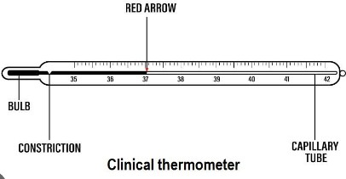
37^{O}C

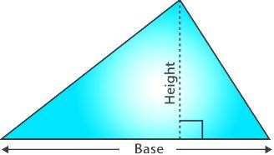
- Work out the area of the following triangle. (3 mks)

20cm

30cm

Area =¹/₂ x base x perpendicular height
=¹/₂ bh
300cm²

- State the Functions of the different parts of the Microscope.(4 mks)

 | PART | USE/FUNCTION
1 | Eyepiece lens | - Used to observe specimen under the microscope.
2 | Body tube | - It holds the eyepiece lens and the objective lens in position  allowing light from the specimen to pass to the observer.
3 | Stage | - It is where the specimen is placed during examination or  viewing.
4 | Arm | - It supports the body tube and the lenses.  - It is also used to carry the microscope when moving it from one place to another.

- Name the following heating instruments. (5 mks)

Spirit lamp | Candle | Electric hot plate | Portable burner | Kerosene stove
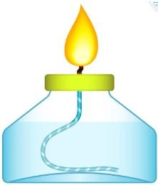 |  | 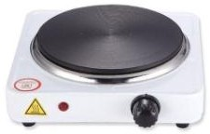 | 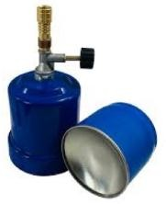 | 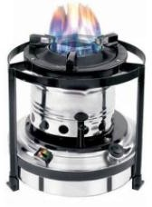

- State the Functions of the parts of a Bunsen burner.( 7 mks)

Part | Function
Collar | Regulates amount of air entering the Bunsen burner through the air hole.
Air hole | Allows air to enter the chimney. (air mixes with the gas making flame hotter and  blue.
Chimney  (barrel) | Raises the flame to a suitable height for burning.
Base | Supports the Bunsen burner and prevent it from toppling.
Gas hose | The flexible hose pipe connects the Bunsen burner and the gas tap.
Flame | A hot glowing mass of ignited gas that is generated by something on fire.
Gas inlet | Controls the flow of gas to the Bunsen burner.

