COMPETENCE BASED CURICULLUM
JUNIOR SCHOOL ASSESSMENT
GRADE 7 2024 TERM ONE

CREATIVE ARTS 2HRS
SCHOOL: ……………………………………………………………………………..……
NAME: ……………………………………………………..……………………..………..
ASSESSMENT NO: ……………….………. SIGN: …....DATE: ………..….
ASSESSMENT RUBRICS (for official use)
%SCORE RANGE | Below 40 | 40-59 | 60-79 | 80-100
PERFORMANCE LEVEL | Below expectation | Approaching expectations | Meeting expectations | Exceeding expectations
 | 1 | 2 | 3 | 4

FOR EXAMINERS
Out of | 50 Marks
Learner’s score
Percentage score (%)
PERFORMANCE LEVEL
INSTRUCTIONS: Answer all questions in the spaces provided.

Answer all questions

- What is art?(2 mks)
………………………………………………………………………………………………………………………………………………………………………..
- Name five senses through which Art can be experienced. ( 5 mks)
- …………………………………
- …………………………………
- …………………………………
- …………………………………
- …………………………………
- What is entrepreneurship?( 2mks)
…………………………………………………………………………………………………………………………………………………………………………………………

Arts can be divided into four categories namely (4 mks)
- ……………………………………………..
- ……………………………………………..
- ……………………………………………
- ……………………………………………
- Outline four research area where you can get information on Categories of Arts.(4 mks)
- …………………………………………………………………………..
- …………………………………………………………………………..
- ………………………………………………………………………….
- …………………………………………………………………………..

- State 3 importance of doing research on categories of the arts. (3 mks)
- …………………………………………………………………………………..
- ………………………………………………………………………………….
- ………………………………………………………………………………….
- State three factors to be considered when preparing and making the presentation.( 3mks)
- …………………………………………………………….…………………
- ………………………………………………………………………………
- ……………………………………………………………………………….
- State four elements of a presentation.(4 mks)
- ……………………………………….
- ………………………………………..
- ………………………………………..
- ………………………………………..

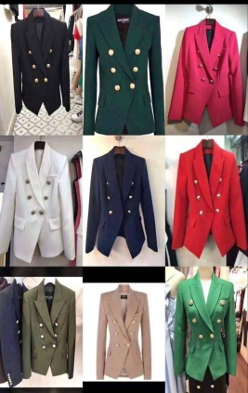
- Match the art activity to the picture. ( 4 mks)

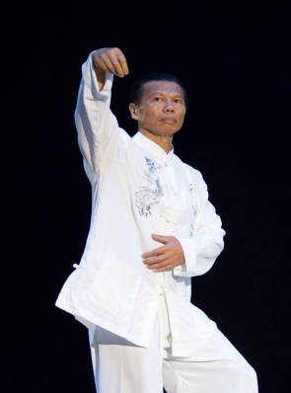

FASHION AND DESIGN
PERFORMING ART
MARTIAL ART
LITERACY ART

- Give two examples of career opportunities in fine arts(2 mks)

- ………………………………………
- ………………………………………

- Name two examples of the following:
  - Visual arts.(2 mks)
  - ………………………………
  - ……………………………..
  - Performing arts.( 2 mks)
  - ……………………………….
  - ……………………………
- What are 2D art forms?(2 mks)
……………………………………………………………………………………………………………………………………………………
- Outline two examples of 2D Art forms :(2 mks)
- ………………………..
- ………………………..
- ………………………..

- Draw a box from perspective and clearly show the components. (3 mks)

- Define (6 mks)

Hue.
………………………………………………………………………………………………………………………………………………………….

Intensity.
……………………………………………………………………………………………………………………………………………………………………

  - Value.
…………………………………………………………………………………………………………………………………………………………………..

- What is music? (2mks)

……………………………………………………………………………………………………………………………………………………………………

- Identify the three sections of a narrative (3mks)

- ……………………………………
- ……………………………………
- …………………………………….

- Write down two importance of studying performing arts to you? (2mks)
- ………………………………………………………………………….
- ………………………………………………………………………….

- What is the difference between performing arts and other arts? (2mks)
…………………………………………………………………………………………………………………………………………………………………………………………………………………………………………………………………………………………………………………………………………

- Write down three elements of performing arts. (3mks)
- ……………………………………………
- …………………………………………...
- …………………………………………..
- Any kind of setting or space and during any time period.
- Fill in the chart below;
………………… ……………………..
- Name the following sol-fa notes signs.
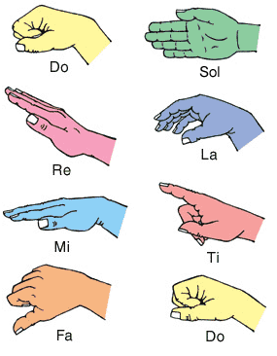

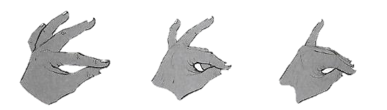
- Look at the hand signs below for notes B,A and G. Put the notes B A G under the correct hand sign.

- How can a song benefit a singer and listeners?
- ………………………………………………………………………..
- ………………………………….…………………………………….
- ………………………………………………………………………
- When performing a dance or a song adjudicators/judges check on;
- ………………………………………………………………………..
- ………………………………………………………………………..
- ………………………………………………………………………..
- Name two categories of participants in a dance presentation:
- ………………………………………….
- …………………………………………
- Define the following terms
  - Pitch: ……………………………………………………………………………………………………………………………………………………………..
  - Volume: …………………………………………………………………………………………………………………………………………………………….
  - Tempo; ……………………………………………………………………………………………………………………………………………………………..
  - Dance formation: ………………………………………………………………………………………………………………………………………………………………
- What is body adornment?
………………………………………………………………………………………………………………………………………………………………
- What is the meaning of: (2mks)

  - An artiste:
……………………………………………………………………………………………………………………………………………………………………

  - Audience
……………………………………………………………………………………………………………………………………………………………………
- Draw a drum and name the following parts; skin membrane, sling, sound box and tuning laces. (4mks)

- Drama can be described as?:
………………………………………………………………………………………………………………………………………………………………. (2mks)

THIS IS THE LAST PRINTED PAGE
……………….Every learner counts …………

