COMPETENCE BASED CURICULLUM

JUNIOR SCHOOL ASSESSMENT
GRADE 7 2024 TERM ONE

CREATIVE ARTS 2hrs
SCHOOL: ……………………………………………………………………………..……
NAME: ……………………………………………………..……………………..………..
ASSESSMENT NO: ……………….………. SIGN: …....DATE: ………..….

- What is art?(2 mks)
Art is a general term used to describe expression of creative human skills, Feelings and imaginations.
- Name five senses through which Art can be experienced. ( 5 mks)
- Sight.
- Hearing.
- Touch.
- Smell.
- Taste.
- What is entrepreneurship?( 2mks)
Entrepreneurship refers to the process of setting up, developing and running a business.

Arts can be divided into four categories namely (4 mks)
- Visual arts.
- Applied arts.
- Performing arts.
- Literary or written arts.
- Outline four research area where you can get information on Categories of Arts.(4 mks)
- Internet.
- Books.
- Magazines.
- Artists that you know.
- Libraries.
- Museums.
- Art galleries.
- State 3 importance of doing research on categories of the arts. (3 mks)
- Main reason is to get new information about a specific area.
- It also helps you get different views and what people think about an issue.
- It also enables you to find out about the wide are in the arts.
- It helps one by developing a career in arts.
- It helps you to understand how to develop entrepreneurial skills when still in school.
- State three factors to be considered when preparing and making the presentation.( 3mks)
- Relevance of content.
- Oral presentation.
- Teamwork
- Message/theme
- Place/position
- Resources
- Type of presentation to be made(oral, written, display etc)
- State four elements of a presentation.(4 mks)
- Speaker/Presenter
- Audience
- Resources
- Content

- Match the art activity to the picture. ( 4 mks)

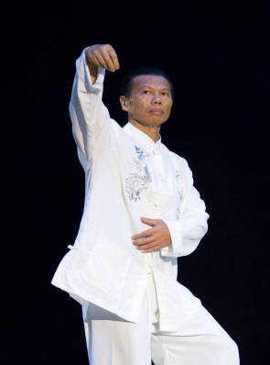

FASHION AND DESIGN
PERFORMING ART
MARTIAL ART
LITERACY ART

- Give two examples of career opportunities in fine arts(2 mks)

- Painter.
- Sculptor.
- Ceramist.
- Courtroom sketch artist.
- Portrait artist.
- Craft artist.
- Mixed media artist.
- Name two examples of the following:
  - Visual arts.(2 mks)
  - Drawing.
  - Painting.
  - Sculpture.
  - Montage.
  - collage
  - Performing arts.( 2 mks)
  - Music.
  - Dance.
  - Theatre.
  - Puppet shows.
  - Poetry.
  - Spoken word.
  - Electronic production.
  - Verse.
  - Narrative

- What are 2D art forms?(2 mks)
These are art forms that only have length and width. The artworks are done on a flat surface and have no depth.

- Outline two examples of 2D Art forms :(2 mks)
- Drawing.
- Painting.
- Montage.

- Draw a box from perspective and clearly show the components. (3 mks)

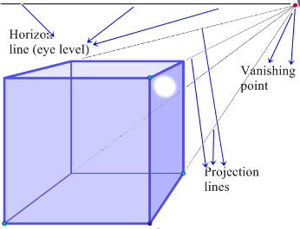

- Define (6 mks)

Hue.
This is a colour property that differentiates one colour from another. This is the same name of a colour.

Intensity.
Intensity of a colour refers to the purity or saturation of a colour.it is the brightness or dullness of a colour.

  - Value.
Value refers to the lightness or darkness of a colour.

- What is music? (2mks)

Music is a collection of coordinated sound or sounds. Making music is the process of putting sounds and tones in an order, often combining them to create a unified composition.

- Identify the three sections of a narrative (3mks)

- exposition,
- rising action,
- climax,
- falling action
- resolution

- Write down two importance of studying performing arts to you? (2mks)
- While Performing Arts allow children to develop creative passions,
- They simultaneously teach children language and communication skills,
- Helping them to communicate effectively with others with confidence.
- Performing Arts are all about self-expression,
- exploring alternative options and
- embracing individuality ETC

- What is the difference between performing arts and other arts? (2mks)
The performing arts are arts such as music, dance, and drama which are performed for an audience. They are different from the visual arts, which are the use of paint, canvas or various materials to create physical or static art objects.

- Write down three elements of performing arts. (3mks)
- Time,
- Space,
- Body, and
- Presence of the artist,
- Relation between the creator and the public.
- Place in the street,
- Any kind of setting or space and during any time period.
- Fill in the chart below;
CROTCHET SEMIBREVE
- Name the following sol-fa notes signs.
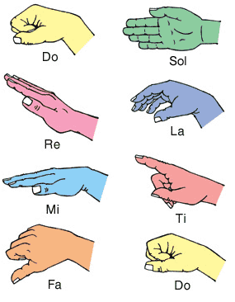

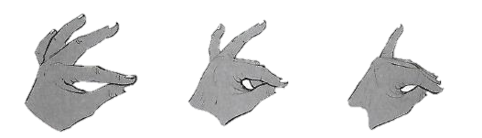
- Look at the hand signs below for notes B,A and G. Put the notes B A G under the correct hand sign.

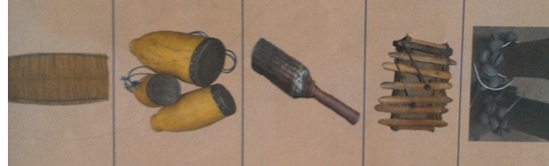
A
G
B
- How can a song benefit a singer and listeners?
- Stress reliever
- Earn income
- Entertaining
- Pass time
- Hobby and improving talent etc.
- Educate and enlighten
- Embrace moral values etc.
- When performing a dance or a song adjudicators/judges check on;
- Tonal variation
- Adornments
- Accompaniment
- Volume
- Pitch
- Message/ theme
- Articulation of words and voices
- Harmony etc.
- Costumes
- Name two categories of participants in a dance presentation:
- Presenter
- Listeners
- Define the following terms
  - Pitch: highness or lowness of sound
  - Volume: loudness or softness of a sound
  - Tempo; speed of a sound
  - Dance formation: how performers are arranged in a dance/ presentation
- What is body adornment?
The make ups or jewellery worn while performing
- What is the meaning of: (2mks)

  - An artiste:
It is a professional entertainer, especially a singer or dancer

  - Audience
Audience in the arts refers to an individual's. Or group's viewing, hearing, reading, and/or listening of an artistic product or products.
- Draw a drum and name the following parts; skin membrane, sling, sound box and tuning laces. (4mks)
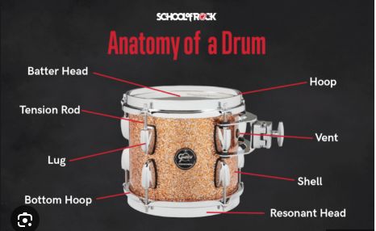

- Drama can be described as?:
the art of composing, writing, acting, or producing plays; a literary composition intended to portray life or character or enact a story, usually involving conflicts and emotions exhibited through action and dialogue, designed for theatrical performance. (2mks)

THIS IS THE LAST PRINTED PAGE
……………….Every learner counts …………

