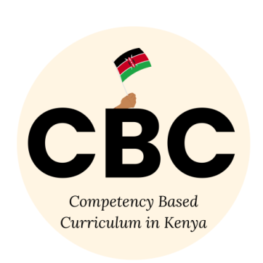
COMPETENCE BASED CURRICULUM
JUNIOR SCHOOL
FORMATIVE ASSESSMENT
TERM ONE 2024
GRADE 7

Name……………………………………………….………………………………………………
Centre ………………………………………………………………….......................................
Assessment No. …………………………………………… Stream………………………
Learner’s Sign…………………………………..… Date: ………………..…………………
CHRISTIAN RELIGIOUS EDUCATION
FOR EXAMINERS

ASSESSMENT RUBRICS (for official use)
%SCORE RANGE | Below 40 | 40-59 | 60-79 | 80-100
PERFORMANCE LEVEL | Below expectation | Approaching expectations | Meeting expectations | Exceeding expectations
 | 1 | 2 | 3 | 4

- Write down values that Christian acquire by learning Christian Religious Education. (3 mks)
- ……………………………………………….
- ……………………………………………….
- ……………………………………………….
- Why should CRE be taught in schools?(3 mks)
- …………………………………………………………………………………
- ………………………………………………………………………………..,.
- ………………………………………………………………………………….
- List down the similarities and differences between the two Biblical accounts of creation. (4 mks)
Similarities (2mks) | Differences (2mks)

- Explain the attribute of God from the two creation accounts. (3 mks)
- ………………..………………………………………………….
- …………………………………………………………………..
- ………………………………………………………………….
- Explain different ways in which people promote and protect the animals, fish and birds.(2 mks)
- …………………………………………………………………………………..
- …………………………………………………………………………………..
- Why is the Bible important to the society?(2 mks)
- ……………………………………………….…………………………………….
- ……………………………………………………………………………………..
- Explain the two dimensions of the Bible. (2 mks)
- ………………………………………………………………………………………………………………………………………………………………………………
- ………………………………………………………………………………………………………………………………………………………………………………
- How can Christians participate in charity work in the community to serve God and others?(2 mks)
- ………………………………………………………………………………………
- ………………………………………………………………………………………
- List the Poetic books of the Old Testament. (4 mks)
- ………………………………………..
- ………………………………………..
- ………………………………………..
- ………………………………………..
- God created us and gave us different unique…………………………………….
- List down two examples of Christian Values;
- …………………………………………………..
- …………………………………………………..

- We become God’s………………………………… when we use our abilities and talents to care for His creation.

- Forcing young children into difficult tasks or work for payment is known as child ………………………………………………………

- The disobedience of Adam and Eve led to the…………………………………….. of human beings.
- There is ……………………………..when family members work together and stay in agreement.
- A ……………………………..is a difficult situation that one can find himself or herself in.
- The twelve followers of Jesus Christ were known as ……………………..

- The ability to make good judgement and give good advice on an issue is known as………………………………………………

- God wants us to ………………………………….our elders.

- Name the three men who were thrown in the furnace of fire;
- ……………………………………………………
- ……………………………………………………
- ……………………………………………………..
- Which prophet challenged the prophets of Baal ____________________
- State what is happening in the following pictures people in the bible.
