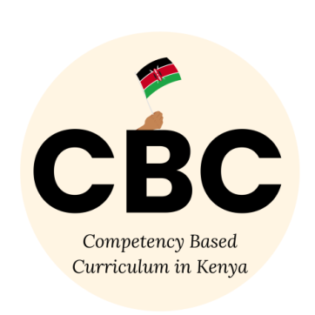
COMPETENCE BASED CURRICULUM
JUNIOR SCHOOL
FORMATIVE ASSESSMENT
TERM ONE 2024
GRADE 7

Name……………………………………………….………………………………………………
Centre ………………………………………………………………….......................................
Assessment No. …………………………………………… Stream………………………
Learner’s Sign…………………………………..… Date: ………………..…………………
CHRISTIAN RELIGIOUS EDUCATION
- Write down values that Christian acquire by learning Christian Religious Education. (3 mks)
- Love, respect ,self-control
- Responsibility, kindness, honesty etc
- Why should CRE be taught in schools?(3 mks)
- It makes one understand that the trinity works as one.
- Moral values you acquire helps you to take care of the environment
- One develops communication skills
- It’s a career subject
- Helps students to appreciate their culture.
- List down the similarities and differences between the two Biblical accounts of creation. (4 mks)
Similarities (2mks) | Differences (2mks)
In both God is the creator | 1st- God rested on the seventh day  2nd- not mentioned
God existed before the creation | 1st- god commanded and everything came into existence  2nd god created man, woman
God is the source of life | ETC

- Explain the attribute of God from the two creation accounts. (3 mks)
- Caring-He saw that it is bad for man to be lonely.
- Orderly- God created everything in six days, each in its own day
- Respectful- he respected the Sabbath day by resting
- Source of life- god breath unto man’s nostrils to give him life. etc
- Explain different ways in which people promote and protect the animals, fish and birds.(2 mks)
- By watering them –giving them safe drinking water
- Cleaning them- to make them free from dust and germs
- Treating and vaccinating them- by treating wounds, diseases and bacteria
- By sheltering them- giving them a good place to live
- By feeding them- providing them with food to eat etc
- Why is the Bible important to the society?(2 mks)
- It teaches moral values and lessons to the society.
- Used for reference and guidelines
- For taking oaths and prayers during events etc
- Explain the two dimensions of the Bible. (2 mks)
- Old Testament-first dimension of the Bible-divided into five categories (Law, Historical, Poetics, Letters, General) books.
- New Testament-second dimension of the Bible- divided into seven categories (Gospel, Prophetic, Historical etc.
- How can Christians participate in charity work in the community to serve God and others?(2 mks)
- Visiting and praying for the sick.
- Cleaning cloths, compound and utensils for the elderly and sick.
- Entertaining the elderly, sick and the children
- Feeding the orphans, elderly and poor’
- Giving offering in church
- Building homes, furniture and houses for the poor and sick etc
- Paying school fees and other necessities for the poor and deceased etc.
- List the Poetic books of the Old Testament. (4 mks)
- Job
- Psalms
- Proverbs
- Songs of songs
- God created us and gave us different unique_image/ talents/ likeness
- List down two examples of Christian Values;
- Love, respect ,self-control
- Responsibility, kindness, honesty etc

- We become God’s children when we use our abilities and talents to care for His creation.

- Forcing young children into difficult tasks or work for payment is known as child _labour

- The disobedience of Adam and Eve led to the sinning of human beings.
- There is peace when family members work together and stay in agreement.
- A challenge is a difficult situation that one can find himself or herself in.
- The twelve followers of Jesus Christ were known as disciples.

- God wants us to obey/ respect/ help our elders.

- Name the three men who were thrown in the furnace of fire;
- Shadrack
- Meshack
- Abednego
- Which prophet challenged the prophets of Baal Prophet Elijah
- State what is happening in the following pictures of people from the Bible.
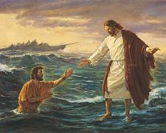
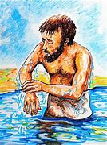

Jesus helping Peter to get out of the water
Naaman dipping himself in River Jordan to cure Leprosy

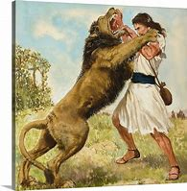
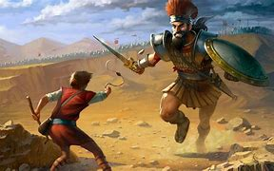

David fighting off Goliath
Samson is killing a lion

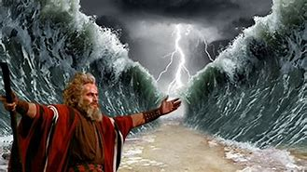

Moses opening the Red Sea

