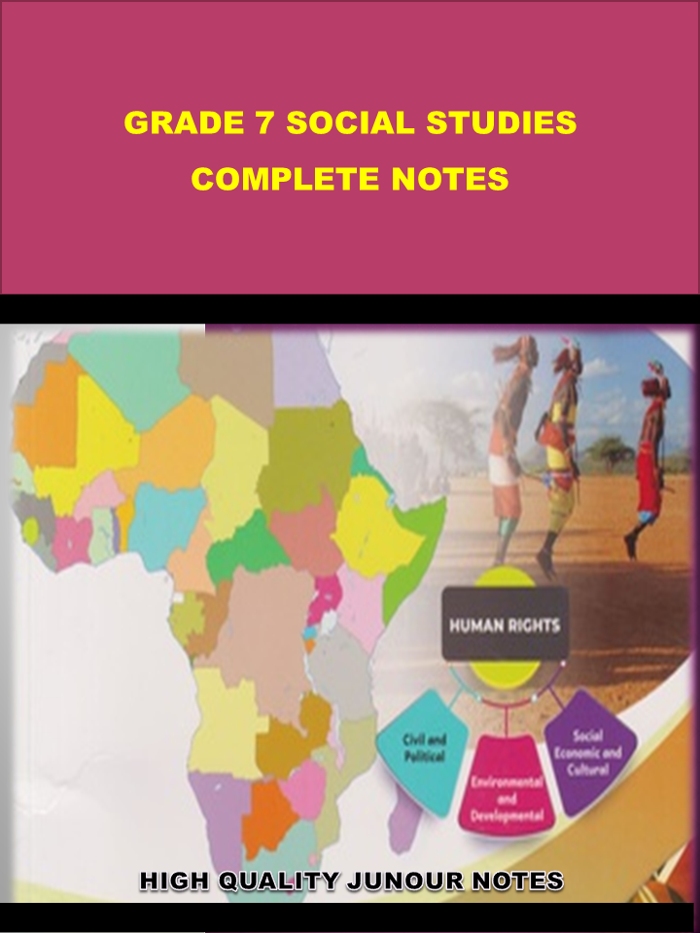
WWW.KENYAPLEX.COM
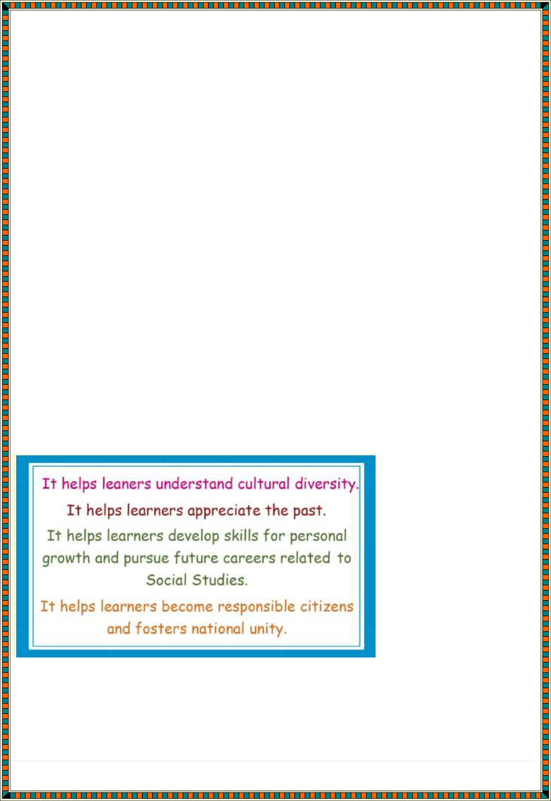
SOCIAL STUDIES
a. Career and entrepreneurial opportunities in Social Studies

The main goal of teaching social studies is to teach students to become good citizens. We are living in a diverse society — one that requires knowledge of social studies to succeed. With a social studies background, children become adults that can participate civilly in our democratic society. Social studies connect students with the real world.
Specific topics within social studies that are studied in school coursework include:
- geography,
- anthropology,
- economics,
- history,
- sociology,
- political science, and
- civics.

Importance of social studies

- Better Reading And Learning
Social studies is one area in education where content integration is key. Students are given reading material that corresponds with the current

learning topics. Giving reading materials in context helps students become better readers. They also become better learners because they are asked to use analysis, critical thinking, and writing to show understanding.

Citizen Responsibilities And Values
How can we expect young people to contribute positively to society, engage in discourse, and thrive in a democratic society if they are not exposed to the topics and aspects of history and life that made society the way it is?
Students need an understanding of history, political science, culture, and all humanities to be able to understand why it is important to be a good citizen.

Cultural Understanding
Students should be exposed to cultures far beyond what they experience personally every day. Not every student has the opportunity to interact with other cultures on a daily basis. We need students to learn about, understand, and appreciate cultural differences if we expect them to have meaningful interactions with people of all backgrounds in the future.

Economic Education
Economics is a crucial part of social studies, whether studied on its own, or as a part of history, anthropology, or political science. By learning economics, young people understand how their financial decisions have an impact on their future, as well as the future of society.

Critical Thinking
Critical thinking is a part of social studies — students are taught to evaluate others’ decisions and make connections between influences and
circumstances. Young people get the opportunity to learn from others’ mistakes through social sciences.

Real-World Understanding
Studying social sciences gives students an understanding of the real world around them. Students learn about places, cultures, and events around the

world, what conspired to make them the way they are, and can make inferences about how the rest of the world works.

Political Skills
From social studies classes, students learn about government, political ideas, country economy and resources, and more. Students gain political skills by analyzing and evaluating existing systems and imaging the future of the place in which they live.

Respect History
History is what made the world the way it is, and it is essential that people study it in order to have an appreciation for and understanding of the way the world works. Learning about history is what makes it possible to learn from the past and plan for the future.

Career opportunities related to social studies Social work
Statistically, and probably unsurprisingly, the majority of Social Studies graduates go on to work in the broad field known as “social work”.

Counselling
Another popular career option for Social Studies graduates is to complete some further education and come a counsellor.

Prison services and probation
As part of your Social Studies degree you’ll look at the legal system and ask important questions about crime and punishment.
If you have a particular interest in this area then a career in the probation or prison service might appeal to you. Roles could be administrative or you could be working in direct contact with offenders and those on probation.

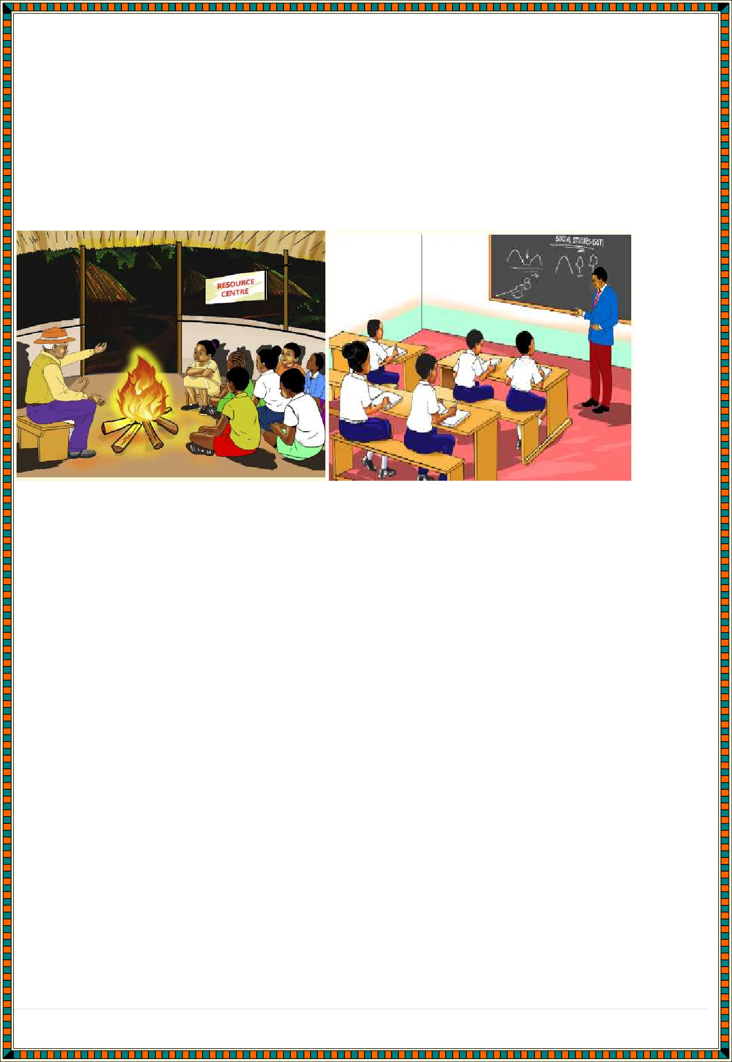
Community development
This is similar to jobs in social work but you’ll be dealing with the community on a larger scale rather than on an individual or family basis.
Roles in community development have the overall goal of improving the lives of a larger group, sometimes within a specific geographical area or people who have specific needs.

Some career opportunities that one would pursue from studying Social Studies in Kenya and globally include
- teaching,
- surveying,
- law,
- archeology,
- political science,
- diplomacy and meteorology.

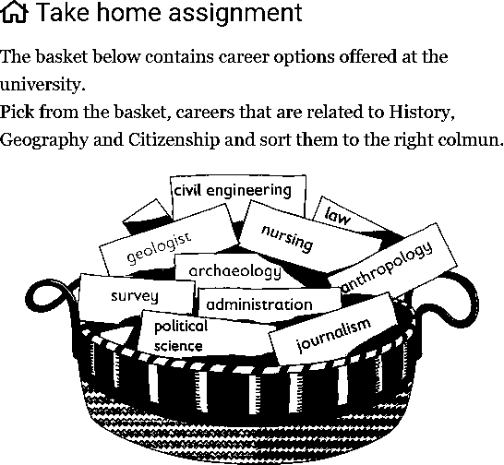

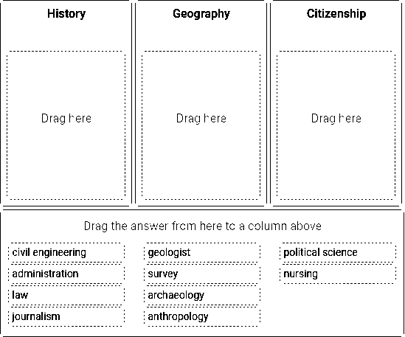

Entrepreneurial opportunities for Social studies in the society
Therefore, we can state with conviction that the social entrepreneurs (individuals, organizations, or groups) are innovative and proactive risk- takers who attempt to create a sustainable community, social, or industry- wide change to address endemic problems. These entrepreneurs identify, assess, and exploit opportunities in an attempt to create social value.
Further, they use a wide range of market-driven resources (and other resources) to create this transformation.
- Social enterprises which serve the financially poor population. In these markets, the profit margins are very low and the risks are high. Further, in certain sectors like microfinance, there is a constant debate as to whether a commercial operation can fulfil the needs of the poorest client groups more effectively than modified NGO models. In this niche, some examples of social entrepreneurship organizations are micro-clinics in low-income zones, affordable irrigation tools to poor farmers, etc.

- New and challenging markets where the entrepreneur is required to incur heavy expenses to stimulate demand and create opportunities. This is due to the prevalent stigma and the challenges faced in acclimatizing people to newer and more complex technologies as well as challenging perceptions about certain services which need to be provided by the state. Some examples are offering counselling services to people living with HIV/AIDS or other socially marginalized groups, micro insurance products for farmers, etc.
- Markets for products which offer environmental benefits but are not fully commercially competitive. Many environment-friendly business lines are completely commercially viable. However, there are many others which are suitable for hybrid social entrepreneurship.

Strategies for addressing Gender stereotype associated with career choices and Entrepreneurial opportunities
A gender stereotype is a generalized view or preconception about attributes, or characteristics that are or ought to be possessed by women and men or the roles that are or should be performed by men and women. Gender stereotypes can be both positive and negative for example, “women are nurturing” or “women are weak”.
Gender stereotyping is the practice of ascribing to an individual woman or man specific attributes, characteristics, or roles by reason only of her or his membership in the social group of women or men.
- revising text books;
- ensuring that teachers receive gender training;
- implementing programmes to encourage girls to pursue education and employment in non-traditional fields;
- undertaking public information and education programmes to change attitudes concerning the roles and status of men and women;
- taking measures to train public officials and the judiciary to ensure that stereotypical prejudices and values do not affect decision-making;

- emphasizing through awareness raising activities the importance of women’s participation in decision making roles;
- adopting measures, including temporary special measures, to eliminate occupational segregation based on gender stereotypes;
- adopting positive measures to expose and modify harmful genders stereotypes within the health sector;
- addressing gender stereotypes/ing that impairs or nullify equality in marriage and family relations, including through implementing comprehensive policy
and awareness raising initiatives designed to overcome stereotypical attitudes about the roles and responsibilities of women and men in family and society

Roles of SST for promotion of Social cohesion
  - Promotion of equality for everyone in the society
  - Enhancing justice for everyone in the society
  - Respect for oneself, and others in their opinions and choices
  - Promoting unity of the society regardless of the differences
  - Creating awareness on the need for social cohesion.
  - Introducing activities that promote social cohesion

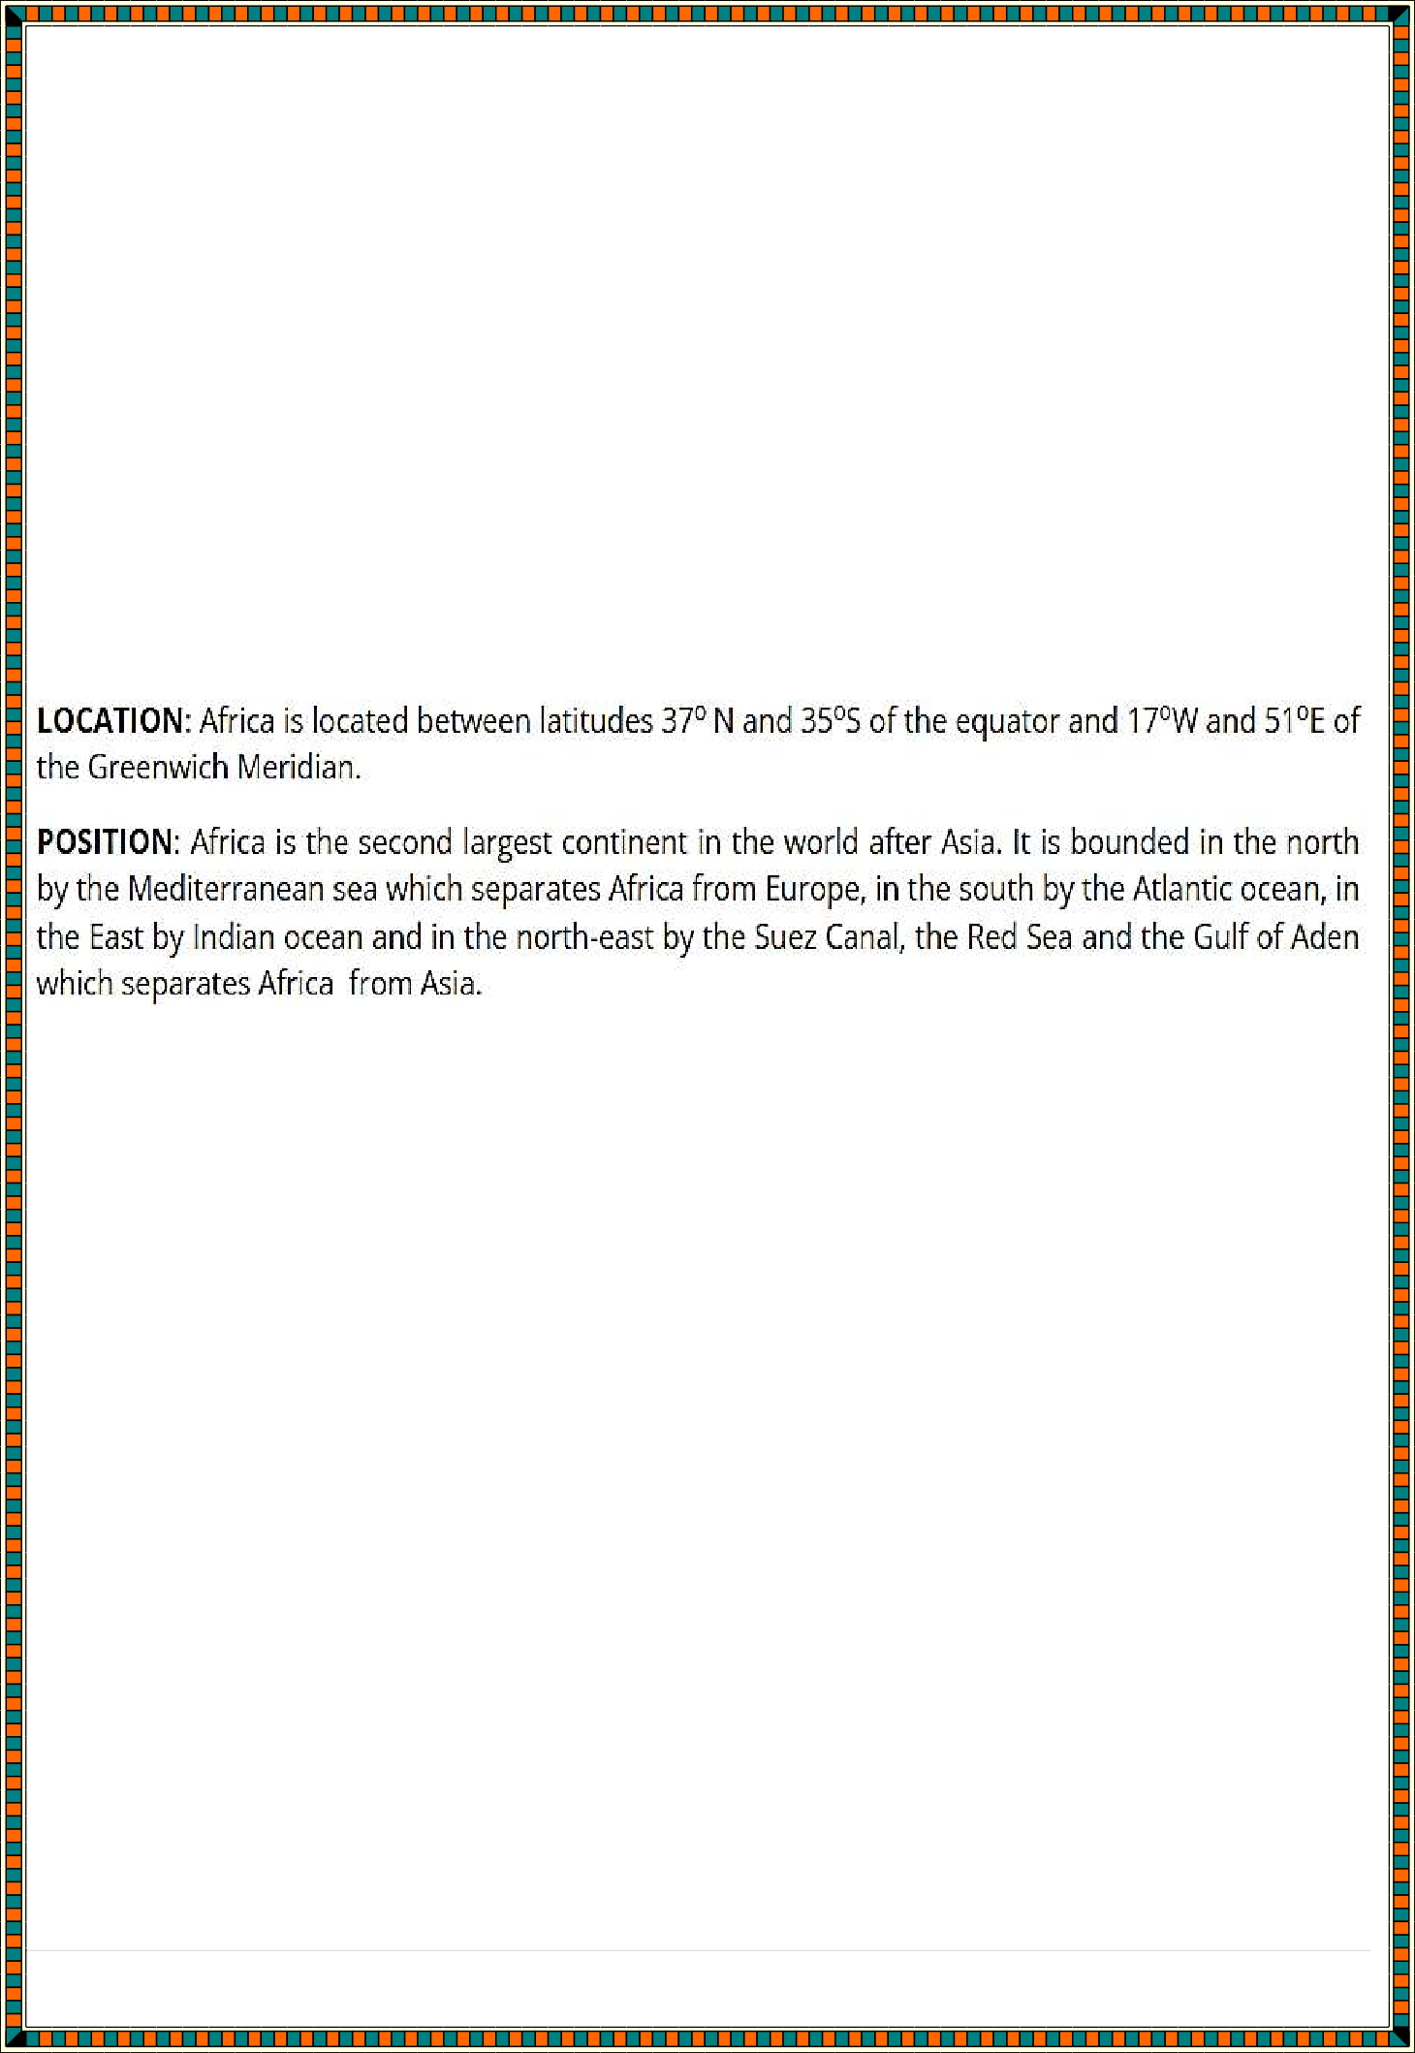
NATURAL AND BUILT ENVIRONMENTS

a. Maps and Map work
A map is a representation of the whole or part of the earth’s surface drawn to scale.
- Shows outline of objects on the ground
- Drawn as if the drawer was above the ground
- It shows details
- Most of the features are indicated by symbols. Position, shape and Size of Africa

Size: Africa is the world's second-largest and second-most populous continent, after Asia in both cases. At about 30.3 million km2 (11.7 million square miles) including adjacent islands, it covers 6% of Earth's total surface area and 20% of its land area. [7] With 1.4 billion people as of 2021, it accounts for about 18% of the world's human population. Africa's population is the youngest amongst all the continent

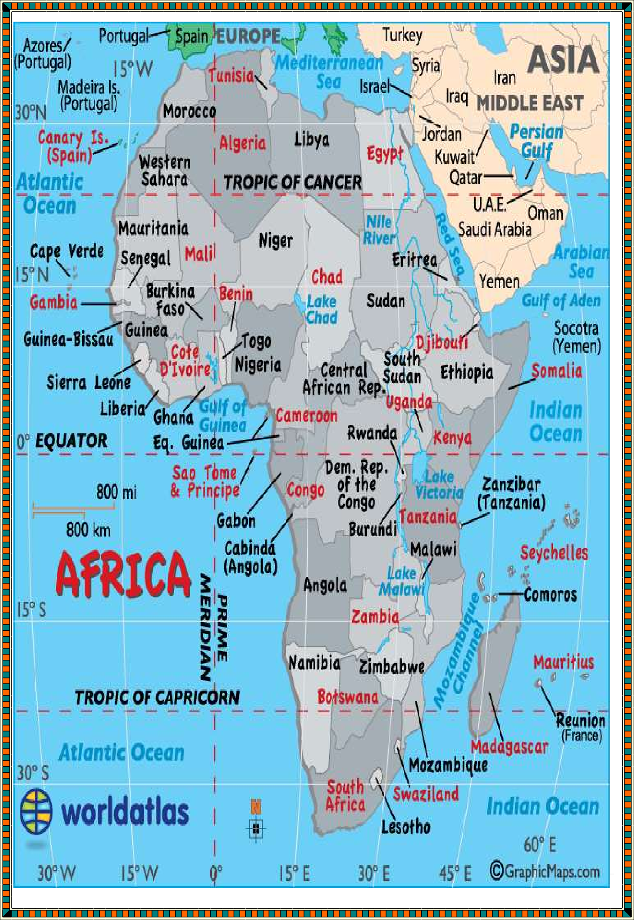

11 | P a g e “ R e - I n v e n t i n g C B C f o r p o s s i b l e s o l u t i o n s ”

Using latitudes and Longitudes to locate places and features on a map
Latitude is a measurement on a globe or map of location north or south of the Equator.
Latitudes are imaginary lines that runs from East to West on a map. The latitude of a place is the angular distance from the equator to that place. The latitude which divides the globe into two equal parts is called the Equator or Latitude 0°. Major latitudes are:

- Tropic of cancer - 23.5° North
- Tropic of Capricorn - 23.5° South
- Equator - 0°
- Artic circle - 66.5° North
- Antarctic circle - 66.5° South

CALCULATING STRAGHT LINE DISTANCES USING LATTITUDE
Latitudes are used to locate places on the earth surface. They are also important in calculating straight line distances or longitudinal straight line distance between places. In order to calculate the distance Between two places.

  - We find the distance covered through one degree of latitude equal to 111km.
  - Find out the number of latitudes between the two places.
  - Multiply the distance through one degree of latitude by the number of latitudes between the two places.

Example: Find the longitudinal straight line distance between place A 45°N and place B 11°N.
Solution
-Distance covered through one degree of latitude = 111km.
-Number of latitudes between place A and place B = 45°-11° = 34°
-Longitudinal straight line distance = 111km * 34° = 3774km
Longitude Longitudes are imaginary lines that run from North to South on a map. The longitude of a place is the angular distance of that place measured in degrees. This distance is measured from the centre of the earth to the East or West of the Greenwich meridian called longitude 0°. Longitudes are also called Meridians. They meet at the North and South poles. There are 360° of longitude which is equal to 360° of a
circle. Major longitude are;

- 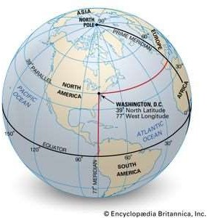Longitude 0° - Greenwich Meridian
- Longitude 180° East or West - International date line

CHARACTERISTICS OF LONGITUDES

- They meet at the North and South poles.
- They run from North to South.
- They are measured in degrees, East or West of the Greenwich meridian.
- Lines of longitudes have equal lengths.
- Lowest longitude is longitude 0° and the highest longitude is longitude 180

HOW TO CALCULATE LOCAL TIME FROM LONGITUDES
Step 1: Find out the difference in longitudes between two places given.
Step 2: Convert or change the difference in longitude to time, if the difference in degrees is more than 15°, multiply it by 4 minutes.
Step 3: Adjust the time according to the position of the longitude if it is east, we add but if it is west, we subtract time.
Example 1: What is the local time at Madres in India on longitude 80°E, if local time in Yokadouma in Cameroon on longitude 15°E is 4 p.m.?
Solution Step 1: Longitudes difference = 80°-15° = 65°
Step 2: Convert longitude difference to time: 65°*4mins = 260mins = 4hrs20mins Step 3: Add or subtract time
4hrs20mins + 4pm = 8:20pm Because longitude 80°E is in the East.
Example 2: What is the local time in Baghdad 45°E, 35°N when it is noon in Bombay 75°E, 18°N.
Solution
1) 75°- 45° = 30°
2) 30°/15° = 2hrs or (30°*4mins)/60mins = 2hrs
- 12 noon - 2hrs = 10 am
Exercises

  - If the time in Accra (Ghana) on longitude 0° is 12noon. What will be the local time in Philadelphia (U.S.A) on longitude 70°W.?
  - What is the local time of Yaoundé 15°E and 5°N, when G.M.T is 8:00 am?

The longitude difference for a town in the East and another in the west is obtained by adding the longitudes.
DIFFERENCES BETWEEN LONGITUDES AND LATTITUDES
LATITUDES | LONGITUDES
They run from E to W | They run from N to S
They are parallel lines | They met at the poles
They are complete circles | They are semi-circles

Length of latitudes vary with the equator distance | Longitudes have equal length
Equal distances of 111km | Distance decreases towards the poles
Only the equator is a great circle | All longitudes are great circles
Ranges from 0° to 90° | Ranges from 0° to 180°
LOCATION OF PLACES USING LONGITUDES AND LATTITUDES
Longitudes and latitudes are used to locate places on a map. The Greenwich meridian is the starting point for al longitude readings. Lines to the East of Greenwich meridian are measured in degrees and readings are followed by letter E, example: 35°E and vice-versa. All latitudes above the equator are measured in degrees north of the Equator and readings are followed by letter N. example: 15°N. Readings measured to the south of the equator are followed by letter S. example: 15°S. To be more accurate, we use degrees and minutes .
1 degree is equal to 60 minutes. For example;
-Cameroon is located on latitude 5°00'N and longitude 12°30'E,
-Yaoundé - 3°51'N and 11°31'E,
-Bertoua - 4°34'N and 13°42'E,
- Douala - 4°05'N and 9°45'E.

Picture, plan and Map
- A map is a representation of the whole or part of the earth’s surface drawn to scale.

Picture:
- It is an image of a real object.
- Gives details in their visible shapes and sizes
- Can be inform of free hand, drawing, painting or a photograph
- Not drawn to scale

Plan:
- Outline of something drawn to scale.
- Also drawn as if a person was directly above the ground
- It represents a very small place
- The scale is large to show details e.g. house plan
- Gives specific information

Types of Maps used in Social Studies
Classified according to the purpose for which each map is drawn.
Topographical Maps: This shows selected natural physical features on a small portion of a country.
Atlas maps: this is a collection of maps in one volume.
Sketch maps: maps which are roughly drawn. A good sketch map should have the following characteristics:
- Neat and clear
- Title
- Frame
- Key
- Compass direction

Uses of Maps
- Sketch maps are used to summarize information for easy reference.
- Used for locating other countries.
- Used for comparing sizes of countries.
- For locating climatic regions of different parts of the world.
- Give information on distribution of geographical phenomena e.g. vegetation on the earth’s surface.
- Help travelers to find their way.
- Used to calculate distance of a certain place.
- Used to locate physical features like landforms.

Earth and Solar System
SOLAR SYSTEM
The solar system is made up of the sun and the 8 planets. It is also called a planetary system. These planets include; Mercury, Venus, Earth, Mars, Jupiter, Saturn, Uranus, Neptune.
Recent discoveries prove that Pluto is now a dwarf planet. These planets revolve around the sun in a path called Elliptical orbit. The sun is at the center of the solar system. It is made up of burning gases and has a temperature of about 6000°C. Some planets have smaller heavenly bodies that move around them called satellites. The smallest planet is Mercury. It is the hottest and nearest planet to the sun. Mars which is the fourth planet has 2 satellites. Jupiter is the largest planet and has 13 satellites.
The Earth is the third planet from the sun and the only planet where life exists. It has one natural satellite called the moon. The moon takes 29 days to go round the earth. The Earth rotates on its axis and revolves on its orbit. Stars are heavenly bodies that produce their own light. The solar system and a collection of other stars form the galaxy. The galaxy in which our solar system is found is called the Milky Way.
THE SIDE OF THE EARTH
The total area of the earth is about 510,100,779 km². The distance measured round the edge of the equator is about 40,085km. It is called the Equatorial circumference. The polar circumference is 39,995km. The Equatorial diameter is the straight line distance that crosses the earth through the equator. It is about 12,762km. The polar diameter is about 12,722km.

EVIDENCE TO SHOW THAT THE EARTH IS SPHERICAL IN SHAPE
There are many evidences to show that the earth is spherical in shape. These are:

Sunrise and Sunset
The earth rotates from West to East. Places in the East therefore receive sunlight before places in the West. All places on the earth would not receive sunlight at the same time if the earth was flat.

Sunrises and Sunset at different times on curved surface.
- Ship's Visibility

when a ship is observed at a distance from the sea, one will first see the smoke, and later the funnel before the entire ship. This shows that the sea surface is curved. If the earth was flat, the whole ship could be seen at once.
- Eclipse of the Moon

when the earth comes between the sun and the moon, the earth's shadow that falls on the moon is a dark circle. If the earth was flat, its shadow would be circular.
- Travelling round the World

When somebody travels from a particular point A to the same direction, the person will come back to the same point. If the earth was flat, this could not be possible.
- Aerial Photograph

Photographs taken from rockets, show that the earth is spherical in shape.
- Proves from other Heavenly Bodies

Other heavenly bodies like the sun, the stars, and the planets are spherical in shape. These show that the earth is also spherical.
Origin of the earth
Theories explaining the origin of the Earth

The Passing star theory
A star with a greater gravitational pull than the sun passed by the sun. It drew off a stream of gaseous material from the sun.

The material split, cooled and condenses to form planets set in orbit around the sun.
Some smaller materials formed the moon and other heavenly bodies.
  - Nebula cloud theory
The nebular theory is an explanation for the formation of solar systems. The word “nebula” is Latin for “cloud,” and according to the explanation, stars are born from clouds of interstellar gas and dust. The transition from an undifferentiated cloud to a star system complete with planets and moons takes about 100 million years.
All planets revolve around the sun in the same direction. This would be possible if they all formed from a cloud of debris around a star (proto sun)
The model of the sun is mainly made of hydrogen. The composition of sun can be measured using helioseismology which agrees with the theory that star is formed as a giant ball of hydrogen generating heat by nuclear fusion in the core.

Effects of Rotation and Revolution of the earth in the solar system
ROTATION OF THE EARTH
Rotation of the earth is the spinning of the earth on its axis from W to E. The earth moves in a clockwise direction once every 24hs. That is it takes one full day for the earth to turn from the International Date Line and back to it. The earth rotates once through 360° in 24 hours, 180° in 12 hours, 15° in 1hour and 1° in 4 minutes.

Effects of the Earth’s Rotation
- Rotation of the earth causes
- Day and night
- Deflection of winds and ocean currents
- The rising and falling of tides
- Difference in time
- Day and Night
As the earth rotates from W to E, places in the east experiences daylight before places in the west. This is because places in the east are under sunlight, while places in the west are away from the sun when rotation starts.

Deflection of Wind and Ocean Tides
Rotation of the earth causes winds and ocean currents to be deflected. They are deflected to the right in the Northern Hemisphere and to the left in the Southern Hemisphere.

The Rising and Falling of Tides
Tide is the rising and falling of sea level during the day. It is caused by the earth’s rotation. During rotation, the sun and the moon attract some parts of the earth due to gravitational force. Where the force of gravity is much, the ocean bulges along the coast causing high tides. Where the force of gravity is less low tides are produced.

Differences in Time
The earth takes 24 hours to complete a rotation of 360°, and 1 hour to turn 15°. Longitudes which are 15° apart will therefore take 1 hour difference in time. The time in the east is always ahead of the time in the west. This is because, places in the east experience sunlight before those in the west.
Example; during the 2014 world cup competition in Brazil football matches were been played there during the day, but they were watched at the same time, on Cameroon television in the evening.

REVOLUTION OF THE EARTH
The effects of revolution include are;
  - Varying lengths of day and night.
  - Changing attitude of the midday sun.
  - Changes in season.

Varying Lengths of Day and Night
Due to the inclination of the earth’s axis, there are changes in the length of days and nights time during the year.
On the 21st of June the sun is directly on the tropic of cancer in the North Pole at midday. During this period, the length of day light increases as latitude increases. In the south, length of day decreases because the sun does no rise there. This period is called summer solstice.

On March 21st and September 23rd at noon, the sun is directly on the equator. During this time, the earth has equal hours of daylight and equal hours of darkness. This period is called Equinox (equal days and nights.)
On the 22nd of December, the sun is directly on the tropic of Capricorn. This is called winter solstice. During this period, the length of day light in the southern hemisphere increases as latitude increases. In the Northern hemisphere there is darkness.

Changing Altitude of the Midday Sun
As a result of the earth’s inclination, there are changes in the altitude of the midday sun on the 21st of June at midday; the sun is directly on the tropic of cancer in the North Pole.
On the 23rd of September, the sun is on the equator at midday.
On the 22nd of December, the sun is on the tropic of Capricorn at midday.

Changes in Season
Changes in the length of day and night time and the altitude of the midday sun cause a rise and fall in temperature during the year. The period of the year, when temperature rises is called summer while the period when temperature falls is called winter.
In summer, temperature increases the weather is bright and days are longer than nights. From the 23rd of June to the 23rd of September, it is summer in the Northern hemisphere. In Cameroon, it is the warm rainy season. The north is directly under the sun.
In winter, from the 22nd December to 21st March temperature falls and places are colder. During this time, nights are longer than days and less heat are received. In Cameroon, it is the cold dry season.
From the 23rd of September to the 23rd of December, it is autumn in the Northern hemisphere.

Spring season begins from the 21st of March to 21st June in the Southern hemisphere. During this period, nights and days are equal.

DAWN AND TWILIGHT

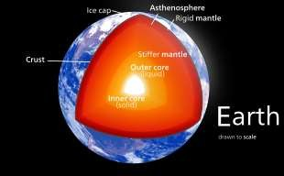Dawn is a brief period between sunrise and full day.
Twilight is the period between sunset and complete darkness.

Internal structure of the earth in the solar system

The earth’s structure is made up of several layers. These layers consist of;
The earth’s crust or lithosphere, The mantle or the mesosphere and The core or the bryosphere.
THE MAIN LAYERS OF THE EARTH

The Earth’s Crust (Lithosphere)
This is the outermost layer of the earth made up of solid hard rocks. Its thickness varies from 6km to 40km. It is divided into two layers. These layers are;
Sial (Continental crust) Sima (Oceanic crust) Sial
A sial is the continental crust that moves up the continents. It is made up of igneous, sedimentary and metamorphic rocks with minerals such as silica and aluminum. It is lighter with an average density of 1.7.

Sima
This is the oceanic crust that makes up the ocean floor. It is heavier with an average density of 3.0. It has mainly basaltic rocks with minerals such as silica and magnesium. The lighter continental crust seems to be floating on the denser oceanic crust.

The Mantle (Mesosphere)
The mantle is also called the mesosphere. It is much thicker and is about 2900km thick. It contains very dense rocks rich in magnesium and iron (Fe). The rocks are in a molten state and a temperature of about 5000°C. This is the layer where magma is formed.

The Core (Bryosphere)
The core is the center of the earth and the hottest zone. It is about 6700km thick. This layer is below the mantle. It is also rich in iron and Nickel (Ni). The core is subdivided in two parts.
  - The outer core,
  - The inner core.
The outer core is in the molten state and the inner core is in the solid state and consist mainly iron (Fe). These layers are separated from each other by boundaries called discontinuities.

Weather

Elements of weather

They include:
    - Temperature
    - Air (Atmospheric) Pressure

    - Wind (Speed & Direction)
    - Humidity
    - Precipitation
    - Visibility
    - Clouds (Type & Cover)
    - Sunshine Duration

Factors considered when siting a weather station
- The area should be away from building/trees/tall objects
- The ground should be free from flooding
- The area should have a wide view/open space
- The area should be secure
- The ground should be gently sloping
Weather and climate are very important to man and his environment, the most important benefit of weather and climate is that they bring rain, snow and other forms of precipitation. This precipitation or rain is what sustains all living things on the earth surface (humans, plant, animal, and other microorganisms). Without a constant supply of water on the earth, it would be difficult to predict what sorts of crops could be cultivated in a given region. If a change in climate were to alter the weather so that it produced too little or too much water, it will still have a major impact on agriculture and livestock.
Weather and climate affect the distributions of plants and animals across various biomes of the world. For instance, the tundra biome (the Antarctica tundra) is characterized by a cold and dry climate, it supports very little species of plants and animals, while the marine biome is colder at the pole, but warmer at the equator- it supports various species of plants and animals. However, both biomes are constantly sharpened by the changes in atmospheric conditions.
The natural ecosystem is constantly influenced by the activities of weather and climate, hence, places with extreme dry climate (desert environments) are the best locations for mining of minerals and metals that are used for many production industries such as electronics. On the other hand, the rain forest environment, which receives much rainfall, is a home to various plant species in which some are known for their pharmaceutical benefits.
The study of weather and climate is obviously important to man as it helps one to determine future climatic changes in some specific parts of the world.

Weather and climate are very important aspects of mans natural environment; they create awareness as to what might happen on daily or yearly basis. Such awareness helps us to prepare ahead of the upcoming disasters that may occur in the future and also to find possible ways to adapt to such situations. Such phenomena are, for example hail, heavy rainfall, sleet, ice, etc.
Weather forecast are also important as they warn us about the dangers of some natural occurrences or disaster that may occur in our natural environment in the future, such disasters include fire risk, hurricane, snows, hail, thunderstorm, tornadoes, etc.
Weather and climate directly or indirectly affect many of our activities; the weather specifically helps us to decide on the type of crops to cultivate, the cloth to wear, and the kind of food to eat, lastly, it determines where and the nature of houses we live in.

Constructing weather instruments
Learners to construct the following instruments in reference to their learner’s book: Materials should be sourced locally.
- Rain gauge
- Wind vane
- Windsock HISTORICAL INFORMATION

Sources of Historical Information
Historical sources of information are classified into three categories:
- Written – they include:
  - Books
  - Archives
  - Journals
  - Novels
  - Paintings
  - Magazines
  - Diaries
  - Constitutions
  - Periodicals
- Unwritten- they Include

  - Oral tradition- this is the passing of information from one generation to the other by word of mouth.
  - Archaeology – is the study of human remains and artefacts.
  - Anthropology- it is the study of man’s past culture, beliefs and economic activities
  - Linguistic – is the language and its variations across many cultures as well as similarities.
  - Genetics - Genetics is the study of heredity in general and of genes in particular.
  - Paleontology - scientific study of life of the geologic past that involves the analysis of plant and animal fossils, including those of microscopic size, preserved in rocks.

Electronic Sources
  - Microfilms
  - Films
  - Videos
  - Radio
  - Television
  - Computer databases

Difference between Primary and Secondary sources of Historical information
A primary source is an original document containing a firsthand account of the event being studied, created at or about the time the event occurred.
For example:
- Letters
- Journals/Diaries
- Maps
- Government Documents/Statistics
- Photographs or Film
- Autobiographies
- News Accounts
A secondary source is a secondhand account, or a history of the event that was created at some point after the event occurred, or a source created by parties who were not personally involved in the event.
For example:
- Textbooks

- Retrospective magazine articles
- Scholarly journal articles
- Research books on topic
- Websites

Ways of preserving sources of Historical information
Preservation involves maintaining an object or information in a format that ensures the continued use and accessibility of the information provided.
It includes developing criteria for selecting materials that have cultural or historical importance and assessing their preservation needs; halting the deterioration of materials by providing a stable environment and proper supplies and equipment for storage; developing and implementing policies for the safe use of materials; and providing the resources necessary to engage in an on-going preservation program committed to the continued existence of valued materials.
Preservation also includes preparing for potential disasters such as floods, fires, tornadoes, and earthquakes.
Ways include:
- The use of paper that is acid-free serves as a long-term solution for preserving information.
- In addition to environmental controls, papers containing valuable information should not be subjected to direct sunlight, ultraviolet rays, or fluorescent light, all of which can weaken paper and fade writing.
- Also, paper should not be handled while eating or drinking, as food and drink near books can attract insects and rodents that may damage the paper. As with all types of media that contain valuable information, paper should not be stored in attics, basements, or places where mold and mildew may develop or already be present.
- Books should be stored on metal shelves or sealed wooden shelves and should be shelved upright.
- Photos should be stored in an environment that does not have high temperature and high humidity or excessive fluctuations in temperature and humidity.
- Do not scratch of damage surfaces of computer disks.
- Spread Awareness: The most important way to preserve sources of history is to spread awareness about the historic importance of the architecture and scriptures etc. By this method people may be able to volunteer in the preservation.

- Conduct Research: Research of historical resources would not only help discover new sources but also preserve older ones.
- Establish Museums: Museums can preserve and portray the historical resources.
- Conduct Workshops: Workshops can be held among people on how to conduct research and lead preservation projects.
- Influence Government: Government can fund preservation projects.
Influencing them is very important.
- Establish Preservation Department: A government of the country must establish a governmental depart that takes care of the preservation of historical sources. It must fund projects and lead them too.
- Donate in the Field: People who give importance to history and know its significance must donate for the preservation projects etc.
- Initiate Event: Events related to preservation must be conducted in order to motivate people to work for the preservation.
- Encourage Students: Students of history and architecture should visit these sites in order to increase their interest in preservation of the sites etc.

Importance of sources of Historical Information
They include:
  - They help in future research on different cultures
  - They can help in predicting the future
  - They help us understand our past
  - They help in understanding the dynamics in society i.e. politics
  - The help in understand how communities, races interact.

PEOPLE AND POPULATION

Human Origin

Traditional stories of human origin

Origins of Human Beings
A number of theories have been put forward to explain the origin of human beings
- The creation theory.
- The mythical/ traditional theory
Among African communities, there are myths about their origin all of them pointing to the fact that the first man was created by God. Some examples include;
- Among the Agikuyu, their God (Ngai) created the first man, Gikuyu. He the provided him with a wife, Mumbi. He gave him land at Mugurwe wa Gathanga.
- One of the myths among the Nandi state that the first two people, male and female came from the knees of a giant man, when the knees began swelling and later burs for the two to come out from each of the either knees.
Religious stories about the origin of Human Kind

The Creation theory
The Jews, Christians and Muslims recognize the creation story as narrated in the first book of Bible and in Qur’an.
It says that the whole universe was created by God.
That God also created man, woman and all living things and all non-living creatures.
Man was created in God’s own image and woman created to provide man with companionship.

Factors proving that africa is the cradle of mankind
- Several archeological sites have been found in Africa
- Presence of savannah grassland where man could hunt and gather food
- Warm tropical climate, ideal for early man's existence
- Africa is centrally located geographically, making it possible for early man to migrate to other regions as the continents were drifting

- Several tools and weapons remains have been discovered in the continent.

Ways of recording traditional stories about the origin of human kind in the society
- Through memory
- Through computers
- Written in books
- Through videos
- Through songs
- Through drawings

Early Civilization

State, Kingdom and empire

Empire Kingdom

An empire is a sovereign state consisting of several countries or peoples subject towards the authority of a single person often an emperor or empress.
A kingdom consists of land from the same region or area head under the nominal rule of king or queen.

An empire is always ruled by a singular authority, in this case, being the emperor/empress
A kingdom can have more than one ruler at a time. In the event it has two kings it is known as a diarchy and a kingdom ruled by many kings is known as an oligarchy

An empire grows larger by expanding and absorbing individual states and nations. For better administration, a representative of the emperor, who acts as the governor of the region will carry out day-to-day administrative functions.
A kingdom will transition into an empire when it absorbs other city-states through conquest until it grows more than its original size.

Usually, an emperor or empress is the absolute authority who makes critical decisions regarding the empire, but in certain setups, the voice of powerful aristocrats are also heeded.
A king or queen is the absolute authority, but in the case of a constitutional monarchy, its authority may be limited by a parliament or any other ruling body of ministers.

State: a political organization of society, or the body politic, or, more narrowly, the institutions of government.

Ancient kingdoms include

- Egypt
- Great Zimbabwe
- Kingdom of Kongo
- Ancient Egypt
Ancient Egypt can be thought of as an oasis in the desert of northeastern Africa, dependent on the annual inundation of the Nile River to support its agricultural population. The country’s chief wealth came from the fertile floodplain of the Nile valley, where the river flows between bands of limestone hills, and the Nile delta, in which it fans into several branches north of present-day Cairo. Between the floodplain and the hills is a variable band of low desert that supported a certain amount of game. The Nile was Egypt’s sole transportation artery.
Ancient Egypt has come to be regarded as man's first civilization. This history of ancient Egypt began some 10. 000B.C. when North Africa experienced a drier climate which corresponded with the end of the last Ice Age in the world. In about 7000B.C some hunters entered the valley of the River Nile in search of animals for food and also fish for food. Later, these hunters settled in large numbers and started an agricultural revolution. As towns grew, the people became more organized. The leaders of the first Egyptian settlements were said to have religious powers with which they could control the floods of the River Nile and also rainfall. Because of this, the priests were influential people in Ancient Egypt and with their help, the first Egyptian kingdom was established in about 3500B. C.

From that date till 332B. C. thirty (30) dynasties reigned and ruled in Ancient Egypt. The manifestation of Ancient Egyptian civilization under these rulers (pharaohs) of the various dynasties is the main subject of this chapter, But before delving into the various aspects of organization in Ancient Egypt, it is necessary to know the factors that favoured the rise and growth of Ancient Egypt and its civilization.

Factors that led to the Rise of Ancient Egypt
- The existence of River Nile- these served to help in the following functions:
  - It served to protect against predators and attack from other kingdoms
  - It provided a mean of transport for the people

  - It provided water for agriculture. Basin irrigation was majorly used to water farms.
  - It had also fish which used as food as well sold for economic gain
  - the Nile helped to unite people on the east and west banks, making trade and exchanges between the villages, towns and cities possible.
  - the Nile River had a religious significance and even had a god of its own, called Osiris.
- Egypt's geographical position at the center of the Middle East has always given it an edge. It was considered a channel of knowledge
between Europe and africa as well Mesopotamia.
- In technology, medicine, and mathematics, ancient Egypt achieved a relatively high standard of productivity and sophistication.
They were the first to introduce mummification, medicine, agriculture, fermentation, engineering and architecture. The ancient Egyptians were pioneers in astronomy: their expertise played an important role in determining the annual flooding of the Nile, and aligning the pyramids towards the pole star.
- Good leaders: Ancient Egypt was also fortunate to have very able and wise leaders, especially during the years of the first dynasties.
- The influence of other civilizations: Following the creation of the state of Ancient Egypt, contacts were made with other
civilizations as time passed. Some of these contacts helped to greatly enrich the civilization of Egypt. For example, the
Ancient Egyptians learned to fight war on horseback from the Hyksos, people from Asia who conquered Egypt in 1730B. c.
Ancient Egypt also learned much from the Sumerians, The Hebrews and Babylonians from Asia. They also borrowed from the Greek and Roman civilizations from Europe. These peoples also borrowed much from Ancient Egypt's civilization.
- Religion: The worship of gods like those of the Nile, the sun and many others helped to bring the people of Ancient Egypt
together. This unity was very helpful to the construction of Egypt's rich civilization.

- Existence of fertile lands that led to rise of productivity
- Existence of a bigger population that provided labour to the farms as well as market for goods.
- The existence of good transport network that ensure delivery of crop produce.
- The knowledge of weather and climatic conditions also ensured their success in agriculture.
- Introduction and adoption of iron technology in Africa by 1000AD, which enabled the Egyptians to make and use iron tools like ploughs, which made farming more efficient.
- Availability of food crops that had already become indigenous to Egypt, e.g. wheat and barley.
- Availability of many tamable animals in Egypt e.g. goats and sheep

Great Zimbabwe

  - Great Zimbabwe is the name for the stone remains of a medieval city in southeastern Africa.
  - It is composed of three parts, including the Great Enclosure (shown here). It is believed to have been a royal residence or a symbolic grain storage facility.
  - Great Zimbabwe is the name of the stone ruins of an ancient city near modern day Masvingo, Zimbabwe. People lived in Great Zimbabwe beginning around 1100 C.E. but abandoned it in the 15th century.

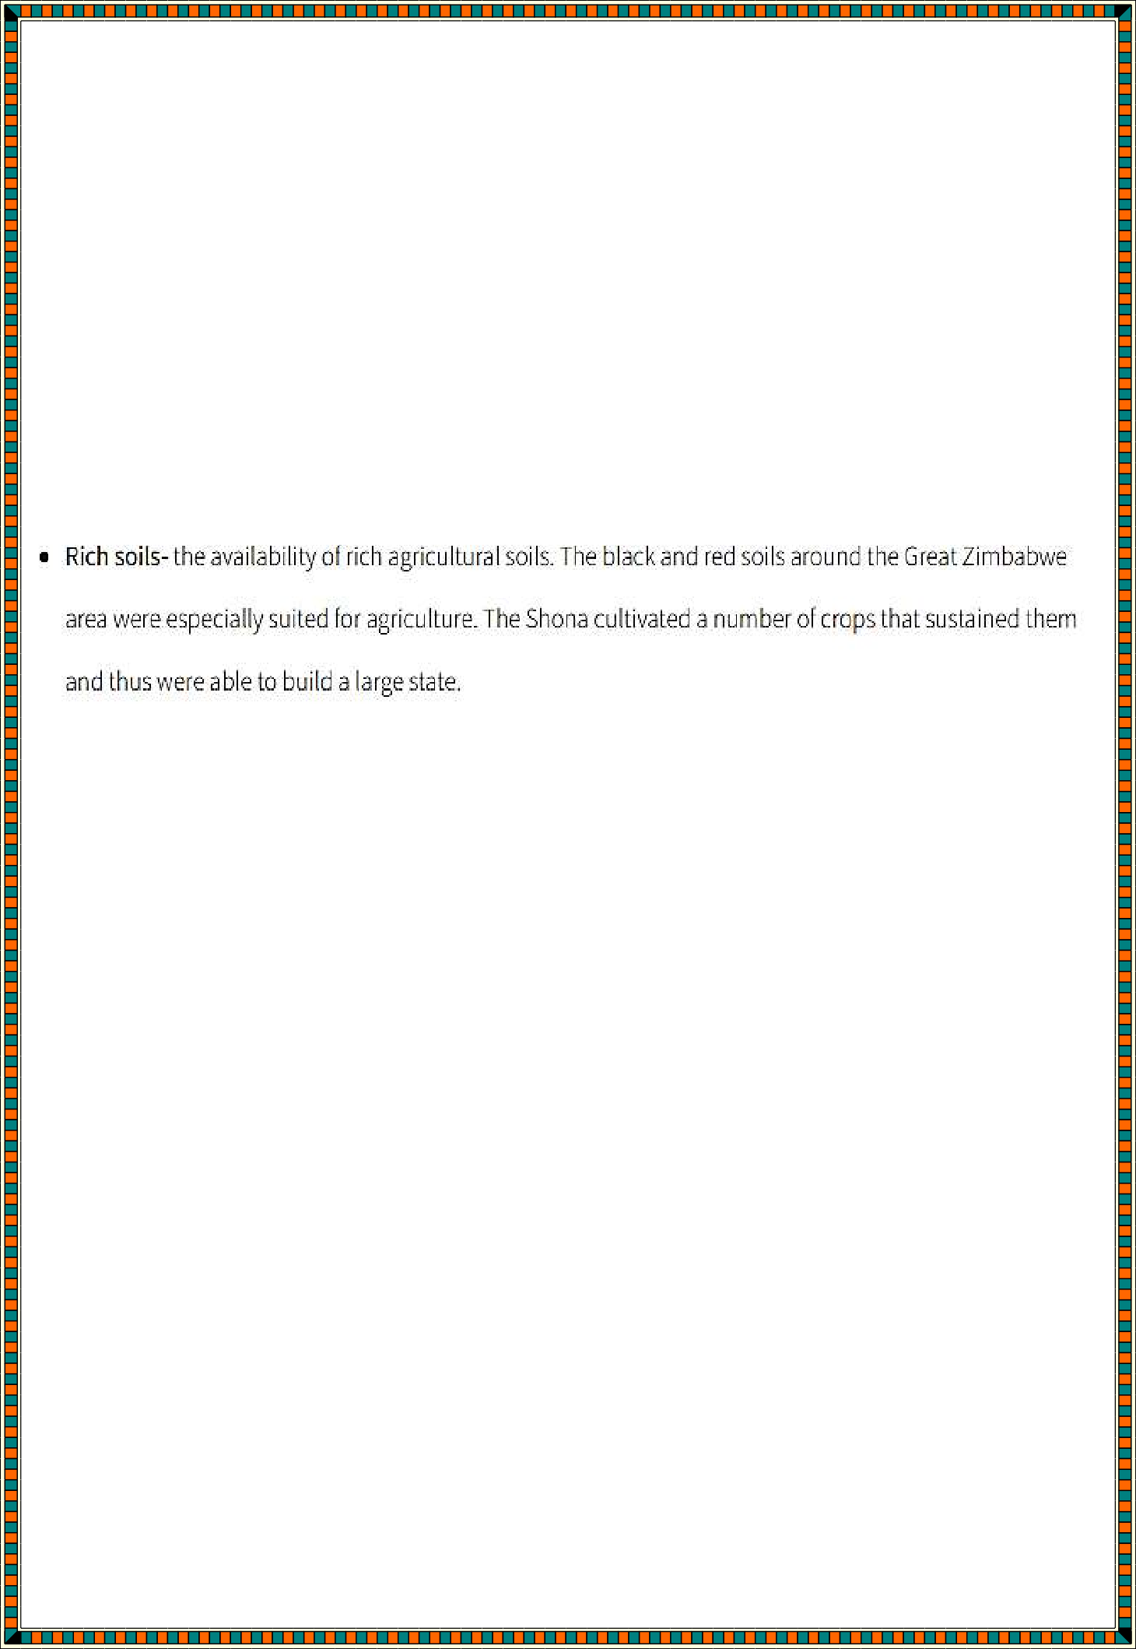
  - The city was the capital of the Kingdom of Zimbabwe, which was a Shona (Bantu) trading empire. Zimbabwe means “stone houses” in Shona.
  - Great Zimbabwe was part of a large and wealthy global trading network

Factors leading to the rise of the Great Zimbabwe Empire
- The decline of Mapungubwe from around 1300, due to climatic change. This was a neighboring kingdom.
- The greater availability of gold in the hinterland of Great Zimbabwe. Due to its marketability, it attracted many traders.
- The existence of trading activities e.g. Cattle, gold, copper coins with as far as China.

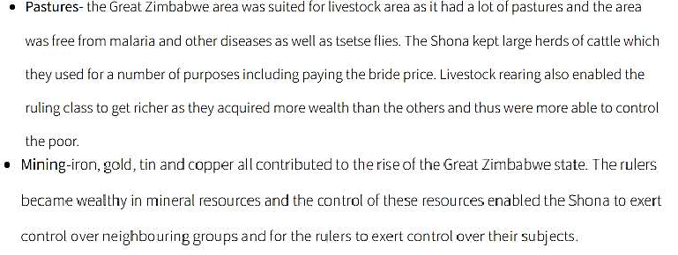
•

•

•
- The existence of good leadership also contributed to its faster rise.

Kingdom Kongo
  - Kongo, former kingdom in west-central Africa, located south of the Congo River (present-day Angola and Democratic Republic of the Congo).

  - 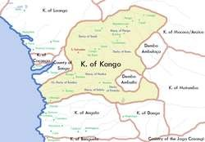According to traditional accounts, the kingdom was founded by Lukeni lua Nimi about 1390. Originally, it was probably a loose federation of small polities, but, as the kingdom expanded, conquered territories were integrated as a royal patrimony.
  - Soyo and Mbata were the two most powerful provinces of the original federation; other provinces included Nsundi, Mpangu, Mbamba, and Mpemba.
  - The capital of the kingdom was Mbanza Kongo. The capital and its surrounding area were densely settled—more so than other towns in and near the kingdom. This allowed the manikongo (king of Kongo) to keep close at hand the manpower and supplies necessary to wield impressive power and centralize the state.

Factors leading to the rise of Kingdom of Kongo
  - It is generally acknowledged that alliances and military conquest contributed to the rise of the Kingdom of Kongo. Alliances between tribes were solidified through intermarriage, mutual agreements, and cooperation under one centralized monarch or "nkani".
  - The kingdom of Kongo prospered in trade - this was in Ivory, copper, salt, cattle hides and slaves.
  - Existence of a working population - the kingdom produced its own goods via specialised groups of craftworkers such as weavers (who produced the famous raffia fabrics of Kongo), potters, and metalworkers.
  - The existence of shell currency- the spiral nzimbu shells which originally came from Luanda, an offshore island located some 240 km away. Initially used as a means of storing wealth and as a standard

measure of the value of other goods, the shells came to be used like coins to pay for goods and labour.
  - The existence of a highly centralized rule by a single monarch or nkani who appointed regional governors throughout his territory. These governors, in turn, appointed local officials and collected tribute such as ivory, millet, palm wine, and leopard and lion skins from local chiefs, which were passed on to the king at Mbanza Kongo. Tributes were paid at lavish annual ceremonies which involved much feasting and beer-drinking. In return for their offerings, chiefs and officials received the king's favour, military protection, and some material rewards such as food delicacies and clothing.
  - The existence of Congo river- this provided a means of transport as well as water for agriculture among other things.
  - The existence of rich mineral – minerals like copper which were extracted and exported by traders who came from middle east.

Contributions of Early Civilization to the modern world.
The early civilization contributed to the modern world in the following ways.
  - Expansion and modernization of modern agriculture- this involved use of irrigation methods and mechanization. Modification of seeds was also a result of early civilization. E.g. Basin Irrigation in Egypt.
  - in the field of medicine- it contributed to various inventions like
mummification (preservation of the dead), treatment of fractured bones as well as development of vaccines. E.g. In Egypt
  - Expansion of knowledge- this was done through dissemination of information in books, patches, scrolls as well as establishment of learning institutions. Like early education institutions were found in Egypt.
  - Fermentation in modern day dates back to early civilization in Egypt.
  - Use of currency in trade in modern day to day dates back to early civilization e.g. the use of shell currency in Kingdom Kongo.
  - In the field of Engineering early civilization enabled construction of buildings by use of Angles E.g. Construction of Pyramids in Egypt.
  - In architecture – this involved aligning the pyramids towards the pole star and also know the level of flooding during flooding seasons of the Nile.

  - Inventions in the transport system was as a results of early civilization.
E.g. two wheeled, four wheeled hard carts.
  - In politics- early civilization contributed a lot in establishment of various states and countries as well other modern Kingdoms. This was further enhanced by constitutions or by-laws that guided the early civilization governments.

- Social Organization of selected African Communities up to the 1900
Social organization revolves around way of life for the following selected African communities.
- The Ogiek - The Okiek (Ogiek), sometimes called the Ogiek or Akiek (although the term Akiek sometimes refers to a distinct subgroup), are a Southern Nilotic ethnic group native to Tanzania and Southern Kenya (in the Mau Forest), and Western Kenya (in the Mount Elgon Forest)
a hunter-gatherer society, living in western Kenya
- The Zulu - are a Nguni ethnic group native to Southern Africa. The Zulu people are the largest ethnic group and nation in South Africa, with an estimated 10–12 million people, living mainly in the province of KwaZulu- Natal.

They originated from Nguni communities who took part in the Bantu migrations over millennia. As the clans integrated together, the rulership of Shaka brought success to the Zulu nation due to his improved military tactics and organization.

Zulus take pride in their ceremonies such as the Umhlanga, or Reed Dance, and their various forms of beadwork.

The art and skill of beadwork takes part in the identification of Zulu people and acts as a form of communication and dedication to the tribe and specific traditions. The men and women both serve different purposes in society in order to function as a whole. Today the Zulu people predominantly believe in

Christianity, but have created a syncretic religion that is combined with the Zulu's prior belief systems.[3]
- Ahsante - The Asante were one of the Akan-speaking peoples who settled in the forest region of modern Ghana between the 11th and 13th centuries. The separate Asante chiefdoms were united by Osei Tutu in the 1670s and in 1696 he took the title of Asantehene (king) and founded the Asante empire. In Asante, the family line is matrilineal - inheritance passes from the mother to her children. The Golden Stool is also passed down matrilineally, to one of the king's maternal nephews.

Social Organization of the Ogiek community up to 1900
- Honey was their staple food - Honey was eaten, used to brew traditional beer (rotikap gomek), and traded with neighboring communities.
- They hunted and trapped wild animals. Various tools were used, including: clubs, spears, bows and arrows.
- They also practice small scale agriculture and keep livestock such as cows, sheep and goats. They grow vegetables, maize, beans, and potatoes. This was subsistence farming.
- The smallest unit of life was the family. Two or more related families with a common ancestor make a lineage. The lineage was responsible for enforcing traditional laws and order.
- Roles were divided – the father duty was to provide food, protect and head the family, while the mother’s role was to bear children, look after the home, and the children helped in house chores.
- The Ogiek circumcised both boys and girls at puberty separetly
- They had the age set system which grouped circumcised differently
- The Ogiek were polygamous and the wives their own separate houses and fields.
- The Ogiek believed in a supreme being called Tororet and offered prayer to him seeking for help.
- They also believed in the existence of ancestral spirits (oiik) – they were believed to offer protection of of the community.
- The Ogiek also practiced Divination to foresee the future using supernatural powers by use of divination ball.
- Their clothing was made from skins of animals slaughtered.

Social Organization of the Zulu up to the 1900
- Socially the king was the leader as he presided over traditional ceremonies such as the traditional fruit harvest which was attended by all people the kingdom.
- Initiation ceremonies were performed to mark the entry into adulthood. During Shaka’s reign, however, circumcision was abolished.
- Marriage was restricted until one served in the army for a period of 40 years. At this age, the military men could be retired at the same time with the females of an appropriate age for marriage.
- The Zulu were divided in social classes called clans, traditionally the royal clan provided kings and chiefs while warrior come from the class of commoners
- The Zulu worshiped their gods and the most important was the god of the war.
- The king controlled all social affairs and was the biggest social figure.
- Polygamy was common among the Zulu

Social Organization of the Asante up to the 1900
  - The Kingdom was composed of many communities who spoke the Akan language.
  - The Asante were organized in clans
  - Marriage between members of the same clan was prohibited
  - Inheritance of property was matrimonial.
  - The community was bound together by the Golden stool
  - There was an annual cultural festival (odwira) held at kumasi to honour the ancestors.
  - The society was divided into social classes/stratification
  - The kings were regarded as semi-divine/religious traders
  - The Asante were polytheists/worshipped many gods and goddesses
  - The ancestors mediated between god and the people
  - The Asante had a supreme God called Nyame

Similarities in the social organization of the Ogiek, Zulu and Ahsante
  - All were organized into clans
  - All had a belief in a supernatural being in different ways.
  - They all believed in the existence of ancestral spirits
  - They all had ceremonies at different times of the year.
  - All practiced Marriage.
Differences in the social Organization of the Ogiek, Zulu and Ahsante

Ogiek | Zulu | Ahsante
Supreme being was  called tororet | god of war | Nyame
Polygamous | Polygamous | -

Human Diversity and inclusion
- Diversity recognizes that, though people have things in common with each other, they are also different many ways.
- Inclusion is where those differences are seen as a benefit, and where perspectives and differences are shared, leading to better decisions.

Personality differences that differentiate people

While personality shows what you are outside or what you are to the world, character reveals what you are inside. As these are directly related to a person’s attitude and behaviour, most people get confused between these two easily.
  - Personality refers to the combination of qualities, attitude and behaviour, that makes a person distinct from others.
  - Personality implies Who we seem to be
  - Personality is a set of personal qualities
  - The personality is the mask or the identity of a person
  - Personality is subjective
  - Personality is the outer appearance and behaviour of a person.
  - The personality of an individual may change with time.
  - personality, does not need validation and support of the society

the Personality attributes that differentiates us include:
- Authenticity
Authenticity relates to how genuine you are. You may show this by providing honest answers and being true to yourself in your interview. When you're working, you may demonstrate authenticity by showing how

you truly feel each day. It's also important to act and treat others professionally.

Confidence
Confidence in your abilities, education and qualifications may distinguish you from other candidates. They may help you better explain how an organization could benefit from hiring you. Aim to present yourself confidently in your interview without seeming like you're bragging.

Curiosity
Curiosity is a beneficial attribute in the workplace because it encourages you to continue to acquire new skills and knowledge. This may help you learn more about new industries or clients, or motivate you to try new things.

Diligence
Diligence encompasses various soft skills, such as attention to detail and organization. It fosters a commitment to success and ensures everything in a project is accurate. One way to demonstrate diligence is to follow all directions specifically, showing your comprehension skills and ability to do what's asked of you.

Empathy
Empathy refers to the ability to relate to others and understand their emotions. It's a crucial attribute to help employees understand each other and work well as a team.

Generosity
Generosity involves helping others, especially when you may not benefit from the situation. This may help your co-workers appreciate you more and create a more positive and supportive work environment. While you may show generosity by offering to help a co-worker with their tasks, it may also be as simple as complimenting someone on their achievements or providing them with constructive feedback to improve their future performance.

Honesty
Honesty is essential for creating trust among co-workers. It helps show that you can be trusted with your responsibilities.

Integrity
Integrity relates to how well you represent and follow your morals. This involves acting as a good role model for others, speaking truthfully and behaving honourably.

Kindness
Kindness refers to your compassion and forgiveness of others.

Perseverance
Perseverance shows your ability to remain motivated to succeed in any circumstances.

Positivity
Positivity may help you remain committed to your work and create a pleasant work environment.

Sociability
Sociability is important because it helps ensure conducive environment for everyone. Some roles may require more social skills than others. Engaging others in conversation and encouraging them to talk may help show your sociability.

Transparency
Transparency, like honesty, relates to being open about your experience and qualifications.

Desirable and undesirable personality attributes in a multi-cultural Society
multiculturalism: A characteristic of a society that has many different ethnic or national cultures mingling freely.
- Desirable characteristics: These are characteristics such as being hardworking, or displaying honesty and integrity.
- Undesirable characteristics: These are ones such as lying and stubbornness.
Desirable characteristics are known as qualities and undesirable characteristics are known as personality defects. Characteristics have been grossly grouped in these two categories. Qualities bring about general well-

being and have an overall positive effect on the person and one’s interactions. Defects on the other hand bring mental anguish both to the person having them and the people he interacts with.

Undesirable personality attributes

Manipulative and deceptive practices
Find yourself unable of asking for what you want and need, instead bending others to your will in order to get what you want and need? Why you believe you are doing the correct thing is understandable. Even if you want something badly enough, it may be difficult to simply come out and say so.

One who is preoccupied with himself/herself
You’re out with your friends, and you’re the kind of person that spends the whole time talking about yourself.

Quick to Judge
When you have a negative opinion of someone, it is one thing. When you
really tell them, that’s another story. No one wants to be in the company of someone who is always criticizing them for their appearance, their diet, or their words.

Negative and gloomy.
What if you’re one of those people who sees the glass as half-empty?
In our world, there are many different types of people that believe in different things. Being one of these people is completely OK. This becomes an issue when you cause everyone else in your immediate vicinity to fall along with you.

The Perfectionists

What exactly is wrong with being a perfectionist? This is a question that only a perfectionist would ask.
Despite the fact that there is nothing wrong with wanting things to go smoothly, when your life gets too concerned with the little details, it becomes a major issue.
Not just for yourself, but also for others in your immediate vicinity.
The pursuit of perfection is then mirrored in the eyes of your friends and others in your immediate vicinity. And no one will ever be able to live up to such expectations. At the end of the day, they are forgotten.

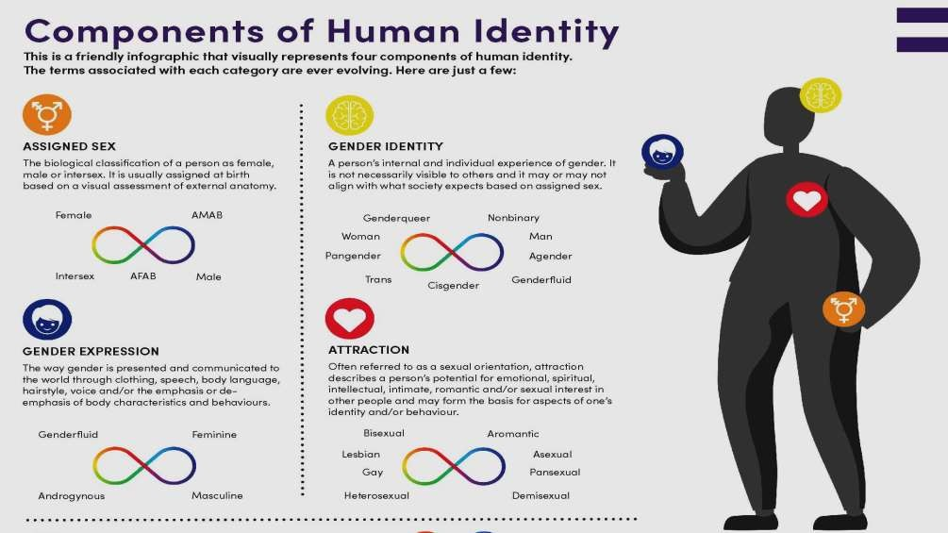Different components of Human identify in a multi-cultural society

Others include:
- Race/ethnicity
- Class
- Age

Ways of applying inclusion in day to day interactions

Mindful communication: listen more, talk carefully
Communication is the first aspect to work on. Often, if used inappropriately, our words can express wrong intentions or create misunderstandings.
Here are some examples:
- When addressing a group, avoid using gender-specific words such as “ladies”, “dudes”, “men”, “guys”. Especially in the presence of gender non-conforming or mixed gender individuals, appellations may turn out to be misplaced, cause miss gendering, and cut off group members.
- Avoid assertive language and words: Introduce your contribution with “In my opinion” or “According to my experience” or “Based on what I’ve read and learned”. Leave space for questions and replies, make sure you do not lecture when you get involved in a conversation.

Challenge stereotypes
Unconscious biases, prejudices, lack of information, influence of the media, and teachings coming from our cultural and social beliefs may all impact the way that we interact with others. For example, we are often informed by the beliefs and value systems we are exposed to, including

through our family and friends and the things we learned at school. These deeply ingrained belief and value systems can also lead to actions and reactions that can sometimes be exclusive and unfair.

Avoid assumptions
One of the most common mistakes in everyday interactions is to make assumptions.

Assumptions are a difficult starting point because they take for granted that our audience shares the same requirements and experiences as we do.
Although assumptions are often developed unconsciously, it is important to recognize the moment when we apply them in our interactions with others.
For example, it is important to avoid assumptions about the gender of the person or groups we are speaking with and always try to use gender inclusive language.

If you meet a disabled person, do not assume what they are able or not able to do something.

Be aware of your privileges
Talking about privileges can be difficult and often very uncomfortable.
However, being aware of our own privileges is a crucial first step to adapting a more inclusive attitude.

A privilege can be defined as “a right, license, or exemption from duty or liability granted as a special benefit, advantage, or favor”
Privileges are social, political, and cultural constructions that are translated into hierarchical relationships in our everyday and professional lives. Part of a broader system, these constructions are solidified through structural and institutional dynamics, and they serve to reinforce fabricated societal divisions based on perceived or constructed divisions and/or pretenses.

- Peace and Conflict resolution
Peace is a concept of societal friendship and harmony in the absence of hostility and violence. In a social sense, peace is commonly used to mean a lack of conflict (such as war) and freedom from fear of violence between individuals or groups.
Conflict is simply differing ideas or actions, often related to the selfish pursuit of needs (known and unknown) that end in a state of unrest. It is a necessary and permanent part of life. The important thing to remember is that conflict is natural. It can be a slight conflict that causes no harm or an egregious conflict that results in irreparable damage.

Contribution of personal peace to a responsible citizen
Personal Peace is often referred to as intrapersonal peace or inner peace. It means peace with oneself. When you have personal peace, it means you accept yourself the way you are, no matter how you look outside, or what you think about yourself: spirit, soul, and body. This also comes as a result of a deep and better personal understanding.
Its helps in avoiding conflicts between individuals It helps improve work place and home relationships It helps in understanding others better
Its helps us to assist others without much strain
Its helps us develop desirable personality attributes that can help us achieve much.
It helps be accommodative of others despite our varied opinion and actions

Personal characteristics that express a state of peace
All suffering is a result of imbalance—physically, mentally or spiritually.
- Being charitable
- Being self-discipline
- Straightforward
- Compassion for all creatures
- Absence of greed
- Radiance of character
- Forgiveness

- Patience
- Freedom from hate

Approaches that can promote one’s inner peace
- Controlling your stress
- Taking a mental health day, morning or moment
- Reading spiritual literature
- Changing our perspective - Much turmoil and anguish come from sticking to your own personal perspective. You may get bent out of shape when the other person cannot see things the way you do. You can expend a lot of time and energy trying to get someone to see your point of view, and leave yourself exhausted and frustrated.
- Practice Non-Judgment
- Focus on serving - People prone to worry have the “what if” syndrome. You let worry and anxiety overtake your every thought. What if I don’t make enough money? What if I lose my job? What if the person I love doesn’t love me back? With each thought, your mind spirals into chaos. When you place your focus on helping and serving, somehow the anxiety goes away. As you become more relaxed, you’ll notice that many of the things you were worried about disappear. Every time you start the “what ifs,” replace them with the phrases, “How can I help?” and “How can I serve?”
Importance of enhancing Peace
- Peace makes sure that you do not go on the medicines to run your life.
- Peace helps you keep mentally and physically fit.
- Peace ensures that you are aware of yourself.
- Peace helps you take better decisions.
- Peace gives you strength and you stay calm when things go unexpectedly.
- Peace gives you the freedom to do experiments in your life.
- Peace helps you put things in order.
- Peace enlightens you.
- Peace helps you see things as they are.

- 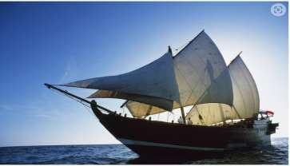Peace makes you intelligent and increases your EQ.
- Peace connects you better with other people.
- Peace helps you understand the surroundings.
- Peace to the mind is like base to the home, roots to the tree.
f. Slavery and Servitude

forms of slavery and servitude in Traditional African Society
Slavery is when someone actually owns you like a piece of property.
Servitude is similar to slavery - you might live on the person’s premises, work for them and be unable to leave, but they don’t own you. These forms include.
- Human Trafficking: Human Trafficking sees people being forcibly moved and recruited using violence or threats in order for them to be exploited for labor, prostitution, marriage, etc.
- Forced Labour: Forced Labour is where someone is forced to
undertake work against their will and threatened with violence.
- Debt bondage: Debt bondage is where those trapped in poverty are forced to borrow money from others and can then be forced to work in order to ‘pay back’ this debt. This is one of the most common types of slavery.
- Forced and early marriage: Forced and/or early marriage is where
someone has been forced to marry against their will and/or with the threat of violence/ consequences.
- domestic servitude The Indian Ocean Trade

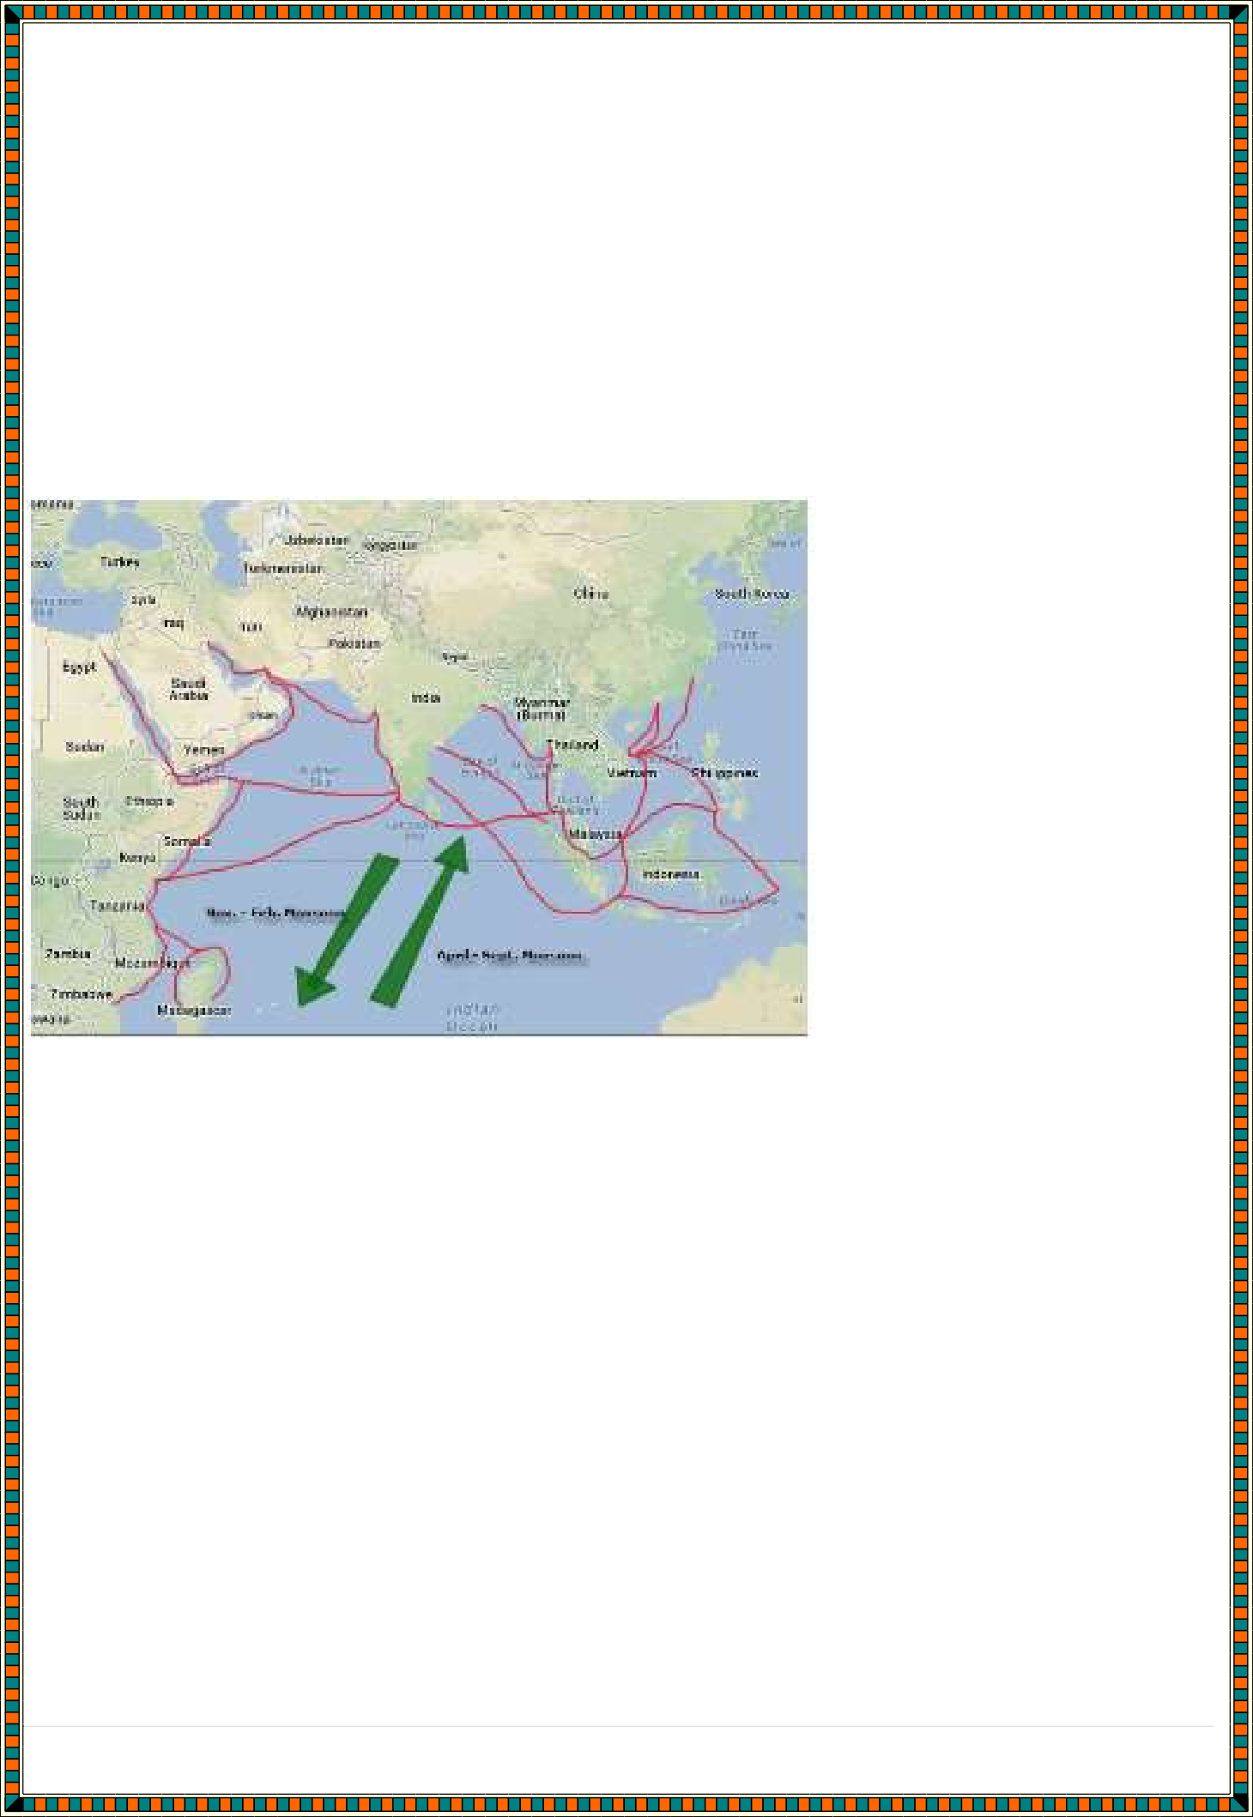
The Indian Ocean trade routes connected Southeast Asia, India, Arabia, and East Africa, beginning at least as early as the third century BCE. This vast international web of routes linked all of those areas as well as East Asia (particularly China).
Long before Europeans "discovered" the Indian Ocean, traders from Arabia, Gujarat, and other coastal areas used triangle-sailed dhows to harness the seasonal monsoon winds. Domestication of the camel helped bring coastal trade goods such as silk, porcelain, spices, in cense, and ivory to inland empires, as well. Enslaved people were also traded.

The Indian Ocean trade was a world of Islamic merchants ferrying porcelain from China to the Swahili Coast, ivory to India, cotton to Indonesia, spices to Arabia, and so on. Regional cultures, politics, religions, and entire histories were exchanged through the Indian Ocean Trade.
Factors leading to the development of Indian Ocean slave Trade
  - Availability of items of trade encouraged traders to come to the coast
  - The high demand for goods/trade items from the Kenyan coast by consumers in The outside world led to increased trade
  - The existence of local trade among the Africans along the coast provided a base upon which the Indian Ocean trade developed.

  - The Monsoon winds facilitated the movement of vessels/ships to and from the coast thus enabling the merchants to take part in the trade.
  - The Indian Ocean provided access to traders from Asia and Europe.
  - The relative peace/political stability provided conducive environment for trade.
  - The availability of credit facilities from Indian Banyans/money lenders enabled many people to take part in trade
  - Existence of enterprising merchants at the coast/foreign lands promoted trading links enabled trade to flourish.
  - The natural harbors along the coast ensured safe docking of ships for loading and unloading of items of trade
  - Advancement in ship/boat building led to better sailing vessels thus increased trading activities to and from the coast.
  - Availability of slaves

Organization of the Indian Ocean Slave Trade in 15th Century
The Indian Ocean Trade began with small trading settlements around 800 A.D., and ended in the 1500s when Portugal invaded and tried to run the trade for its own profit.
As trade intensified between Africa and Asia, powerful city-states flourished along the eastern coast of Africa.
These included Kilwa, Sofala, Mombasa, Malindi, and others. The city-states traded with inland kingdoms like
Great Zimbabwe to obtain gold, ivory, and iron. These materials were then sold to places like India, Southeast
Asia, and China. These were Africaʼs exports in the Indian Ocean Trade. These items could be sold at a profit because they were scarce in Asian countries.
At the same time, the East African city-states were buying items from Asia. Many residents of the city-states were willing to pay high prices for cotton, silk, and porcelain objects. These items were expensive because they were not available in Africa at the time. These were Africaʼs imports in the Indian Ocean Trade.

The city-states along the eastern coast of Africa made ideal centers of trade. An important attraction was the gold obtained from inland kingdoms. The gold was needed mainly for coins, although it was also used for works of art, ornamentation on buildings, and jewelry. And, the city-states were easy to reach from Asia by ship because of the favorable wind and ocean currents. Ships had no trouble docking at the excellent ports and harbors located on the coasts of the city-states, making it easy to unload and load cargo. And ,merchants, tired after their long overseas journey, enjoyed the fine restaurants, lodging, and entertainment offered by the port cities.
Finally, East Africa was a peaceful region, and the few conflicts that did occur were small and brief.
All of these factors created an ideal setting for import-export companies to conduct business.
Many of the merchants from the Arabian peninsula, India, and Southeast Asia stayed in the city-states of East Africa. Interracial marriages were not uncommon, and gradually over the centuries, a new and distinct ethnic group developed, known as the Swahili. Today millions of Swahili people live in the nations of East Africa, where the Swahili language is widely spoken. (You can take Swahili courses at many colleges here in the U.S.) The Swahili language is a mixture of the Arabic, Hindi, and Bantu languages.
The Swahili city-states steadily grew and prospered, and were a major world economic power by the 1400s.
Although the city-states were famous throughout Africa and Asia, no European countries knew of them. You can imagine the surprise, then, of Portuguese captain Vasco da Gama when, in 1498, he came upon the bustling port cities of Sofala, Kilwa, Mombasa, and Malindi as he sailed up the eastern coast of Africa. He and his crew were welcomed by each of the cities he visited, although neither his ships nor the European items
they attempted to trade were of much interest to the Swahili governments.

Social Injustices committed on the Africans during Indian Ocean Slave trade in the 15th Century

  - It fueled conflict between the communities as demands for slaves increased leading to insecurity
  - It created class through emergence of wealthy merchants who displayed high standards of living.
  - African religion was downtrodden as intermarriages between Arabs and Africans led to rise of Swahili speakers which were converted to Christianity
  - It led to erosion of African culture – this because as the interaction with arabs continued African culture was bound to diminish.
  - Slavery reduced African dignity as they were just seen as dogs to be in chains
  - Many were thrown into waters if they had no value
  - African women working as domestic workers we mistreated through bodily harm and sexual harassment.
  - Many children remained orphans as the fathers and mothers were taken as slaves during the trade.
  - It led change of roles as the fatherless children were now forced to seek means of survival.
  - It led to destruction of African families and homes through torturing and separation of the bond that tied these families
  - It led to rise in many orphan children and widows as the able men were taken captives as slaves.

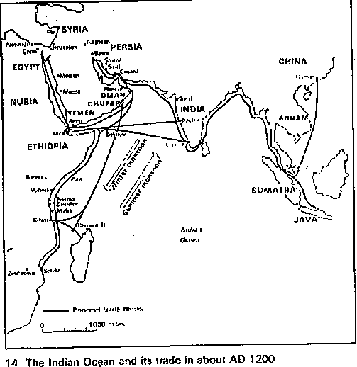Geographical regions covered by Indian ocean trade in Africa

Population Distribution in Africa
Population distribution means the pattern of where people live. World population distribution is uneven. Places which are sparsely populated contain few people. Places which are densely populated contain many people.

Factors influencing Population distribution in Africa Climate
Areas which experience conducive climates especially adequate and reliable rainfall together with mild and moderate temperature attract a dense population than desert and semi desert lands with low and unreliable rainfall.

Relief
The nature of relief greatly influences population by either attracting or discourage settlement. For example, in extremely high relief regions, the temperatures are too cold for human settlement and the ruggedness too hinder construction of homes and communication lines. On the other hand, gently rolling slopes attract dense settlement because they are easy to construct communication lines and settlement.

Vegetation
Dense forests such as those in the Congo basin, hinder rapid population settlement because they are very difficult to clear, water logged and contain vectors that cause diseases to man and there are wild animals which are dangerous to human life. On the other hand, savannah grasslands are densely populated because they are easy to clear and their climate is conducive for human survival.

Government policy
The government policy may either attract or discourage settlement. Some areas may be gazette by law for example national parks, Game reserves or forest reserves. Government may also encourage settlement by establishing settlement schemes and resettle people from densely populated areas.

Utilization of natural resources
The exploitation of natural resources for example minerals may attract human settlement while seeking for employment.

Urbanization
The growth of towns and cities is also a very important facilities influencing population distribution in Africa. Urban centres provide a good number of functions which attract people to them. For example cheap power, trading activities, good accommodation, good medical care, cheap and constant transport, clean water, higher institutions of learning, government offices, recreation centres, and the like.

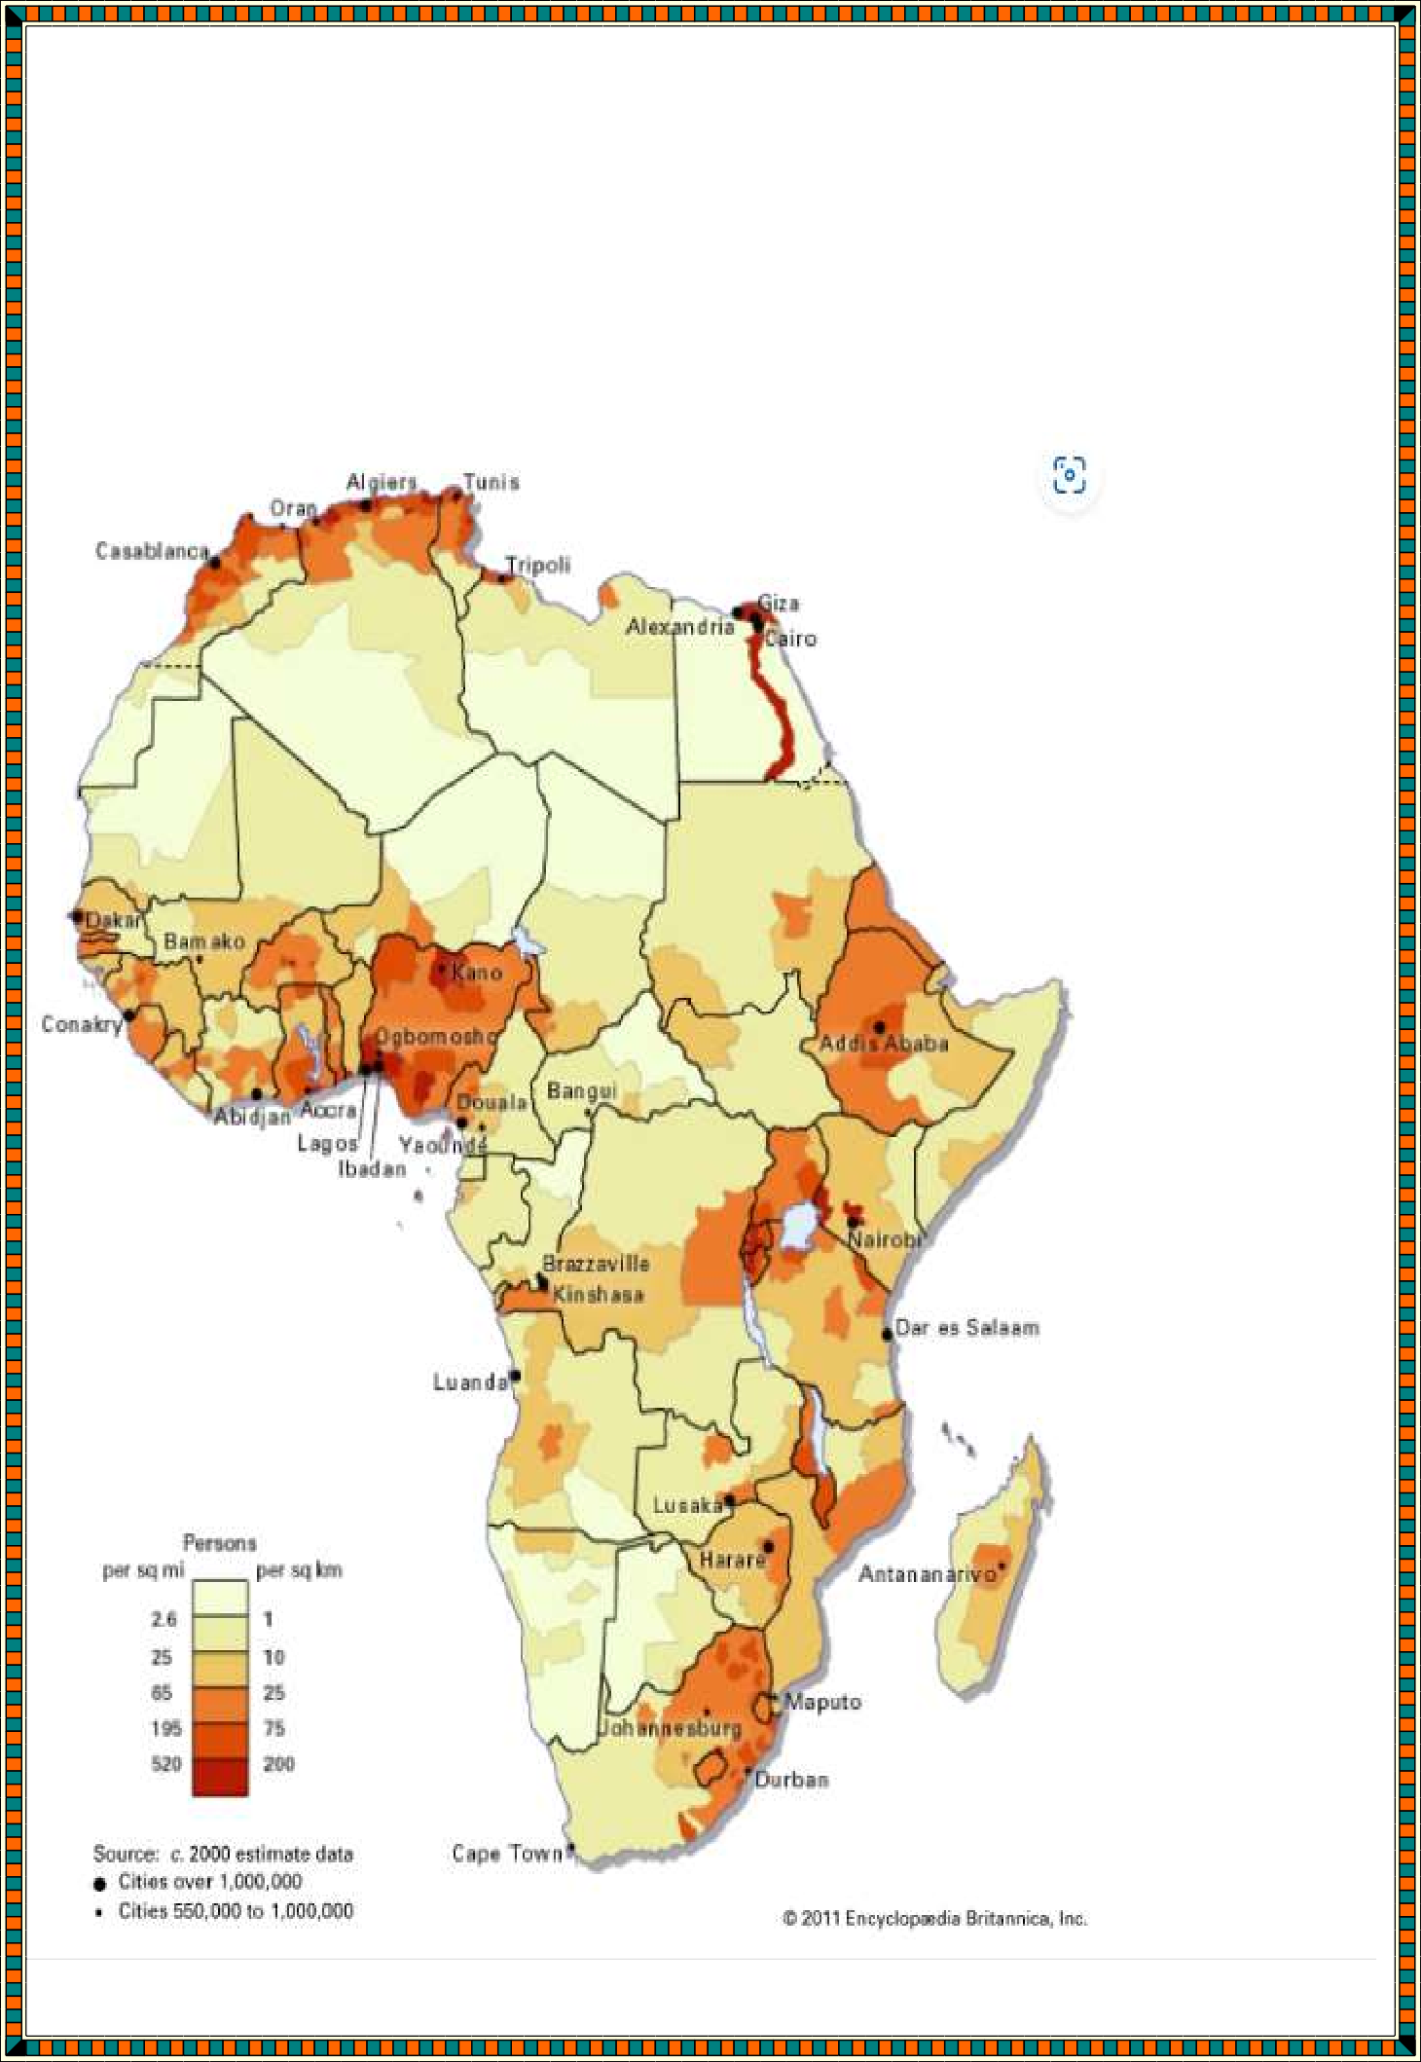
Political stability
Areas that are unstable and insecure have got low populations e.g. Karamoja where there is a lot of cattle rustling compared to areas that are generally politically stable and secure hence attracting dense settlements
e.g. towns like Kampala and Mombasa.

Densely and sparsely populated areas in Africa

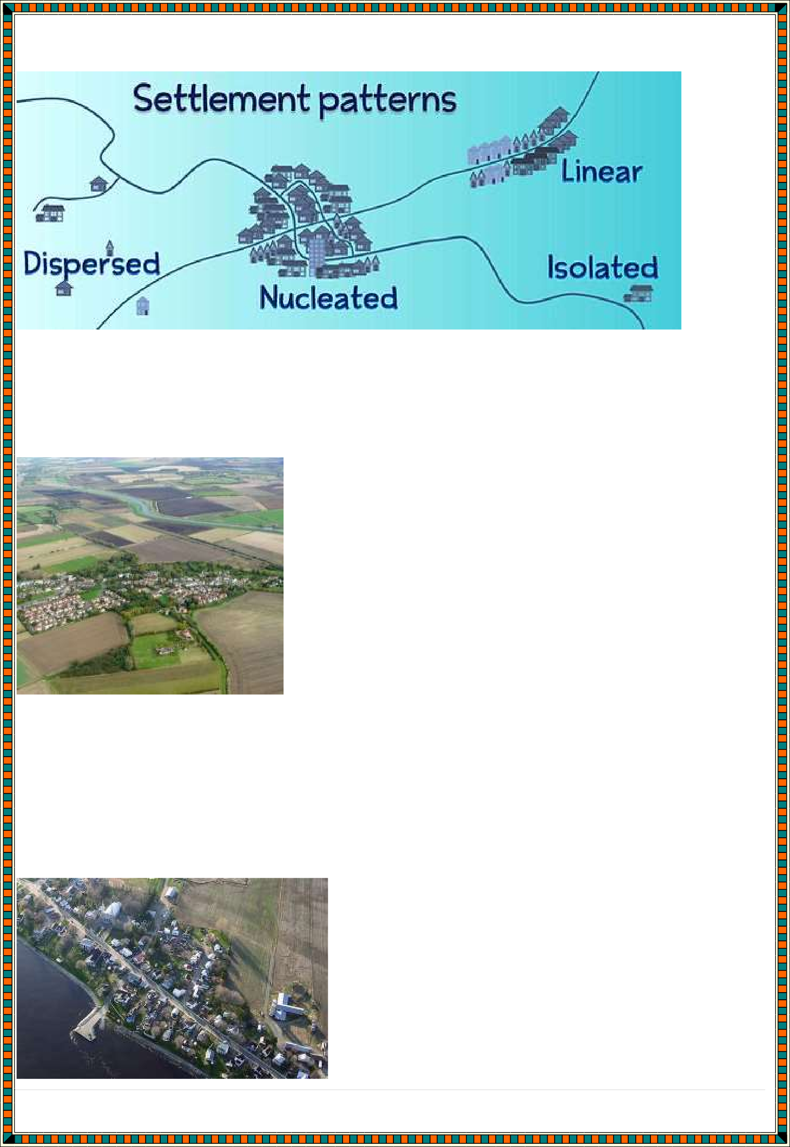
Settlement patterns in Africa

nucleated settlement:
Nucleated settlements are ones where the houses are grouped closely together, often around a central feature like a church, pub or village green.

Linear settlements are settlements where the buildings are constructed in lines, often next to a geographical feature like a lake shore, a river or following a road.
Where linear settlements follow a road, the road often predates the settlement.

dispersed settlement:
Dispersed settlements are ones where the houses are spread out over a wide area. They are often the homes of farmers and can be found in rural areas.

FIELD WORK
Field work is the process of observing and collecting data about people, cultures, and natural environment s.
Types of field work
- Field Excursion
-Visiting an area near or far from the school to see geographical phenomena then note down and discuss later in class.
Aim
  - Reinforce what has been learnt in class
  - Gain more geographical knowledge
  - Identify and appreciate geographical features
  - Identify problems of geographical interest

Field Research
-Systematic problem solving done by experts in which scientific methods of collecting, recording and analyzing data are used.

Field Study
-Study conducted within a neighbourhood in which one theme is pursued
e.g. ‘A study of a local farm’.
Methods of data collection and recording in field work

Surveys and Questionnaires
Surveys and questionnaires, in their most foundational sense, are a means of obtaining data from targeted respondents with the goal of generalizing the results to a broader public. Almost everyone involved in data collection, especially in the business and academic sector relies on surveys and questionnaires to obtain credible data and insights from their target audience.

Interviews
An interview is accurately defined as a formal meeting between two individuals in which the interviewer asks the interviewee questions in order to gather information. An interview not only collects personal information from the interviewees, but it is also a way to acquire
insights into people’s other skills.

Observations
The observation method of data collection involves seeing people in a certain setting or place at a specific time and day. Essentially, researchers study the behavior of the individuals or surroundings in which they are analyzing. This can be controlled, spontaneous, or participant-based research.

Methods of data analysis and presentation in field work
Learners to refer to their book
Challenges and solutions in carrying out field work
- Physical obstructions i.e. tall buildings, hills, trees hence may hinder one from observing certain features or accessing some areas.
- Abrupt weather changes e.g. rainy, fog, misty, windy. Avoid mentioning sunshine.
- Language barrier
- Inadequate tools

- 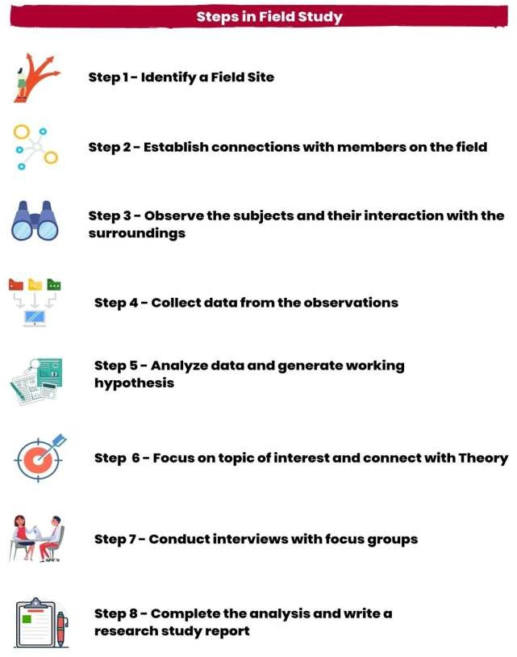Obsolete tools/outdated tools
- Hostile respondents
- Getting biased and exaggerated information.

Procedures in carrying out field work

- Identify and acquire researchers of the field
It is essential to acquire researchers who are specialized in the field of research. Moreover, their experience in the field will help them undergo the further steps of conducting the field research.

Identify the topic of research
Post acquiring the researcher, they will work on identifying the topic of research. The researchers are responsible for deciding what topic of research to focus on based on the gaps observed in the existing research literature.

Identify the right method of research
After fine tuning the research topic, researchers define the right method to approach the aim and objectives of the research.

Visit the site of the study and collect data
Based on the objectives, the observations begin. Observers/Researchers go on field and start collecting data either by visual observation, interviews or staying along with the subjects and experiencing their surroundings to get an in-depth understanding.

Analyze the data acquired
The researchers undergo the process of data analysis once the data is collected.

Communicate the results
The researchers document a detailed field study report, explaining the data and its outcome. Giving the field study a suitable conclusion.

RESOURCES AND ECONOMIC ACTIVITIES
  - Early Agriculture
Areas where early agriculture was practiced in selected geographical regions. They included:
- Riftvalley
- Egypt
- Nubia
Crops grown and animals kept Crops in rift valley
- Millet
- Maize
- beans,
- cassava,
- sorghum,
- pigeon peas
Animals kept
- Cows
- Goats
- Sheep
- Dogs
Crops grown in Egypt
- emmer (a wheat-grain),
- chickpeas and lentils,
- lettuce,
- onions,
- garlic,
- sesame,
- wheat,
- barley,
- papyrus, Animals kept in Egypt

- cattle,
- goats,
- pigs,
- ducks,
- cows, and geese. Crops grown in Nubia
- grains,
- peas,
- lentils,
- dates, and possibly melons Animals kept were mainly cows.
Method of irrigation used in ancient Egypt
Basin
Egyptians developed and utilized a form of water management known as basin irrigation. This practice allowed them to control the rise and fall of the river to best suit their agricultural needs. A crisscross network of earthen walls was formed in a field of crops that the river would flood. When the floods came, the water would be trapped in the basins formed by the walls. This grid would hold water longer than it would have naturally stayed, allowing the earth to become fully saturated for later planting. Once the soil was fully watered, the floodwater that remained in the basin would simply be drained to another basin that was in need of more water
Shadoof
The shadoof is used to lift water from a water source onto land or into another waterway or basin. The mechanism comprises a long counterbalanced pole on a pivot, with a bucket attached to the end of it. It is generally used in a crop irrigation system using basins, dikes, ditches, walls, canals, and similar waterways.

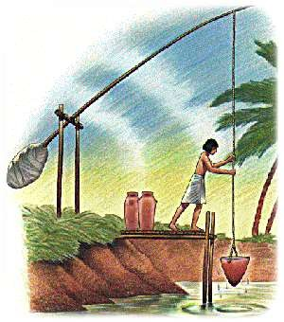

Canal
These were constructed along the farms to transport water to others regions.

Nilometer
A nilometer was used to predict flood levels. This instrument was a method of marking the height of the Nile over the years. Nilometers were spaced along the Nile River. They acted as an early warning system, alerting these early people that waters were not as high as usual, so they could prepare for drought or for unusually high floodwaters.

Contribution of the Nile valley agriculture to world civilization
The Nile River is one of the most well-known rivers in the world. The Nile River Valley was vital to the success of several ancient civilizations. The Nile River allowed the earliest civilizations to flourish in spite of the surrounding harsh desert climate. The Nile River Valley includes not just the river, but the surrounding banks and low lands that benefit from the river flooding.
- For ancient civilizations, the Nile River Valley was a source of food and income. When the water crested in October, the land was prime for planting crops such as wheat, barley, and papyrus. Ancient civilizations developed irrigation systems to redirect water and enhance the growing season. In addition, the river was plentiful with fish, which could be sold or traded.
- The Nile River served as a mode of transportation. Ancient civilizations were able to maneuver the waters to trade between the cities along the banks. The mobility encouraged growth in villages along the river.
- Ancient Egyptians greatly valued the Nile River; it was the center of their existence. The Nile River was celebrated in paintings and myths. The cycle of the Nile marked the change of season. Egyptian beliefs were interwoven with the Nile River. The Egyptians viewed the Nile River Valley as a gift from the gods; it was a portal between humans and gods. To Egyptians, the river was part of their identity and showed great reverence for it.
- It led to inventions in the field of agriculture like methods of irrigation and agriculture

- It led to development of transport system that ensured transportation of crop produce.
- It led to the development of methods of food storage in order to be used for long of for the future.
- It also contributed to the invention in the field of medicine like perseveration of the dead, healing fractured bones.
- The knowledge of weather forecast in Egypt also contributed in the modern day weather forecast.
- The knowledge of mathematics in agricultural daily activities also contributed to modern day mathematics like Pythagoras.
- There was increased production, hence food supply was regular.
- Sufficient and nutritional foods led to increase in population.
- Surplus agricultural production resulted to trade, e.g., food was exchanged with pots and tools.
- There was invention of writing, arithmetic and geometry due to the need to keep records. The writings were referred to as Hieroglyphics.
- Shadoof irrigation methods were developed that put more land into use.
- Urban centres emerged, e.g., Memphis, Thebes.
- Farmers settled more permanently and improved their living standards.
- Religion developed, e.g., god was associated with farming, offering to gods was practised.
- As a result of the agriculture practised along the banks of the Nile, people settled there. Those settlements grew in size and became urban centres within the ancient Egyptian Kingdom.
-
Importance of domestication of plants and animals in africa Domestication is the process of hereditary reorganization of wild animals
and plants into domestic and cultivated forms according to the interests of people. In its strictest sense, it refers to the initial stage of human mastery of wild animals and plants.
The first attempts at domestication of animals and plants apparently were made in the Old World during the Mesolithic Period. Dogs were first domesticated in Central Asia by at least 15,000 years ago by people who

engaged in hunting and gathering wild edible plants. The first successful domestication of plants, as well as goats, cattle, and other animals—which heralded the onset of the Neolithic Period.
Domestication of vegetatively reproducing plants, such as those with tubers, probably preceded domestication of the seed plants—cereals, legumes, and other vegetables.

There are a number of factors that made it necessary for human beings to discover agriculture. These were:
- There were climatic changes that caused the animals to migrate farther from their previous locations.
- Due to an increase in human population, the natural environment could not provide adequate food. Thus, there was a need for a regular supply of food.
- People and animals competed for food leading to scarcity of food. This forced people adopt cultivation.
- Similarly, over hunting on the part of man depleted the stocks of animals that he could rely on for food.
- Natural disasters such as floods or forest fires would kill the animals and vegetation making it necessary for human beings to domesticate plants and animals.
- Hunting and gathering had become an insecure source of food as man would occasionally return empty handed having failed to catch game. Figure 3.1 shows some of the areas along the Nile Valley where early agriculture was practised.
- Hunting as well as gathering would sometimes be hindered by unfavourable weather conditions, e.g., snow or rain that would make it uncomfortable for man to go and hunt.
- Hunting and gathering was tiring and streneous due to the constant movement that was required as man followed the animals during their migration.
- Besides food, man also domesticated animals and crops because of their economic value. For instance, animals provided him with clothing, i.e., from their hides and skins.

- Man domesticated animals for other purposes like their use in transport. Some animals like the dog assisted him in hunting and provided him with security.

Domestication has the following importance’s
- Domestication of plants and animals ensured steady supply of food.
- Products like skin were used for clothing and beddings hence keeping man warm.
- Bones were used to make ornaments and needles hence decorating man.
- Animals like donkey, horses and oxen were used as a means of transport and for pulling ploughs this was later used much in agriculture to make cultivation easier.
- The dog gave man companionship and security.
- Animals were traded for other items.
  - Economic Organization of selected African communities up to 1900

Economic organization of the Ogiek
- They were farmers as they kept bees and were known as beekeepers and also they grew vegetables.
- They were also hunters and gathers. They hunted and trapped wild animals. Various tools were used, including: clubs, spears, bows and arrows.
- They also practiced trade with the honey they had harvested.
- They also practiced traditional craft like basketry, weaving among others
- They were also skilled iron workers as they made tools using iron

Economic organization of the Zulu
- They participated in the local trade where they exchanged commodities such as fish, salt and cloth with their neighbours, Goan and Go.
- They participated in the long distance trade as middlemen between traders from North Africa and those from the South. Their main commodities of trade were salt, gold kolanuts and slaves.
- They grow crops such as kolanuts and grain/ kept animals

- They practiced crafts especially the manufacture of items such as baskets and pots.
- They practiced iron working and made tools like hoes, bangles and arrows
- They practiced hunting and gathering of fruits and roots.
- They practiced mining activities
- They practiced fishing

Economic organization of The Ahsante
- They participated in the local trade where they exchanged commodities such as fish, salt and cloth with their neighbours, Goan and Go.
- They participated in the long distance trade as middlemen between traders from North Africa and those from the South. Their main commodities of trade were salt, gold kolanuts and slaves.
- They grow crops such as kolanuts and grain/ kept animals
- They practiced crafts especially the manufacture of items such as baskets and pots.
- They practiced iron working and made tools like hoes, bangles and arrows
- They practiced hunting and gathering of fruits and roots.
- They practiced mining activities
- They practiced fishing

Similarities in economic activities practiced by selected African communities
  - They all practiced trade
  - They were all hunters and gatherers
  - They all practiced iron working
  - They all practiced traditional craft
  - They also practiced farming

Difference in economic activities practiced by selected African communities

The Ogiek | Zulu | Ahsante
Did not practice long distance trade | Did not | Practiced long distance trade.
Did no practice mining | Practiced mining | Did not

Crops grown were different

  - Internal Dynamics and Transformation In Africa
- Internal dynamics in Africa – has to do with changes that are taking place in Africa that greatly affect how people relate and behave.
- Transformation - a complete change in the appearance or character of something or someone. In Africa it’s the complete change in the appearance of African continent
Transformation brought by introduction of money in africa

impacts of the introduction of money economy in traditional african society
INTRODUCTION
- Money was introduced to Africa by the Europeans
- Before colonial period, Africans practiced barter trade
- actual goods exchanged with other goods e.g. animals would be exchanged with food grains, millet, sorghum, cow-peas, children exchanged for food during famine
- Trade merchants from Asia had introduced into Africa forms of currency such as the cowrie shells, gold and the Indian rupees
- Europeans introduced currency still used today

ECONOMY
Careful management of resources, finances, income and expenditure of a family, a business enterprise, community or a country. The economy of a country is to be well managed if it has the ability to meet the social economic needs of her members.
Development - it’s measured by the healthy of its economy in the provision of health, education, housing, sanitation, employment longevity of life, decrease of maternal and child mortality.

MONEY ECONOMY
Use of money as a means of exchange in economic activities e.g. banking, investment, insurance, payment of goods and services.
REASONS FOR MONEY INTRODUCTION
- Colonization brought a lot of changes such as unoccupied land declared ‘Crown land’ for colonialists
- Tax introduction Africans were supposed to pay taxes to the government. Taxes were paid in form of money
- Introduction of formal education School fees was introduced. Fees were paid in form of money
- Introduction of modern medical services People paid medical services using money
- Emergence of new lifestyles
- Converts to Christianity were emphasized on to have materials, hence had to work to improve their living standards. They built houses, took their children to schools practiced modern family techniques hence had to use money.
IMPACT OF THE INTRODUCTION OF MONEY ECONOMY IN AFRICA
Introduction of wage — labour
Break up of family ties as people migrated from rural to urban areas in search of employment
African land taken by the colonialists, reducing people to squatters hence need to work
There was creation of a gap between people — the rich and the poor Emergence of vices e.g. corruption, bribery, prostitution, robbery Deterioration of cherished African values e.g. bride wealth has become commercialized, customs lost etc
Loss of African human dignity. Africans had to pay taxes to the colonial government. They were forced to work in European farms so as to get money. They worked under dehumanizing conditions
Production of traditional food crops declined replaced by cash crops Individual ownership of land was emphasized. Land could be sold at will

There was increase of rural — urban migration leaving the rural people less educated
Exploitation of the poor by the rich — poor wages, overcharging prices on foods.
Destruction of the natural environment to create room for building projects, urban centres
The cost of living increased. Almost everything is acquired by money.

Uses of money in economy trade
- Money as medium of exchange solves the barter’s problem of lack of double coincidence of wants as money has separated the acts of sale and purchase. You can sell goods for money to whosoever wants it and with this money you can buy goods from whosoever wants to sell them.
- Money as measure (unit) of value or a unit of account solves the barter’s problem of absence of common measure (unit) of value. Money serves as a unit of value or unit of account and acts as a yardstick to measures exchange value of all commodities. The value of each good or service is expressed as price (i.e. money units) which guides both consumer and producer to make a transaction. Thus money makes keeping of business account possible.
- Money as store of value solves the barter’s problem of difficulty in storing wealth (or generalised purchasing power). Moreover, money in convenient denominations (like Indian coins of 5, 10, 20, 50, 100 paise and currency notes of 2, 5, 10, 100, 500, and 1,000)
solves the barter’s problem of absence or lack of divisibility. (Coins of less than 50 parcent are no longer in use now.)
- Money as standard of deferred payments helps to solve the barter problem of lack of standard of deferred payment. Again, it helps to make contracts which involve future payments. Doubtlessly money helps in removing the difficulties of barter system.
- Money helps in maximizing consumers’ satisfaction and producers’ profit. It helps and promotes saving.
- Money promotes specialization which increases productivity and efficiency.
- It facilitates planning of both production and consumption.

- Money can be utilized in reviving the economy from depression.
- Money enables production to take place in advance of consumption.
- It is the institution of money which has proved a valuable social instrument of promoting economic welfare. The whole economic science is based on money; economic motives and activities are measured by money.
Comparison in the use of money in currency trade and barter trade in africa
The primary difference between barter and currency systems is that a currency system uses an agreed-upon form of paper or coin money as an exchange system rather than directly trading goods and services through bartering. Both systems have advantages and disadvantages, although currency systems are more widely used in modern economies.
Bartering systems were used within the local community, but advances in technology and transportation make it possible for modern society to barter on a global level.
Bartering has its limitations, which led to the creation of currency systems. Currency serves as a medium of exchange, resolving mismatched demands associated with the barter system.
In early civilizations, common agreed-upon goods, such as animal skins or salt, served as a currency that individuals could exchange for goods and services.
Most nations use fiat currency in a monetary currency system.

Sustainable use of resources
sustainable use of natural resources means the use of renewable natural resources at a rate that does not exceed the resource ’s capacity for regeneration, does not impair the resource’s ecological functions and services, and does not jeopardize the ability of future generations at the same location to enjoy the resource in equal abundance.

Sustainable use of resources includes:
- Regulation of all kinds of pollution (air, land, water)
- Creating public awareness on the use of resources and the importance of conserving.
- Using sustainable ways in agriculture to conserve the environment. Avoid use of chemicals.
- Using alternative sources clean and renewable sources of energy that conserve the environment.
- Recycling wastes to avoid waste accumulation in the environment that would in return destroy the environment. Reduce, reuse, and recycle. Cut down on what you throw away. Follow the three "R's" to conserve natural resources and landfill space.
- Planting trees - Trees provide food and oxygen. They help save energy, clean the air, and help combat climate change.

POLITICAL DEVELOPMENT AND GOVERNANCE
a. Political development in africa up to 1900.
Political Organization of the Ogiek community up to 1900
- The political system was based on the lineage family system.
- Two or more related families formed a lineage.
- The lineage was responsible for enforcing traditional laws and order.
- The eldest person in the lineage acted as the spokesperson.
- The smallest unit was the family headed by the father.
•

Political Organization of the Zulu community up to 1900
- The kingdom was highly centralized with the king as the head and traditional chiefs under him.
- The king was assisted by the traditional chiefs and military Indunas for effective control of the society.
- The traditional council of elders played an important role in Zulu society. They advised the king on the important matters of the state. However, during the time of Shaka, their role declined.
- The king had powers to appoint and to dismiss any of his officials. They were there answerable to him.
- Zulu kingdom had a strong standing army with the king acting as the commander in chief.
- The arm was well-trained, equipped and ready to fight at any time. The army was on alert to defend or offend the Zulu enemies.
- The army lived in barracks called settlements and this among other included the settlement of Bulawayo.
- The army was divided into age regiments each under a military commander called an Induna.
- Each military settlement had a section of royal women headed by senior women and acted as spies for the king on the Indunas.
- The Indunas were not allowed to hold meetings without consent and permission from the king. This was to stop any conspiracy against the king.

- Succession to the Zulu throne was hereditary. That is the king’s eldest son could inherit the Zulu throne.
- The conquered area formed the outer provinces of the Zulu state. Each province was under the military Induna and assisted by the chief.

Political Organization of the Ahsante community up to 1900
- The Asante Empire was centralized state divided into three divisions namely. The nucleaus (Kumasi) states outside Kumasi (Amatoo) and the conquered states.
- The overall ruler of the Empire was Asantahene. Kimasi was under the direct control of the Asantahene.
- The conquered states were ruled by their kings but treated as provinces of Asante. Asantahene appointed representatives in each conquered sate.
- The Asantahene ruled with the help of a confederacy of Kings (Omanhene). Confederacy council. They took an oath of allegiance to ensure Loyalty to the Asantahene.
- The Omanhene represented the Asantahene in the conquered states/Omanhene, Sone autonomy but were expected to pay tribute to the Asantahene and contribute soldiers in times of war.
- The Empire had a standing army which defended/ conquered other states and maintained law and order in the Empire.
- Religion played an important army which defended/ conquered other states and maintained law and order in the Empire.
- The sacred Golden stool which was introduced in the 18th century by Asantahene Osei. Tutu strengthened unity in the Empire. It was kept at the headquarters, Kumasi. Each Omanhene was given a symbolic black stool to signify unity of purpose in the province.
- The empire had a well-established judicial/ court system based at Kumasi and was headed by the Asantahene. The Omanhene were given powers to try minor cases at the provinces.
- The empire has a strong economic base that depended mainly on taxes and profit derived from the long distance trade. This strong economy aimed the empire.

The concept of scramble and partition of africa
The Scramble and Partition of Africa - the Scramble for Africa also called the Partition of Africa, or the Conquest of Africa was the invasion, annexation, division, and colonization of most of Africa by seven Western European powers during a short period known to historians as the New Imperialism (between 1881 and 1914).

Various European Groups that came to Africa

Factors that led to the presence of Europeans in Africa Economic factors
Due to the industrial revolution in Europe in the 19th century, they required:
- Markets for their manufactured goods
- Raw materials to feed their industries
- Areas to invest their surplus capital
- European traders sought protection from their home countries when faced with competition
- Need for agricultural land in Africa to grow food crops
- Need for cheap labour from Africa to produce raw materials
- Speculation about the availability of minerals in Africa.

Political Factors

Bismarck and the rise of Germany
- Rise of nationalism
- The proof of a country’s prestige/superiority was through acquisition of colonies.
- A country that did not acquire colonies would open the gates to political decadence.

Strategic factors
- The Egyptian question
✔It revolved around the ownership of the Suez Canal
✔Both Britain and France had economic interests in Egypt
✔Their clash culminated in the British occupation of Egypt in order to protect the River Nile and British interests in India.

French activities in West Africa and the Congo
✔It accelerated the scramble for the search for colonies in Africa.

King Leopold's (of Belgium) activities in the Congo
✔King Leopold created the 'Congo Free State in 1884
✔This precipitated a crisis in Africa which culminated in the convening of an international conference in 1884-1885 i.e. the Berlin Conference.
Social factors

The Missionary Factor
- The missionaries came to Africa to spread Christianity, civilize the Africans, abolish slave trade and encourage legitimate trade.
- In case of problems, they sought for protection from their mother countries.
- Public Opinion
- Majority of people in Europe favoured acquisition of colonies.

Rise of Racialism
- Europeans felt they were a superior race to others since they were industrialized.
- They had a duty to civilize Africans
- Cecil Rhodes once remarked we are the first race in the world and the more of the world inhabit, the better it is for the human race.

Growth of European Population
They needed their colonies to act as outlets for their surplus produce

Humanitarian factor
Humanitarian groups in Europe who had campaigned against slave trade urged their home governments to occupy Africa to facilitate effective abolition of slave
trade.
African countries and their colonizers
Britain
✔East Africa - Kenya, Uganda
✔Central Africa - Nyasaland, Northern Rhodesia, southern Rhodesia
✔North East Africa - British Somaliland
✔Southern Africa - Bechuanaland, Swaziland, Basutoland, Union of South Africa.
✔North Africa - Egypt, Sudan
✔West Africa - Gold Coast, Nigeria, Gambia, Sierra Leone.

France
✔North East Africa - Eritrea, French Somaliland
✔West Africa - Senegal, Ivory Coast, Dahomey, Upper Volta, Guinea, Mali, Belgium, Niger, Mauritania.

✔Central Africa - Chad, French Central Africa, French Congo
✔North Africa - Tunisia, Algeria, Morocco.

Germany
✔East Africa - Tanganyika
✔Central Africa - Rwanda, Burundi
✔West Africa - Togo, Cameroon
✔South West Africa. Portugal
✔Angola, Mozambique, Portuguese Guinea Belgium
✔Belgium Congo Italy
✔Libya, Italian Somaliland

Spain
✔Spain Spanish Guinea, Spanish Morocco

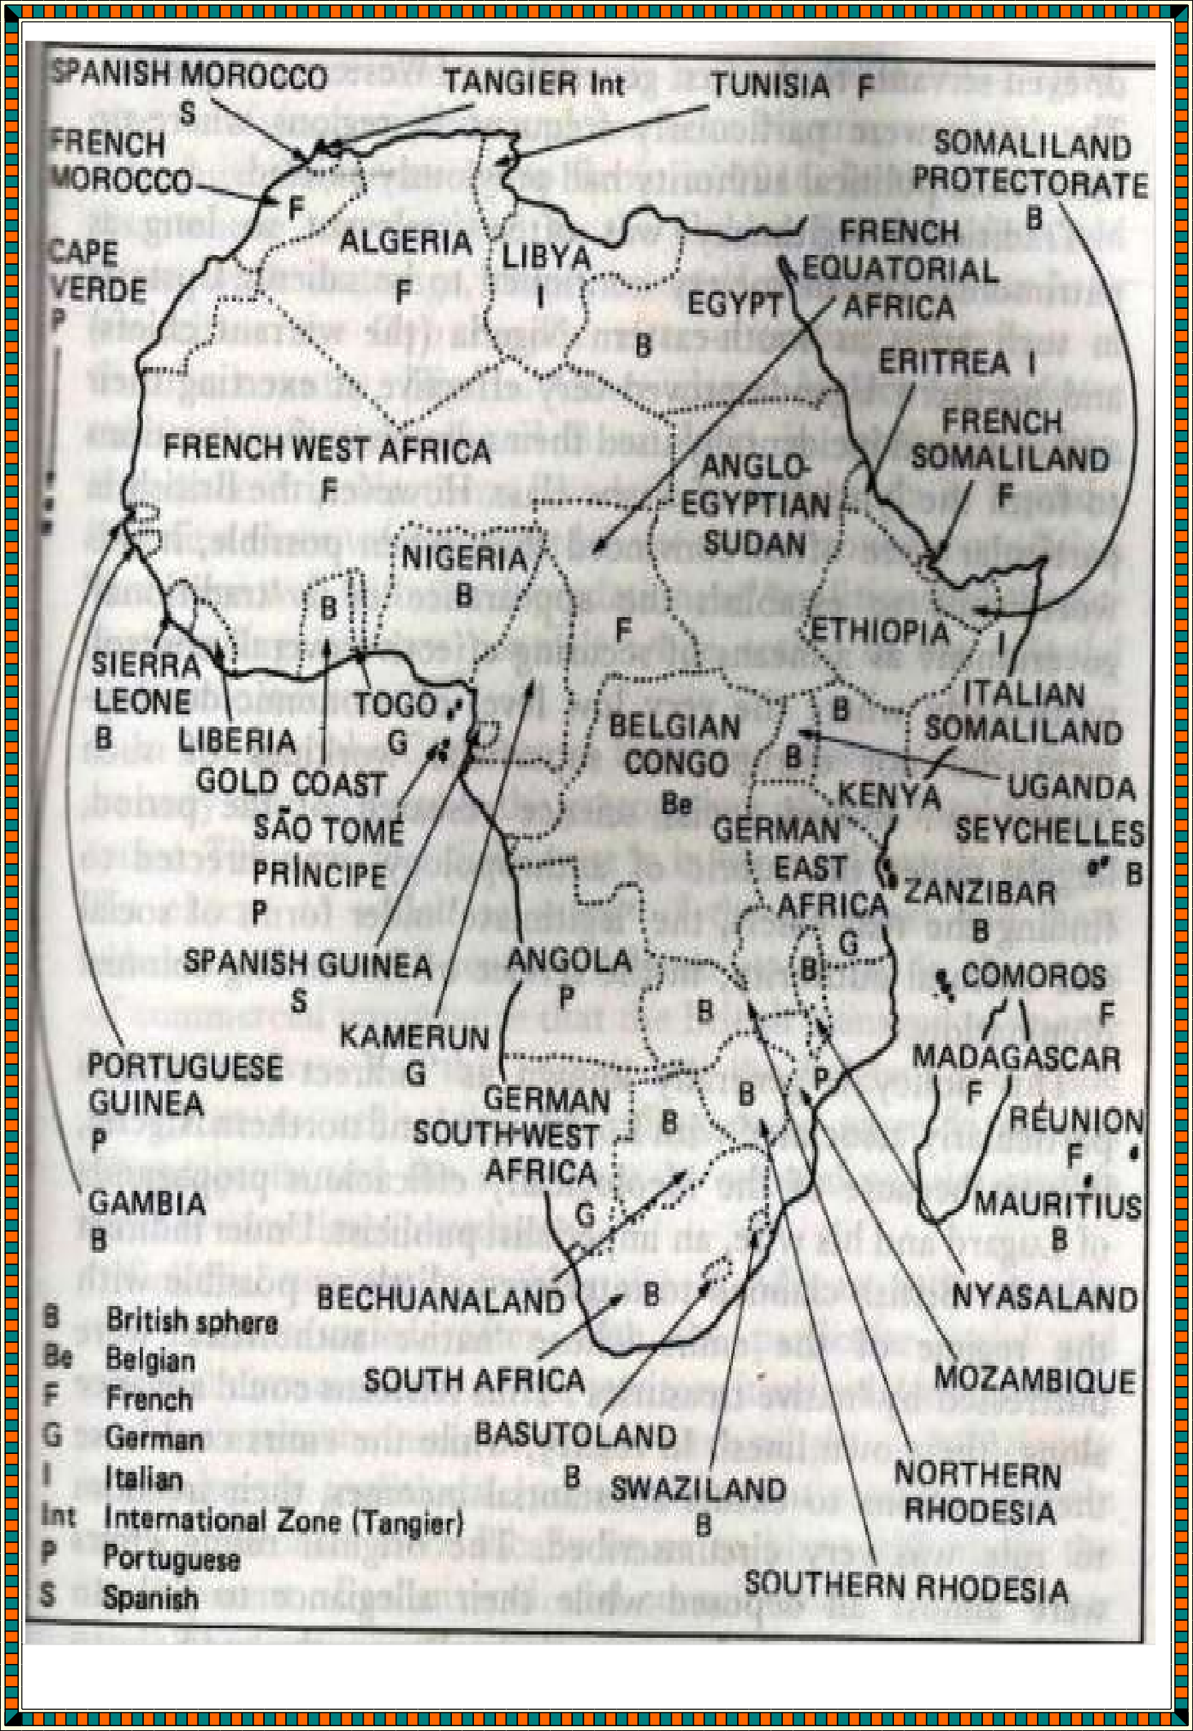

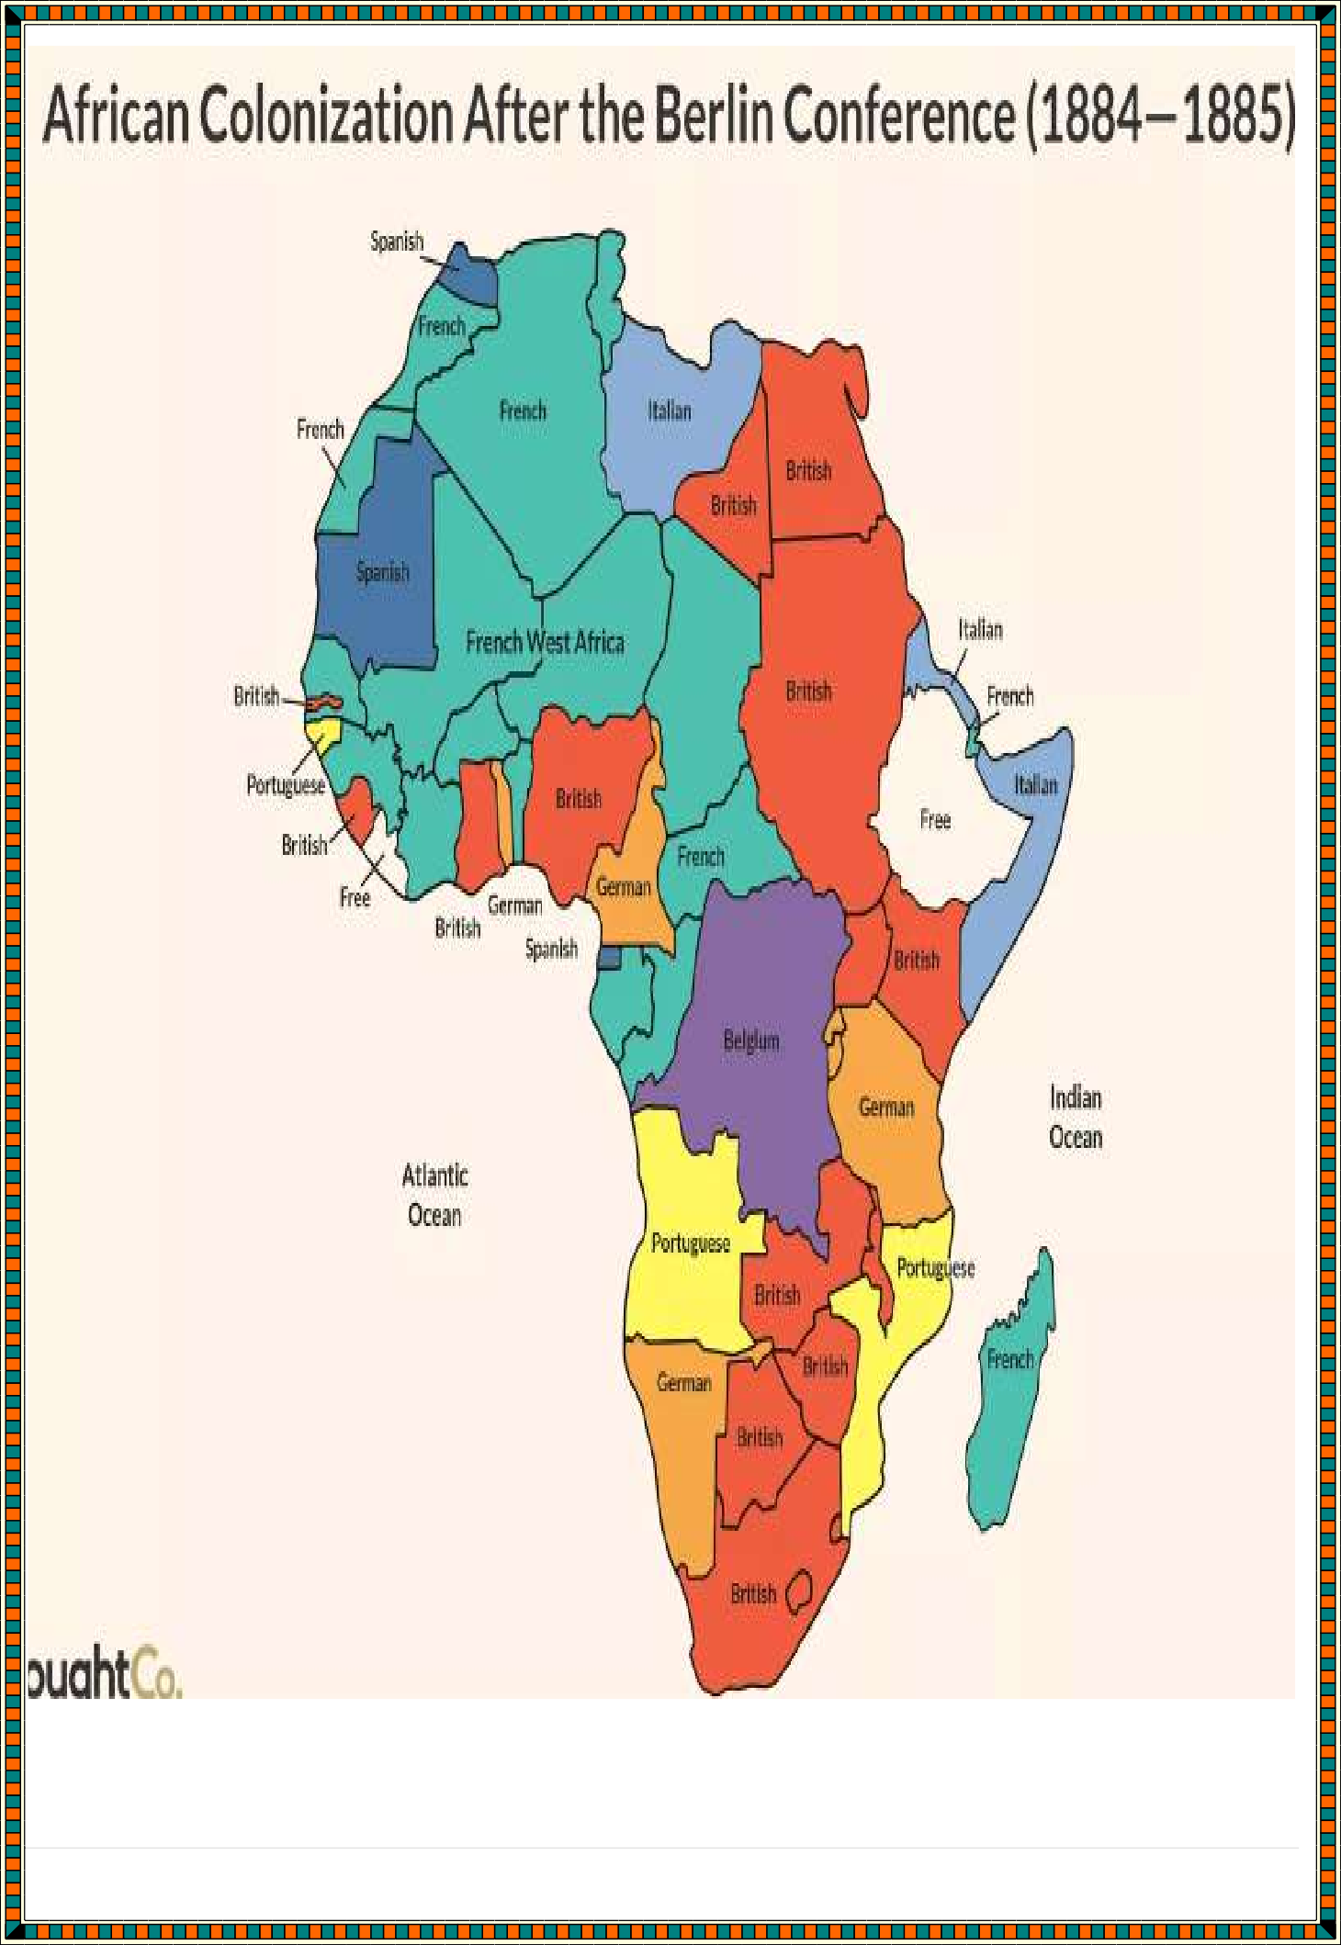

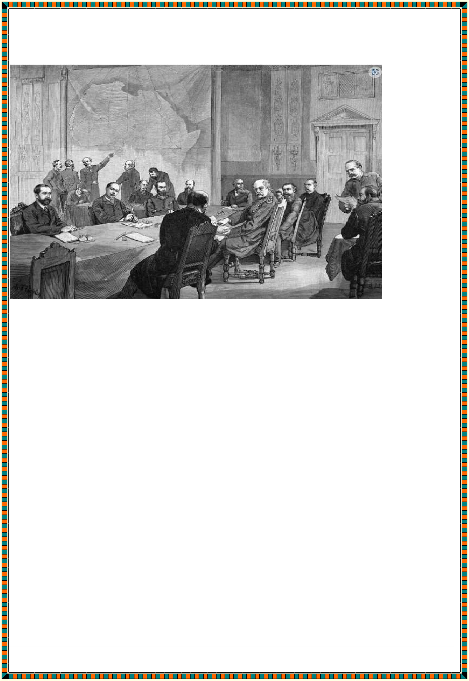
Terms of berlin of 1884 – 1885 on the partitioning of Africa

In 1884, at the request of Portugal, German chancellor Otto von Bismark called together the major western powers of the world to negotiate questions and end confusion over the control of Africa. Bismark appreciated the opportunity to expand Germany's sphere of influence over Africa and hoped to force Germany's rivals to struggle with one another for territory.
Terms included
- It created spheres of influence. Any European power occupying any part of Africa had the obligation to notify others to avoid double conflicting claims
- Effective occupation - Any claim of an African territory had to be accompanied by effective occupation.
- Each power had to stamp out slave trade in their territory and encourage legitimate trade
- Rivers Zambezi, Congo and Niger were left free for navigation by all European powers
- King Leopold was recognized as the sovereign ruler of the Congo Free State.

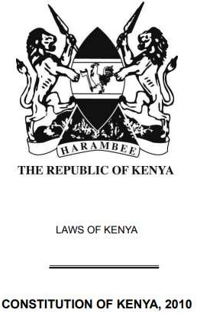The Constitution of Kenya

Importance of the constitution of Kenya Provides stability to the country
The constitution is made up of three important constituents that include the executive, the judiciary, and the legislature. These three vital components provide stability to a country. In absence of a constitution, the nation could be at the threat of corruption and threat among its masses.

Help prevent disputes among different sections of society
The Constitution serves as a written tool that acts as the personification of the social or political rules of an organization. These rules help the country to execute its policies and procedures without any disputes or issues. These provisions aid the nation to evade the possibilities of threats related to a civil war breakdown.

Forms the fundamental structure of the government
Another advantage of the constitution is that it describes all the cultural and legal aspects under which governmental institutions and people’s bodies will be regulated. This becomes very significant when there are

frequently occurring overseas communications by international organizations in the personal affairs of the nation.

Grants the right to the people to choose their government
The constitution gives the power to the citizens to choose the government of their choice. Based on their performance and contribution in the development of the nation, people can decide the best government official to serve the nation.

Protects the right of the individual
The constitution safeguards the rights of the citizens in terms of self- expression, religious practice, non-discriminatory treatment, fair criminal procedures and more. It states that the government is answerable to the people via conducting free and regular elections.

Governs the distribution of power
The Constitution states the power and authority of every governing body. Doing this, it enables every entity that is related to the country to learn about the power that the legal body and the government holds.
The information that the constitution states also help to define the duties of the parties involved. It could be a governmental institution, a firm or the masses of the nation. The Constitution administers the relation between the people and the government so that none of the parties can misuse the power in any manner.

Superior to all regulations and rules of the country
The constitution is supreme of all the other laws and regulations of the country. This implies that for any provision to circulate in the nation, it has to be approved by the constitution. It also implies that every law enacted by that government needs to be in conformism with the Constitution.

Specifies the objectives of a nation
Another important role of the constitution is that it mentions the strategic, political, and other objectives of the nation. These goals are what a country is focusing to accomplish in the coming years. It could be related to democracy, socialism, national integration, and secularism.

Grants fundamental rights to people
It is the constitution of a nation that assures provision and rights for any individual or a set of people to ensure their overall well-being and dignity in society. The constitution aids the people to avail the fundamental rights that they are entitled to. These rights include the right to life, right to freedom, right to property, and right to engage freely in the existing democratic system. All these fundamental rights are safeguarded by the Constitution.

Controls power transfer
Besides the welfare of its citizens, and regulating the tasks of the country, the constitution has the power to transfer the supremacy of the nation during a national emergency. This power of the constitution is exercised in those situations when there is a threat to the nation regarding its resources. It has a very important role to play in situations of a disaster that can cause severe destruction to a specific area of the nation or civil war breakdown.

National Values as enshrined in the constitution of Kenya
- patriotism, national unity, sharing and devolution of power, the rule of law, democracy and participation of the people;
- human dignity, equity, social justice, inclusiveness, equality, human rights, non-discrimination and protection of the marginalized;
- good governance, integrity, transparency and accountability; and
- sustainable development.

Ways of upholding and protecting the constitution of Kenya
They include:
- Defending the rights of every individual
- Obeying the rights and privileges of every individual
- Obeying court orders.
- Participating on National elections.
- Holding our leaders to account and uphold adherence to the constitution
- Obeying the laws stated in the constitution.
- Electing leaders who obey the rule of law.

Democracy
Democracy is a system of government in which laws, policies, leadership, and major undertakings of a state or other polity are directly or indirectly decided by the “people,”

Characteristics of democracy
  - Legitimacy: A legitimate government is one put in place, accepted and recognized by the people, it is a major feature of a democratic system of government that power vests in the people of the state. Therefore, a government in place without the approval of the people is not a legitimate government and as such cannot claim to be a democracy.
  - Rule of law: the rule of law is the supremacy of the law of a state over
every citizen or any other person residing in that state, this means that nobody is above the law no matter his status in the society. This is important in a democracy especially a representative democracy to act as a form of check and balance in the powers of the elected representatives so that they do not develop any illusions of being better than the people who elected and thereby empowered them.
  - Public opinion: public opinion has to do with the aggregate of the individual point of view as regards a particular matter by a significant population of a community or state as the case may be. Since democracy is a government of the people, the opinion of the said people cannot be overemphasized in determining issues in the government that will be to their benefit or detriment.
  - Periodic and transparent elections: For the people to be an active part
of their government especially in a representative democracy, provisions must be made for a periodic, free and fair election which will be conducted after sufficient political education to the people so as to aid them in making informed choices in electing their representatives at the poll on the election day.
  - Separation of powers: In a direct democracy, the decision resides in every member of the community and in the representative democracy where the people elect leaders to handle the affairs of the state, there

is separation of powers into different arms of government so as to allow for necessary checks and balances in the powers and administration of the separate arms of government.
  - Fundamental human right: In a democracy, the fundamental human rights of the citizens like right to life, right to fair hearing, right to dignity of the human person, right to personal liberty and others must be upheld according to the constitution of such country based on the major constituent of democracy which is the people.

Types of democracies practices in africa
- Direct democracy: direct democracy is a form of democracy which involves individual participation of every eligible citizen in the processes of government. This form of democracy works easily in a small community where all members of the community can come together to sit upon matters arising in their political arena, the opinion of every single member is put into consideration before a conclusion can be reached.
- Representative or indirect democracy: this is a form of democracy where the the affairs of the state is carried on by representatives elected by the general public through application of the universal adult suffrage i.e the sovereignty resides in the representatives and not with the people.
- Presidential democracy: this is a form of representative democracy whereby the people elect a leader, the President in a free and fair election to be at the helm of affairs. The President is the head of government and the head of state who leads in executive capacity independent of the legislative arm of government.

Importance of democracy in society
- Protecting the interests of citizens. People get the chance to vote on the key issues affecting their country or can elect representatives to make these decisions.
- Promoting equality. One principle of democracy is that all people are
equal in the eyes of the law, and every person gets a vote.

- Preventing abuse of power. In democracies, elected officials are responsible for carrying out the will of those who elected them. If they misuse their position, they won’t be re-elected.

Role of citizens in a democratic representation
First, a citizen in a democracy should have the duty to vote. If it were up to me, voting would be a requirement. What is wonderful about a democracy is that we choose who will represent us. There is no point to a democracy in which we do not participate.

Second, a citizen in a democracy should have an obligation to understand the powers and duties of the government, generally set forth in a constitution. If we do not know this, the government that does not act properly has no checks upon it and can avoid carrying out its duties.

Third, a citizen in a democracy should have the responsibility of knowing his or her rights, which are also generally set forth in a constitution. If we do not know what our rights are, they are meaningless.

Fourth, a citizen in a democracy should always know who his or her representatives are. If we do not know who is representing us, we do not know whether or not that person is representing us properly, to whom we should complain if that is the case, or to whom we should state our own opinions and preferences.

Fifth, a citizen in a democracy should assume the responsibility of being informed about the issues that affect the country as a whole, for example, the economy, immigration policy, environmental policy, and foreign policy.

Sixth, a citizen in a democracy is also a citizen of the world and as such, should be informed about the major issues that affect other countries. These inevitably have an impact on the citizen. A drought in one country might

mean providing foreign aid or might mean a rise in prices of a commodity that the citizen needs.
Seventh, a citizen should be concerned and informed about local conditions, those that affect him or her most directly, what a city is doing about urban blight or homeless people. This is one of the most important aspects of living in a democracy when a citizen is informed, since the information closest to home is usually the best information, and this provides one's greatest opportunity to participate in the democratic process.

Eighth, a citizen should be willing to pay taxes, since without taxes to provide a democratic government, there would be no democracy. A democracy must provide for all of its citizens.

Ninth, a citizen must have a duty to obey the law. A democracy cannot exist in a lawless society, and without the willingness of citizens to obey the law, which is really a social contract, no government has the wherewithal to police a nation of lawbreakers, and anarchy results.

Tenth, a citizen must support public education in every way possible, through the payment of taxes, through local volunteer efforts, through affording this system the respect to which it should be entitled. Public education is the foundation of democracy, meant to educate children to be responsible and knowledgeable participants in the democratic process.
Education is our power to perpetuate the democracy. Characteristics of various types of democracies in governance
Democracy is the best approach to learning what each social or ethnic group wants, particularly in a diverse country like Kenya. The five characteristics of democracy are as follows:
- Elected Representative: The people choose their representatives to serve as their leaders. Hence, people are entitled to take part in making decisions.

- Independent Judiciary: Conflicts are settled more democratically because the court is independent of the government.
- Civil Liberties: People can access civil freedoms like freedom of speech and expression.
- Organized Opposition Party: A well-organized opposition party is crucial to democracy because it serves as a check on the executive branch.
- Rule of Law: In a democracy, the rule of law is upheld, and everyone is subject to the law. In the eyes of the law, the law is supreme, and all citizens are treated equally.

Ways of applying democratic values during interaction with others
- Making contributions to the day to day activities of the country
- Taking responsibility for their actions, by making rules and laws together and supporting them
- Participating in decision-making processes of the country, relating it with the democratic processes such as councils, parliaments, government and voting.
- Showing understanding of how changes are effected in the country and the society as a whole.
- Evaluating the effectiveness of different ways in which change can be brought and implemented at different stages in life.
- Participating effectively in school and community-based activities.
Human Rights
human rights as those rights which are inherent in our state of nature and without which we. cannot live as human beings.

- The first generation of human rights is civil and political rights.
- The second generation of human rights includes economic, social and cultural rights and the
- third generation of human rights are called solidarity rights.
- The first generation rights i.e., civil and political rights are the initial form of natural rights. These rights developed during the English Revolution of the 17th century and the French and American Revolution of the 18th century. The key theme underlying these rights is liberty.
- The first generation rights include:
  - the right to life,
  - the right to liberty, and
  - the right to property and
  - have expanded to include non-discrimination,
  - freedom from arbitrary arrest,
  - freedom of thought,
  - freedom of religion,
  - freedom of movement etc.
These rights are often seen as a manifestation of negative rights since they can be enjoyed only when there is a restriction upon others. The key documents to understand the content of the first generation of human rights are Article 3 to Article 21 of the UN Declaration and the International Covenant of Civil and Political Rights of 1966 which came into force in 1976.
- In the twentieth century, especially post World War II, second- generation rights began to earn a greater prominence. The economy of countries was torn by war and there was massive destruction as a result of the world wars.
- Therefore, the effort for economic, social and cultural rights developed during the twentieth century. The rights rely on socialist assumptions and the underlying theme is equality which is in contrast to first- generation rights and the notion of liberty.
- The second-generation rights include:
  - the right to work,
  - the right to health care,

  - the right to education,
  - the right to social security etc.
Therefore, these rights are seen as a manifestation of positive rights as they place a claim on the state and a duty to oblige for action, for example, welfare provisions.

- The third generation of rights emerged post-1945 and are referred to as solidarity rights. This is for the simple reason that these rights are concerned with social groups and society on the whole rather than an individual.
- They are therefore seen as collective rights. The underlying theme of the third-generation rights is fraternity. Usually, these rights are shaped by the difficulties faced by the countries of the Global South.
- These rights include:
  - the right to development,
  - the right to environmental protection,
  - the right to self-determination,
  - the right to peace etc.
The Stockholm Convention of Human Environment of 1972 and the Earth Summit of 1992 at Rio can be analyzed to understand these rights.

Classification of human rights
- Civil and political rights
The rights that protect the life and personal liberty of a person are called civil rights. They are necessary to maintain the dignity of a person. These include rights like the right to life, liberty and security of a person, the right to privacy, the right to own property, freedom of thought, religion and movement.
Political rights are such rights that allow a person to participate in governmental activities. These include rights like the right to vote and the right to be elected. The nature of such rights is different, but they are interrelated to each other. Both these rights are covered in the International Covenant on Civil and Political Rights.

These rights are also called first-generation rights. The following civil and political rights are recognized in the declaration of human rights by the United Nations:
- Right to life, personal liberty, and security
- Freedom from slavery
- The prohibition against torture and inhuman treatment
- Equality before the law and equal protection
- Remedy before national tribunals
- Freedom from arrest, which is arbitrary in nature
- Right to a fair trial and public hearing by an impartial tribunal
- Freedom from ex-post-facto laws
- Right to privacy
- Right to nationality
- Right to own property
- Right to freedom of religion and conscience
- Freedom of expression
- Freedom to conduct a peaceful assembly
- Take part in government activities

Fundamental rights
Some human rights are guaranteed to the citizens of the state through constitutional provisions and cannot be infringed upon at any cost, even by the state authorities. These are termed as fundamental rights. The
expression ‘fundamental rights’ is stated in declarations and constitutional provisions of many states. The Virginia Declaration of 1776 states that men are free and independent and have certain inherent rights. The French Declaration of Rights of Man and Citizen, 1789 provides that men are born free and have equal rights. The Indian Constitution guarantees six fundamental rights to the citizens of the country. These are:
- Right to Equality
- Right to freedom
- Right to religion
- Cultural and educational rights
- Right against exploitation
- Right to constitutional remedies

Natural rights

The history of human rights is rooted in ancient times and the philosophical concepts of natural law and thus, also termed natural rights. Plato was one of the first writers to give a standard ethical code of conduct. Aristotle opined that rights change as per the different kinds of circumstances faced by society from time to time. Since human rights are universally applicable to every person in the world it is similar to natural rights. Natural rights have been derived from natural law which opines that law must reflect moral reasoning and must be related with morals imbibed in a person or set by the society. On the other hand, positivism states that human rights are a result of enactments of statutes and orders by law which comes with various sanctions attached to it.

Moral rights
Human rights that determine the spiritual and moral conduct of a person are termed moral rights. They are primarily contained in moral rights as they highlight various moral values that cannot be highlighted by any set of institutional rights. They promote moral values like respect for everyone, brotherhood, secularism, protection of life, peace in society, etc. Human rights also put moral obligations on the state and people not to violate and infringe on the rights of other people. If done so, it will be punished as per the provisions of the set statute.

Legal rights
The rights that are recognized by the legal system of a country are called legal rights. The two essential elements of these rights are:
- The holder of the right, and
- A person bound by duty.
Rights and duties are correlated to each other. A person cannot have a right without any corresponding duty. A person having a right also has a duty not to violate another person’s rights. Human rights are given to every individual irrespective of any considerations, and the state has the corresponding duty to protect the rights of its citizens. Article 2 of the Universal Declaration of Human Rights lays down that it is the primary duty of the state to promote, protect, and implement all human rights through

various measures and legislative provisions. The government of any state should pass any such laws which infringe on the rights of the people.

Economic rights, cultural Rights and social rights
These rights are also called freedoms and guarantee a person the minimum necessities of life. These are also included in the International Covenant on Economic, Social and Cultural Rights. These form a part of positive rights as the state is required to frame policies and provisions to implement such rights. These rights are based on the concept of social equality and are second-generation rights. These rights include the right to work, social security, physical and mental health, and education. The various economic, cultural, and social rights recognized by the Universal Declaration of Human Rights are as follows:
- Right to social security
- Right to work and choice of employment
- Right to rest
- Right to standard living and health
- Right to education
- Freedom to participate in cultural life
- Right to social and international order

Characteristics of human rights
  - Human rights are universal in nature which means that they are given to every individual irrespective of his/her caste, creed, race, religion, nationality and place of birth.
  - These are inalienable rights. Many philosophers believe that these are natural rights given by God and cannot be taken away or changed by anyone.
  - These are indivisible and interdependent rights. If a government gives one right then it has to protect the other rights of its citizens. For example, it is the duty of government to protect the right of fair hearing and provide food, shelter and clean environment to its citizens in order to protect the right to life of its citizens.
  - They are inherent to each person and available since birth.
  - They are not lost if the man is not familiar with his rights or if he does not use his rights. For example if a person is not aware of his right to

consult the advocate then it does not mean that his right is finished. It is then the duty of authorities to provide him with free legal aid or tell him his rights.
  - They protect the dignity and personality of humans. Rights like right to life, right to liberty, right against arbitrary arrest and punishment etc protect the dignity of a person.

Sources of Human Rights International treaties
These are the most important sources of human rights. There are multiple treaties on human rights which are binding on the states who are party to such treaties. For example, the European Convention on Human Rights, the American Convention, the African Charter on Human Rights, and People’s Rights.

International customs
These rights have acquired the status of customary international law by their practice and, thus, are binding on all the states irrespective of their consent. Many of these rights are a part of customary international law and thus known as a source of human rights.

International instruments
There are several declarations, resolutions, and recommendations related to human rights that have been adopted by the United Nations as a source of such rights. Some of these are the Universal Declaration of Human Rights (1948), declarations adopted at the Tehran Conference (1968) and the Vienna Conference (1993).

Judicial decisions
The International Court of Justice serves as another important source of human rights by setting up precedents and decisions in various disputes and case laws relating to violations of human rights.

Official documents
Documents and journals like Human Rights Law Journal, Human Rights Review, European Law Review, and other collective official work under the United Nations serve as the source of human rights.

Concept of Equity and non-discrimination in fostering solidarity
- Equality affirms that all human beings are born free and equal. Equality presupposes that all individuals have the same rights and deserve the same level of respect.
- All people have the right to be treated equally. This means that laws, policies and programs should not be discriminatory, and also that public authorities should not apply or enforce laws, policies and programs in a discriminatory or arbitrary manner.
- Non-discrimination is an integral part of the principle of equality. It ensures that no one is denied their rights because of factors such as race, colour, sex, language, religion, political or other opinion, national or social origin, property or birth.
- In addition to those grounds, discrimination on certain other grounds may also be prohibited. These grounds include age, nationality, marital status, disability, place of residence within a country and sexual orientation.
When do I need to consider the rights of equality and non- discrimination?
You will need to consider the rights of equality and non-discrimination whenever you are working on legislation, a policy or a program that draws distinctions between people or groups based on any of the following grounds:
- race
- sex
- disability, or
- age.
You will also need to consider the rights of equality and non- discrimination whenever you are working on legislation, a policy or a program that draws distinctions between people or groups based on:
- colour

- language
- religion
- political or other opinion
- national or social origin
- property
- birth
- nationality
- marital status
- place of residence within a country, or
African Diasporas
African Diaspora is the term commonly used to describe the mass dispersion of peoples from Africa during the Transatlantic Slave Trades, from the 1500s to the 1800s. This Diaspora took millions of people from Western and Central Africa to diﬀerent regions throughout the Americas and the Caribbean.
Factors that contributed to the presence of African Diasporas across the world
- European nations hand links with West Africa hence the shipping of many Africans from trans Saharan trade.
- African chiefs had developed a taste for European goods such as glass, clothes, rum and fire —arms which in turn made them sell many Africans as slaves to the Europeans.
- The establishment of mines and plantations and in new lands increased the demand for slaves to provide labour in the farms and mines.
- The increased demand of raw materials by European industries resulted in an increased in demand for slaves in America to work on the plantations
- Ship — building technology improved with building of larger ships with a greater capacity for such slaves.
These factors among others highly contributed to the shipping of many Africans to the Diaspora majorly as slaves.

Countries inhabited by African Diasporas in 1960
These countries included:
- United states of America
- Brazil
- France
France
The African diaspora in France is one of the largest in the world. Their members are from its former colonies in Africa and from its overseas territories in the Caribbean. The largest African community in Africa is the Algerians (730.000). Until it gained independence in 1962, Algeria was a part of the French territory. France also had strong ties with Morocco and today Moroccans are the second largest group of immigrants in France (670.000). African immigrants came to France in consequence of the colonization process and, from the 60s onwards, to seek employment.

United States
A quarter of the African-American population in Boston, Miami and New York were born abroad and 8 percent of the total of African Americans in the US were born outside the country[xv]. Ever since the Immigration and Nationality act in 1965 and the opening of new legal channels, African immigrants have started to come to the US.
Today, Americans with African descent make up 13.5% of the total US-population. Throughout the last decades, they have been becoming increasingly more present in the middle classes.

Latin America
African immigrants came to South America and the Caribbean as a result of the transatlantic slave trade. In the 1780s, slavery started to be criticized by the Christian Church, philosophers and economists and, as countries gained independence, slavery was abolished.
Over time, African descendants influenced most aspects of everyday life. Carnival, which used to be only celebrated by Afro-Latinos, has now become a public holiday in Brazil.
Unlike African Diasporas in the rest of Latin America who combine their African past with the culture of their host country, African descendants in the Caribbean who account for more than 90% of the population, are in search of a new national identity. They do

not define themselves in terms of Africans but rather as Jamaican or Haitian nationals, for instance. They came to terms with their past and no longer need to think of themselves as Africans.

Role of the Diasporas in political development in Africa
Pan-Africanism
- Pan-Africanism unifies the cultural and political world of African diasporas and the self-determination of people from Africa, or at least of African origin, as well as the people of African descent resident outside Africa. Initially, there was an anti- slavery and anti-colonial movement amongst black people of Africa and the Diaspora in the late nineteenth century. Since then, the aims of Pan-Africanism have evolved through the ensuing decades [.
- This movement had its origin in the United States in the late nineteenth century, thanks to the work of the advocate M.M. Garvey. He stated the idea of creating a common state in Africa to welcome back all the African Americans. Later on, Du Bois claimed the need to gain full rights, both in Africa and in the countries in which African communities resided, created by the forced migration represented by the slave trade in the previous centuries.
- Pan-Africanism gained legitimacy with the founding of the African Association in London in 1897, and the first Pan-African conference was held, again in London, in 1900 when Henry Sylvester Williams, the power behind the African Association, and his colleagues were interested in uniting the African Diaspora, and gaining political rights for those of African descent[.
- Between 1919 and 1945, Du Bois organized several conferences, which increased and expanded the influence on the development of the African descendants’ emancipation movement in the Americas and Europe, as a way of nationalism in colonial Africa. Moreover, between the world wars, Pan-Africanism became more related and influenced by communism and trade unionism, especially through the writings of George Padmore, Isaac Wallace-Johnson, Frantz Fanon, Aimé Césaire, Paul Robeson, CLR James, WEB Du Bois, and Walter Rodney.
- Significantly, Pan-Africanism had expanded beyond the continent into Europe, the Caribbean and America. WEB Du Bois organized a series of Pan-African Congresses in London, Paris, and New York in the first half of the twentieth century. International awareness of Africa was also heightened by the Italian invasion of Abyssinia (Ethiopia) in 1935.

- As a result, many leaders struggling for the independence from European colonial dominations were formed in this cultural and political context of Pan-Africanism. Among these, N. Nkrumah, J. Nyerere, A. Toure, M. Keita.
- The Pan-African ideal also inspired the emergence of regional groupings, some of which were short-lived, due to the immediate emergence of nationalistic feelings or tribal differences.
Role of African Diasporas in promotion of African Unity in Society today
- They have promoted equality for Africans whenever they are.
- They helped in forming organizations that today still unite Africans e.g. in terms of education
- Through their contributions they have helped shape economic developments in africa
- They have affirmed the worth of black people and therefore rejected the inferiority ascribed by racist thought in the late 19th and 20th Cs
- It helped to launch the struggle for rights and equality for black people in the diaspora and Africa as well

Global Citizenship
A global citizen is someone who is aware of and understands the wider world – and their place in it. They are a citizen of the world. They take an active role in their community and work with others to make our planet more peaceful, sustainable and fairer.
Global citizenship involves
- Exploring local and global connections and our views, values and assumptions
- Exploring issues of social justice locally and globally
- Exploring the complexity of global issues and engaging with multiple perspectives
- Applying learning to real-world issues and contexts
- Opportunities to make informed, reflective action and be heard
Interconnectedness and interdependence among countries
Interconnectedness refers to the ability to understand and function in an increasingly multicultural, international, yet interconnected environment. It fosters the development of individuals to become successful professionals, civic leaders, and informed citizens in a diverse national and global society.

Interdependence is measured by the costs of severing the relationship (or the benefits of developing it). The higher the costs to one country, the greater is the degree of dependence of that country.
Why countries interconnect and interdepend on each other Industrialization
Industrialization leads to the advancement of economies which in turn triggers the in- house manufacturing of several products. When a country specializes in the production of a certain product, it then needs to import other products from other countries. An example is that of Asia (Pakistan); it specializes in the manufacturing of footballs however leather and other preparatory materials are imported from China.
Producing specialized goods enhances production efficiency and therefore, most countries only focus on their specialties, providing a narrow range of goods and services. This creates economic interdependence among nations; the need for outsourcing or importing other products for the fulfillment of basic needs.
Economy advancement
As an economy develops, it focuses on establishing more industries and manufacturing more goods within the country's premises. This can lead to the creation of raw materials and other labor services from within the country or from neighboring economies.
Regional Production
One main reason for high economic interdependence among economies is the region- specific production. Different regions observe different weather, different soil, and other conditions. Within such circumstances, they specialize in the production of certain goods and crops only, while other necessities are fulfilled by importing goods.
For example, China is one major exporter of Apples, it produces more than 41 million tons of apples each year. Blessed by the perfect climate and land to harvest apples, China is an expert in harvesting Apples. On the other hand, America exports Maize, Soybean, and Milk. Both of these countries exchange their products with each other and are economically interdependent.
Labor Specialization
Another main driving force of Economic interdependence is Labor Specialization. When too many similar products are produced by one nation or a party, the production becomes specialized and economic interdependence takes place. That party then forms

trading relationships with other parties for the supply of products and services that they cannot produce.
Education
This is to enhance diffusion of knowledge among countries as they share knowledge on different disciplines. E.g. hiring of specialists like Doctors and nurses across various countries.
Positive effects of globalization at local and National Levels
- Access to New Cultures
Globalization makes it easier than ever to access foreign culture, including food, movies, music, and art. This free flow of people, goods, art, and information is the reason you can have Thai food delivered to your apartment as you listen to your favorite UK-based artist or stream a Bollywood movie.
- The Spread of Technology and Innovation
Many countries around the world remain constantly connected, so knowledge and technological advances travel quickly. Because knowledge also transfers so fast, this means that scientific advances made in Asia can be at work in the United States in a matter of days.
- Lower Costs for Products
Globalization allows companies to find lower-cost ways to produce their products. It also increases global competition, which drives prices down and creates a larger variety of choices for consumers. Lowered costs help people in both developing and already- developed countries live better on less money.
- Higher Standards of Living Across the Globe
Developing nations experience an improved standard of living—thanks to globalization.
- Access to New Markets
Businesses gain a great deal from globalization, including new customers and diverse revenue streams. Companies interested in these benefits look for flexible and innovative ways to grow their business overseas
- Access to New Talent
In addition to new markets, globalization allows companies to find new, specialized talent that is not available in their current market. For example, globalization gives

companies the opportunity to explore tech talent in booming markets such as Berlin or Stockholm, rather than Silicon Valley.
Negative effects of Globalization at National and local levels
- Loss of Cultural Identity
While globalization has made foreign countries easier to access, it has also begun to meld unique societies together. The success of certain cultures throughout the world caused other countries to emulate them. But when cultures begin to lose their distinctive features, we lose our global diversity.
- Terrorism
It is a significant problem in most developed countries. Due to worldwide integration, people travel a lot. Some of them move abroad for studying, business, visiting relatives, work and access hospitals services. However, not all of them are totally honest. Lots of terrorists came to a foreign country with a worker visa having a hidden goal to perform a terrorist attack. It’s a problem that has posed fear among citizens who can’t trust their neighbors. Unfortunately, terrorists recruit young people, residents of the country and make them believe they are doing the right things. That’s why there are fear, mistrust, and tension in society.

- Job Insecurity
Before globalization, skilled people got employment in government sectors and companies where they received high salaries. Job opportunities were waiting for those who completed colleges and earned a degree. People would resign a job and quickly get another. Due to globalization, there are many people seeking employment all over the world. Employers take advantage of cheap labor. One can get a dismissal because of a slight mistake as the employer can find a skilled worker who is ready to be paid less.
- Price Instability
Price instability is a significant effect of globalization on business. Some people establish industries overseas where they get cheap raw materials and labor. They can cut production costs and sell their goods at a low price. Due to competition, some high- quality products differ in prices. No matter how the World Trade Organization has tried to control price fluctuation, their efforts are not successful. These companies reach out to

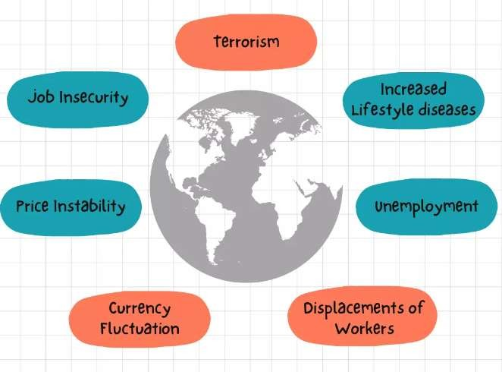consumers using modern technology. Successful businesses are for those who can find a competitive advantage and especially make high-quality products for a low price.
- Currency Fluctuation
International trade buys and sells products using the US dollar. The price of dollar fluctuates day-to-day in developing countries, this results in imbalanced economy and unnormal prices for goods and services. National currencies are affected the most by IGOs.

Qualities of Global Citizen in the modern Society
- Global citizens try to understand other people and have empathy for them.
- Global citizens act fairly in their choices, their decisions, and their words.
- Global citizens believe that they are just as important as everyone else.
- Global citizens believe that all people are equal. They do not think of some groups or individuals as superior or inferior to others.
- Global citizens accept differences and do not react with hostility to people who are different from them.
- Global citizens are willing to help and cooperate with others.
- Global citizens have their own ideas and express them, but they are open to changing them if they are proved wrong.
- Global citizens are curious and want to learn more about the world.

- Global citizens look after the environment and don’t waste things.
- Global citizens believe they can make a positive difference in the world
How to contribute to the wellbeing of the international community while maintaining a sense of rootedness to Kenya
  - Offer social support like Aid to affected countries.
  - Enhance social trust
  - Support members living harmoniously together
  - Foster civic engagement
  - Empower all members to participate in global democracy.
Global Governance
Global governance encompasses activities that transcend national boundaries at the international, transnational, and regional levels and is based on rights and rules that are enforced through a combination of economic and moral incentives.
Guiding principles of leadership and integrity in promotion of good governance
- selection on the basis of personal integrity, competence and suitability, or election in free and fair elections;
- objectivity and impartiality in decision making, and in ensuring that decisions are not influenced by nepotism, favouritism, other improper motives or corrupt practices;
- selfless service based solely on the public interest, demonstrated by—
- honesty in the execution of public duties; and
- the declaration of any personal interest that may conflict with public duties;
- accountability to the public for decisions and actions; and
- discipline and commitment in service to the people.
Formation of Organization of African Unity
was an intergovernmental organization established on 25 May 1963 in Addis Ababa, Ethiopia, with 32 signatory governments. One of the main heads for OAU's establishment was Kwame Nkrumah of Ghana. It was disbanded on 9 July 2002 by its last chairman, South African President Thabo Mbeki, and replaced by the African Union (AU).

Achievements of OAU
- OAU fought against colonialism, through its liberation committee, OAU succeeded in mobilizing funds, arms and support for the countries that were still under colonial rule. This saw the liberation of several countries like Angola, South Africa and Namibia. After its successful completion of the decolonization task, the liberation committee of OAU was dissolved in 1994
- OAU upheld the idea of African unity through the annual conferences where it managed to bring the different heads of states together, they did not only discuss the important matters affecting the continent but also came to know and understand each other better, this contributed towards African unity.
- OAU settled inter state conflicts between Uganda and Kenya 1987, Somalia and Ethiopia in 1970, Morocco and Mauritania over the western Sahara republic 1976, Somalia and Kenya, Uganda and Tanzania 1978 – 79, Uganda and Congo, Uganda and Sudan, OAU always came in to mediate peace and prevent large scale and prolonged wars.
- OAU helped in dismantling Apartheid by 1994; it used diplomatic talks, mobilized moral, financial and military support in order to weaken the Apartheid regime. It convinced the super powers to impose sanctions against Apartheid South Africa and encouraged the formation of frontline states that is Mozambique, Angola, and Zambia against South Africa.
- OAU promoted economic development in Africa that is in 1963 set up the African Development Bank in Abidjan in Cote-de-viore Ivory Coast, it obtained funds from multi national co-operations and rich Arab states for development. In 1993 at Abidjan OAU proposed the formation of an African economic community.

- OAU supported regional economic integrations after realizing that the idea of continental economic integration will take long to mature, such groupings like ECOWAS for West Africa, PTA and COMESA for East, central and South Africa, the SADC were formed and through these, unity and social economic advancement were spearheaded.
- OAU made efforts to end civil wars; in 1972 it negotiated a peace settlement over the Sudanese civil war, this helped to put the civil war to an end for a period of ten years. Even after the war resumed in 1983, it still made efforts to reconcile the SPLA guerilla movement with Khartoum government. It also intervened in the civil wars in Burundi, Mozambique, Nigeria and Angola.
- OAU made efforts to cater for refugees, during the 1965 OAU summit in Accra African heads of states addressed themselves to the problem of refugees in Africa in their topic “The refuge problem in Africa”. They resolved to give asylum to the refugees, minimize civil conflicts that produced these civil wars and also prevent refugees from engaging in abusive activities.
- OAU revived African culture throug games and sports, African festivals , African Languages like Swahili, Lingala and Hausa, promotion of African literature bureau which saw the writing of a number of novels and plays like “Things fall Apart by Chinua Achebe”, “Lion and the Jewel by Wole Soyinka”.
- OAU promoted international understanding, Africa on the international fora now spoke with one voice, it was also the influence of OAU on international scene that Africa managed to produce UN secretary Generals like Boutros Boutros Ghali and Kofi Annani.
- OAU promoted scientific research and through this OAU helped to stop pests, East coast fever and also went ahead to sensitize people about AIDS, also set up the African Medical Research Fund (AMRF) in order to improve research in diseases. All these efforts helped to improve the welfare of the people.
- OAU called for NAM in relation to international politics, it advised African countries to remain neutral during the period of cold war politics and this helped to reduce crashes.
- OAU condemned secessionions for example it took an uncompromising positions against, Biafran secession, Katanga secessions this helped to bring togetherness within those states and some how nationalism was realized.
- OAU promoted democratic governance in Africa and took a firm ground to condemn coups and political assassinations in addition the principle of one man one vote was upheld, Africa realized different elections for example in Kenya Moi gave

in to Kibaki through elections. All these were achievements that could not be under estimated.
- OAU defended human rights by setting up a human rights charter on 21st October 1986 signed by 30 out of 52 African states and from then they started fighting human rights abuses and encouraged Africans states to set up human rights commissions with in their countries. This has helped to reduce on human suffering on the African continent.
- OAU constantly spoke against neo-colonialism and Africans were encouraged to build self sustaining economies and avoid accepting decisions from the West. This some how enhanced African independence.
Challenges faced by OAU
  - Inability by member states to meet their annual subscription and the problem of defaulters.
  - Lack of military high command.
  - Ideological differences among African members of states.
  - Countries supported rebel activities in each other’s country.
  - Most countries remained very poor and liable to neo-colonialism.
  - OAU was faced with a problem of language barrier.
  - OAU was faced with a problem of prolonged European domination in Africa which drained most of its resources especially South Africa, Namibia and the Portuguese colonies of Angola, Mozambique and Guinea Bissau.
  - The colonial legacy was another problem where Africans remained loyal to their former colonial masters; there were sharp differences between the Anglo-phone and Franco-phone.
  - The problem of coup detas.
  - Divisions influenced by cold war politics.
  - Economic rivalry between African countries.
  - Greed for political power.
  - Boarder conflicts for example Amin wanted to extend the Ugandan boarder.
  - Corruption and embezzlement.
  - Poor infrastructure like roads.
  - Assassinations of African leaders who had it at heart.

Failures of OAU
  - Failure to air out political differences of African states, during the Nigerian civil war of 1967-70, Tanzania, Zambia, Ivory Coast plus Gabon remained in total isolation with Nigeria because they supported the Biafran secession. This was blamed on OAU because it had not made enough sensitization in the need for African unity.
  - OAU failed to create a standing army that would solve African problems. It only relied on soliciting support from African countries in times of crisis and therefore it failed to iron out dictators like Jean Bodel Bokasa of Central Africa, failed to end Amin’s rule in a short period, people like Mugabe of Zimbabwe and Ghadafi of Libya did not uphold on to the democratic principles of elections and this created confusion in African politics.
  - OAU failed to end Neo-colonialism throughout its existence, African countries were depending on the former colonial masters and to make matters worse the 1982 OAU summit that was to take place in Libya flopped because of the influence of USA and it was shifted to Addis Ababa. Therefore it is urged that OAU failed to achieve the desire for total independence.
  - The OAU failed to attain the desired unity of Africa. African countries throughout its existence were more concerned about their home problems rather than the continental issues. This created divisions against the future unity envisaged by its founders.
  - OAU failed to end inter state conflicts for example between 1977 and 1978 Ethiopia was at war with Somalia around 1979 Tanzania and Uganda were also at war, this disunity hampered economic development.
  - OAU failed to amend the OAU charter which emphasized the principle of non interference in the affairs of other states, the dictators always used this clause to prolong their stay in power and abuse human rights a case in point is Apartheid South Africa which constantly called OAU members to respect the non interference clause, other leaders like Ghadafi always told other leaders to mind their own business.
  - OAU failed to establish an economic integration of the continent, African states remained very poor and surprisingly 90% of the total trade in Africa was done outside the continent thus regional groupings like COMESA, Preferential Trade Area (PTA), SADCC failed to realize their objectives.

  - OAU failed to safeguard the sovereignty and respect of the members states for example in 1968 USA troops bombed Libyan cities of Benghazi and Tripoli, in Congo the Belgian troops occupied without the blessing of the OAU, various military take over were partly influenced by foreign countries and Africa did not rested yet OAU did not do enough guarding.
  - OAU failed to enforce non-alignment as member states became aligned either to the east or the West for example where as Kenya adopted capitalism, Tanzania adopted socialism which limited continental unity.
  - OAU failed to discipline member states which did not pay their membership for example Chad and Rwanda for long refused to pay this fee. According to the 1995 statistics out of 53 countries only 17 fully paid and it was estimated that about 583 million dollars were in debts.
  - OAU was also faced with personal conflicts, misunderstandings by Heads of states in Africa for example Nyerere boycotted the OAU summit in Uganda in 1975 because of personal conflicts with Amin, Nasser and Nkrumah disagreed on the form of unity to adopt in Africa. All these were blamed on OAU for failure to create peace and unity.
  - OAU failed to prevent assassinations of African leaders and Africa lost dynamic and political leaders like Lumumba, Sylvanus Olympio of Togo, Anwal Sadat of Egypt, Melicio Ndadaye of Burundi, Juvenile Habyarimana of Rwanda, and the people who were believed would ensure unity in Africa.
  - OAU failed to iron out differences between black Africans and the Arab North Africans. This was significant in the 1977 OAU summit in Somalia. The Arabs wanted a Somali to be elected as secretary General of OAU as opposed to a black from Zambia. This almost fragmented Africa into the Arab North and Black South. However this was solved by the election of a Cameroonian.
  - OAU failed to protect human rights. Most African states were headed by dictators like Amin, Mobutu Seseko, Sun Abacha who even banned political parties, censored the press but OAU simply condemned and could not remove such dictators.
  - Failure to improve the social welfare of Africans. Africans remained very poor, suffered from curable diseases like Bilharzia, there was poor feeding and mal- nutrition yet OAU did little or nothing to improve on this.
  - Failure to stop ethnic nationalism in Africa. OAU completely failed to stop the 1967 to 1979 Nigerian civil war, failed to unite Southern and Northern Sudan and

thus the crisis continued. It failed to cement relations between the Hutus and the Tutsis in Rwanda thus it is argued that the Cardinal objective of peace and stability was not fully achieved.
  - OAU failed to improve on the transport network in Africa which hampered economic progress for example the plan to construct the Trans-African high way from Mombasa to Lagos and from Johannesburg to Tripoli never materialized and this endangered African unity.
  - OAU failed to eradicate the white settlers in Kenyan highlands, Ethiopian highlands, South Africa and Zimbabwe.

Formation of African Union (AU)
The African Union (AU) was officially launched in July 2002 in Durban, South Africa, following a decision in September 1999 by its predecessor, the OAU to create a new continental organisation to build on its work. The decision to re-launch Africa’s pan- African organisation was the outcome of a consensus by African leaders that in order to realise Africa’s potential, there was a need to refocus attention from the fight for decolonisation and ridding the continent of apartheid, which had been the focus of the OAU, towards increased cooperation and integration of African states to drive Africa’s growth and economic development.
Aims of A.U
  - Achieve greater unity and solidarity between African countries and their the people
  - Defend the sovereignty, territorial integrity and independence of its Member States;
  - Accelerate the political and socio-economic integration of the continent;
  - Promote and defend African common positions on issues of interest to the continent and its peoples;
  - Encourage international cooperation
  - Promote peace, security, and stability on the continent;
  - Promote democratic principles and institutions, popular participation and good governance;
  - Promote and protect human and peoples’ rights in accordance with the African Charter on Human and Peoples’ Rights and other relevant human rights instruments;

  - Establish the necessary conditions which enable the continent to play its rightful role in the global economy and in international negotiations;
  - Promote sustainable development at the economic, social and cultural levels as well as the integration of African economies;
  - Promote cooperation in all fields of human activity to raise the living standards of African peoples;
  - Coordinate and harmonise the policies between the existing and future Regional Economic Communities for the gradual attainment of the objectives of the Union;
  - Advance the development of the continent by promoting research in all fields, in particular in science and technology
  - Work with relevant international partners in the eradication of preventable diseases and the promotion of good health on the continent.
  - Ensure the effective participation of women in decision-making, particularly in the political, economic and socio-cultural areas;
  - Develop and promote common policies on trade, defence and foreign relations to ensure the defence of the Continent and the strengthening of its negotiating positions;
  - Invite and encourage the full participation of the African Diaspora as an important part of our Continent, in the building of the African Union.
Achievements of A.U
African Union has contributed the following among its members states:
  - Conflict Resolution, Peace & Security
  - Infrastructure & Energy Development
  - Agricultural Development
  - Trade & Industrial Development
  - Visa Free Africa
  - Democracy, Law & Human Rights
  - Promoting Health & Nutrition
  - Migration, Labour & Employment
  - Promoting Sports & Culture
  - Education, Science & Technology
  - Youth Development

  - 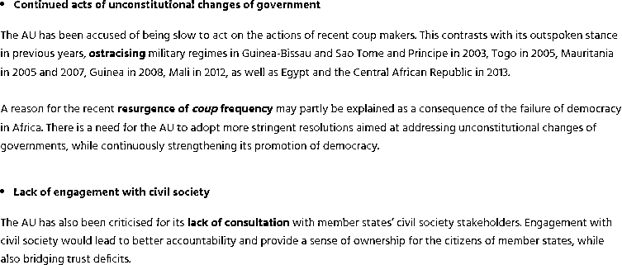Economic Integration & Private Sector Development
  - Diaspora & Civil Society Engagement
  - Gender Equality & Development Challenges of A.U

- Inadequate preparation in response to climatic challenges across Africa.

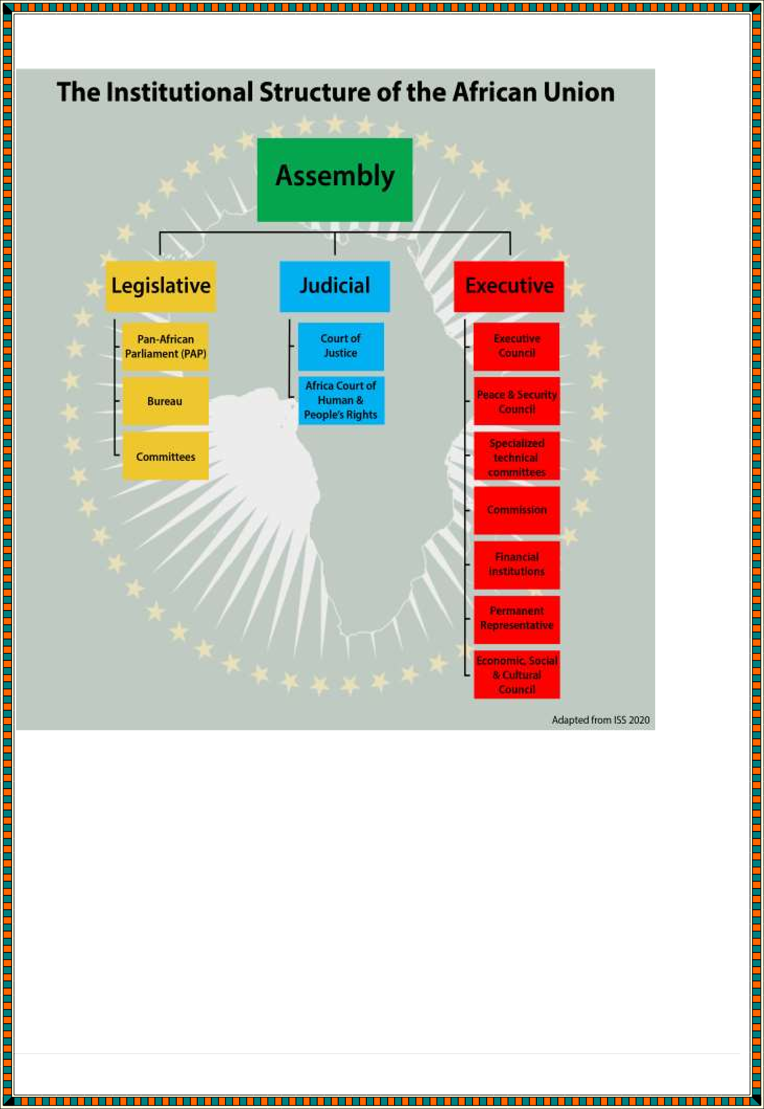
Organizational Structure of AFRICAN UNION

Factors which can promote continental Interconnectedness and interdependence
  - Introduction of one currency for African countries
  - Expansion of roads that link African countries
  - Introduction of free trade across the African continent
  - Enhancing of cultural exchanges among African Communities
  - Specialization in production of goods and services
  - Use of IT in enhancing and linking countries across Africa.
  - Developing the education sector.

