COMPETENCE BASED CURRICULUM
JUNIOR SCHOOL
FORMATIVE ASSESSMENT
TERM ONE 2024
GRADE 7

Name……………………………………………………………….………………………………………………
Centre ………………………………………………………………………………….......................................

Assessment No. ……………………………………………………………… Stream………………………

Learner’s Sign……………………………………………………..… Date: ………………..…………………..
AGRICULTURE AND NUTRITION
FOR EXAMINERS

ASSESSMENT RUBRICS (for official use)
%SCORE RANGE | Below 40 | 40-59 | 60-79 | 80-100
PERFORMANCE LEVEL | Below expectation | Approaching expectations | Meeting expectations | Exceeding expectations
 | 1 | 2 | 3 | 4

- State two components of Agriculture and Nutrition. (2 mks)
- …………………………………………………..
- …………………………………………………..
- What is Soil pollution? (2 mks)
………………………………………………………………………………………………
………………………………………………………………………………………………
- The harmful substances in the soil are known as ………………………………..(1mk)

- Mention six causes of Soil Pollution in Farming.(6 mks)

…………………………………………………………………………..…………………

………………………………………………………………………….………………….

……………………………………………………………………………………………..

……………………………………………………………………………………………..

……………………………………………………………………………………………..

……………………………………………………………………………………………...

Outline five Safe Soil pollution Control measures include the following methods :( 5 mks)
  - …………………………………………………………………………………..
  - …………………………………………………………………………………..
  - …………………………………………………………………………………..
  - …………………………………………………………………………………...
  - ……………………………………………………………………………………
- State three ways of creating awareness message against soil pollution. (3 mks)
  - ………………………………………………………………………………….
  - …………………………………………………………………………………..
  - ………………………………………………………………………………….
- Outline three damages caused by surface run off. (3 mks)
- ……………………………………………………………………………………………….
- ……………………………………………………………………..………………………..
- ……………………………………………………………………………………………….
- Surface run off is conserved or collected in structures such as:(3 mks)

- ………………………………………….
- ………………………………………….
- ………………………………………….
.
- Name four importance of conserving water in Farming.(4 mks)

- ………………………………………………………………………………………….
- ………………………………………………………………………………………….
- …………………………………………………………………………………………..
- …………………………………………………………………………………………..

What is the way or methods used to conserve Surface run-off? (3mks)
- ……………………………………………………………………………………………………………………………………..
- ……………………………………………………………………………………………………………………………………..
- ……………………………………………………………………………………………………………………………………….
- Name the following water retention structures. (3 MKS)
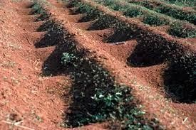
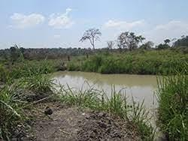
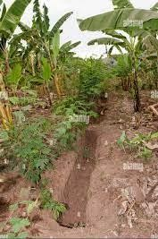

Mention three Crops that can be established in water retention structures. ( 3 mks)
- …………………………………………
- ………………………………………..
- ………………………………………
THE END

