COMPETENCE BASED CURRICULUM
JUNIOR SCHOOL
FORMATIVE ASSESSMENT
TERM ONE 2024
GRADE 7

Name…………………………….…………………………………………
Centre ………………………………………….......................................
Assessment No. ………………………… Stream……………………
Learner’s Sign……………………..… Date: …………………………..
AGRICULTURE
FOR EXAMINERS

ASSESSMENT RUBRICS (for official use)
%SCORE RANGE | Below 40 | 40-59 | 60-79 | 80-100
PERFORMANCE LEVEL | Below expectation | Approaching expectations | Meeting expectations | Exceeding expectations
 | 1 | 2 | 3 | 4

State five Ways of conserving vitamins and mineral salts in vegetables during food handling,preparation and cooking.(5 mks)
- ………………………………………………………………………….
- …………………………………………………………………………..
- …………………………………………………………………………..
- ………………………………………………………………………..
- ………………………………………………………………………….

State five Ways to cook vegetables to preserve nutrients. (5 mks)
- …………………………………………………………………………….
- ………………………………………………………………………………
- ……………………………………………………………………….…….
- ………………………………………………………………………………
- ……………………………………………………………………………..

- Mention three Importance of Trees in conserving the environment.(3 mks)
  - ……………………………………………………………………………..
  - ………………………………………………………………………………
  - ………………………………………………………………………………

Difference between afforestation, reforestation and deforestation.(6 mks)
…………………………………………………………………………………
……………………………………………………………………………………
…………………………………………………………………………………
……………………………………………………………………………
…………………………………………………………………………………
……………………………………………………………………………………
…………………………………………………………………………………….
- State four Roles of trees in soil and water conservation. (4 mks)
  - ………………………………………………………………..
  - ……………………………………………………………….
  - ………………………………………………………………….
  - ………………………………………………………………….
- What is Agroforestry? (2 mks)
……………………………………………………………………………………………………………………………………………………………………………………………..

- Name three minimum tillage practices for water conservation carried out in farming. (3mks)
- ……………………………………………..
- ……………………………………………..
- ………………………………………………
- Name three practices carried out when caring for agroforestry trees. (3mks)
- ………………………………………………………………………………..
- ………………………………………………………………………………..
- ……………………………………………………………………………….

State and explain four nursery management practice done in a tree nursery. (8 mks)
- ……….....................................................................................................
- ………………………………………………………………………
- …………………………………………………………………….
- Give three examples of crops that require fine tilth include(3 mks)
- …………………………….
- …………………………….
- …………………………….
21. Mention two Examples of crops that require medium tilth. (2 mks)
- ……………………………………….
- ……………………………………….

State two reasons for sorting and grading eggs. (2 mks)
- …………………………………………………………………………………
- ……………………………………………………………………………….

- State five factors to consider when Sorting and Grading Eggs (5 mks)
  - ………………………………………………………………………………….
  - …………………………………………………………………………………..
  - …………………………………………………………………………………
  - …………………………………………………………………………………
  - …………………………………………………………………………………..
- Outline four importance of sorting and grading eggs.(4 mks)
- ……………………………………………………………………………
- ……………………………………………………………………………
- ……………………………………………………………………………
- ……………………………………………………………………………
- Outline the Steps followed when processing honey.(5 mks)
- …………………………………………………………………………………
- …………………………………………………………………………………
- …………………………………………………………………………………
- ………………………………………………………………………………....
- ……………………………………………………………………………….

State three reasons for performing the following precautions when Packing Honey. (3 mks)
- …………………………………………………………………
- …………………………………………………………………
- …………………………………………………………………

State four Importance of Processing Raw Honey.(4 mks)
- …………………………………………………………………………………
- …………………………………………………………………………………
- …………………………………………………………………………………
- …………………………………………………………………………………

- State three methods of cooking food. (3 mks)
  - …………………………………….
  - …………………………………….
  - …………………………………….

State four Factors determining the choice of a cooking method.(4 mks)
- ………………………………………………………………………….
- ………………………………………………………………………….
- ………………………………………………………………………….
- ………………………………………………………………………….
- Name the following cooking equipment.(4 mks)

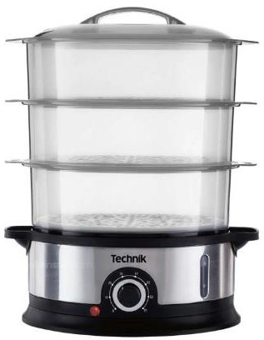
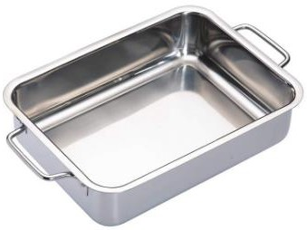
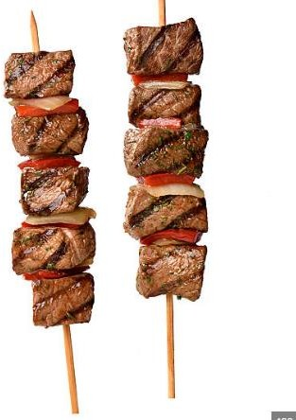
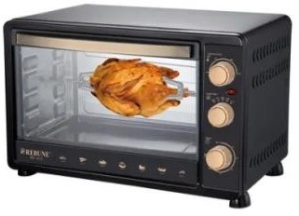

THE END

