COMPETENCE BASED CURICULLUM
JUNIOR SCHOOL ASSESSMENT
GRADE 7 2024 TERM ONE

Agriculture and nutrition

Questions
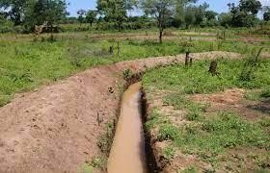
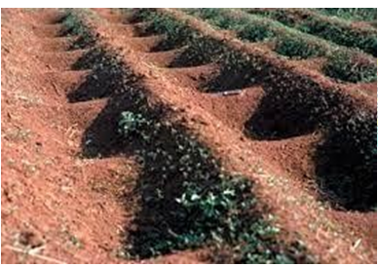
- What are the names of the following water retention structures? (2 mks)
Water Retention Ditches Earth Basins

- Define the following term. ( 2mks)
Soil pollution is the contamination of soil with harmful substances.
- The harmful substances in the soil are known as pollutants or contaminants( 1 mk)
- State four Causes of Soil Pollution in Farming. ( 4 mks)
  - Excessive use of artificial fertilizers.
  - Excessive use of agricultural chemicals (agrochemicals) such as herbicides and pesticides.
  - Throwing plastic wastes in the garden.
  - Throwing Chemical containers.

Soil pollution can be controlled using the following methods: state four methods. (4mks)
  - Carry out farming practices in the proper way.
  - Use of correct types and amount of artificial fertilizer and agrochemicals.
  - Safe disposal of used agricultural chemical containers.
  - Safe disposal of plastic wastes, containers and straws.
  - Practicing organic farming which is the growing of crops and rearing livestock without using artificial fertilizers and agricultural chemical.

State two ways we can use to create awareness message on proper farming practices. (2 mks)
- Dramatization.
- Presenting songs.
- Poems.
- Displaying posters etc.

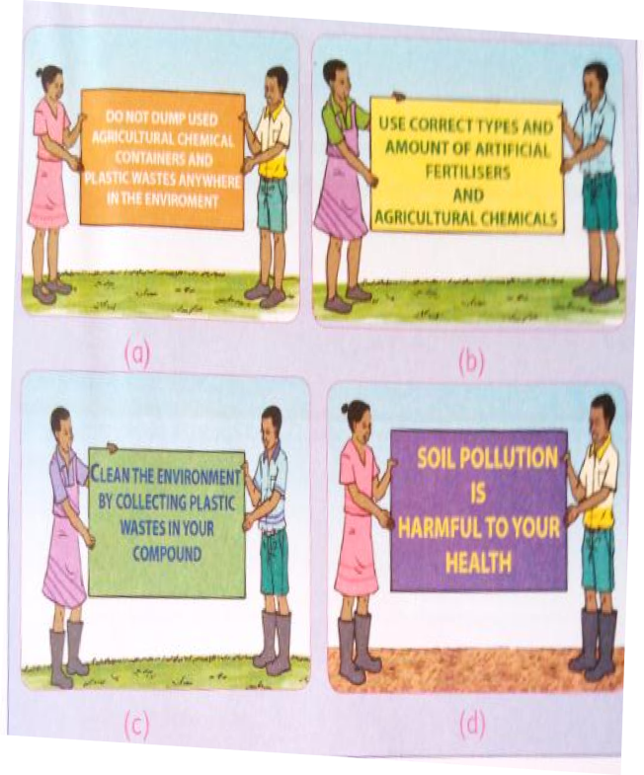
- Create a poster displaying proper ways of farming. ( 4mks)
And/or any other relevant poster
- Give three farming practices that cause soil pollution in farming. ( 3 mks)
- Excessive use of artificial fertilisers.
- Excessive use of agricultural chemicals.
- Dumping if used chemical containers.
- Dumping off plastic wastes.

Give five factors to consider when choosing agroforestry trees. (4 mks)
- Select trees that protect various living organisms.
- Select trees which control soil erosion.
- Select trees which provide multiple products.
- Select trees which provide nutrients to the soil.

Show how to select mother plant trees to provide seeds for establishing agroforestry trees. (3 mks)
- Are mature.
- Are healthy.
- Are suitable for the area.
- Grow fast.
- Are highly productive.

Describe three safe farming practices that prevent soil pollution. (3 mks)
  - Carry out farming practices in the proper way.
  - Use of correct types and amount of artificial fertilizer and agrochemicals.
  - Safe disposal of used agricultural chemical containers.
  - Safe disposal of plastic wastes, containers and straws.
  - Practicing organic farming which is the growing of crops and rearing livestock without using artificial fertilizers and agricultural chemical.

How can we make the members of the community aware of soil pollution control measures? (2 mks)
By creating awareness message and passing the message to the community through posters.

Mention three importance of controlling soil pollution in farming? (3 mks)
- It ensures the soil remains productive.
- It promotes food security by making the soil more productive.
- Ensures safety of the farmers.
- Give three importance of water conservation in farming.(3 mks)
- Promotes food security where conserved water is used to grow crops along after the rains have stopped.
- It reduces cost of production by saving on money that would have been used to buy water and irrigation.
- Conserved water is used for human life and livestock.
- It prevents damage of property by surface run-off after a heavy rainfall.

- Match the following methods of planting ( 3mks)

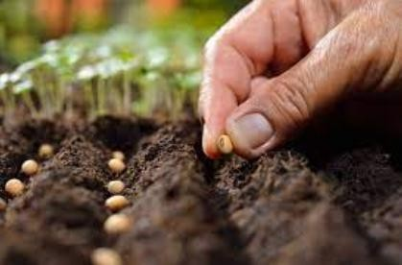
Broadcasting

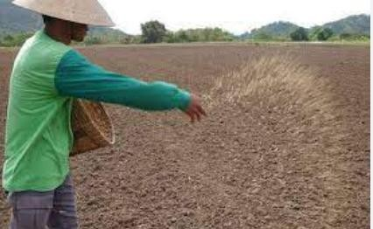
Dibbling
Drilling
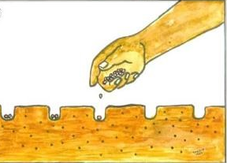

What is the term used for describing the water that runs on the ground surface during and after raining?( 1mk)
Surface run-off.

Name three minimum tillage practices for water conservation carried out in farming.( 3 mks)
  - Uprooting weeds.
  - Slashing weeds.
  - Mulching.
  - Restricted cultivation.

Explain three minimum tillage practices for water conservation in farming.( 3 mks)
  - Uprooting weeds-pulling the whole weed out of the ground.
  - Slashing weeds-use of slasher to cut off weeds. Another crop may be planted without cultivating the slashed field.
  - Restricted cultivation-cultivating only the area around the base of the growing crops to remove weeds as the other parts are left uncultivated. This helps to
prevent loss of soil moisture through evaporation. Conserved water is used by the growing crops.
  - Mulching-this covers the soil around the base of growing crop and prevents loss of soil moisture through evaporation. The water remains in the soil longer and is used by the growing crops.
- State two benefits of studying home science for self.(2 mks)

- It helps learners adapt healthy nutrition habits for wellness.
- It also equips learners with cookery skills.
- Home science equips learners with the principles of consumer education for effective financial management.
- Name three careers and Income generating activities In Home science.(3 mks)
- Education sector.
- Nutrition.
- Social work.
- Hospitality.
- Fashion and design.
- Health.
- Entrepreneurship.
- Write down the meaning of the following terms (4 mks )
Pre-adolescence
Preadolescence is a stage of human development following middle childhood and preceding adolescence. It commonly ends with the beginning of puberty.

Food fortification
Food fortification is defined as the practice of adding vitamins and minerals to commonly consumed foods during processing to increase their nutritional value.

Blanching
Blanching is scalding vegetables in boiling water or steam for a short time. It is typically followed by quick, thorough cooling in very cold or ice water. Blanching stops enzyme actions which otherwise cause loss of flavor, color and texture.

Food enrichment.
This is combination of foods that have different value to improve the quality of nutrients. To add or combine different foods during cooking so as to produce a healthier meal. Addition of milk into porridge and toasting bread using an egg.

- List any two career opportunities in home science. (2mks)
- food analyst,
- health care professional,
- food scientist,
- research assistant,
- nutritionist,
- home science professor/lecturer,
- Chef,
- textile supervisor,
- fashion designer,
- child care,
- housekeeper,
- demonstrator,
- Pantry in-charge.
- State two ways nutrients are lost when handling food. ( 2 mks)
    - Harvesting.
    - Storage.
    - Distribution or supplying.
    - Food preparation.
    - Cooking.
- Identify the product from the following animal. ( 1mk)
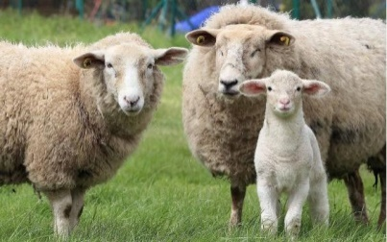

- Wool for clothing
- Skin leather
- State two guidelines that helps us to conserve food nutrients during food preparation and cooking.( 2mks)
  - Peel fruits and vegetables thinly.
  - Wash fruits and vegetables under running water before cutting them.
  - Use sharp knife to slice and cut fruits and vegetables into relatively larger sizes.
  - Cut vegetables just before cooking.
  - Fruits and vegetables should be washed thoroughly using cold water.
  - Reduce the amount of water used in cooking.
  - Reduce the cooking time.
  - Reduce the surface area of food being cooked.
  - Use blanching and parboiling when cooking.
  - Always cover the vegetables while cooking.
  - Sodium bicarbonate (Magadi soda, bicarbonate of soda, or baking soda) should not be used while cooking vegetables
- When investigating the effect of different methods of cooking on colour, texture and taste of vegetables, the following safety precautions should be observed namely?( 3 mks)
  - Be careful when using a sharp knife to avoid cutting yourself.
  - Use kitchen gloves or pan holder to hold a sufuria to prevent burns.
  - When uncovering food, always tilt the lid away from yourself to prevent scalds.
  - Food should be prepared in a well-ventilated room.

- Name Shaping and molding tools below. (3 mks)

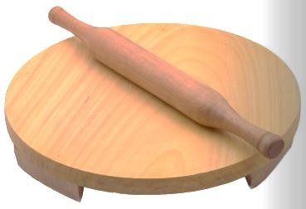
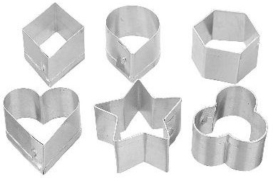

Biscuit cutters Loaf tin. Rolling board and rolling pin

- State two Factors to consider when choosing small kitchen tools and equipment.( 2 mks)

- The cost of the small kitchen tools and equipment to be bought should be within the financial ability of the individual buying.
- The type of material used should be of good quality so that the small kitchen tools and equipment can last long.
- Choose kitchen equipment for their correct use. This makes work more efficient.

- Identify three Care practices for small kitchen tools and equipment used at home.( 3 mks)

- Use warm soapy water when cleaning utensils.
- Tools should be thoroughly cleaned.
- Tools should be dried before storage.
- Wash tools according to the materials they are made from.
- Glass and clay tools are fragile and should be handled with a lot of care when cleaning them.

State three Factors determining the choice of a cooking method. ( 3 mks)
- The type of food to be cooked.
- Time available.
- Fuel or means of cooking.
- Equipment available.

- State the Methods of Cooking different types of foods.( 3 mks)

- Grilling
- Steaming
- Roasting
- State three Equipment used for grilling food.( 3 mks)
- Charcoal grill.
- Electric grill.
- Gas grill.

- State three guidelines to be followed when grilling different types of foods to ensure the food is well cooked.( 3 mks)
- Foods to be grilled for example, meat, should not be too thick to allow them to cook properly.
- The grill should be preheated to the correct temperature before.
- The food must be attended to constantly to prevent burning or over-cooking.
- The food should be turned frequently to ensure even cooking.

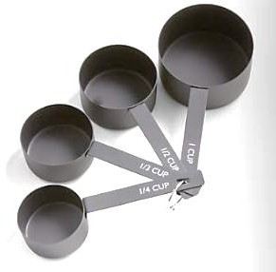
- Name Measuring and weighing tools below. ( 3 mks)
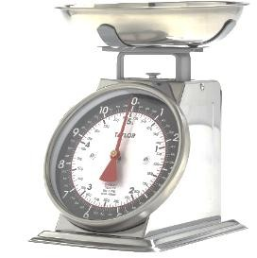
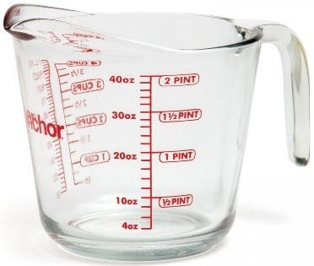

Measuring jug. Kitchen scale. Measuring caps.

- State two disadvantages of Grilling method of cooking?( 2 mks)
- Requires constant supervision.
- Inconvenient.
- Some skill is needed.
- Fire and burn hazards.
- Health concerns.
- Match the roasting Equipment below to their names. ( 6 mks)
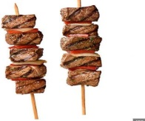
Roasting pan.

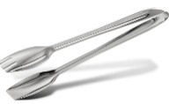
Electric oven

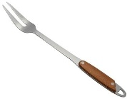
Tongs

Skewer

Gas cooker.
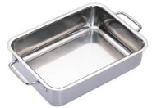

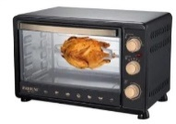
Two prong fork

THIS IS THE LAST PRINTED PAGE
……………….Every learner counts …………

