COMPETENCE BASED CURRICULUM
JUNIOR SCHOOL
FORMATIVE ASSESSMENT
TERM ONE 2024
GRADE 7

AGRICULTURE
MARKING SCHEME

State five Ways of conserving vitamins and mineral salts in vegetables during food handling,
preparation and cooking.(5 mks)
- Washing - Wash vegetables before cutting. Soaking or washing time should be reduced to minimize nutrient loss.it is advisable to wash vegetables with cool water rather than hot water. It is also advisable to wash vegetables before cutting. Avoid cutting then washing as this may cause leaching of nutrients.
- Peeling – Most vegetables have more nutrients preserved when consumed with out peeling. Therefore, excessive peeling should be avoided to ensure more nutrients are conserved.
- Cutting – most vegetables loss nutrients once cut because they are exposed to air. Therefore, it is advisable after cutting vegetable they should be stored in air tight containers. Ensure you remove excess air from the containers.
- Cooking time -cooking time affects nutrients such as vitamin C which is lost when cooking food for long time. This is also determined with cooking method used. Incase boiling is much involved and cooking time is long, then the vegetable tend to lose a lot of nutrients.
- Covering - cooking vegetables with the lid on can help to retain some of the water- soluble vitamins, such as vitamin C and the B vitamins, by trapping steam inside the pot and reducing the amount of nutrient loss through leaching into the cooking water.

State five Ways to cook vegetables to preserve nutrients. (5 mks)
- Choose the right chopping method. The wrong chopping method can also lead to loss of nutrients. ...
- Be careful about the size of the vegetables. ...
- Cook food for the right time.
- Use the right amount of water.
- Avoid re-heating the food.

- Mention three Importance of Trees in conserving the environment.(3 mks)
  - Timber/poles.
  - Firewood.
  - Shade.
  - Food and livestock feed.
  - Organic matter that increases soil fertility.
  - Conservation of both soil and water.

Difference between afforestation, reafforestation and deforestation.(6 mks)
Afforestation refers to planting trees where tress had never existed.
Reafforestation means planting of tress where forests have been cleared.
Deforestation-this is indiscriminate removal of trees from forested areas.

- State four Roles of trees in soil and water conservation. (4 mks)

  - They protect the soil from raindrop erosion by reducing the force with which it fall on the ground.
  - Trees provide shade hence reducing loss of moisture through evaporation.
  - Trees act as windbreaks preventing wind erosion.
  - Roots of trees binds the soil particles together.
  - Trees also reduce speed of running water thus reducing its erosive power which reduces soil erosion.
  - Tree leaves decay/decompose to supply humus to the soil which improves soil fertility and water infiltration.

- What is Agroforestry? (2 mks)
-refers to the growing of crops, trees and rearing of animals on the same piece of land. The planting of trees and shrubs helps to conserve soil and water as described in the roles of trees above.

- Name three minimum tillage practices for water conservation carried out in farming. (3mks)
- Minimum tillage practices include:
- Dibble stick planting.
- Disc-plant (stubble-harrowing)
- Strip and spot tillage.
- Ripping.
- Name three practices carried out when caring for agroforestry trees. (3mks)
- Alley Cropping. Agricultural crops grown simultaneously with long-term tree crops.
- Forest Farming. Cultivation of high-value crops under the protection of a managed forest canopy.
- Riparian Forest Buffers. Natural or re-established streamside forests made up of tree, shrub, and grass plantings.

State and explain four nursery management practice done in a tree nursery. (8 mks)
- Mulching-alight mulch should be applied to prevent excessive evaporation and moderate soil temperatures.
- Watering-tree nursery should be watered regularly preferably in the mornings and evenings.
- Weed control-weeds should be removed through uprooting to avoid competition for nutrients and moisture.
- Pricking out-where seedlings are overcrowded, some should be removed (pricked out)and planted in another nursery bed.
- Root pruning-regular root pruning is done to make lifting of seedlings easier during transplanting and reduce chances of damage to seedlings.
- Shading-a shade should be erected over the nursery to reduce the impact of raindrop hence controlling splash erosion.
- Pest and disease control- sterilize the soil through heat treatment or application of appropriate chemicals.
- Hardening off-practice of preparing seedlings to adapt to the prevailing conditions in the seedbed.it is achieved through gradual reduction of shade and reduced watering.
- Transplanting-should be done at the onset of rains to give young trees a good start.
- This makes the soil to stick around the roots and makes it easy for removal of polythene sleeves during transplanting. After transplanting seedlings should be watered, mulched then provided with a temporary shade to conserve moisture.
- Give three examples of crops that require fine tilth include(3 mks)
- Millet.
- Sorghum.
- Wheat.

21. Mention two Examples of crops that require medium tilth. (2 mks)
- Maize.
- Beans.

State two Reasons for sorting and grading eggs.(2 mks)
- For incubation purposes.
- For selling purposes.

- State five Factors to consider when Sorting and Grading Eggs (5 mks)

Size of the eggs.
- Weight of the eggs.

Colour of the eggs.
- Shape of the eggs.

Condition of the shell, i.e. broken, smooth or rough.
- Cleanliness of the eggs.

- Outline four importance of sorting and grading eggs.(4 mks)
- High quality eggs fetch high market prices.
- Grading encourages farmers to produce high quality eggs, assuring the of high profits.
- Sorting of eggs helps to grade them.
- Buyers prefer large eggs for consumption. Those who need eggs for incubation usually but the medium sized eggs.
- Outline the Steps followed when processing honey.(5 mks)
- Collect all the tools required such as muslin cloth, glass bottle, wooden spoon and wooden rods.
- Break the honey combs into small pieces.
- Place the broken pieces of honey combs on a muslin cloth.
- Wrap honey combs with the muslin cloth.
- Crush and strain honey from honey combs into a container using the wooden rods.

State three reasons for performing the following precautions when Packing Honey.(3 mks)
- Packing into suitable containers: for use or storage or for sale.
Honey stored in suitable containers remain clean and safe for consumption and can be stored for longer period of time.
- Storing in plastic, glass or Aluminium containers and sealed tightly: to prevent air and moisture from getting into the honey.
- Packing honey should be stored at room temperature in a dry place to avoid crystallization.

State four Importance of Processing Raw Honey.(4 mks)
- To ensure clean and quality honey is produced.
- To obtain other products such as bee wax.
- To make honey safe for consumption.
- To remove impurities such as wax, dead bees, bee wings and legs.
- To enable honey, stay for longer period without spoiling before use.
- To add value to the final product.
- Processing makes honey lighter and easier to transport.
- State three methods of cooking food. (3 mks)
  - Grilling
  - Steaming
  - Roasting

State four Factors determining the choice of a cooking method.(4 mks)
- The type of food to be cooked.
- Time available.
- Fuel or means of cooking.
- Equipment available.
- Name the following cooking equipment.(4 mks)

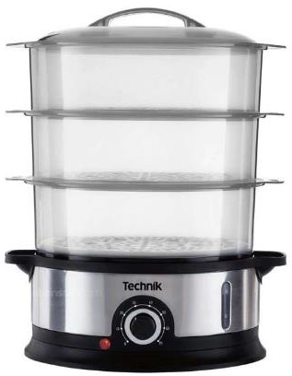
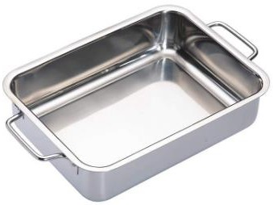
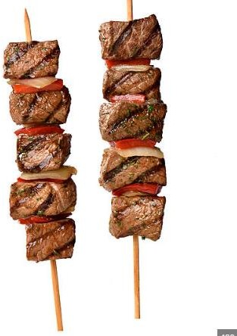
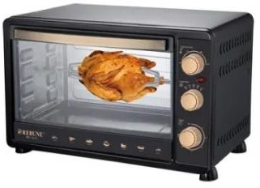

Oven Skewer Roasting Pan Steamer

THE END

