**312/2**

**GEOGRAPHY PAPER 2**

**FORM FOUR EXAMINATION**

**JULY/AUGUST 2024**

**Instructions: This paper contains two section A and B**

**Answer all questions in section A and any two questions from section B**

1. (a) i) Apart from geothermal power, name three other renewable sources of energy in Kenya

* **Wind**
* **Solar/sun**
* **Wood**
* **Biogas. ( 3×1=3mks)**

ii. State two factors that limit exploitation of geothermal power in Kenya

* **Inadequate/shortage of capital to invest in geothermal power production**
* **Shortage of skilled labor to install the geothermal power**
* **Low level of technology which hinders exploitation of energy (2×1=2mks)**

2. (a) . Give **four** advantages of air transport over water transport.

* **Air transport is faster**
* **Air transport is less affected by congestion**
* **Air transport is easier in transporting perishable goods**
* **Air transport is most comfortable over long distances.**
* **Air transport allows access to remote areas.**

**( 4×1 = 4 mks**

(b.) Name three types of communication.

* **Oral/verbal communication**
* **Written communication**
* **Visual/audio communication**
* **Sign language. ( 3×1 =3mks)**

**3** (a) Name two tourist attraction found in Kenyan Rift Valley**.**

**- Lakes e.g Nakuru, Baringo, Naivasha, Elementaita.**

**- Flamingoes / birds.**

**- People’s culture.**

**- Mining sites e.g Kariandusi.**

**- Nakuru National park.**

**- Hot springs / geysers / fumaroles / geothermal.**

**- Menengai crater.**

**- Water falls – Thomson falls.**

**- Wildlife.**

**- Pre-historic sites e.g Kapenguria.**

**- Sport tourism e.g sport fishing, marathon. ( 2 x 1 = 2 Marks)**

(b) State three factors that hinder domestic tourism in Kenya**.**

- **Negative attitude towards local tourism by the citizens.**

**- High cost of accommodation in the lodges and hotels discourages many**

**people.**

**- Poor transport and communication network of roads leading to the parks and other attractive sites.**

**- Preferential treatment gives to the foreign tourists discourage locals.**

**- Inadequate knowledge on the tourist attractive sites**

**( 3×1=3mks)**

**4.(a) What are floods**?

* Floods are unusual/excessive covering of an area by water, through a temporary rise in the level of river, lake, sea or rain. **(2Marks)**

(b) **Mention two advantages of farrow irrigation**.

* Furrows can be repaired when they become eroded.
* Weeds grows in the furrows are constantly removed.

**(2 x 1 = 2 Marks)**

(c**) Name one river which causes large scale flooding in Kenya**

* River Tana
* River Yala
* River Nyando
* River EwasoNyiro
* River Nzoia
* River Kuja **(1x 1 = 1Mark)**

5. **(ii) Name two major imports from Europe to Kenya**

* Machinery
* Capital equipment
* Pharmaceutical products/medicine
* Fertilizers
* Automobiles(  **2×1=2Marks)**

**(b) State three factors that influence internal trade in Kenya**

* Population size
* Cultural differences
* Production of similar goods for trade by different regions.
* Level of development of transport network:
* Level of income or purchasing power.
* Security:

(  **3×1=3mks)**

**SECTION B**

**Answer question 6 and any other questions from this section**

1. **The table below shows total number of livestock in Kenya in 2012**

|  |  |
| --- | --- |
| Type of livestock | Number in millions |
| Dairy cattle  Sheep  Goats  Pigs | 2.4  7.0  7.2  8.5 |
| Total | 25.1 |

Source: Central Bureau of Statistics

1. Draw a divided rectangle 15 cm to represent the data give above (7Mark)

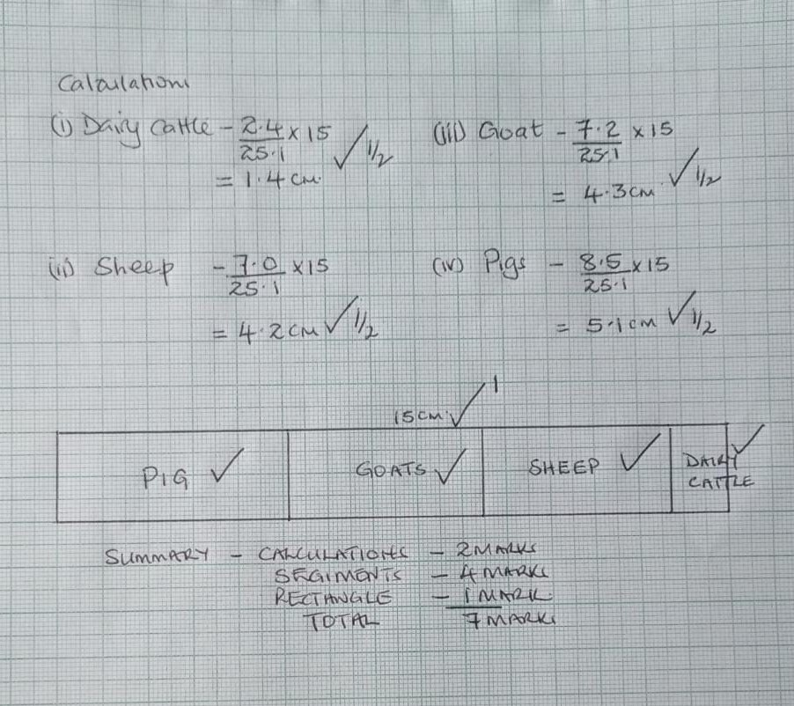

(b) **Give two reason why the population of sheep is higher than that of dairy cattle**

* Sheep survive in a variety of climatic conditions while dairy cattle are restricted to cool and wet climate
* The farm inputs required for dairy cattle are more expensive than those for sheep
* Some breeds of sheep are more resistant to diseases that dairy cattle thus they are more widespread.
* The management of dairy cattle is more demanding than that of sheep

**( 2 x 2 = 4Marks)**

**( c ). Explain three factors that favour beef farming in Argentina.**

* Replacement of coarse grasses with alfalfa and corn has improved the quality of pastures of the beef cattle.
* Crossbreeding of traditional with higher quality breeds/ Hereford Aberdeen
* Angus shorthorn has improved the quality of the yields
* The maritime climate of the area makes grazing of cattle possible throughout the Year
* Availability of water supplied using wind pumps ensures constant supply of water for cattle
* Availability of vast lands suitable for cattle grazing encourages beef ranching
* Availability of market both local and external encourages the farmers to expand the beef industry/ sustains the industry.
* Availability of refrigeration facilities enables beef to reach far off markets in good condition.

**(3×2=6Marks)**

1. **Explain four ways in which the government of Kenya assist nomadic**

**pastoralist to improve the quality of their livestock**

* The government has set up demonstrations ranches to educate the pastoralists on better ways of keeping livestock cattle dips have been constructed to control pests
* Extension services are provided to give advice to the pastoralists
* Boreholes and dams have been constructed to provide water for their livestock
* Roads have been constructed to enable the pastoralists to transport their produce to markets
* Through formal education, the pastoralists have learnt the advantage of keeping manageable sizes of herds
* The government encourages ranching to enable the pastoralists to view livestock Keeping as a commercial undertaking

**(4×2=8mks)**

**7. (a) (i) What is rural settlement? (2 marks)**

* These are human habitats that consists of villages and homesteads and people mainly engage in extractive / primary activities**. ( 2 Marks)**

**(ii)State three characteristics of rural settlements.**

* Consist of homestead and villages.
* Dormant activities are extractive/primary activities.
* Found mainly in the country sides.
* Agriculture is their main source of occupation**.**

**( 3 X 1 = 3Marks)**

**(b) Explain three factors that led to the growth of Kisumu City**

* Its location at the shores of Lake Victoria led to its growth as a lake port handling trade among the three East African countries.
* In 1901 Kisumu became a terminus for the Uganda railway allowing the influx and settlement of early Asian traders. This led to commercial development of the town.
* Kisumu was a regional administrative centre during the colonial period. This led to setting up of administrative offices and other infrastructural facilities.
* The rich hinterland with mineral/agricultural resources provided raw materials for the development of industries/food supply for the town residents.
* The high population in the surrounding areas provided the required labour force for the development of industries.
* The nearby rivers and Lake Victoria provided fresh water for industrial/domestic use**.**
* The well-developed means of transport/road/ railway/ airport made the town easily accessible from other parts of the country.

**( 3×2=6Marks)**

**(c) Explain how the following problems facing Kisumu can be solved.**

**(i) Pollution**

* Disposal of garbage can be improved by providing proper materials for collection
* Regular collection of garbage to avoid heaping wastes.
* Regular dredging of sewerage and drainage system to avoid stagnant water.
* Enacting enforcing laws on environmental management/charging `those found contravening the laws.
* Treatment of effluents from industries before disposal
* Educating the members of the public on dangers of pollution/ on the appropriate ways of refuse disposal to avoid polluting the environment
* Recycling of waste materials to minimize waste on the environment**.**

**(1×2=2Marks)**

**(ii) Crime**

* Encouraging community policing to complement the effort of the police force.
* Controlling the influx of illegal arms in order to reduce the incidents of thuggery.
* Enforcing laws without favour to provide protection to the law abiding citizens.
* Getting rid of street families to reduce the number of idlers in the towns.

Creation of more job opportunities to reduce the number of idlers.

**(1×2=2Marks)**

**(iii) Unemployment**

* Expanding and establishing more industries
* Encouraging and enabling people to be self-employed.

Reviving the collapsed industries to offer more employment opportunities.

**( 1×2=2Marks)**

**(d) Explain four ways in which Rotterdam port differs from Mombasa port (8 marks)**

* Rotterdam has expanded to a new port hence handle large amount of cargo while Mombasa has had little expansion thus handle less cargo.
* Rotterdam uses advanced technology to provide services while Mombasa has limited expansion in technology hence provision of services are slow.
* Rotterdam is connected to the hinterland by railway road, pipeline, air and rivers and canals while Mombasa is connected by road, railway, air and pipeline only.
* Imports passing through Rotterdam are fuels, minerals, agricultural products while Mombasa imports are manufactured goods, petroleum and chemicals.
* Main exports in Rotterdam are manufacture goods and chemicals while at Mombasa exports are minerals and agricultural products.
* Rotterdam serves rich developed and industrialized hinterland while Mombasa serves developing and agricultural hinterland.

**(4 x 2 = 8 marks)**

**8 a) i). Differentiate between indigenous and exotic forests.**

* Indigenous forests is a forest that is made up of trees which are native/natural to a country/region while exotic forest is a forest that is composed of trees that are alien to a country. (**2Marks)**

**ii). Give two exotic hardwood tree species found in Kenya**

* Eucalyptus
* Camphor
* Olive
* Iron wood **(2 x 1 = 2Marks)**

**iii). State four factors that lead to depletion of forests in Kenya.**

* The government policy of degazetement has allowed illegal cultivation and settlement in forest areas.
* Increased population of elephants that destroy trees
* Prolonged droughts have caused drying up of some trees.
* Plant diseases and pests destroy parts of forests.
* Over exploitation of certain species of trees

**(4×1=4Marks)**

**b). Explain three factors that favour the growth of natural forests on the slopes of Mt. Kenya**

* The area receives high rainfall/1000 mm-2200mm throughout the year which
* encourages continuous growth of trees.
* The area has deep fertile volcanic soil that allow the roots for penetration deep into the ground support trees.
* The area is a gazetted reserve prohibiting cultivation and settlement hence

allowing growth of trees.

* The steep slopes discourage settlement thus forests thrive.

**(3×2=6Marks)**

**c). Compare forestry in Kenya and Canada under the following headings;**

**i). Mode of exploitation** In Kenya workers are transported to the logging sites daily while in Canada logging involves setting up a settlement for workers within a region to be harvested**. (2Marks)**

**ii). Transport**

In Kenya transportation is mainly by road transport while in Canada transport is mainly by water transport. **(2Marks)**

**d). i). State three factors favouring the development of softwood forests in Canada**

* Cool to cold climate favours the growth of coniferous trees
* Rugged landscape and steep slopes discourages agriculture and settlement hence forests stablish themselves naturally
* Canada has a low population density hence a lot of land for forestry
* Presence of heavy rainfall on the windward slopes of mtn ranges supports tree growth **(3 x 1 =3 Marks)**

**ii). Give four measures used to conserve forests in Kenya. (4mks)**

* Mature trees felled are replaced immediately.
* Tree farming is practiced in many parts with the aim of raising trees for future use.
* Regions which previously were devoid of trees are being planted with trees
* People are now being encouraged to plant trees and food crops in the same farms.
* The reduction of wastage e.g. the use of waste paper to produce newsprint.
* People are required to seek permits if they have to cut trees. This reduces the rate of trees felling/unlicensed people do not cut down trees.
* The forest reserves are patrolled by guards to ensure that fires are reported promptly and also to ensure unlicensed people do not cut down trees.
* Forest reserves have been set aside to conserve indigenous species.
* Forestry department of the ministry of natural resources carry out research to produce and distribute seedlings to ensure the extension of forests.
* People are being educated through mass media on the importance of trees

**9**.**a)i) Methods of land reclamation**

* Irrigation
* Tsetse fly control
* Planting of trees / afforestation
* Flood control (2 × 1 = 2 marks**)**

ii**)Methods of swamp drainage**

* Construction of drainage pipes.
* Digging open ditches / canals.
* Pumping out water. (2 × 1 = 2 marks )

**b) i) Two rivers that supply water to Mwea**

* Thiba River
* Nyamindi river
* Murubaru river. (2 × 1 = 2 marks)

**ii) Factors influencing establishment of Mwea irrigation scheme**

**Topography**

* The gently slopping / undurating land makes it possible for water to flow by gravity onto / out of the irrigated land.
* The gently slopping land allows for mechanization which allows large areas to be put under cultivation. ( 1 × 2 = 2 marks )

**Soils**

* Presence of black cotton soil which retains water for a long time suitable for cultivation of rice . ( 1 × 2 = 2marks )

**Population**

* The area was originally sparsely populated which enabled large areas to be put under cultivation / very few people were displaced thus it as cheaper to start the scheme. ( 1 × 2 = 2 marks**)**

**Government policy**

* There was need to keep political detainees busy / use them to provide free labour. This made the colonial government to set up Mwea where scheme there was a large detention camp. (1 × 2 = 2 marks )

**c)** **i) Three areas of Zuider zee project**

* North Eastern folder
* South Flavoland
* East flavoland
* Markerward
* Wie ringer meer polder. ( 3 × 1 = 3 marks)

ii) **Differences between land reclamation in Kenya and Netherlands.**

* In Kenya the reclaimed land is relatively small while areas reclaimed in the Netherlands are large.
* In Kenya irrigation is used as a means of reclaiming dry areas while irrigation in the Netherlands is used to lower salinity of the soil in reclaimed lands.
* In Kenya simple methods like digging canals ditches to drain water from the land while in the Netherlands highly advanced methods like draining land from the sea/ creating a polder are used.
* In Kenya dykes are used to control water floods while in the Netherlands dykes protect the reclaimed land from invasion by the sea.
* In Kenya land is reclaimed from marginal areas and swamps while in the

Netherlands it is from the sea.

* Drought resistant crops are planted in marginal areas while in the Netherlands hardy crops lie oats, barley are planted in the polders.
* In Kenya there is low market for irrigated crops while in the Netherlands there is a large market for irrigated crops.

**( 4 × 2 = 8 marks Comparison must be complete to score. )**

**10. (a)(i)Name the substances** (3mks)

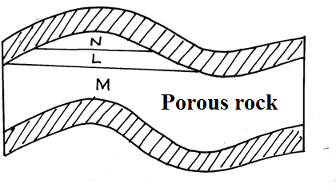

L-Oil

M-Underground water

N-Natural gas

**( 3 x 1 =3 Marks)**

**(ii)Give three by-products obtained when crude oil is refined** (3mks**)**

* Bitumen
* Wax
* Lubricants such as grease
* Petrochemicals

**(3 x 1 =3 Marks)**

**(b State five effects of mining on the environment** (5mks**)**

Mining causes

* dereliction of land
* Pollution of water and land
* Disruption /lowering of the water table
* Instability of basement rock
* Destruction of bio diversity
* Soil erosion
* Wastage of agricultural land

**( 5 x 1 =5 Marks)**

**(c )(i)Describe the stages involved in the processing of trona from lake magadi (6mks)**

On reaching the factory ,trona is separated from water by being put on large sieve –like trays**√**

The water from the trona is directed back into the lake**√**

The trona is then washed to remove impurities such as mud and salt.It is heaped on the ground to dry**√**

After drying ,it is heated in huge cylinders called desiccators .The heating separates sodium carbonate (soda ash) from sodium bi -carbonate **√**.

When heating is complete, the soda ash is allowed to cool**√**.

Soda ash is then ground into poweder and sieved**√**

The powder is packed in paper or jute bags, ready for transportation to the market**√**.

**(6 x 1 = 6marks Procedure must be followed)**

**(ii) Ways in which Kenya has been profited from the mining of trona on lake magadi (8mks)**

* Through exporting trona ,the country earns foreign exchange which is used to important essential items like machinery
* The mining of trona has created employment to many Kenyans improving their living standards it has led to establishment of industries by providing raw materials e.g glass industries
* It has led to provision of social amenities e.g hospitals, schools hence improving living standards.
* Mining of trona has stimulated the development of transport lines e.g it has led to the growth of Magadi town.
* The company that runs the mining of trona has improved the living standards of the local people by providing free water for domestic and livestock use
* The government earns revenue through taxation of the earnings from the sale of ‘’soda ash.

**( 4 x 2 =8 Marks)**