**MARKING SHEME**

**PAPER 312/1**

**GEOGRAPHY PAPER 1 FORM FOUR**

**END OF TERM TWO 2024**

**TIME: 23/4 Hrs**

**Instructions to Candidates**

* Answer all questions in section A.
* In section B, Answer question 6 and any other two questions from the remaining questions.
* Answer all questions using the answer booklet provided.
* Candidate should check that all pages are printed and no questions are missing.

**For Examination use only.**

|  |  |  |
| --- | --- | --- |
| Maximum Score | Candidate Score | |
| Section A. | 25 | |  |
| Question 6 | 25 | |  |
| Question 7 | 25 | |  |
| Question 8 | 25 | |  |
| Question 9 | 25 | |  |
| Question 10 | 25 | |  |
| TOTAL | 100% | |  |

**SECTION A**

**Answer all questions in this section**

1.a) What is the relationship between Geography and Economics. **(2marks)**

* ***Economics is the study of production, distribution, and consumption of commodities. Similarly, geography looks at methods of production and movement of commodities, and factors affecting production, movement, distribution, and consumption of commodities.***
* ***Gives rise to Economic geography. (2Marks)***

  b) Differentiate between habitat and environment. **(2marks)**

* ***Environment refers to all the surroundings /external conditions within which an organism lives while habitat refers to the home of an organism that provides the physical conditions under which it lives***

***(1x2marks=2marks).***

2 a) Distinguish between extrusive and intrusive vulcanicity **(2marks)**

* ***Extrusive vulcanicity is the process where the materials from the interior of the earth break through the crust and reach the surface of the earth in a volcanic eruption while Intrusive vulcanicity is the process where the materials do not have enough strength to break through the crust to the surface but are trapped within the crust.***

***(1x2marks=2marks)***

b) Name **two** resultant features due to intrusive vulcanicity **(3marks)**

* ***Sill***
* ***Dykes***
* ***Laccoliths***
* ***Batholiths***
* ***Lopoliths***
* ***Phacoliths (2 x 1 = 2Marks)***

3 (a) List three components of the solar system **(3marks)**

* ***The sun***
* ***The planet***
* ***The natural satellites***
* ***Asteroids / planetoids***
* ***Meteors / meteorites / meteoroids***
* ***Comets***

***(3x1mark=3marks)***

(b) State **three** characteristics of plane Jupiter. **(3marks)**

* ***Has rings but are too faint to see very well***
* ***The largest planet in the solar system***
* ***5th planet from the sun***
* ***Has many natural satellites / moons***
* ***Revolves for 12 earth years round the sun***
* ***It is a gas giant mainly hydrogen & helium. However, its core may be solid the size of the earth***
* ***Covered by thick layers of ice on its surface/ it has clouds***
* ***Rotates anti-clockwise very fast/ takes about 10 hours to complete a rotation***
* ***It has the Great Red Spot***

***(3x1mark=3marks)***

4 (a) State **three** factors which influence how rivers transport their load. **(3marks)**

* ***Size of individual rock particles.***
* ***Gradient of the river channel.***
* ***Amount of water in the stream/stream volume.***
* ***Amount of load.***

***(3x1mark=3marks)***

b) State **two** processes through which a river transports its load. **(2marks)**

* ***Solution.***
* ***Suspension.***

***(2x1mark=2marks)***

5a) State **two** characteristics of minerals **(2marks)**

* ***They have different degrees of hardness. (Talc is the softest while industrial diamond is the hardest.)***
* ***Some minerals aggregate into distinct shapes.***
* ***Some minerals (like gold, silver, copper, and diamond) have only one element while others (like bauxite) have more than one.***
* ***Minerals can be opaque, translucent, or transparent.***
* ***Minerals have different textures (feel).***
* ***Minerals have specific colours. (e.g., gold is yellow and copper is brown.)***
* ***Minerals have luster. This refers to the surface appearance of a mineral as it reflects light.***
* ***Minerals have different degrees of tenacity. (They can be described as brittle, elastic, ductile or flexible.)***
* ***Minerals differ in streak. (This is the Colour that a mineral leaves when it is rubbed against a hard surface.)***

***(2x1mark=2marks)***

b) State **three** ways in which metamorphic rocks are formed **(3marks)**

* ***May be formed through dynamic metamorphism- When the weight of the overlying rock layers create pressure the rocks at the lower layers get compressed and minerals are realigned forming new rocks.***
* ***May be formed through thermal/contact metamorphism- During vulcanicity hot magma come into contact with the country rock the heat recrystallizes the minerals to form new ones.***
* ***May be formed through thermal dynamic metamorphism- during folding rocks are folded deep below the earth’s surface where they come into contact with hot magma at the mantle and the pressure of the folding change the rock to new one (3x1mark=3marks)***

6. (a) Study the map of Kisumu East (1:50,000), sheet 116/2 provided and answer the following questions.

(i) Convert the ratio scale of the map to into a statement scale. **(2marks)**

* ***convert 50,000 cm to km → 50000/100000= 0.5 km***
* ***1 cm rep 0.5 km***

***(2×1mark=2 marks)***

(ii) Give six figure grid reference of the trigonometrical station 1154 SKP 21 in the southern part of the area covered by the map. **(2marks)**

* ***039832***

***(1×1Mark=1 mark)***

(iii) Calculate the bearing of Rabuor market from Air photo Principal point in GR 0986? **(2marks)**

* ***249±1° i.e., 248°-250°***

***(1×2marks=2 marks)***

***(1×2marks=2 marks)***

(b) i) Identify **two** drainage features in the area covered by the map. **(2marks)**

* ***lake***
* ***rivers***
* ***seasonal swamps***
* ***papyrus swamps***
* ***waterhole***
* ***ditch***

***(3×1marks=3 marks)***

ii) Using a vertical scale of 1cm to represent 100metres, draw a Cross-section to represent the area between GR:040940 and 040990. **(4marks)**

On it mark and name;

* **the escarpment. (1 mark)**
* **Power transmission line. (1 mark)**
* **Plantation. (1 mark)**

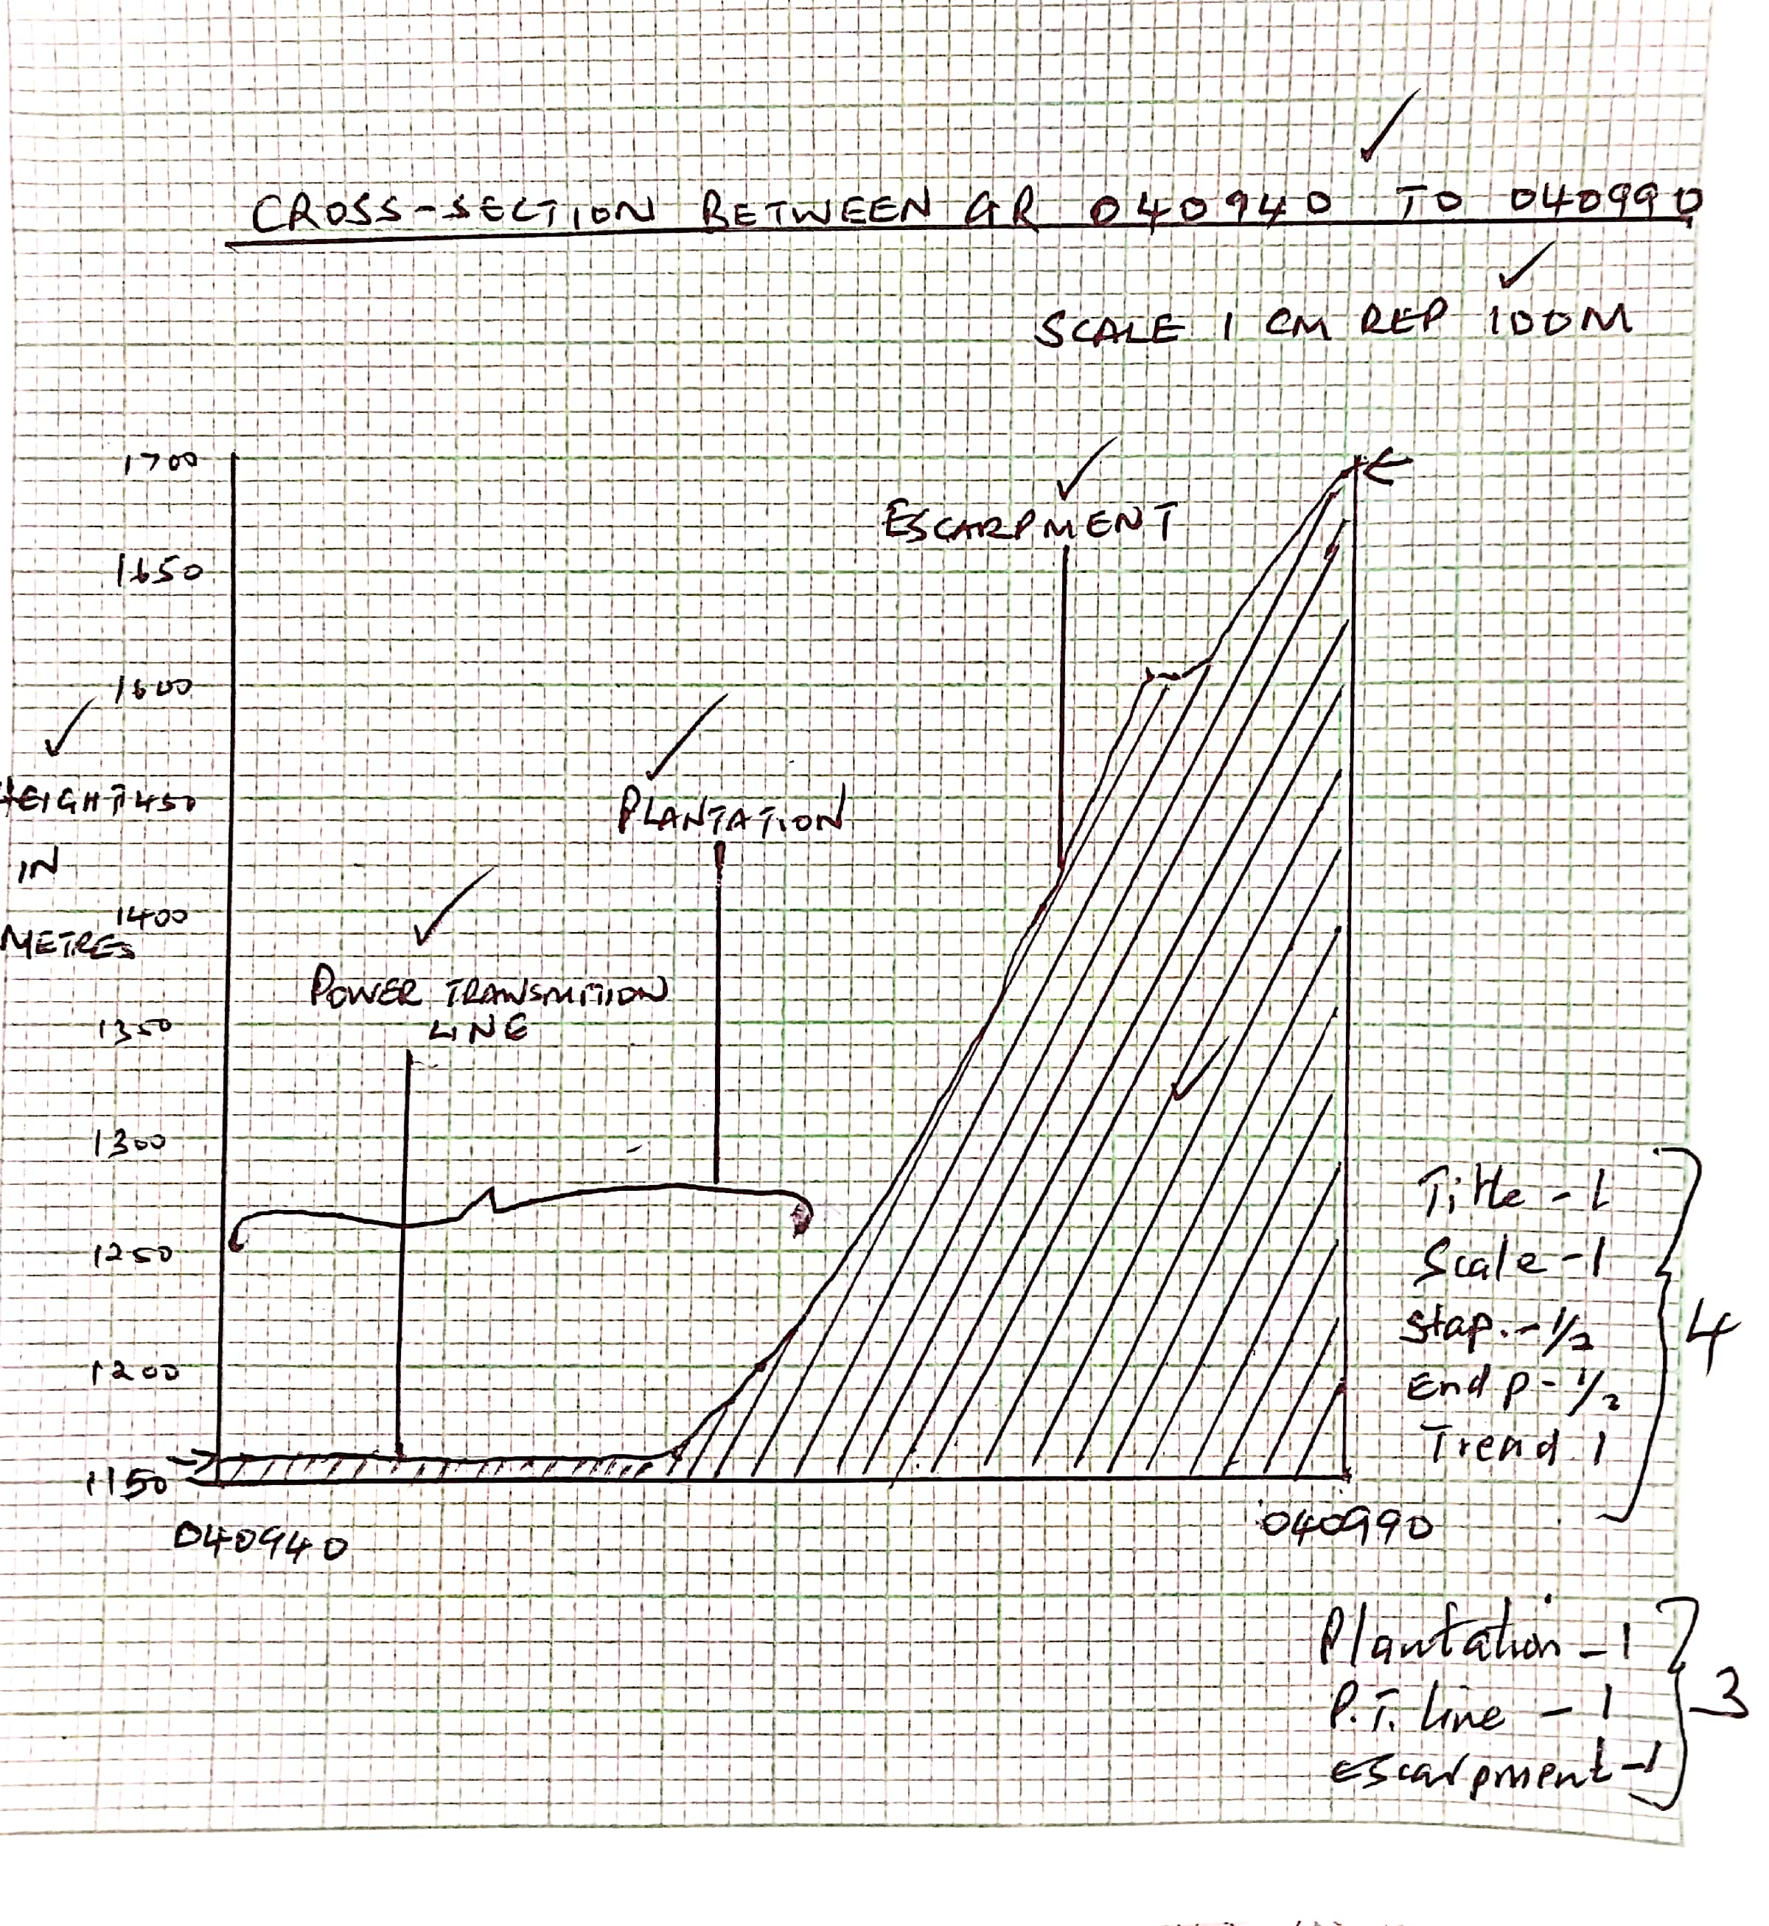

(ii) Describe the relief of the area covered by the map. **(3marks)**

* ***there are steep slopes in the north western part***
* ***there is Kano/ plain in the eastern part***
* ***in the north eastern part, there is Nyando escarpment***
* ***northern part has dissected landscape due to numerous rivers***
* ***there are many rivers valleys***
* ***the highest point is 1872 metres on the Nyando escarpment and lowest point is 1140 metres in the southern part***

***(3×1mark=3 marks)***

(c) i) Give **two** factors that favour cultivation of sugarcane in the area covered by the map. **(2marks)**

* ***presence of Agricultural Sugar Research Station/Government experimental farm which extension services to farmers***
* ***gently sloping land to facilitate mechanization***
* ***few settlements in the plantation area leaving large tracts of land for cultivation***
* ***network of road (C 543/1) and railway line facilitating transportation of sugarcane***

***(2×1mark=2marks)***

ii) Explain how relief has influenced settlement in the area covered by the map. **(4marks)**

* + ***Steep slopes/ escarpments have been avoided because they are unsuitable for construction of houses/ farming.***
  + ***There are a few settlements on the hilly areas because the slopes are gentler***
  + ***The plains are densely settled because the land is flat/ gentle sloping.***
  + ***The basins are avoided because the land is water logged/ swampy/poorly drained***

***(2x2marks=4marks)***

d) Students from the school at Mosogo (Grid square 0681) carried Out a field study of the course of the river Ombeyi.

i) State **two** findings they are likely to have come up with. **(2marks)**

* ***The river has many meanders***
* ***The river has many tributaries/ confluences***
* ***The river disappears into a swamp***
* ***The river has a wide flood plain***
* ***The river is in its old stage***

***(2x1mark=2marks)***

ii) Give two advantages of studying rivers through fieldwork. **(2marks)**

* ***It helps students relate what they have learnt in the classroom***
* ***The students are able to put to use the skills of observation, data collection and recording learnt in class***
* ***The students are able to discover for themselves the uses of the river***
* ***It enables students to acquire appropriate attitudes towards the environment***
* ***The students can gauge the impact of the river in the areas it passes.***
* ***It breaks the classroom monotony for the students and the teachers***

***(2x1mark=2marks)***

7. (a) (i) Differentiate between a coastline and a shore. **(2marks)**

* ***A coastline is a line where the highest storm /wave reach the land whereas a shore is the area between the lowest water level and the highest water level reached by waves/storms.***√√ ***(1×2marks=2marks)***

(ii) Name **two** examples of marginal seas. **(2marks)**

* ***Caribbean***
* ***Arabian***
* ***North China/South China***
* ***Labrador***
* ***Irish***
* ***Norwegian***
* ***North Sea***
* ***Barents***
* ***East Siberian/Laptev***
* ***Tasman***
* ***Coral Sea***
* ***Timor/Banda***
* ***Yellow Sea***
* ***Sea of Japan***
* ***Andaman***
* ***Okhotsk Sea***
* ***Beaufort (2×1mark=2marks)***

(b) i) Apart from oceanic island, name two features on the ocean floor **(2marks)**

* ***Continental slope***
* ***Ridge/Oceanic ridge***
* ***Ocean deep***
* ***Deep sea plain (2×1mark=2marks)***

(ii) Give **two** examples of *Oceanic Islands* ***(2marks)***

* ***Canary***
* ***Cape Verde***
* ***Iceland***
* ***Ascension***
* ***Azores***
* ***Tristan da Cunha***
* ***Falkland***
* ***Sandwich***
* ***Seychelles (2×1mark=2marks)***

(c) (i) State **four** conditions that favour the growth of corals. **(4marks)**

* ***The ocean water should be warm / about 20° – 30°C.***
* ***The ocean water should be shallow to allow sunlight to penetrate the depth of up to 60 metres.***
* ***The oceanwater should be clear (free from silt) mud free water.***
* ***The oceanwater should be saline.***
* ***There should be plenty supplying of plankton / microscopic plant food.***
* ***The oceanwater should be well oxygenated. (4×1mark=4marks)***

(ii) Explain **three** ways in which corals contribute to the economic development of Kenya **(6marks)**

* ***Coral features e.g., coral reefs are of tourist attractions thus earn foreign exchange.√√***
* ***Coral reefs provide breeding grounds for fish. This promotes the fishing industry.√√***
* ***Coral stones are extracted and sold as ornaments / for their aesthetic value.√√***
* ***Coral limestone provide raw material for the cement making.√√***
* ***Coral rocks provide stones which are used in building industry.√√***

***(3×2marks=6marks)***

(d) Members of your class intend to conduct a field study on depositional features along the Kenyan Coast.

(i) State **two** reasons why they would need to carry an atlas during the study. **(2marks)**

* ***To assist/help them identify the routes to the study area***
* ***To enable them determine distances to the study area***
* ***To assist them find directions to the study area (2×1mark=2marks)***

(ii) Name two features of deposition you are likely to identify during the study**. (2marks)**

* ***Beach***
* ***Cuspate forelands***
* ***Sand bars***
* ***Tombolo***
* ***Spits***
* ***Mudflats***
* ***Salt marshes***
* ***Dune belts (2×1mark=2marks)***

(iii) What problems are you likely to encounter during the field study? **(3marks)**

* ***Study area too wide/large to cover entirely/completely hence suffer from fatigue***
* ***Abrupt/sudden change in weather e.g., sudden heavy rainfall would delay the study/Scorching sun/high temperatures would make them uncomfortable; delaying the study***
* ***Accidents in the field would delay/bring the study to an abrupt end***
* ***Inaccessibility of certain areas due to difficult relief and thick vegetation***
* ***Inadequate data in the field would result into a premature termination of the field study.***
* ***Uncooperative respondents***

***(3×1mark=3marks)***

8a) i) Name **two** types of vegetation. **(2marks)**

* ***Natural vegetation***
* ***Derived vegetation***
* ***Cultivated vegetation (2x1mark=2marks)***

ii) Give **two** physiographic factors influencing vegetation distribution **(2marks)**

* ***Altitude***
* ***Aspect***
* ***Terrain and drainage (2x1mark=2marks)***

b) The diagram below shows vegetation zones of an East African mountain. Use it to answer questions b(i) and b(ii) below

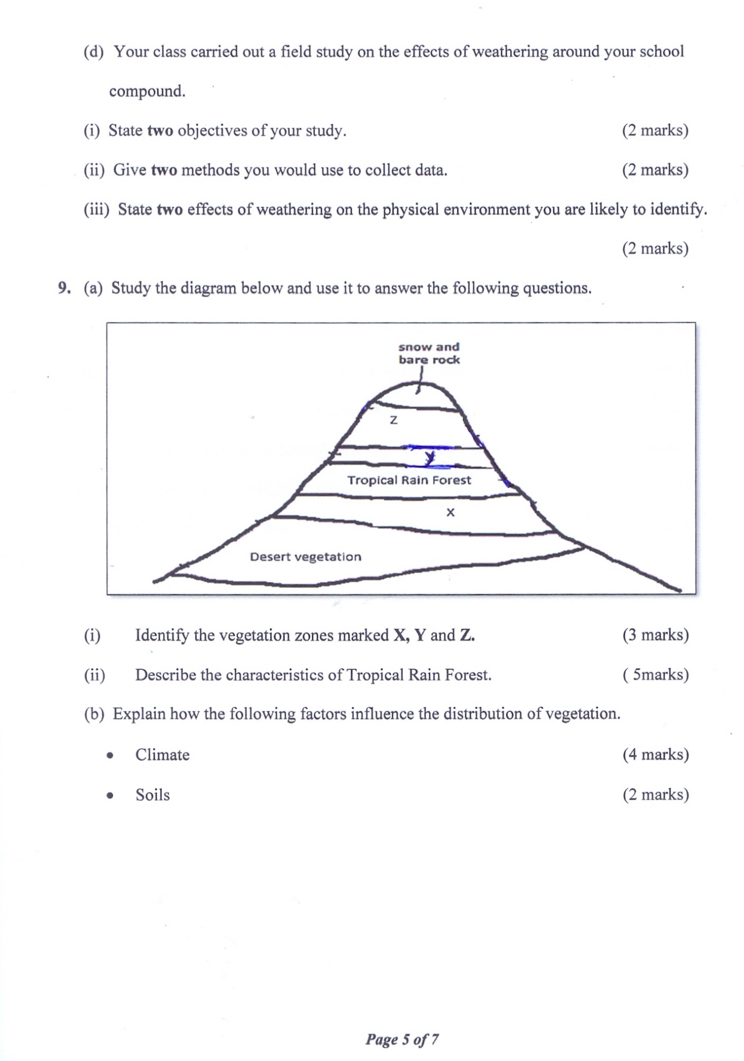

i) Name the vegetation zones **X**, **Y**, and **Z** **(3marks)**

***X-Savannah grassland***

***Y-Bamboo Forest***

***Z-Heath and moorland (3 x 1 =3Marks)***

ii) Give **two** reasons why there is no vegetation cover on the top of the mountain **(2mark)**

* ***Too cold for plants to survive***
* ***Covered by snow***
* ***There is no soil (2x1mark=2marks)***

c(i) State the names given to temperate grassland vegetation in **(2marks)**

* North America----***Prairies***
* Argentina………. ***Pampas (2x1mark=2mks)***

ii) Explain **three** uses of the vegetation labelled X, **(6marks)**

* ***Grazing-plenty tall and short grasses are used for grazing domestic animals/wild animals***
* ***Reduces soil erosion-savanna vegetation acts as soil cover hence reduces soil erosion***
* ***Habitat for bees and wild animals-trees in savannah are habitat for bees which provide honey and home for wild animals e.g., gazelles***
* ***Medicinal use-some shrubs and herbs in savannah are used as medicine e.g., aloe vera***
* ***Fuel-trees provide wood for fuel***
* ***Humus in the soil-decomposing long grass form fertile soil suitable for wheat/maize growing*  *(3x2marks=6marks)***

d)Explain **four** characteristics of tropical desert vegetation **(8marks)**

* ***Some plants have long roots to enable them tap water far deep in the ground***
* ***Some plants have shallow root system which enables them to take moisture from the top layers of soil***
* ***Some plants have sunken stomata and waxy leaves to reduce rate of transpiration***
* ***Some plants have succulent stems to allow them store water***
* ***Some plants are short lived i.e. complete their cycle within the short-wet period***
* ***Some plants e.g. tubers and corms remain dormant during dry spell until wet period stimulates them to germinate***

***(4x2marks=8marks)***

9 a i) state **two** classifications of soil according to soil order **(2marks)**

* ***Zonal***
* ***Intrazonal***
* ***Azonal (2x1mark=2arks)***

ii) Draw a well labelled diagram of mature soil profile **(4marks)**

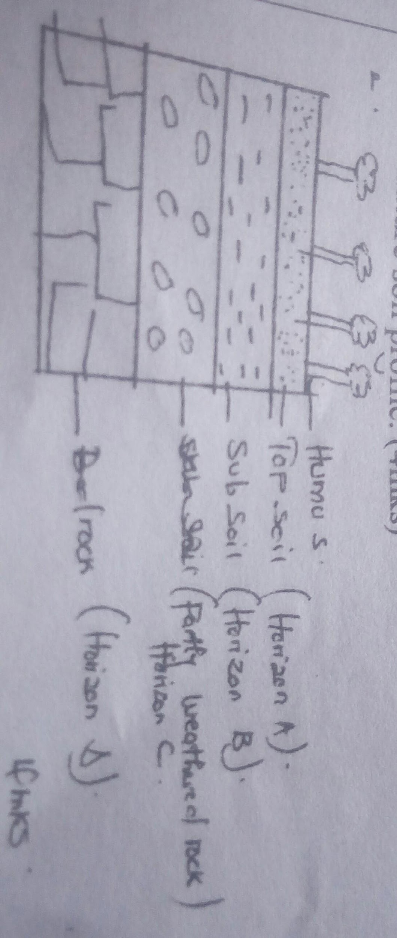

bi) A part from topography name **four** other factors that influence formation of soil **(4marks)**

* ***Climate***
* ***parent rock***
* ***living organisms***
* ***time***
* ***vegetation cover (4x1mark=4marks)***

ii) State **three** ways in which topography influences formation of soils **(3marks)**

* ***Valley bottoms/gentle slopes encourages the formation of deep and fertile soil due to deposition/accumulation of materials***
* ***Steep slopes encourage erosion of top layer of soil thus slowing down formation of soils/thin soils***
* ***Flat/flood plains are saturated with water therefore forming poor soils***
* ***Slope influences arrangements of soil catena (3x1mark=3marks)***

iii)**Three** characteristics of desert soil **(3marks)**

* ***Have very little humus/organic matter content***
* ***They are thin/shallow***
* ***They are sandy and saline***
* ***They are loose and unconsolidated***
* ***They are yellow- brown in colour***
* ***They are rich in calcium carbonate/high lime content (3x1mark=3marks)***

c) i) Name **three** types of soil erosion **(3marks)**

* ***splash erosion***
* ***sheet***
* ***gulley***
* ***rill erosion (3x1mark=3marks)***

ii) Explain **three** effects of soil erosion on human activities **(6marks)**

* + ***The productive top soil is lost and only unproductive stony soil is left lowering the agricultural productivity of land.***
  + ***Soil erosion leaves behind thin soils which cannot hold plants firms in the ground hence the plants are easily uprooted and blown away by the wind.***
  + ***When gullies are deepened up to or below the water table, underground water is exposed leading to some of it flowing away or evaporating causing the water table to be lowered.***
  + ***Loss of soil through wind and water erosion leads to destruction of vegetation cover which eventually turn the affected area into a semi –arid land area.***
  + ***Soil erosion cause sedimentation/siltation in water reservoirs constructed along rivers hence lowering water levels hence shortage of electricity and expensive to dredge.***
  + ***Soil erosion causes water pollution which may lead to death of aquatic animals/destroy mangrove vegetation***
  + ***Where soils is deposited after erosion it forms rich agricultural lands***
  + ***Sand eroded and when deposited on river valley is harvested for construction (3x2marks=6marks)***

10. (a) (i) What is an earth movement? **(2marks)**

* ***This is the displacement of crustal rocks due to tectonic forces that originate and operate in the interior of the earth.***

***(1×2mark=1marks)***

(ii) State **three** causes of earth movements. **(3marks)**

* ***Magma movement within the crust/vulcanicity that causes the displacement of crustal rocks***
* ***Gravitative pressure which pulls crustal rocks towards the earth’s interior***
* ***Convectional currents in the mantle causing frictional drag with the sima rock9s***
* ***Displacement of rocks during isostatic adjustments (3×1mark=3marks)***

(b) i) State **three** boundaries associated with tectonic plates **(3marks)**

* ***Extensional/constructive boundary***
* ***Compressional/destructive boundary***
* ***Transform fault/conservative boundary (2×1mark=2marks)***

(ii) Describe how the Mid Atlantic ridge was formed. **(3marks)**

* ***North and South American plates and Eurasian plate moved apart, a space was created between them***
* ***Magma forced itself out through the space and got deposited on the floor of the Atlantic Ocean***
* ***The materials cooled and solidified to form the mid-Atlantic ridge (3×1mark=3marks)***

(c) (i) Other than fold mountains, give **two** features that result from the folding process. **(2marks)**

* ***Intermontane basins***
* ***Intermontane plateaus***
* ***Escarpments***
* ***Synclinal valleys***
* ***Rolling plains (2×1mark=2marks)***

(ii) Describe how the Alps and Atlas Mountains were formed. **(6marks)**

* ***Continental drift and plate tectonic theories resulted to compressional forces that led to the formation of a huge depression/geosyncline on the earth’s surface. Water accumulated the depression forming the Mediterranean Sea***
* ***The surrounding land masses were intensively eroded and the resultant sediments deposited in the geosyncline in layers.***
* ***The accumulation of sediments and weight caused the geosyncline to subside/sink into the mantle.***
* ***Continued accumulation of sediments in the geosyncline resulted into the formation of thick layers.***
* ***These sediments were later subjected to compressional forces as a result of mantle’s convectional currents; these forces drew the land masses on either side of the geosyncline towards one another.***
* ***Layers of sediments in the geosyncline then folded/crumbled to form the fold mountains with the Atlas forming in the South and the Alps in the North.***

***(6×1mark=6marks)***

(d) Explain **three** positive influences of fold mountains **(6marks)**

* ***Resultant features such as fold mountains; intermontane plateaus etc. attract tourists thus earning foreign exchange to the country.***
* ***Heavy rainfall and snow accumulated on the fold mountains give rise to rivers that are water sources for domestic, irrigation and industrial uses***
* ***Rivers flowing from fold mountains provide water for hydroelectric power production which is used in industries and lighting domestically***
* ***Fold Mountains receive heavy rainfall which supports dense forest. These forests are a source of valuable timber for making furniture, building and construction.***
* ***The trees in the forests hold soil particles together hence preventing soil erosion. (3×2marks=6marks)***