NAME………………………………………………CLASS……………ADNO……………..

END OF TERM 2 2024
FORM 1 GEOGRAPHY
TIME:2HOURS
INSTRUCTIONS TO CANDIDATES
Answer all the questions in the space provided
Questions | Marks
1
2
3
4
5
6
7
8
9
Total

INSTRUCTIONS: ANSWER ALL QUESTIONS IN THE SPACES PROVIDED
1(a)Name three major branches of Geography (3marks)

(b)Name four topics studied under Geomorphology (4marks)

(C)Explain the relationship between Geography and the following subject.
(i)Geography and Chemistry ( 2Marks)

(d)State four reasons as to why it is important to study Geography( 4Marks)

2(a) Differentiate between galaxy and planets (2Marks)

(b)Name two planets that do not have natural satellites (2Marks)

(c)Name two theories that attempt to explain the origin of the earth and the solar system ( 2Marks)

(d)The Earth makes a complete rotation once every 24hrs.How long does it take to rotate through one degree (3Marks)

(e)What is equinox (2Marks)

3(a). The diagram below shows the external and internal structures of the earth
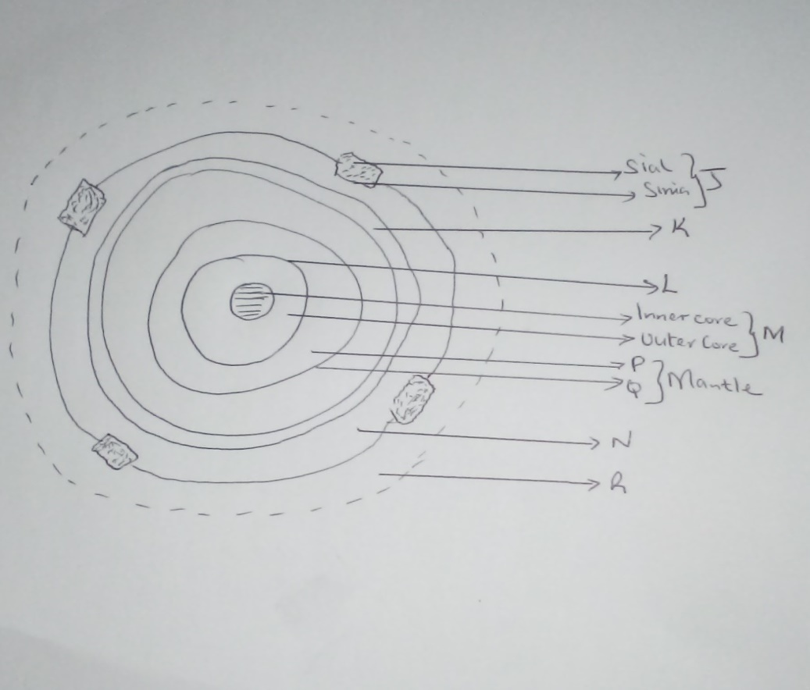
Name the region marked
J
K
L
M
N
P
Q
R- ( 8Marks )
(b)Give three reason why the interior of the earth is very hot (3Marks)

(c)Name three components of atmosphere (3Marks)

4(a) Define the following terms
(i) Statistics (2Marks)

(ii)Statistical methods (2Marks)

4(b) Give four sources of secondary data (4Marks)

(c)Name two types of hypothesis (2Marks)

5.Give four advantages of using contents analysis as methods of data collection
(4Marks)

6(a) You intend to carry out a field study in market nearly your school. State four objectives of the study (4Marks)

6(b) State four problems you are likely to experiences in the market (4Marks)

7(a) Give three types of maps ( 3Marks)

(b) Convert the following scale
1cm represent 5km to R.F ( 2Marks)

(c) R.F to statement scale
1:50000cm (2Marks)

(d) Mention four types of marginal information in topographical maps (4Marks)

(d)Define the following terms
(i)Map ( 2Marks)

(ii)Picture (2Marks)

(b)State the four major characteristics of rocks (4Marks)

(C) Name three classifications of rocks (3Marks)

9(a) Mention three types of bearing (3Marks)

(b)State three uses of maps (3Marks)

(c)Mention three factors to consider while siting a weather Station (3Marks)

(d) Highlight two factors that determine the amount of solar radiation which reaches
(2Marks)

10. The table below shows rainfall and temperature figures for a station in Kenya. Use it to answer question i, ii,iii and iv.
Month | J | F | M | A | M | J | J | A | S | O | N | D
Temp ⁰c | 27 | 25 | 23 | 20 | 18 | 18 | 17 | 19 | 20 | 21 | 21 | 24
Rainfall (Mm) | 53 | 50 | 55 | 251 | 242 | 230 | 180 | 109 | 90 | 51 | 85 | 100
- Calculate the diurnal range of temperature for the station (2mks)

- Calculate the average temperature for the station (2mks)

- Determine the total annual rainfall (2mks)

- iv) Which month recorded the highest amount of rainfall (1mk)

