FORM ONE
END OF TERM 2 2024
GEOGRAPHY EXAMATION
TIME: 2HOURS
MARKING SCHEME
1(a)Name three major branches of Geography
(1)Physical Geography
(2)Human and Economic Geography
(3)Practical Geography (3x1=3Marks)
(b)Name four topics studied under Geomorphology
- The earth and solar system
- The internal structure of the earth
- The structure of the atmosphere
- Rocks and minerals
- Internal landforming process/endogenenic processes
- External landforming process/Exogenic process ( 4x1=4Marks)

(c)Explain the relationship between Geography and the following subject.
(i)Geography and Chemistry
Geography uses chemistry to study of chemical composition of rocks, minerals and soil formation while chemistry uses geography to show distributions of rocks, soil and minerals of the earth and showing the different chemical compositions on them ( 2marks)
(d)State four reasons as to why it is important to study Geography
- It provides knowledge about the environment/makes us understand the earth we live in.
- It creates awareness on social values which create national unity in our country.
- It help the students to manage time properly.
- It create international awareness which promotes international understanding/Co-operation.
- Promotes awareness on proper use of environmental resources/resource managing.
- Promotes development or practical skills (4x1=4marks)
2(a) Differentiate between galaxy and planets
Galaxy is a large group of bright stars that form clusters or pattern in space while planets are large and spherical celestial bodies in space which move around the sun following their orbits. (2marks)
(b)Name two planets that do not have natural satellites
(i)Mercury (ii) Venus (2x1=2marks)
(C)Name two theories that attempt to explain the origin of the earth and the solar system
(i)Nebula cloud theory
(ii)Passing star theory (2x1marks)
(d)The Earth makes a complete rotation once every 24hrs.How long does it take to rotate through one degree
360⁰=24hrs (1mk) =1440 mins
1⁰=1440∕360 (1mk) =4mins (A1) 3marks
(e)What is equinox
It is the time of the year when the sun is overhead the equator, days and nights are equal in both Northern and Southern Hemisphere 2x1=2mark
3(a). The diagram below shows the external and internal structures of the earth
Name the region marked
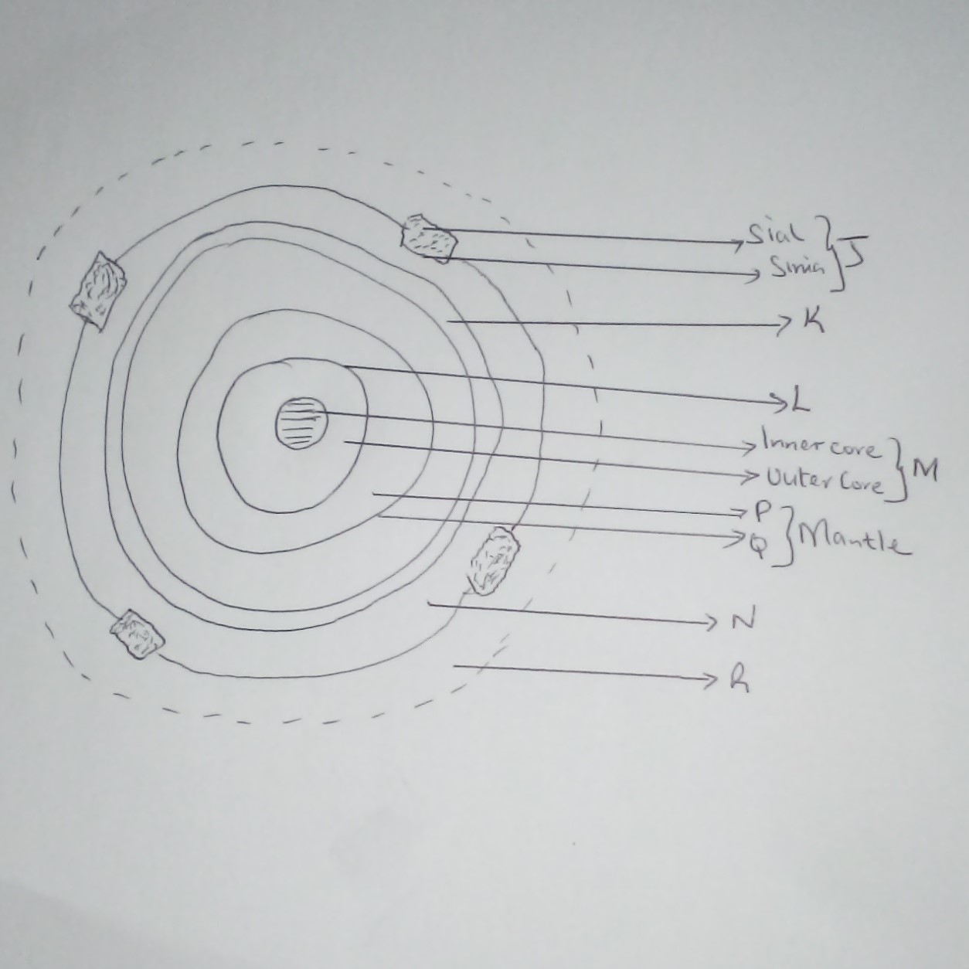

J- Crust
K-mohorovicic(Moho) discontinuity
L-Guternburg discontinuity
M-Core
N-Hydrosphere (ocean)
P-Lower mantle
Q-Upper mantle
R-Atmosphere
(8x1=8Marks )
(b)Give three reason why the interior of the earth is very hot
(i) 0riginal heat of the material that broke from the sun as the earth was formed is still retained as the interior cold at slow rate.
(ii)Radio activity that generates a lot of heat
(ii)Weight of overlying crustal rocks that exerts a lot of pressure that generate heat
( 3x1=3Marks)
(c)Name three components of atmosphere
(i) Gases or air
(ii) Water vapor or moisture
(iii) Hygroscopic particles including smoke, dust, salt and pollen grain (3 X1 = 3Marks)
4(a) Define the following terms
(i) Statistics
These are numerical facts and figures collected and arranged in systemic order for a specific purpose ( 2x1=2marks)
(ii)Statistical methods
Techniques used in collecting, recording, analyzing, presenting and interpreting statistical data to make a varied conclusion and recommendation (2x1=2mks)

4(b) Give four sources of secondary data
- Textbooks/geographical notes
- Magazine / journals
- Maps/atlas
- (iv) Newspapers
- Library books
- Census reports/annual report /professional reports
- Periodicals
- Statistical abstract
- Video recording /cds/tv/films
- Photographs
- Geological maps
- Audio recording/radio
- Internet browsing/electronic media (4x1=4marks)
(c)Name two types of hypothesis
(i)Null hypothesis/Negative hypothesis –stated in negative forms
(ii)Alternative hypothesis/substantive/positive hypothesis
(2x1=2marks)
5. Give four advantages of using contents analysis as methods of data collection
(i)It is easy methods of getting data especially if it already well analyzed
(ii) Cheap methods because it does not involves a lot of travelling
(iii) Saves on time especially if all required information is available in one source eg library
(iv) It enables one to obtain old or past information
(v) Provide information that one cannot get first hand or directly
(4x1=4marks)

6(a) You intend to carry out a field study in market nearly your school
State four objectives of the study
(i)To find out when the market started
(ii) To find out the types of goods sold at the market
(iii) To establish how the market is organized
(iv)To find out the price of goods sold at market
(v) To find out the type of the people selling and buying at the market.
(vi)To investigates the problems faced by the traders I n the market
(vii)To identify the type of transport used to bring goods at the market
(Any others relevant point 4x1=4marks)
6(b) State four problems you are likely to experiences in the market
(i)Traders may give false or unreliable information or irrelevant answers
(ii) Illiteracy of some traders may lead to communication barrier
(iii)Inadequate time to cover a large market
(iv)Poor weather eg heavy rainfall or muddy conductions may hinder data collection
(v)Unwilling or hostile traders who may refuse to give information
(Vi) Cogestation in the market may make movement difficult
(vii) Noisy environment may limit data collection.
(Any other relevant point 4x1=4marks)
7(a) Give three types of maps
(i)Atlas maps
(ii)Sketch maps
(iii)Topographical maps
( 3x 1=3Marks)
(b) Convert the following scale
1cm represent 5km to R.F
1cm represent (5x100000)cm √
1cm represent 500000cm
R.F=1:500000 √ OR 1/500000 (2Marks)
(c) R.F to statement scale 1:50000cm
1cm represent 50000cm
50000cm=(50000/100000)cm
=0.5km
Statement 1cm represent 0.5km
(d) Mention four types of marginal information in topographical maps
(i) Name of the map
(ii) Sheet title
(iii)Grid system numbers
(iv)Map series, sheet number, index and Edition
(v)Latitudes and longitudes
(vi) Compass and Magnetic declination
(vii) Administrative boundaries
(viii)Index to adjoining sheets
(ix)Key convectional signs and symbols
(x)Publisher and copyright
(xi) Conversion table
( Any 4x1=4Marks)
(d)Define the following terms
(i)Map
Is representation of a flat surface showing part or whole of earth’s surface drawn to scale on a flat surface. (2marks)
(ii)Picture
Is an image of an actual object represented by drawing, painting or photograph( 2marks)
8 (a) Define the term mineral
Is an inorganic substance with definite chemical composition and physical properties occurring naturally on or below the earth’s surface? (2marks)
(b)State the four major characteristics of rocks
(i)Some are permeable and others impermeable
(ii)Have joints or lines of weakness
(iii)Have different mineral elements in them
(iv)Some are hard and highly resistant to erosion while others less resistant.
(v)Some are brittle and breaking along lines of weakness and others are flexible or elastic and easily bend or fold.
(vi)Some are crystalline and others are non-crystalline
(vii)Stone have single minerals element while other have many mineral elements
(Any 4x1=4maximum)

(c) Name three classifications of rocks
(I) Igneous rocks
(ii) Sedimentary rocks
(iii) Metamorphic rocks (3x1=3Marks)
9(a) Mention three types of bearing
(i)The True North
(ii) Magnetic North
(iii) Grid North
(b)State three uses of maps
(i)Locate countries and administrative boundaries
(ii)Compare sizes and shapes of countries
(iii)Show different climatic regions of the world
(iv)Show distribution of vegetation, drainage features, geological features
(c)Mention three factors to consider while siting a weather station
(i)Should be located in an open place where there is free flow of air
(ii)Should be far from buildings, vegetation or other structures that might cause obstruction
(iii)Site should be relatively flat and free from flooding
(iv)Site should be secure
(Any 3x1=3Marks)
(d) Highlight three factors that determine the amount of solar radiation which reaches the surface of the earth
(i)Intensity of the sun’s radiation in the space and the earth average distance from the sun
(ii)The transparency of the atmosphere
(iii)The position of the earth on its orbit which produce different seasons
(iv)The inclination or angle of the surface on which the sun’s rays fall
(v)The area and the nature of the surface on which the rays fall
(Any 3x1=3Marks)
10. The table below shows rainfall and temperature figures for a station in Kenya. Use it to answer question i, ii,iii and iv.
Month | J | F | M | A | M | J | J | A | S | O | N | D
Temp ⁰c | 27 | 25 | 23 | 20 | 18 | 18 | 17 | 19 | 20 | 21 | 21 | 24
Rainfall (Mm) | 53 | 50 | 55 | 251 | 242 | 230 | 180 | 109 | 90 | 51 | 85 | 100
i) Calculate the diurnal range of temperature for the station (2mks)
- 27⁰c – 17⁰c = 10⁰c (2mks)
ii) Calculate the average temperature for the station (2mks)
27 + 25 + 23 + 20 + 18 + 18 + 17 + 19 + 20 +21 + 21 + 24
12

= 253 ≈ 21.1⁰c / 21⁰c (2mks)
12
iii) Determine the total annual rainfall (2mks)
53 + 50+ 55 + 251 + 242 + 230 + 180 + 109 + 90 +51 + 85 + 100
= 1496mm (2mks)
iv) Which month recorded the highest amount of rainfall (1mk)
- April (1mk)

