**COMPETENCE BASED CURRICULUM**

Kenya Junior Secondary Education Assessment

FORMATIVE ASSESSMENT

TIME

2 HRS

ENDTERM 1

SOCIAL STUDIES

G8

2024

**SCHOOL:** ……….……………………………………………………..……

**NAME:** ……………….…………………..………………………...………..

**SIGNATURE: ………………ASSESSMENT NO…………………………..**

***RUBRICS (for official use)***

|  |  |  |  |  |
| --- | --- | --- | --- | --- |
| **MARK SCORE RANGE** | ***Below 40*** | ***40-59*** | ***60-79*** | ***80-100*** |
| **PERFORMANCE LEVEL** | *Below expectation* | *Approaching expectations* | *Meeting expectations* | *Exceeding expectations* |
|  |  |  |  |  |

|  |  |
| --- | --- |
| **OUT OF** | **100%** |
| **LEARNERS SCORE** |  |
| **PERCENTAGE SCORE** |  |
| **PERFORMANCE LEVEL** |  |

**FOR FACILITATOR’S USE ONLY**

**Answer all Questions**

1. List three components of social studies. (3 mks)
2. _____________________________
3. _____________________________
4. _____________________________
5. State four importance of learning social studies.( 4 mks)
6. _______________________________________________________________
7. _______________________________________________________________
8. _______________________________________________________________
9. _______________________________________________________________
10. State three career opportunities related to social studies. (3 mks)
11. ______________________________________________
12. ______________________________________________
13. ______________________________________________
14. State three entrepreneurial opportunities in social studies. (3 mks)
15. __________________________
16. __________________________
17. __________________________
18. State three gender stereotypes associated with career choices and entrepreneurial opportunities in Social Studies. ( 3 mks)
19. _________________________________________________________________
20. _________________________________________________________________
21. _________________________________________________________________

8. Outline three strategies that we can address gender stereotypes in career and entrepreneurial opportunities related to social studies. (3mks)

1. _____________________________________________________________________.
2. ______________________________________________________________________
3. ______________________________________________________________________
4. What were characteristics of Ramapithecus. (3 mks)
5. __________________________________________________________________
6. ___________________________________________________________________
7. ___________________________________________________________________
8. Match the following stages of man correctly



RAMAPITHECUS



HOMOHABILIS



ZINJENTHROPUS

1. Identify three elements of a Map. ( 3mks)
2. _______________________________________--
3. _______________________________________
4. ________________________________________
5. What is the capital city of the following African nation? (1 mk)

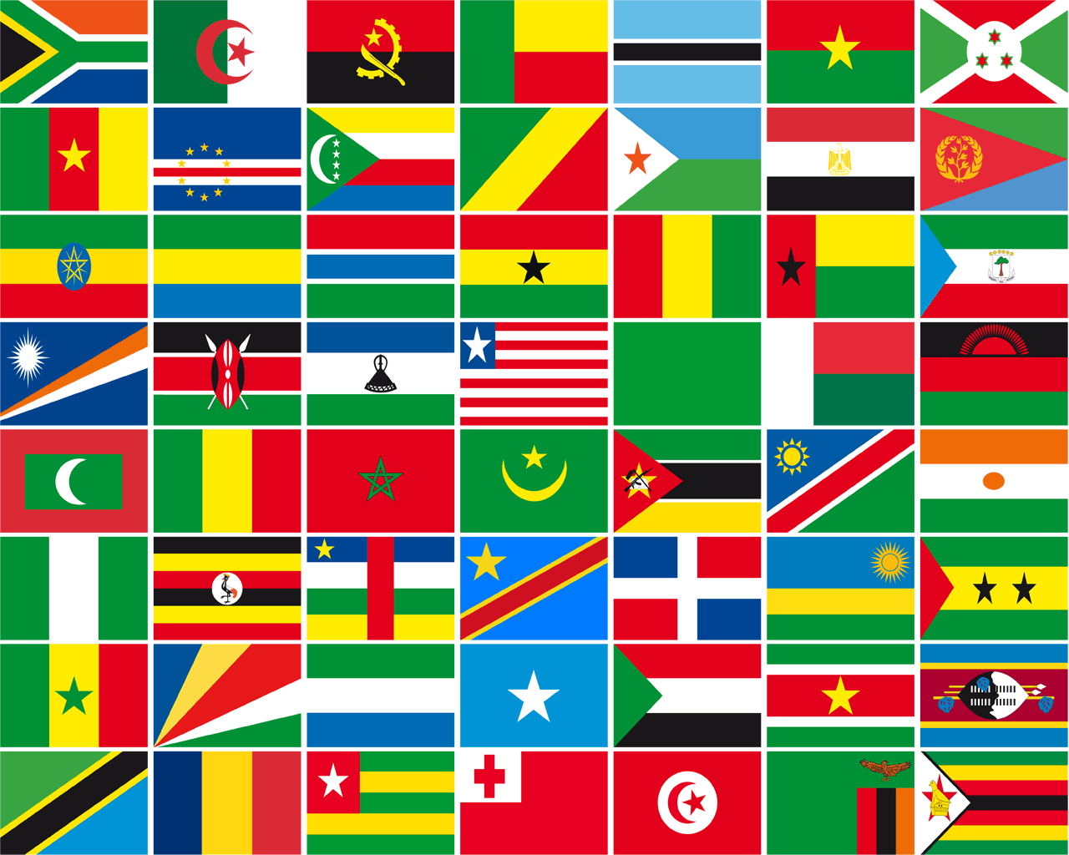

1. Identify two offshore islands in Africa. (2mks)
2. _____________________________________________
3. _____________________________________________
4. State three components of the solar system. (3 mks)
5. _________________________________
6. _________________________________
7. _________________________________
8. State four effects of rotation of the Earth (4 mks)
9. ___________________________________________________________________
10. ___________________________________________________________________
11. ___________________________________________________________________
12. ___________________________________________________________________
13. State the two theories that explains the origin of man.
    1. _______________________________________________
    2. ______________________________________________
14. 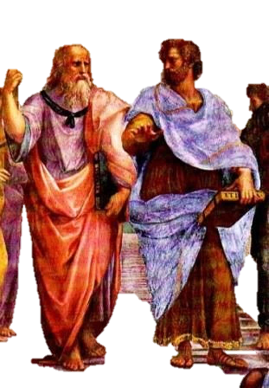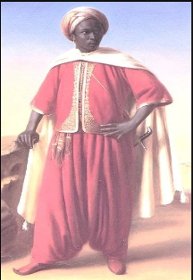Match the following early visitors to Africa with their names.

Arabs

Egyptians

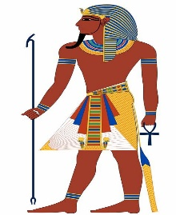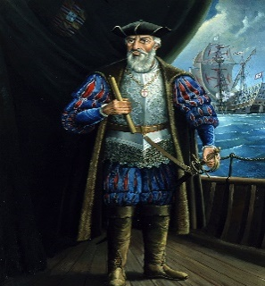

Greeks

Portuguese

1. Name the stages of man from the first to the current. (4 mks)
   1. __________________________________
   2. __________________________________
   3. __________________________________
   4. __________________________________
   5. ___________________________________
   6. ___________________________________
   7. ____________________________________
   8. _____________________________________

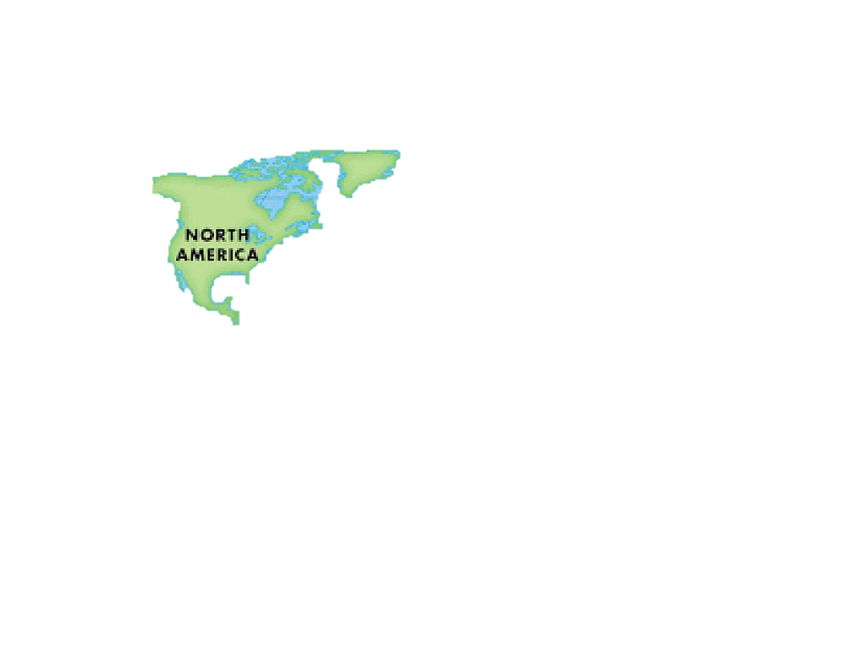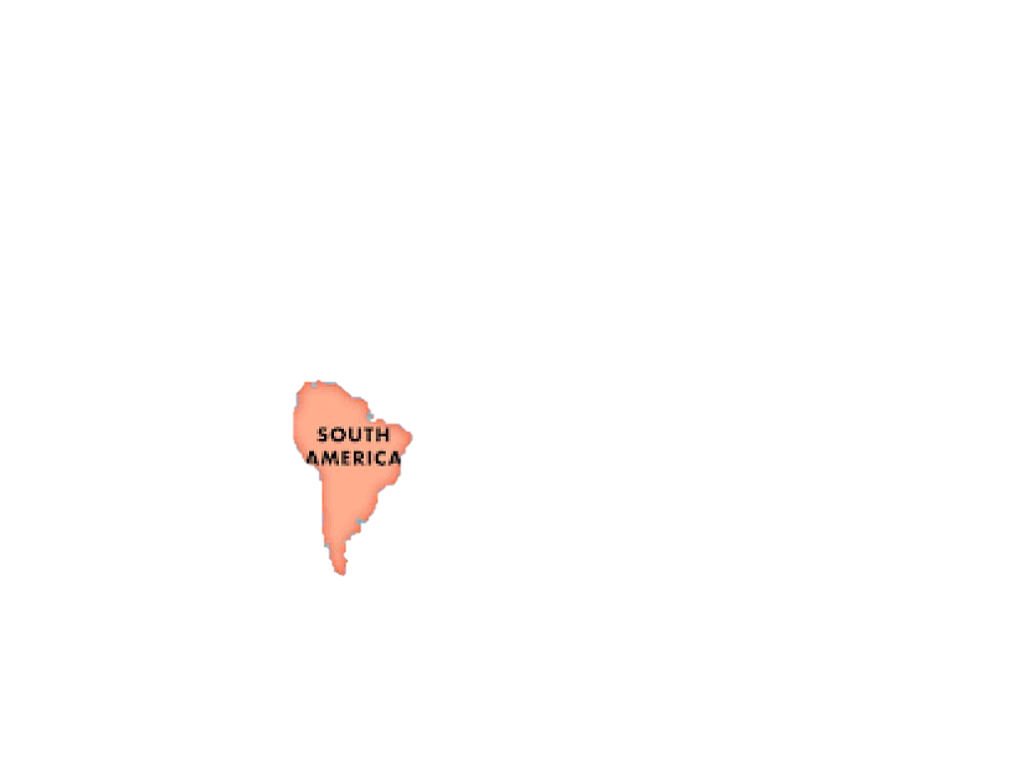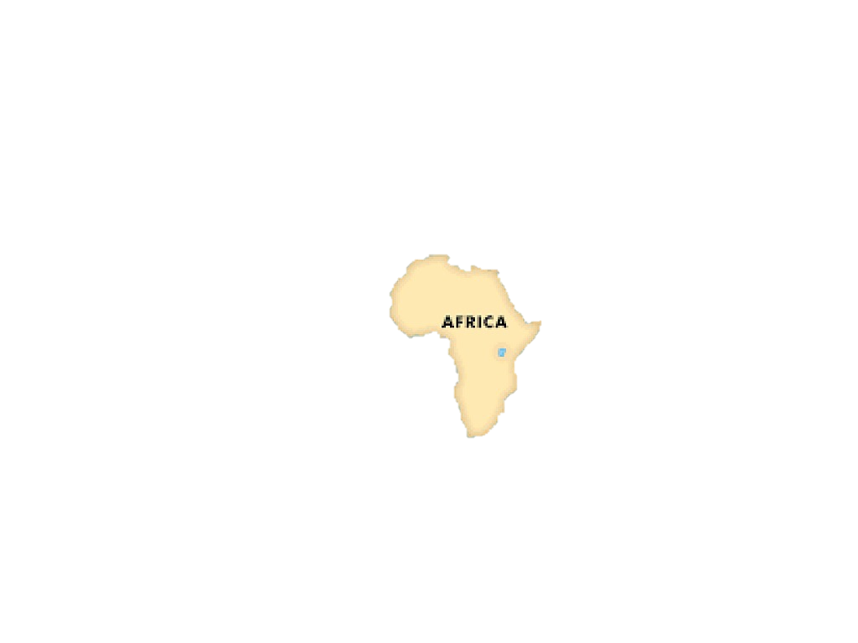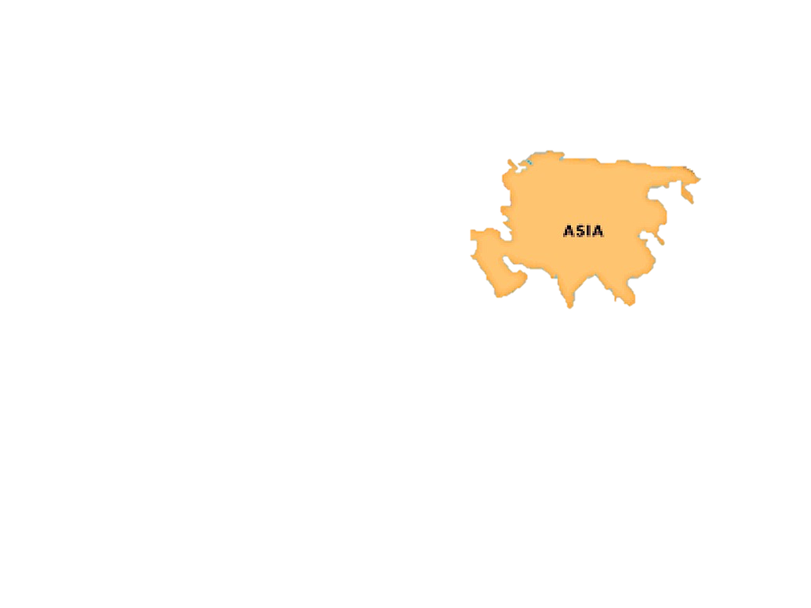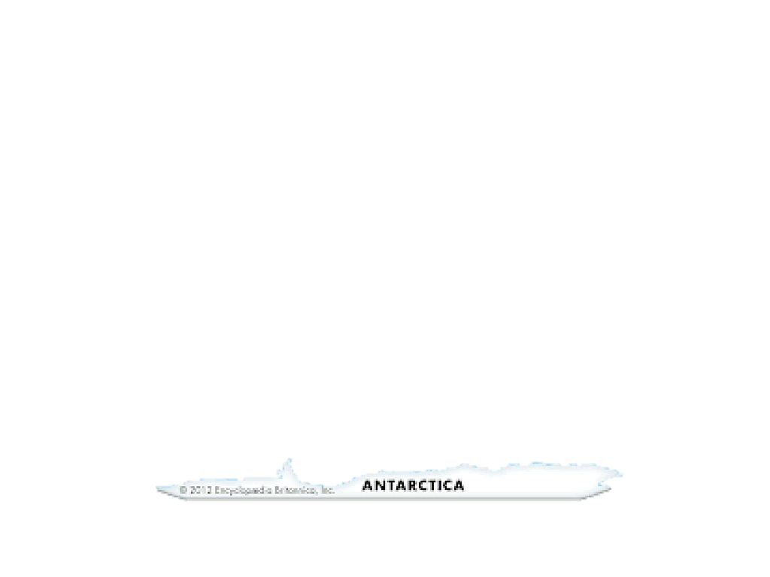

1. Name the following continents.(5 mks)

1. State three Factors that led to the presence of Europeans in Africa. (3 mks)
2. __________________________________________________________________________
3. __________________________________________________________________________
4. __________________________________________________________________________
5. State the countries colonized by the following colonial masters. (3 mks)

|  |  |
| --- | --- |
| Colonial master | Countries they colonized. |
| Britain |  |
| Belgium |  |
| Portugal |  |

1. State four terms of the Berlin Conference of 1884-1885 on partitioning of Africa.(4 mks)
2. _____________________________________________________________________
3. ______________________________________________________________________
4. ______________________________________________________________________
5. ______________________________________________________________________
6. Name the countries marked ABCDE. (6 mks)

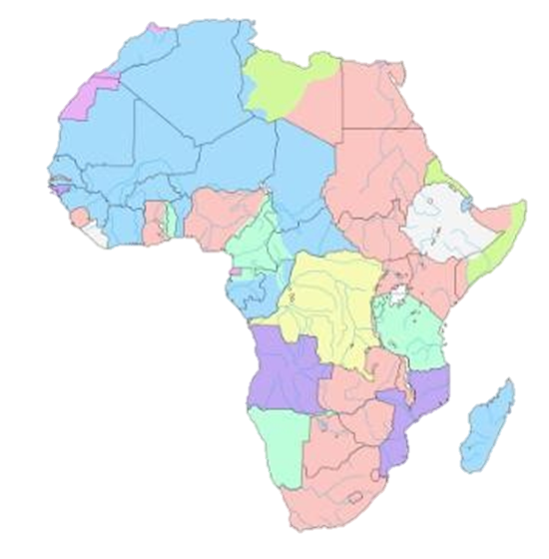

A B

C

D

E

F

A-Libya

B-Egypt

C-South Sudan

D-Congo

E-Madagascar

F- South Africa

1. State three National Values provided in the Constitution of Kenya.(3 mks)
2. _______________________________________________________________
3. _______________________________________________________________
4. _______________________________________________________________
5. List down four proofs that the earth is spherical .(4 mks)
6. _______________________________________________________________
7. ________________________________________________________________
8. ________________________________________________________________
9. _________________________________________________________________
10. Identify the following parts of internal structure of the earth. (2 mks)

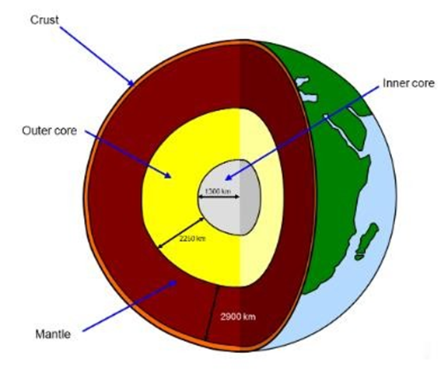

#### Describe three factors that contributed to the presence of African Diasporas across the World. (3 mks)

1. _____________________________________________________________
2. _____________________________________________________________
3. _____________________________________________________________
4. Africans in diaspora play an important role in the political development in Africa. Mention at least three roles. (3 mks)
5. _____________________________________________________________________
6. _____________________________________________________________________
7. _____________________________________________________________________
8. State three Positive effects of globalization. (3 mks)
9. ______________________________________________________________________
10. ______________________________________________________________________
11. ______________________________________________________________________
12. Mention three Qualities of a global citizen in the modern society.(3 mks)
13. __________________________________________________________________________
14. __________________________________________________________________________
15. __________________________________________________________________________
16. Who were the founders of OAU?(6 mks)
17. ____________________________________________________
18. ____________________________________________________
19. ____________________________________________________
20. ____________________________________________________
21. _____________________________________________________
22. _____________________________________________________.

### Mention three Principles of Leadership and integrity.(3 mks)

1. ___________________________________________
2. ___________________________________________
3. ___________________________________________