**COMPETENCE BASED CURRICULUM**

Kenya Junior Secondary Education Assessment

FORMATIVE ASSESSMENT

TIME

2 HRS

ENDTERM 1

SOCIAL STUDIES

G8

2024

**SCHOOL:** ……….……………………………………………………..……

**NAME:** ……………….…………………..………………………...………..

**SIGNATURE: ………………ASSESSMENT NO…………………………..**

***RUBRICS (for official use)***

|  |  |  |  |  |
| --- | --- | --- | --- | --- |
| **MARK SCORE RANGE** | ***Below 40*** | ***40-59*** | ***60-79*** | ***80-100*** |
| **PERFORMANCE LEVEL** | *Below expectation* | *Approaching expectations* | *Meeting expectations* | *Exceeding expectations* |
|  |  |  |  |  |

|  |  |
| --- | --- |
| **OUT OF** | **100%** |
| **LEARNERS SCORE** |  |
| **PERCENTAGE SCORE** |  |
| **PERFORMANCE LEVEL** |  |

**FOR FACILITATOR’S USE ONLY**

**Answer all Questions**

1. List the components of social studies. (3 mks)
2. History,
3. Geography and
4. Citizenship
5. State four importance of learning social studies.( 4 mks)
6. Social studies prepare learners to join career paths.
7. Learners are exposed to different styles of leadership. Understanding they system of government helps learners to make informed decisions.
8. Social studies encourage learners to appreciate different cultures, values and traditions.
9. It gives a historical understanding about the past which helps in shaping our future.
10. Helps one to understand the real world around us.
11. Helps us to become good citizens.
12. Helps us to know the current affairs.
13. Helps us to utilize the available resources to serve humanity.
14. Helps us to appreciate and relate well with other people
15. State three career opportunities related to social studies. (3 mks)
16. Law -Advocate -Lawyer
17. Geology
18. Museology
19. Cartography
20. Urban planning
21. Meteorology and climatology
22. Aviation
23. Archaeology
24. Medicine
25. Teaching
26. Survey
27. Engineering
28. State three entrepreneurial opportunities in social studies. (3 mks)
29. Pottery
30. Basketry
31. Ecotourism
32. Horticulture
33. Agro forestry
34. Fishing
35. Dairy farming
36. State three gender stereotypes associated with career choices and entrepreneurial opportunities in social studies. ( 3 mks)
37. People have different views regarding the roles or careers chosen by women or men.
38. Some people believe that certain careers or entrepreneurial opportunities belong to a given gender (male or female). These are called gender stereotypes.
39. Everyone has an equal opportunity or chance to study their career of choice.
40. They can also pursue a given entrepreneurial opportunity of their choice.
41. Gender is the state of being male or female in relation to social and cultural roles.
42. Stereotypes are fixed general ideas or images that assume that a person behaves in a particular way.
43. Stereotypes limit aspirations and development of talents.
44. They create gender differences.
45. These gender differences ought to be addressed using appropriate strategies.
46. A strategy is a careful plan or method of dealing with an issue

8. Outline three strategies that we can address gender stereotypes in career and entrepreneurial opportunities related to social studies. (3mks)

1. Committing and encouraging both males and females to take a full range of careers and business opportunities
2. Ensuring representation of both genders in leadership
3. Treating both males and females equally by using texts and circular that does not promote gender bias
4. Develop policies, law- and decision-making process that represents both males and females.

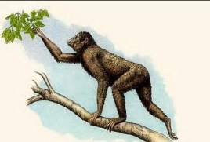

1. What were characteristics of Ramapithecus. (3 mks)
2. also called kenyapithecus
3. He was manlike.
4. He had small canines.
5. He was quadrupedal (he moved on his four limbs), though he occasionally walked on two legs
6. Match the following stages of man correctly



RAMAPITHECUS



HOMOHABILIS



ZINJENTHROPUS

1. Identify three elements of a Map. ( 3mks)
2. Key.
3. Scale.
4. Compass direction.
5. Title
6. Frame
7. 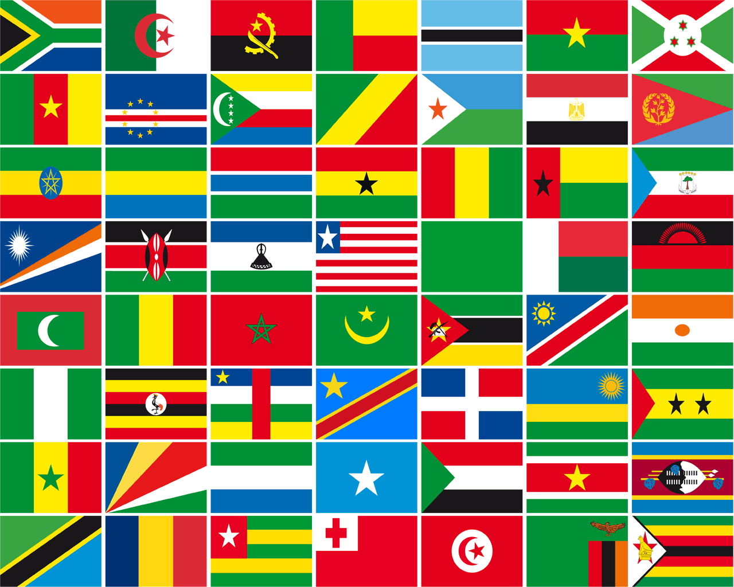What is the capital city of the following African nation? (1 mk)



Nairobi

Kampala





Tunis

Bujumbura

1. Identify two offshore islands in Africa. (2mks)
2. Seychelles
3. Sao Tome and Principe
4. Mauritius
5. Comoros
6. Madagascar
7. Cape Verde
8. State three components of the solar system. (3 mks)
9. 8 planets
10. Dwarf planets
11. Moons
12. Asteroids
13. Comets
14. Meteors
15. Meteorites
16. Sun
17. State four Effects of Rotation of the Earth (4 mks)
18. Creates day and night because at any one time one side of the earth faces the sun (day) and the other remains in darkness (night).
19. Causes deflection of winds and ocean currents in the N hemisphere to the left and in the S hemisphere to the right.
20. It causes rising and falling of ocean tides.
21. Causes time difference between longitudes.
22. Lowest altitude during solstices.
23. Causes lunar eclipse due to revolution bringing the earth in line with the sun and the moon.
24. State the two theories that explains the origin of man.
    1. Scientific theory
    2. Creation theory.
25. 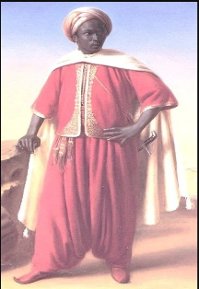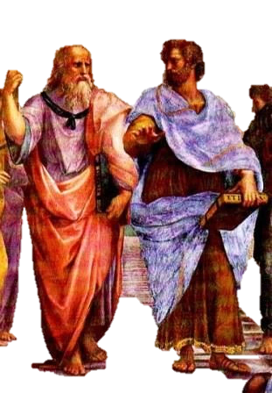Match the following early visitors to Africa with their names.

Arabs

Egyptians

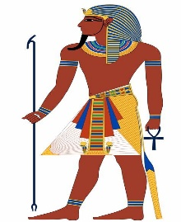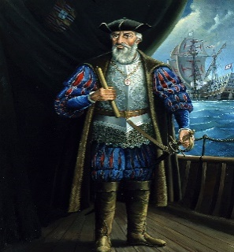

Greeks

Portuguese

1. Name the stages of man from the first to the current. (4 mks)
   1. Egyptopithecus
   2. Dryopithecus
   3. Ramapithecus/kenyapithecus
   4. Australopithecus
   5. Homohabilis
   6. Homoerectus
   7. Homosapiens
   8. Homosapiens sapiens
2. Name the following continents.(5 mks)

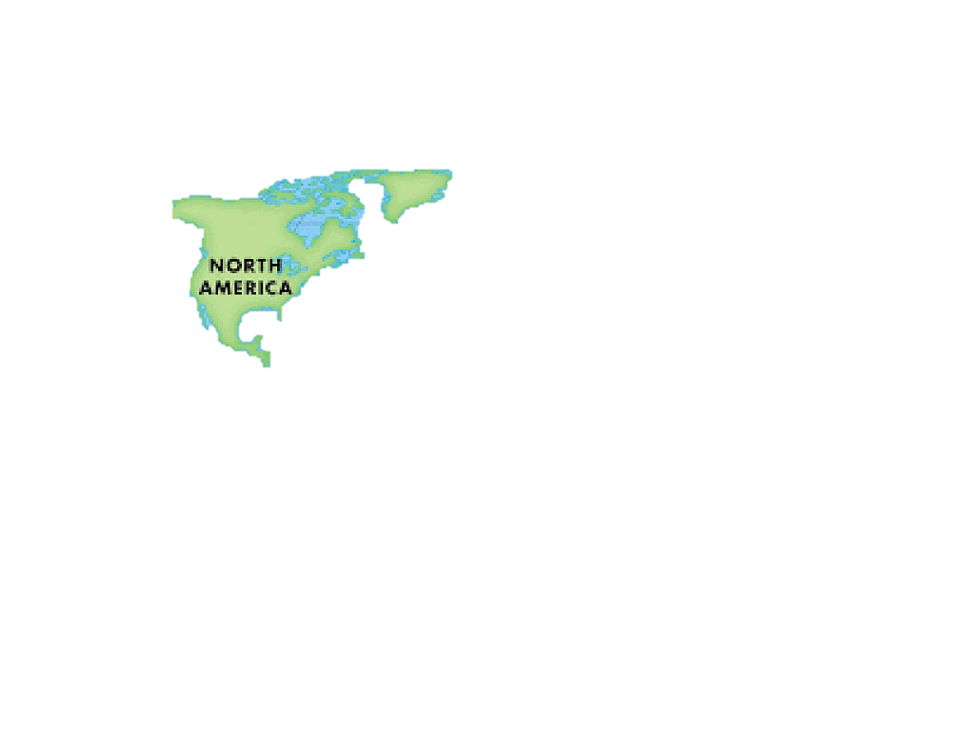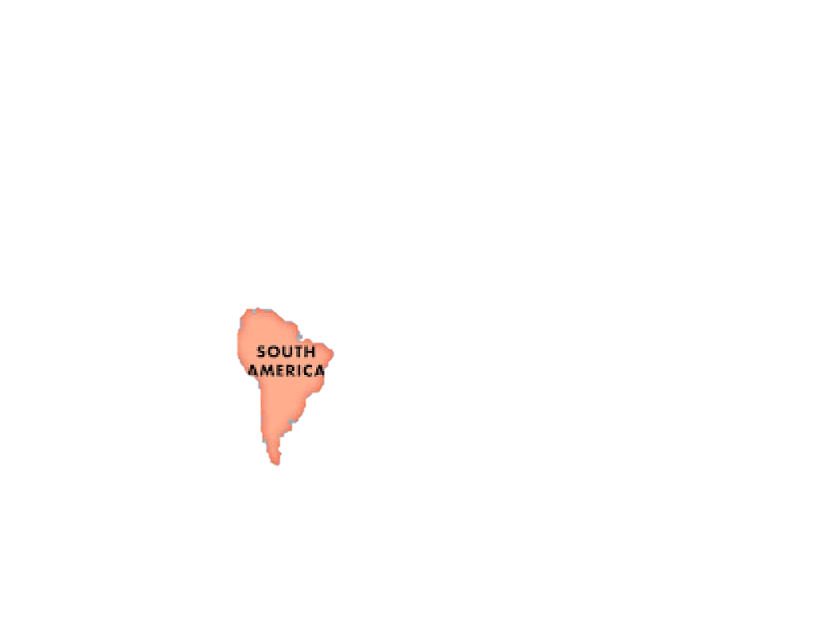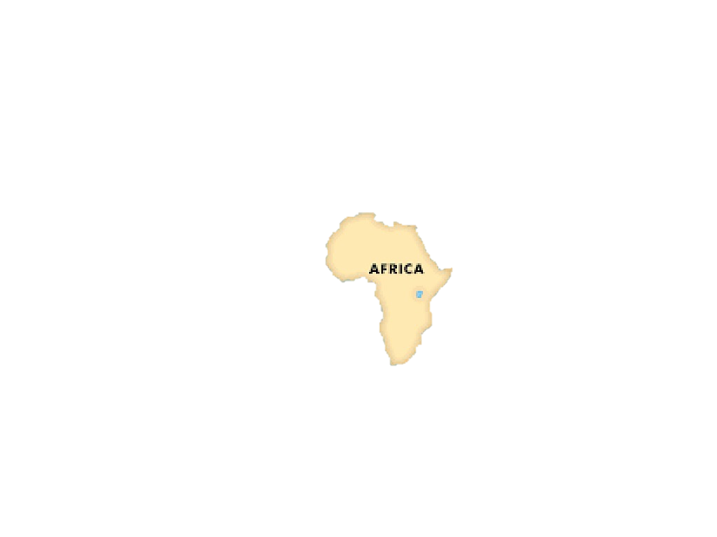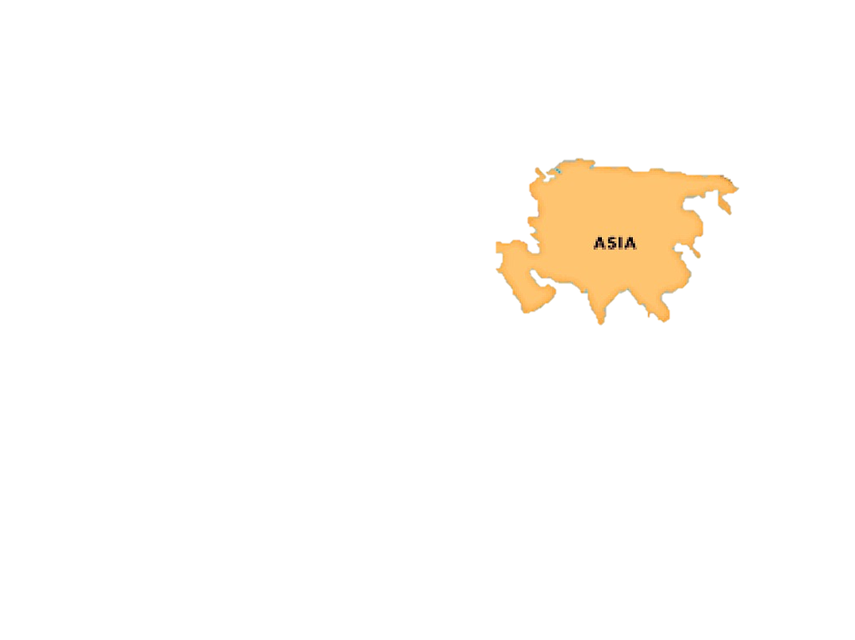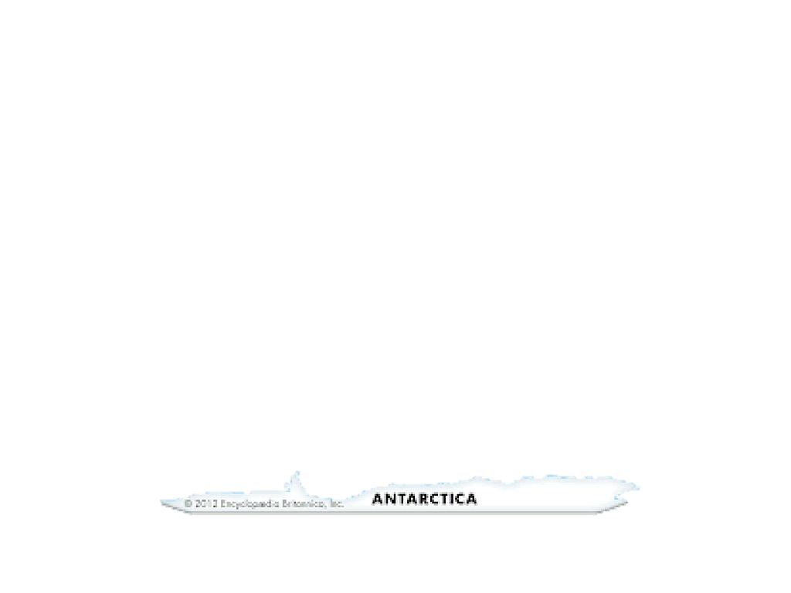

1. State three Factors that led to the presence of Europeans in Africa. (3 mks)
2. To spread Christianity.
3. In search of raw materials for their industries in Europe.
4. Search for markets for their finished goods.
5. National pride and prestige.
6. For exploitation.
7. To spread European civilization.
8. State the countries colonized by the following colonial masters. (3mks)

|  |  |
| --- | --- |
| Colonial  masters | Countries they colonized. |
| Britain | South Africa, Kenya, Nigeria, Ghana, Zimbabwe. |
| Belgium | Congo, Rwanda. |
| Portugal | Angola, Mozambique. |

1. State four terms of the Berlin Conference of 1884-1885 on partitioning of Africa.(4 mks)
2. Congo, Niger and Zambezi rivers are free for navigation and commerce.
3. Declare the spheres of influence and colonies.
4. Solve any boundaries dispute through negotiations.
5. Ensure security of all Europeans in our colonies.
6. Name the countries marked ABCDE

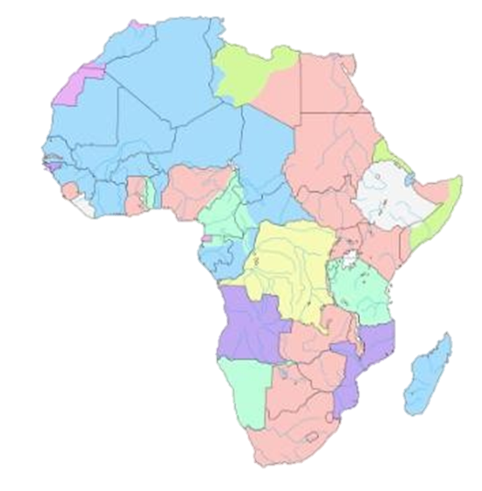

A B

C

D

E

F

A-Libya

B-Egypt

C-South Sudan

D-Congo

E-Madagascar

F- South Africa

1. State three National Values provided in the Constitution of Kenya.(3 mks)
2. Patriotism.
3. National unity.
4. Rule of law.
5. Equity.
6. Inclusiveness-
7. Social justice
8. Equality-
9. Integrity
10. Human rights
11. List down four proofs that the earth is spherical
12. circumnavigation
13. Approaching ship
14. earth rotates from west to East
15. Eclipse of the moon
16. Earth curved horizon
17. All other planets are round
18. Identify the following parts of internal structure of the earth

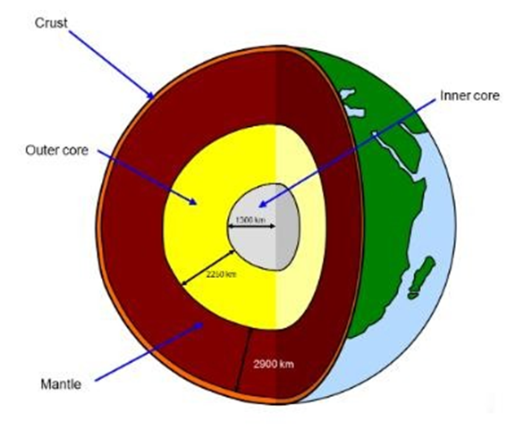

#### Describe three factors that contributed to the presence of African Diasporas across the World. (3 mks)

1. Trans-Atlantic trade.
2. Refugees.
3. Search for education opportunities.
4. African seeking asylum due to political instability and community hostility.
5. Search for employment opportunities.
6. Africans in diaspora play an important role in the political development in Africa. Mention at least three roles. (3 mks)
7. They help formulate policies that improve the political environment in their home countries.
8. They also help in voting during general elections.
9. They help in funding political parties during elections.
10. They protect political asylum in the diaspora.
11. They help in pushing for political changes in countries that have leaders who abuse power.
12. They provide funds to organizations that help in civic education
13. State three Positive effects of globalization. (3 mks)
14. Improvement of the economy.
15. Led to poverty reduction and general development of some countries.
16. Creation of employment opportunities or jobs.
17. There is greater access to technology due to sharing.
18. There is cultural diversity due to ease in movement around the world. .
19. Enable easy communication and flow of information around the world.
20. Has enables importation of cheap and affordable goods.
21. Has led to access to new talents.
22. Led to access to new markets.
23. Mention three Qualities of a global citizen in the modern society.(3 mks)
24. Should understand other people and have empathy.
25. Should act fairly in his or her choices and decisions.
26. Believes that all people are equal.
27. Accepts differences among people.
28. Cooperatives with others.
29. Should be curious and ants to know about others.
30. Should be open minded and confident.
31. Should be able to respect the universal human rights.
32. Should conserve the environment.
33. Believes in making positive changes in the world.
34. Should advocate for peace in all areas.
35. Should be adaptable and flexible to any global challenges
36. Who were the founders of OAU?(6 mks)
37. Kwame Nkurumah from Ghana,
38. Haille Selassie from Ethiopia,
39. Julius Nyerere from Tanzania,
40. Gamal Abdel Nasser from Egypt,
41. Leopolld Sedar Senghor from Senegal and
42. Ahmed Bella Ben from Algeria.

### Mention three Principles of Leadership and integrity.(3 mks)

1. Integrity.
2. Honesty.
3. Openness and Transparent.
4. Accountability.
5. Impartial.
6. Selfless.
7. Public participation.
8. Competence and sustainability.
9. Commitment.
10. Participation and representation.