**JUNIOR SCHOOL EDUCATION ASSESSMENT**

**2ND TERM 2024**

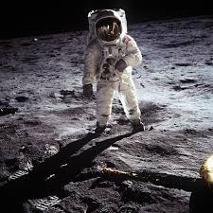 **GRADE 8**



SOCIAL STUDIES

END OF MAY ASSESSMENT

NAME: _______________________________________________________

SCHOOL: _____________________________________________________

ASSESSMENT NUMBER ____________________ DATE___________________

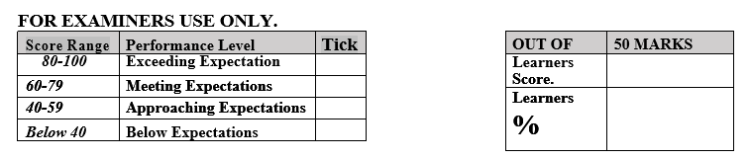

**LEARNER’S INSTRUCTIONS**

1. Write your name, School, Assessment Number and the exam date in the spaces provided above.
2. Answer all the questions in this paper.
3. Any rough work must be done in this paper.
4. All your answers must be written in the spaces provided in the question paper.
5. Writing and giving relevant examples is highly recommended.
6. It’s highly recommended to draw illustrations when explaining a concept.
7. Learners should check the question paper to ascertain that all the pages are printed as indicated and that no questions are missing.
8. Your answers must be clearly written (Legible) and well organized.
9. Use blue or black pens when writing answers and a pencil when drawing.
10. Learners must answer the questions in English.
11. Mention five career opportunities related to social studies. (5 mks)

# ___________________________ c____________________________

# ____________________________ d___________________________

### State three components of social studies? (3 mks)

* 1. _____________________ b_____________________ c _________________

1. Some of the entrepreneurial opportunities for social studies in our society include? (4 mks)
2. _____________________________ c_______________________________
3. ______________________________ d________________________________
4. State four factors that led to growth of Ancient Egypt Civilization. (4 mks)
   1. _________________________________________________
   2. ________________________________________________
   3. _________________________________________________
   4. ________________________________________________

#### State four contributions of early civilization to modern world. (4 mks)

1. _____________________________________________________________________________
2. _____________________________________________________________________________
3. _____________________________________________________________________________
4. _____________________________________________________________________________
5. Identify the stages of evolution of man.(2 mks)
   1. ___________________________________ c_________________________________________
   2. ___________________________________ d ________________________________________
6. State three Factors that led to the presence of Europeans in Africa. (3 mks)
7. ……………………………………………………………………………………
8. ……………………………………………………………………………………
9. ……………………………………………………………………………………..
10. List four continents in the worlds. (4 mks)
11. ______________________________ c _____________________________________
12. _______________________________ d________________________________________
13. State the countries colonized by the following colonial masters. (7 mks)

|  |  |
| --- | --- |
| Colonial masters | Countries they colonized. |
| Britain |  |
| Belgium |  |
| Portugal |  |
| Germany |  |
| Italy. |  |
| Spain. |  |
| France |  |

1. State four terms of the Berlin Conference of 1884-1885 on partitioning of Africa.(4 mks)
2. ………………………………………………………………………………………..
3. …………………………………………………………………………………………
4. …………………………………………………………………………………………
5. …………………………………………………………………………………………
6. Name the countries marked UVWX

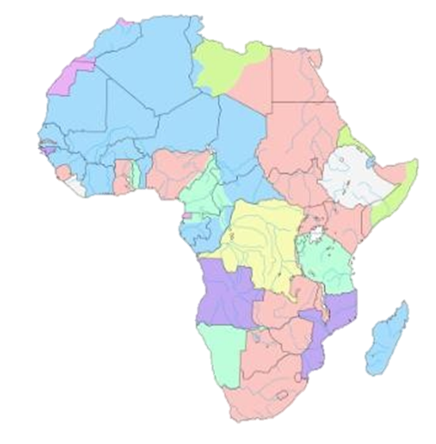

W

X

Z

Y

W-……………………………………………..

X-……………………………………………..

Y-……………………………………………..

Z-……………………………………………..

#### State three importance of Democracy in the society. (3 mks)

1. ………………………………………………………………………………..
2. ………………………………………………………………………………..
3. ……………………………………………………………………………….
4. State three Importance of the Constitution.(3 mks)
5. ………………………………………………………………………………………….
6. ………………………………………………………………………………………….
7. …………………………………………………………………………………………
8. State three National Values provided in the Constitution of Kenya.(3 mks)
9. …………………………………………………………………………………….
10. …………………………………………………………………………………….
11. …………………………………………………………………………………….

#### Name two types of democracy.(2 mks)

1. ……………………………………………………………………………………
2. ……………………………………………………………………………………
3. What is the Role of Citizens in democracy representation.(3 mks)
4. ……………………………………………………………………………………..
5. ……………………………………………………………………………………..
6. ………………………………………………………………………………………
7. List down four proofs that the earth is spherical
8. …………………………………………………………………………………….
9. …………………………………………………………………………………….
10. …………………………………………………………………………………….
11. …………………………………………………………………………………….
12. Identify the following parts of internal structure of the earth

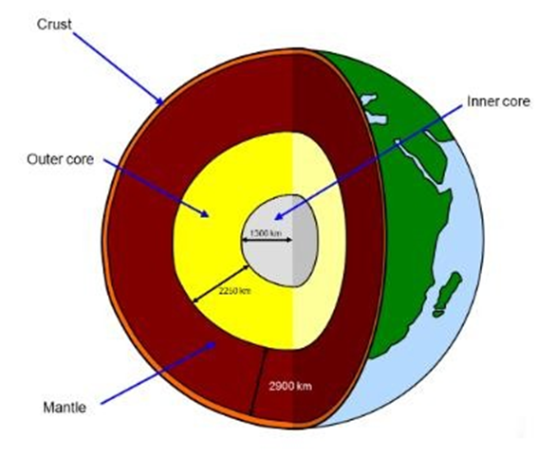

1. The following ways can be used to promote equity and non-discrimination in the society. Namely. (4 mks)
2. ………………………………………………………………………………………….
3. ………………………………………………………………………………………….
4. ………………………………………………………………………………………….
5. …………………………………………………………………………………………..

#### Describe three factors that contributed to the presence of African Diasporas across the World. (3 mks)

1. ………………………………………………………………………………………….
2. ………………………………………………………………………………………….
3. …………………………………………………………………………………………
4. Africans in diaspora play an important role in the political development in Africa. Mention at least three roles. (3 mks)
5. ………………………………………………………………………………..
6. ………………………………………………………………………………..
7. ………………………………………………………………………………..
8. NAME the following stage of evolution of man correctly



1. State three Positive effects of globalization. (3 mks)
2. ……………………………………………………………………….
3. ……………………………………………………………………….
4. ……………………………………………………………………….

##### State the Negative effects of globalization include;(4 mks)

1. …………………………………………………………………………
2. …………………………………………………………………………
3. …………………………………………………………………………
4. …………………………………………………………………………
5. Mention three Qualities of a global citizen in the modern society.(3 mks)
6. ……………………………………………………………………………….
7. ……………………………………………………………………………….
8. ……………………………………………………………………………….
9. Who were the founders of OAU?(6 mks)
10. ……………………………………………………………………
11. ……………………………………………………………………
12. ……………………………………………………………………
13. ……………………………………………………………………
14. ……………………………………………………………………
15. ……………………………………………………………………
16. What is?

Evolution …………………………………………………………………………………………………………………………………………………………

#### Archaeological site or prehistoric site

……………………………………………………………………………………………………………………………..………………………………..

#### Archaeologists

……………………………………………………………………………………………………………………………………………………………..

#### Fossils

………………………………………………………………………………………………………………………………………………………………