COMPETENCE BASED CURRICULUM
Kenya Junior Secondary Education Assessment
FORMATIVE ASSESSMENT
TIME
2 HRS
ENDTERM 1
PRE-TECHNICAL STUDIES
G8
2024
SCHOOL: ……….……………………………………………………..……
NAME: ……………….…………………..………………………...………..
SIGNATURE: ………………ASSESSMENT NO…………………………..
RUBRICS (for official use)
MARK SCORE RANGE | Below 40 | 40-59 | 60-79 | 80-100
PERFORMANCE LEVEL | Below expectation | Approaching expectations | Meeting expectations | Exceeding expectations

OUT OF | 100%
LEARNERS SCORE
PERCENTAGE SCORE
PERFORMANCE LEVEL

FOR FACILITATOR’S USE ONLY

Answer all Questions

State three components of pre-technical studies. (3 mks)
- ______________________________________________________________________
- ______________________________________________________________________
- ______________________________________________________________________

State three roles of pre-technical studies in day today life.(3 mks)
- ______________________________________________________________________________________
- ______________________________________________________________________________________
- ______________________________________________________________________________________
- CPU has 3 components, list them. (3mks)
- _______________________________________________________________________
- _______________________________________________________________________
- _______________________________________________________________________

Name three examples of metals. (3 mks)
    - _______________________________________________________________________
    - _______________________________________________________________________
    - _______________________________________________________________________
- Identify the metal used to make the following material.(5 mks)

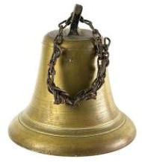
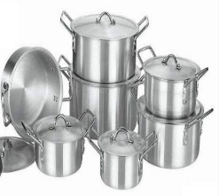
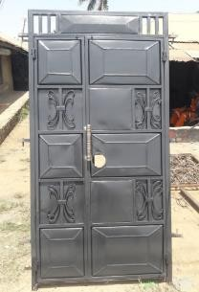
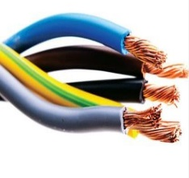

- Write in full. (6mks)
a.) ALU
________________________________________________________________________________________________________________________________________________________
b.) USB
________________________________________________________________________________________________________________________________________________________
c.) HDMI
________________________________________________________________________________________________________________________________________________________
- State two problems experienced when setting up computers. (2mks)
- _______________________________________________________________________
- _______________________________________________________________________
- List down three causes of Repetitive Strain Injury (RSI) (3mks)
- _____________________________________________________________________
- _____________________________________________________________________
- State three physical threats to computers. (3mks)
- _______________________________________________________________________
- _______________________________________________________________________
- _______________________________________________________________________
- State three Function of a computer. (3 mks)
- _______________________________________________________________________
- _______________________________________________________________________
- _______________________________________________________________________
- State four Advantages of using a computer. (4 mks)
- _______________________________________________________________________
- _______________________________________________________________________
- _______________________________________________________________________
- _______________________________________________________________________

Outline three Importance of communication in the work environment.(3 mks)
  - __________________________________________________________________
  - __________________________________________________________________
  - __________________________________________________________________

- Name four ICT Tools used in Communication.(4 mks)
- ________________________________________________________________________
- ________________________________________________________________________
- ________________________________________________________________________
- ________________________________________________________________________.

- Name three Examples of technical drawings:
  - ______________________________________________________________________
  - ______________________________________________________________________
  - ______________________________________________________________________
- Name the Types of Lines used in drawing. (4 mks)
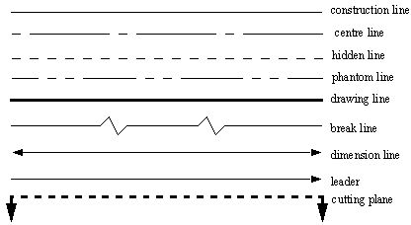

- State four factors of production.(4 mks)
- _______________________________________________________________________
- _______________________________________________________________________
- _______________________________________________________________________
- _______________________________________________________________________

- State three characteristics of economic resources used for production of goods and services.(3 mks)
  - __________________________________________________________________
  - __________________________________________________________________
  - __________________________________________________________________

- Give three examples of non-metallic materials.(3 mks)
      - ______________________________________________________________________
      - ______________________________________________________________________
      - ______________________________________________________________________

Name the parts of the computer shown below. (4 mks)

State three examples of safety measures. (3 mks)
- ________________________________________________________________________
- ________________________________________________________________________
- ______________________________________________________________________

Identify four Physical threats at workplaces. (4 mks)
- ______________________________________________________________________
- ______________________________________________________________________
- ______________________________________________________________________
- ______________________________________________________________________

Name at least four examples of online threats at work place. (4 mks)
- ______________________________________________________________________
- ______________________________________________________________________
- ______________________________________________________________________
- ______________________________________________________________________

State three ideas and practices on how to personal and sensitive data from the public when online. (3 mks)
  - _________________________________________________________________
  - _________________________________________________________________
  - _________________________________________________________________

Identify two Safety Rules and Regulations at Work. (2 mks)
  - __________________________________________________________________
  - __________________________________________________________________
- List any two computer hardware components. (2mks)
- _____________________________________________________________________
- _____________________________________________________________________
- Mention two Careers related to Personal Safety.( 2mks)
- ______________________________________________________________
- ______________________________________________________________

- Name the following items. (3 mks)

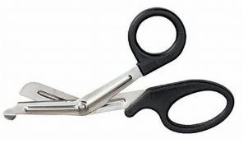
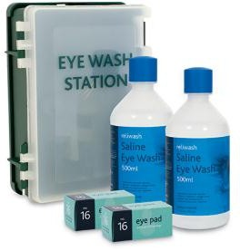
___________________ ______________________ __________________

- Give two examples of Metals. (2 mks)
- _________________________________________________________
- _________________________________________________________

- Draw any four safety wears. (10 mks)

