COMPETENCE BASED CURRICULUM
Kenya Junior Secondary Education Assessment
FORMATIVE ASSESSMENT
TIME
2 HRS
ENDTERM 1
PRE-TECHNICAL STUDIES
G8
2024
SCHOOL: ……….……………………………………………………..……
NAME: ……………….…………………..………………………...………..
SIGNATURE: ………………ASSESSMENT NO…………………………..
RUBRICS (for official use)
MARK SCORE RANGE | Below 40 | 40-59 | 60-79 | 80-100
PERFORMANCE LEVEL | Below expectation | Approaching expectations | Meeting expectations | Exceeding expectations

OUT OF | 100%
LEARNERS SCORE
PERCENTAGE SCORE
PERFORMANCE LEVEL

FOR FACILITATOR’S USE ONLY

Answer all Questions

State three components of pretechnical studies.
Pretechnical studies is a technical learning area comprising of:
Pretechnical studies – a learning area that involves acquiring practical skills and experience in technical area.
Computer science the study of computers and how computer technology can be used to solve problems.
Business study-involves study of activities that involves production, distribution and consumption of goods and services aimed at making profits.

State three roles of pretechnical studies in day today life.
- It gives learners the skills they need to think critically and solve problems as well as preparing them for a technical & digital future.
- Facilitates development of appropriate skills and knowledge gained from the learning areas Such as computer science and business studies.
- Offers a wide range of careers in pretechnical area such as in safety and material handling, in computer science such as programmers, software engineering and in business studies such as accountant, traders, manager, bankers and shopkeeper.
- Pretechnical studies promotes independence and self-learning through various skills
- Enhancing chances of creating employment opportunities and self-employment in individual.
- It equips learners with skills to use when observing personal safety and safety in working environment.
- CPU has 3 components, list them. (3mks)
- Arithmetic and logic unit (ALU),
- A control unit, and
- Various registers.

Name three examples of metals. (3 mks)
    - Copper.
    - Iron.
    - Aluminium.
    - Steel.
    - Silver among others.
- Identify the metal used to make the following material.(5 mks)

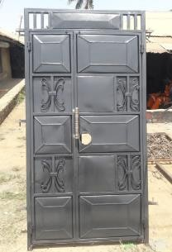
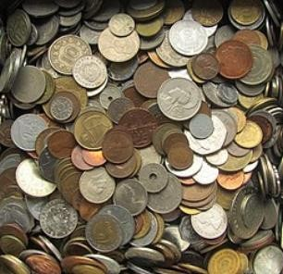

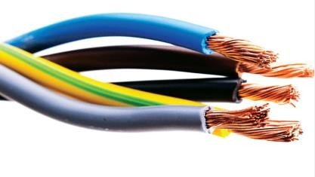
Iron or steel
Silver or copper

Copper
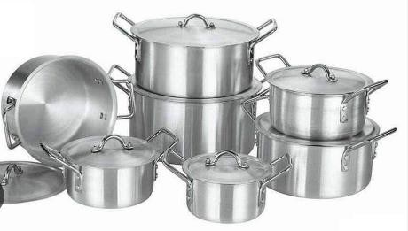
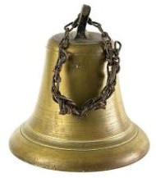

copper

Bronze
Aluminum

- Write in full. (3mks)
a.) ALU
The full form of ALU is arithmetic logic unit. It is a combinational digital circuit that performs arithmetic operations on binary numbers.
b.) USB
USB, in full universal serial bus, technology used to connect computers with peripheral devices
c.) HDMI
The full form of HDMI is the High Definition Multimedia Interface. It is an all-digital audio-video interface that transmits information to a computer monitor, video projector, digital television and so on, in uncompressed mode.
- State two problems experienced when setting up computers. (2mks)
- The Computer Won't Start.
- A computer that suddenly shuts off or has difficulty starting up
- Have a failing power supply.
- The Screen is Blank.
- Abnormally Functioning Operating System or Software.
- Windows Won't Boot.
- The Screen is frozen.
- Computer is Slow.
- Strange Noises.
- Slow Internet.
- Forgotten passwords
- List down three causes of Repetitive Strain Injury (RSI) (3mks)
- Repetitive strain injury (RSI) is caused by repeated use of a body part, such as your shoulder, elbow, forearm, wrist or hand.
- Some examples of activities that can cause RSI are computer use, carpentry, material handling, or even recreational activities
- State three physical threats to computers. (3mks)
- Virus.
- Trojans.
- Worms.
- Spyware.
- Key loggers.
- Adware.
- Denial of Service Attacks.
- Distributed Denial of Service Attacks

- State three Function of a computer. (3 mks)
- Stores data and information
- Process data into information using given instructions
- Accepts data from the user
- A computer gives out information to the user

- State four Advantages of using a computer. (4 mks)
- Computer process data faster than human beings
- Computers keep data and information secure
- Computers can store a lot of data in a small physical space
- Computer can do the same repeatedly without getting tires or bored
- Computer are able to perform different types of jobs at the same time
- A computer is reliable because it consistently does what it is supposed to do.
- Computers have a very big storage capacity and can store data and information for a very long time

Outline three Importance of communication in the work environment.(3 mks)
  - Good communication ensures making decision is easier.
  - Communication helps to build positive relationships, teamwork and trust at workplaces.
  - Good communication helps to achieve greater goals.
  - Communication enables managers’ shares goals with shareholders both inside and outside the organisation. It gives managers permission to stimulate behaviour changes in employees and suppliers and to inspire loyalty from the employees and customers.
  - It allows managers to convince employees and unions to abandon counterproductive practices, managers persuade leaders to provide financing and it permits managers to calm angry customers and impress new ones.
  - Preventing misunderstanding and conflicts.
  - Improving customer services.
  - Meeting goals and earning success.
  - Promoting creativity and innovation.
  - Advancing individual career prospects.

- Name four ICT Tools used in Communication.(4 mks)

- Emails-used to exchange information over the internet to other individuals.
- Mobile phones- allows calling and messaging in communication.
- Computers -computer provide various communication channels such as emailing, video calling etc.
- Videos and web conferencing- Video conferencing has a focus on face-to-face communication. Web conferencing has a focus on interaction and collaboration such as document sharing.
- Social networking - use of dedicated websites and applications to interact with other users.
- Online collaboration - using the internet and online tools to collaborate.
- Softwares like word processor are used to design letters and memos that are used to pass information in business.
- Social media is used to give immediate response to customer needs.

- Name three Examples of technical drawings:
  - Architectural
  - Mechanical systems drawings.
  - Electrical drawings,
- Name the Types of Lines used in drawing. (4 mks)
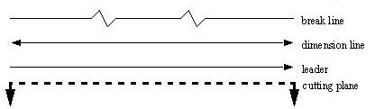
- State four factors of production.(4 mks)
- Land.
- Labour.
- Capital.
- Entrepreneurship.

- State three characteristics of economic resources used for production of goods and services.(3 mks)
  - Uneven distribution-economic resources are not found in all places.
  - Scarcity- these resources are not enough to satisfy all human wants.
  - Economic resources have alternative uses.
  - Usefulness-Economic resources have utility and they are useful.
  - Mobility-They can be transported from one place to another.
  - Combinability-Economic resources can be combined to produce different goods and services.
  - Monetary Value-Economic resources are measured in terms of money. Therefore, they have monetary value.
  - They can change ownership.

- Give three examples of non-metallic materials.(3 mks)

      - Wood.
      - Stones.
      - Textile.
      - Soil.
      - Glass.
      - Leather.
      - Plastic.
      - Rubber.
      - Water.
      - Air among others

Name the parts of the computer shown below. (4 mks)

Monitor/screen
Keyboard
CPU/Processor
Mouse

State three examples of safety measures. (3 mks)
- Wearing face mask to prevent spreading of airborne diseases or breathing in dirty air.
- Buckling a safety belt while in a vehicle to avoid falling off the seat in case of emergency brakes.
- Wearing hand gloves when working to avoid injury and dirt to the hands when working.
- Wearing gum boots to protect the feet from injury when working in areas with mud or sharp objects.
- Wearing an overall to guard against soiling clothes.

Identify four Physical threats at workplaces.(4 mks)

- Sharp edged tools and objects that can easily cut or poke someone.
- Disarranged rooms where one can easily tumble and fall.
- Naked electric wires that can easily cause electric shock.
- Poorly lit rooms where one can easily know oneself against objects.
- Poorly stored items on the shelves where they can easily fall off and hit someone.
- Working without protective gear where one can easily be hurt or injured.
- Rooms with wet slippery floors where one can easily slip and fall.

OSCAR MWANGI O705443680

Name at least four examples of online threats at work place. (4 mks)
- Malware/virus attack.
- Hacking.
- Data theft.
- Cyber bullying.
- Friend requests from unknown people.
- Phishing attacks.
- Ransom ware-attempts to encrypt data and calling for ransom to release it or unlock code

State three ideas and practices on how to personal and sensitive data from the public when online. (3 mks)
  - Protect and manage personal information.
  - Do not accept friend requests from strangers.
  - Avoiding harmful or illegal content.
  - Buy online items from secure and trusted sites.
  - Installation of antivirus software.
  - Backing up data.
  - Use of strong passwords.
  - Log out from your online accounts after using public internet to browse.
  - Do not communicate with strangers online.

Identify two Safety Rules and Regulations at Work.(2 mks)
  - To ensure that you know how to safely perform the task.
  - To ensure you know the hazards of the task and how to protect yourself.
  - To wear the required personal protective equipment necessary for the task.
  - To always work clear of suspended loads.
  - To always keep your mind and eyes on the task at hand.
  - To obey all warning signs and barricades.
  - To inspect all tools and equipment to ensure they are not defective before using them.
  - Do not perform a task under unsafe conditions and report any unsafe tools, equipment or hazardous conditions.
  - All chemicals’ containers should be well labelled and covered.
  - Maintain good housekeeping at workplace all the time.

- List any two computer hardware components. (2mks)
- The case,
- Central processing unit (CPU),
- Random access memory (RAM),
- Monitor,
- Mouse,
- Keyboard,
- Computer data storage,
- Graphics card,
- Sound card,
- Speakers and
- Motherboard.

- Mention two Careers related to Personal Safety.( 2mks)
- Production of personal safety items such as face masks, hand gloves, ladders, upholstery, fire extinguishers etc.
- Marketing of safety equipment and products as technical sales personnel.
- Personal safety services such as fire officer, coast guards, divers, ambulance drivers, and safety education and training among others.
- Crossing guards
- These are people who help children or adults to cross busy roads
- Safety engineers
- These are people who monitor a working environment and inspects buildings and machines. They later recommend the safety precautions to be observed in the working environment
- Life guards
- These are people who help children and adults to swim safely. There also ensure that all people are following rules set by the swimming place. They attend to those who face challenges while swimming
- Risk manager.
- This person researches and makes a report on the safety of a particular work and the hazards that are expected.
- Environment health and safety consultants.
- They perform some roles similar to those of safety engineers. They offer advice on how to minimise health and safety risks in the workplace.

- Name the following items

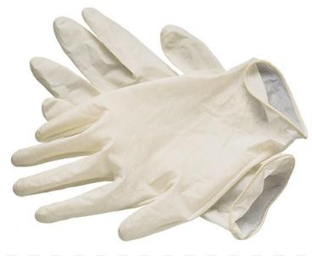
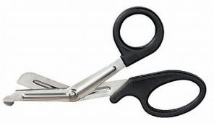
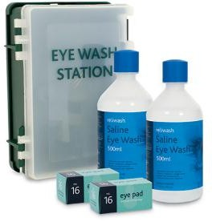
Eyewash. Disposable gloves Scissors

- Give two examples of Metals. (2 mks)
- Copper.
- Iron.
- Aluminum.
- Steel.
- Silver among others.

- Drawing of a helmet, apron. overall, gloves, safety jacket, gumboots, goggles, masks, muffs, etc

